PROPOSED TOWN & COUNTRY PLANNING APPLICATION FOR RESIDENTIAL DEVELOPMENT
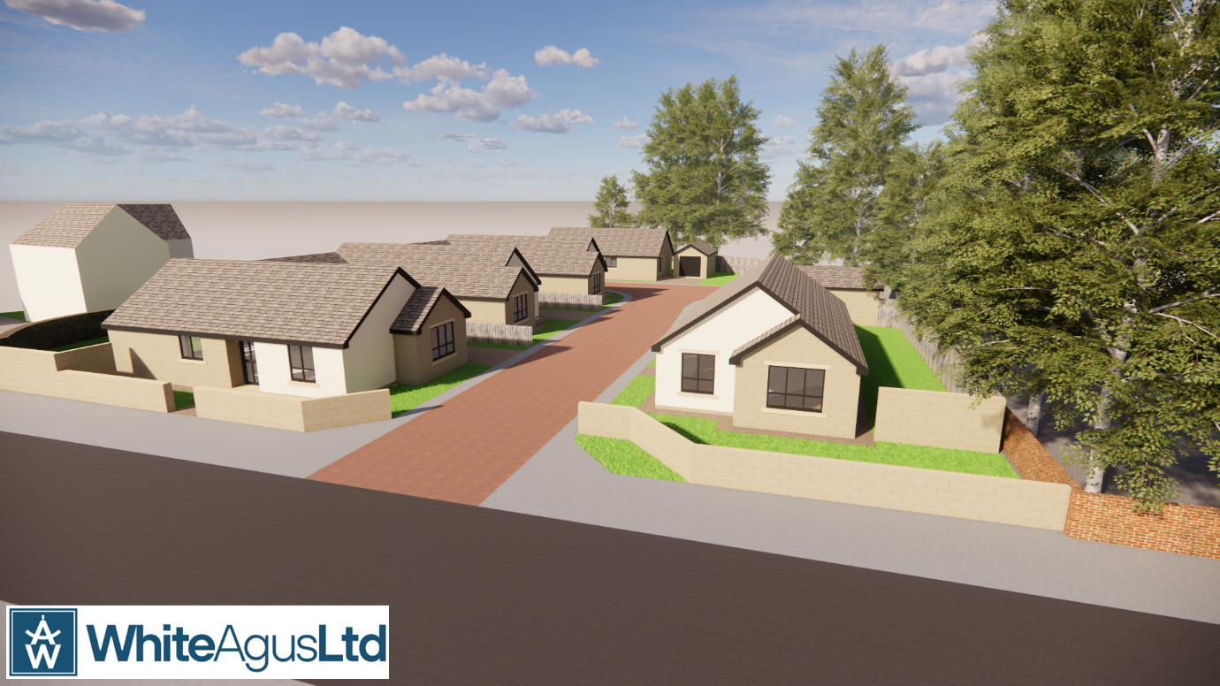
AT
ROYSTON W.M.C.
CHURCH STREET
ROYSTON

For
AVEY HOMES LTD

DESIGN AND ACCESS STATEMENT- Rev 1

Prepared by
WHITE AGUS LTD

BACKGROUND

The proposal is to demolish the existing buildings on site and erect 4No detached, two-bedroom bungalows with associated access and parking.

Regarding the marketing of the premises, we have been advised that the ‘club’ had been in financial difficulties for a number of years. Despite attempts to make the business financially viable the Club failed and fell into administration. We understand that this was not the first time that this has occurred.
The building was repossessed and marketed without success, and new owners could not be found. The property was subsequently sold at auction.
A plan showing similar drinking establishments is attached. It is not difficult to understand why a business of this type would struggle to survive in the current economic climate and following a global pandemic.
The building could not readily be converted to other uses and the fabric of the building requires significant repairs.

SITE

The application site is a former Working Men's Club occupying a Freehold site of 0.52 acre in an established residential village located to the northeast of Barnsley.

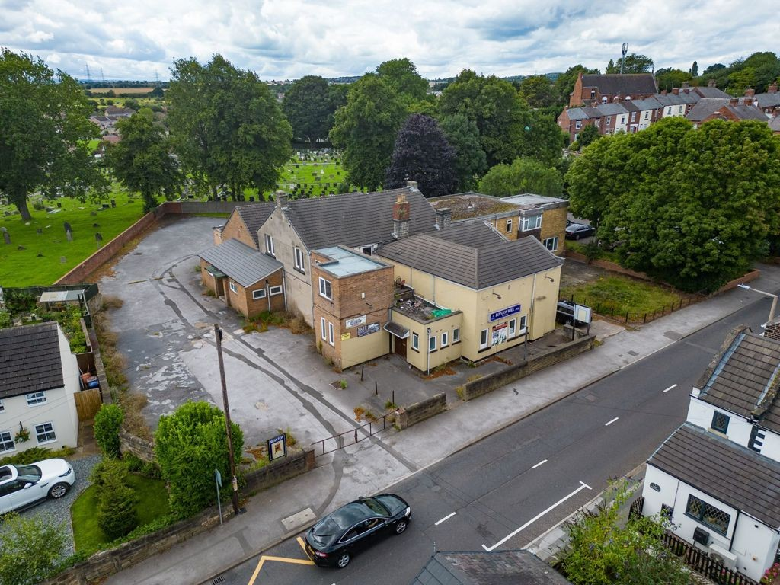

The current building comprises 827.70 sqm of accommodation over two levels and comprises an open plan bar, entertainment area and snooker room to the ground floor together with a 3 bedroom flat above.

The site has a large area of hardstanding that was the Club carpark with direct access from Church Street.

Ther site is within a mixed-use area with Royston town centre a short walk away.

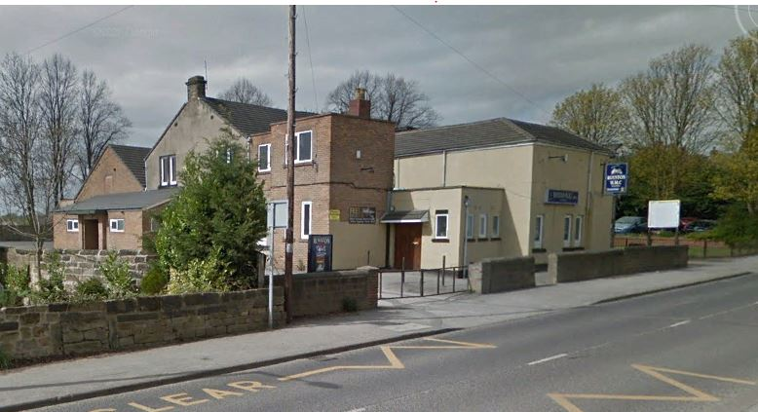

Existing building and Access from Church Street

Efforts to sell the site as a going concern or for other community use have been unsuccessful.

There are other drinking establishments and Working Men’s Club within close proximity the site.
The site is surrounded by residential properties with a cemetery to the rear of the site and a car park immediately to the north west.

There are trees beyond the site boundaries and an Arbouricultural Report is included with the submitted documents

PROPOSALS & DESIGN CONSIDERATIOns

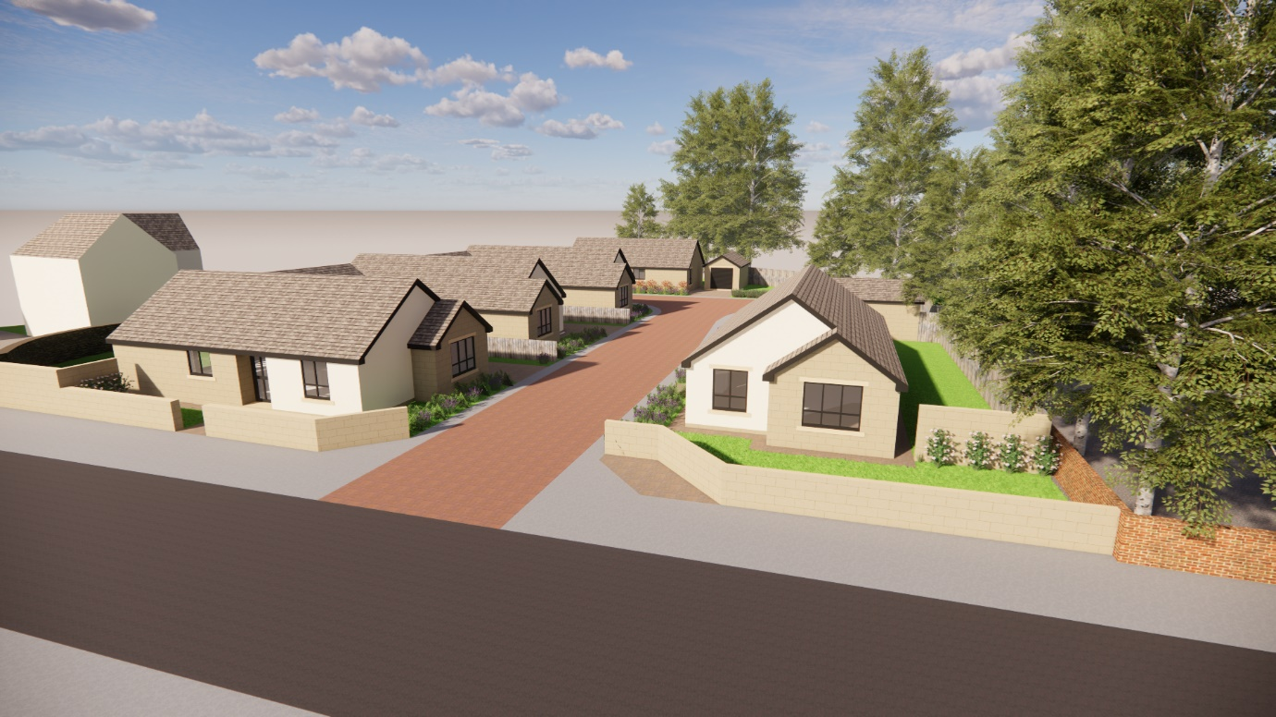

The site lies within a residential area with little definitive architectural character.
Consideration has been given to the impact on the existing residential properties adjacent the site.
It has been concluded that there will be no significant impact upon the existing residential properties, which will enjoy separation distances well in excess of the recommendations of the South Yorkshire Residential design Guide.
The proposed traditionally constructed dwellings are in keeping with the general style of properties on new developments throughout the Borough.
The proposals for residential development of the site as shown on the submitted proposals will cause no significant harm to the local environment.
The size of properties and accommodation proposed for the dwellings is considered appropriate for the location when assessed in relation to other residential developments in the locality and market forces
The orientation and aspect of the building has been designed with regard to separation from adjoining buildings, footways, highways, site topography and scale of surrounding features.
The size and location of openings has been determined with full regard to the scale of building, orientation of accommodation and requirements for means of escape and ventilation.
The development has not been designed in isolation. Consideration has been given to buildings in the wider context and the impact of the proposals on views from surrounding properties, the highway and pedestrian routes.
The scheme has been designed with a view to providing visually attractive aspects from both traffic routes and pedestrian footways.
The layout of the development was governed by the location of the access point, restriction due to site topography existing services covered by legal covenants and the proximity of adjacent building.
The design of the scheme is appropriate in relation to the site, its surroundings and land use policies.
Gradients have been determined in relation to existing site topography and with regard to providing suitable access and movement around the site for disabled persons.

social & Economic context.

Any potential for excessive overlooking from the development or overshadowing will not occur because of any of the proposed development due to the siting of the buildings, orientation of windows to habitable rooms and separation distances between the proposed dwelling and adjacent garden areas.
Due to the modest scale of the development there will be no significant impact upon local services. However the site is situated close to Royston Town Centre which offers retail, commercial and transport opportunities
It is unlikely that any jobs will be created because of the development other than those persons employed to carry out the building works.
The site is close to frequent public transport links into Barnsley Town Centre and surrounding areas.
The site is within walking distance of shops and local amenities.
The general amenity of the area will be improved by the loss of the Club with potentially noisy and disruptive activities and associated car parking.

Access
Access to the site will be via a relocation of the existing access points on Church Street.
The proposed parking standards comply with the South Yorkshire Design Guide. The majority of parking provision for the whole development has been located away from the main Church Street frontage.
Both the external and internal layouts will meet or exceed the requirements of all relevant provisions of the Building Regulations, particularly regarding features and provisions to meet Part M requirements for disabled people and Part B in relation to fire and emergency escape and Part K.

Entrance doors, and the internal layout of dwellings will meet or exceed the requirements of all relevant provisions of the Building Regulations, Particularly regarding features and provisions to meet Part M requirements for disabled people and Part B in relation to fire and emergency escape and Part K in respect to guarding of stairways and prevention of falling (particularly with regard to children).

trees
An Arboricultural Report is included with the submitted documents.

CONCLUSIONS
The site is in a sustainable location and the presumption must be in favour of residential development.

Dwellings of the type proposed are fully compatible with the general character of the locality.

The development is within an existing settlement, close to existing amenities and public transport links.

Because the scheme is small in scale it will not impact on the community infrastructure, services or facilities.

The density of the proposed development is acceptable in relation to the surroundings.

