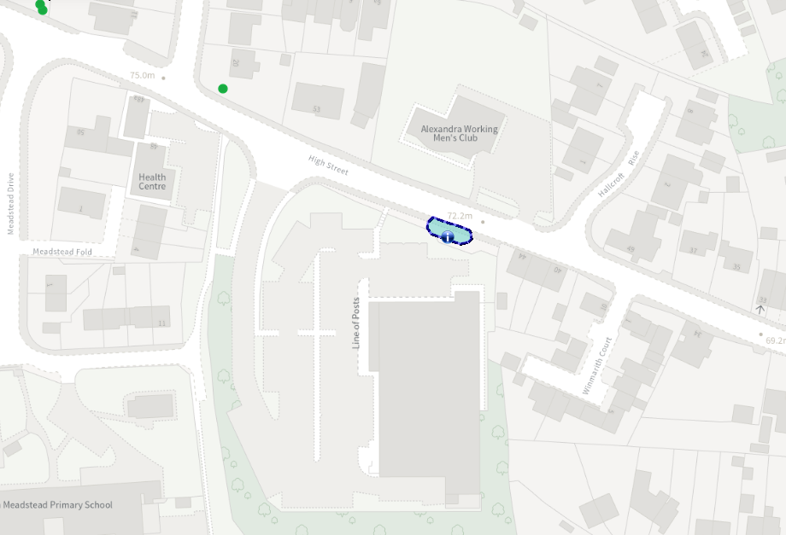
Site location Plan
Aldi

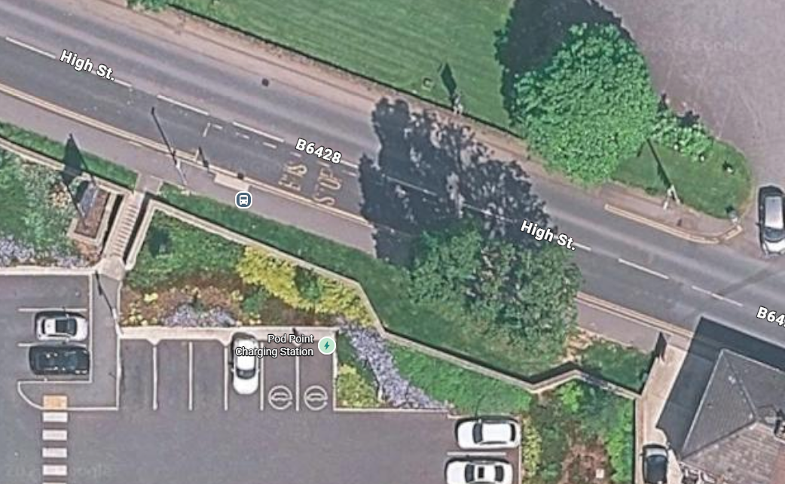
Tree ID Plan – Group G1 on TPO
T3

44 High Street
Aldi, carpark
T1
T2

