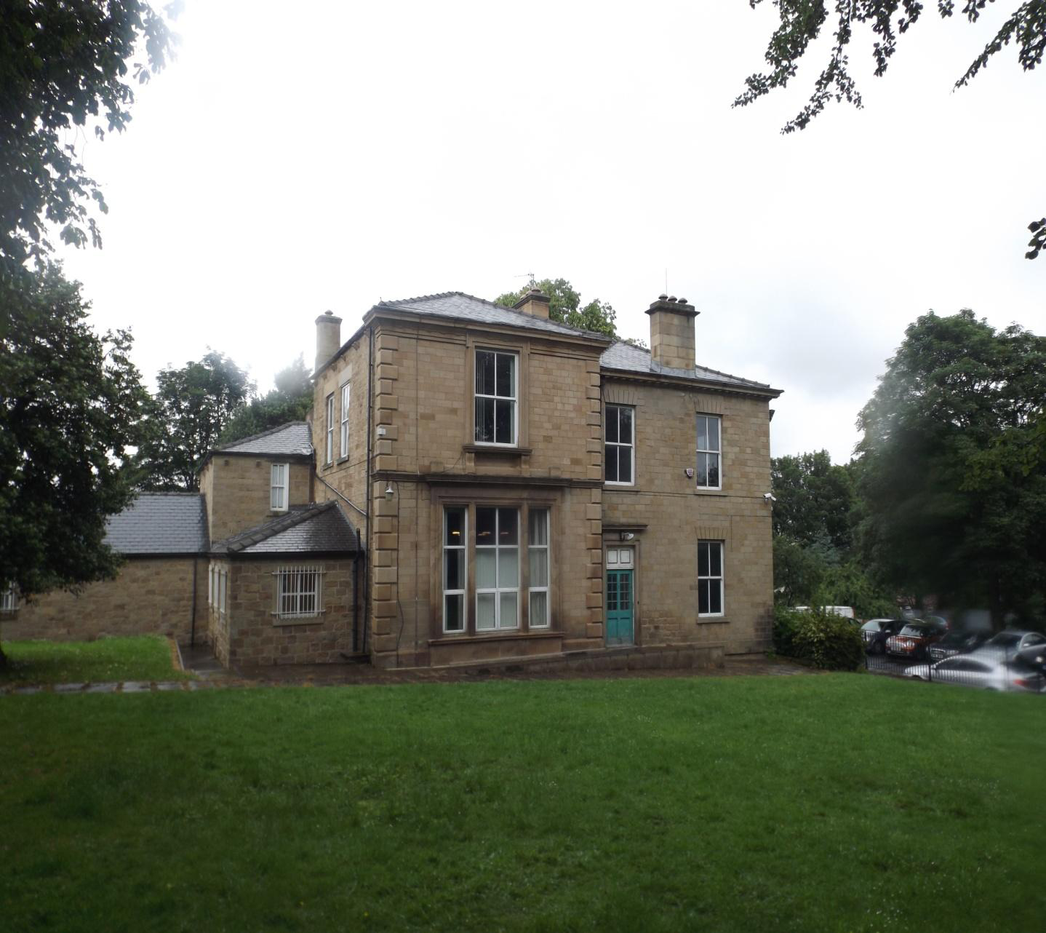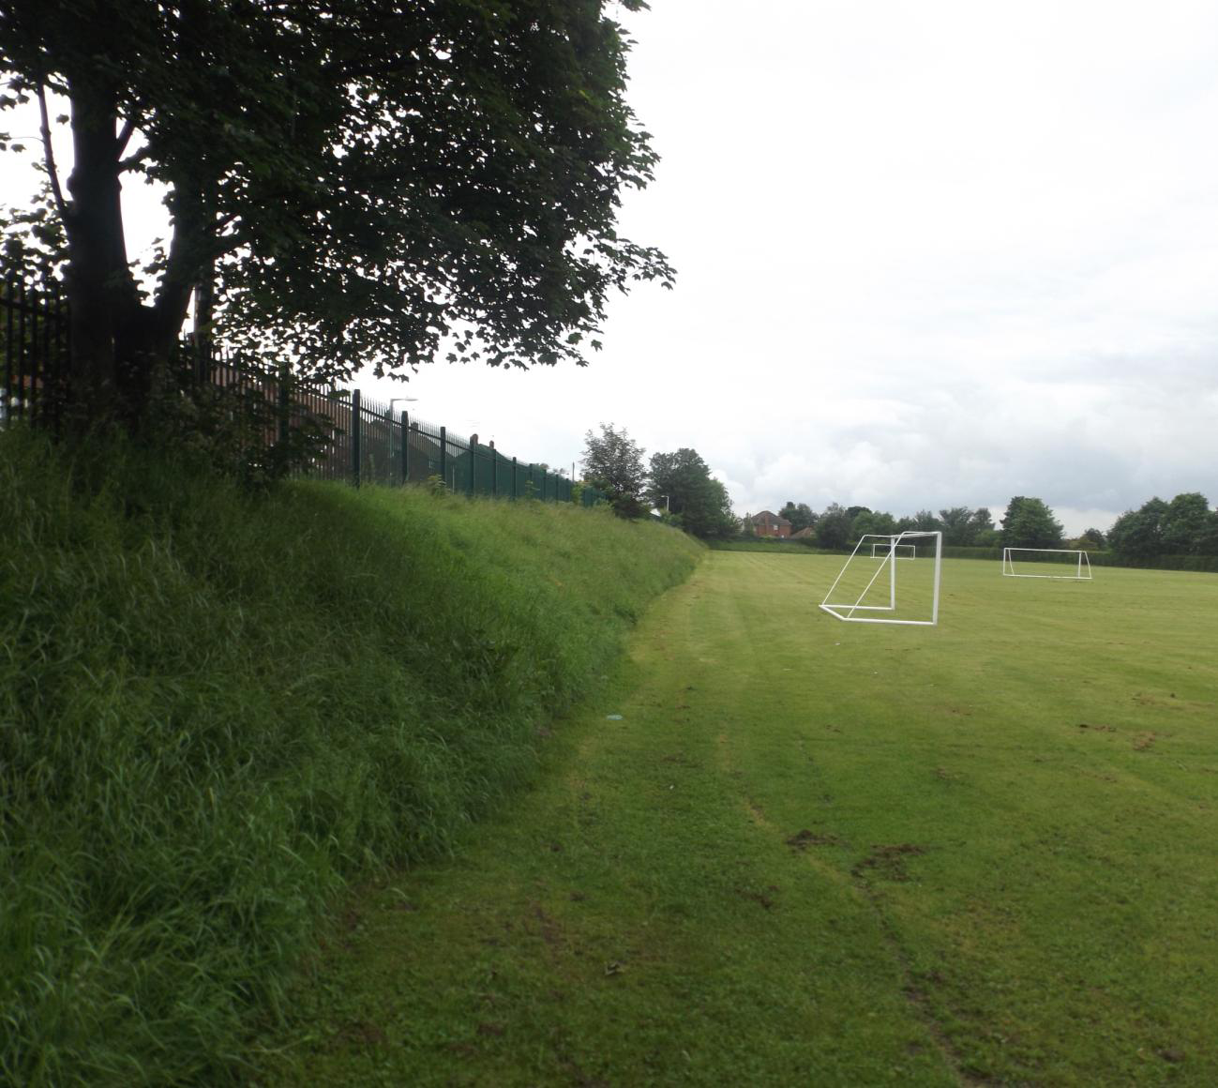

Barnsley College Housing Development Sites
Statement of Community Involvement




CONTENTS

 |  | Page No.
SECTION 1 | INTRODUCTION | 2
SECTION 2 | BACKGROUND | 2
SECTION 3 | POLICY REQUIREMENTS | 5
SECTION 4 | SUMMARY OF RESPONSES | 6
SECTION 5 | CONCLUSIONS | 8

APPENDICES

Appendix 1: Plan of Extent of Public Consultation Letter Notification

Appendix 2: Sample Public Consultation Event Letter Sent To Residents

Appendix 3: Consultation Event Questionnaire

Appendix 4: Screen Shot of College Web Site at www.barnsley.ac.uk/capita-developments

SECTION 1: INTRODUCTION

1.1 This Statement of Community Involvement outline the background to the
proposed development including a summary of the information presented at the public event. It will discuss the planning policy requirements relevant in the
undertaking of a Statement of Community Involvement and public consultation, provide a summary of responses received following the public consultation
event, including project team responses to those issues raised.

SECTION 2: BACKGROUND

2.1 The submission of the planning application follows an extensive pre-application
consultation and discussions with Barnsley Council, a public exhibition with local residents and councillors and the publication of the developments via Barnsley College web site. The event publicised the proposals for developing Carrington Avenue for housing and also the scheme for housing at Belle Vue as well as the conversion of the existing building to flats.

Consultation Process
2.2 The concept of developing the sites for residential development were proposals were first prepared and with initial discussions held with Barnsley Council in February 2014.

2.3 local Councillors were notified of the development ahead of the letter drop notification.

Public Consultation Event
2.4 The public consultation event took place on 18th June 2014 between the
hours of 5pm and 8pm at Belle Vue House on Cockerham Lane. Prior to the exhibition, Capita undertook a letter drop notification of all residents in the surrounding locality to inform them of the forthcoming public exhibition. The extent of the letter drop notification was discussed with the Council and went beyond what would be the normal neighbourhood consultation undertaken by the Local Planning Authority for these type of planning applications. A plan identifying those
areas notified is attached at Appendix 1.

2.5 All residents within the identified area were provided with written notification of the consultation event (sample letter contained at Appendix 2) which also included a map identifying the relevant sites. Relevant ward Councillors from the Old Town ward
were notified and invited to the event.

2.7 Finally, in addition to the letter notification, the event was also publicised and information was provided through the creation of a web page on Barnsley College web site.

2.8 The event was attended by representatives from the College and a number of staff from the Capita Project team, including a Traffic Engineer, Project Director, Planning and Heritage Consultants and Architect.

2.9 Within the exhibition room, consultation boards were displayed, with each set of boards attended by members of the development team to explain the proposals to residents at the consultation event. Additional members of the development circulated the room to discuss the scheme with anybody who was not able to see a board at that time or had additional questions.

2.10 On arrival residents were invited to sign an attendance register in order to assess the level of interest in the event. In total 32 attendees signed the register although it is known that in excess of this number including representatives of Barnsley Civic Trust.

2.11 A total of 23 consultation responses were received in response to the consultation event, by way of completed comments forms. A summary of the consultation responses is set out in Section 4 of this Statement.

Other Consultations Undertaken
2.12 Beyond the organised public consultation events, various members of the project team have engaged with various third parties who have specific interests in the development including the following;

Sport England
The Football Association
Local Junior Football Teams – Including Wombwelll Juniors, Barnsley Ladies, Redfearns and Junior Tykes
Barnsley Conservation Officer
Barnsley Civic Trust

2.13 Comments from each of these groups have been incorporated, where possible,
within the overall development proposals.

SECTION 3: POLICY REQUIREMENTS

Barnsley Council Statement of Community Involvement
3.1 The Statement of Community Involvement was adopted in August 2006 and sets out for developers and applicants how they should involve people in development proposals before submitting planning applications.

3.2 The SCI reflects the changes brought in through the 2004 Planning and Compulsory Purchase Act and recognises the need “to place the community at the heart of making planning decisions”. The SCI explains how the local community may be consulted in all areas of the planning process including the preparation of development plans and planning applications. The SCI encourages developers to engage with local residents and businesses, particularly on large scale developments.

SECTION 4: SUMMARY OF CONSULTATION RESPONSES AND
PROJECT TEAM FEEDBACK

4.1 This section of the Statement of Community Involvement provides an analysis of the comments received from attendees at each of the public consultation events and
sets out how these comments have been considered and addressed as part of the
proposed development, as appropriate. The majority of residents were concerned with the Carrington Avenue although there were written responses from five householders from Cockerham Avenue and Cockerham Lane who were primarily concerned with the development at Belle Vue.

Consultation Responses on Belle Vue
4.2 From the total group of questionnaires in relation to 8 objected to the housing scheme at Belle Vue 7 residents supported the principle and 8 did not know. In relation to the conversion of Belle Vue House to apartments 6 objected 8 supported the principle and 6 did not express a view

4.3 From all the residents who offered an opinion, 8 objected to the creation of mini pitches to compensate for the loss of playing fields, 9 supported the idea and 4 did not express an opinion.

4.4 From the residents in Cockerham Ave and Cockerham Lane who live closest to Belle Vue 2 specifically objected to the development of housing there, 1 supported housing on the site and 2 did not express a view. Only one person living in the vicinity of Belle Vue opposed the principle of converting the house to apartments.

4.5 These residents adjoining Belle Vue were concerned with the likely parking impact as a result of the development.

Response
4.6 Discussions have taken place with the Council’s Highway engineers and monitoring of the area will take place. If problems arise as result of the development it is likely that a residents parking scheme can address any potential for overspill car parking from the College itself. It is anticipated that any housing scheme will meet the Council’s parking standards with two in curtilage parking spaces being provided for the larger properties and one space each for the apartments. he scheme will provide
Written comments made

Consultation Responses on Carrington Avenue
4.7 From all the written responses there were 12 people who objected to the principle of housing on the Carrington site, a further 4 did not comment or did not know and 7 respondents supported the principle.

4.8 During the consultation event and from the written responses relating to Carrington the main areas of concern fall within four main areas.
1. Parking and Narrowness of Carrington Ave
2. Congestion in the area;
3. Loss of Open Space
4. Loss of View

4.9 From the written responses from residents from within the vicinity of, or living on Carrington Eve 8 had concerns regarding the width of Carrington Ave and its ability to allow traffic through if there was development on both sides of the road and the lack of parking in particular for those properties facing onto the street.

Response
4.10 It should be noted that the scheme shown to residents were only illustrative plans showing how the site could be developed for housing. However these plans have been amended to include a garage to those properties fronting and an additional driveway car park space within their curtilage. Therefore each property will benefit from two parking spaces. This will ensure that there would be no significant increase in on street parking.

4.11 Four respondents commented on the potential for congestion in the area and in particular the pinch points such as the tunnel at Honeywell Lane the exit from Cockerham Lane.

4.12 Capita have undertaken traffic surveys in the area and specifically at these junctions. The supporting Transport Assessment will demonstrate that the traffic as a result of both developments will not lead to significant delays at these junctions during peak times. Any necessary improvement works identified by the Transport Assessment to ensure the free flow of traffic and safe access onto the sites will be undertaken by the developer.

4.13 Three residents from Carrington Avenue have expressed concern at the loss of the open space.

Response
4.14 The applicant will demonstrate through the submission of the Open Space Assessment that although the proposal does involve development on green space, that there is adequate access to open space within the area. The provision of replacement mini pitches as part of the College’s redevelopment proposals will meet an acknowledged deficiency within the North Neighbourhood Area.

4.15 One resident commented on the lack of school places within the area.

Response
4.16 The Council has identified schools in the area that need to increase capacity as a result of the development and the College has agreed a suitable contribution to pay towards the creation of additional places in local schools.

SECTION 5: CONCLUSIONS

5.1 This Statement of Community Involvement has set out in detail the how the community consultation undertaken as part of the pre-application progression of the Barnsley College Development Proposals. This SCI was carried out in accordance with Barnsley Council’s community consultation requirements as described within its 2006 Statement of Community Involvement.

5.2 This SCI demonstrates that the applicant has undertaken reasonable steps in order to gauge public opinion and respond to residents concerns wherever possible within the final scheme. Engagement with the local community and the varied
third party interests has helped ensure that the development proposals achieve the aims and objectives of both the Council and other consultees where possible.

