Tree protection plan for the proposed installation of Visitor Information Shed at Wentworth Castle Gardens
Version 2: 31 July 2023

The position of the Visitor Information shed is in proximity to a number of Scots Pine Trees, as shown on the map below.
This plan sets out how the trees in the area will be protected during the installation of the shed, to ensure their continued wellbeing.
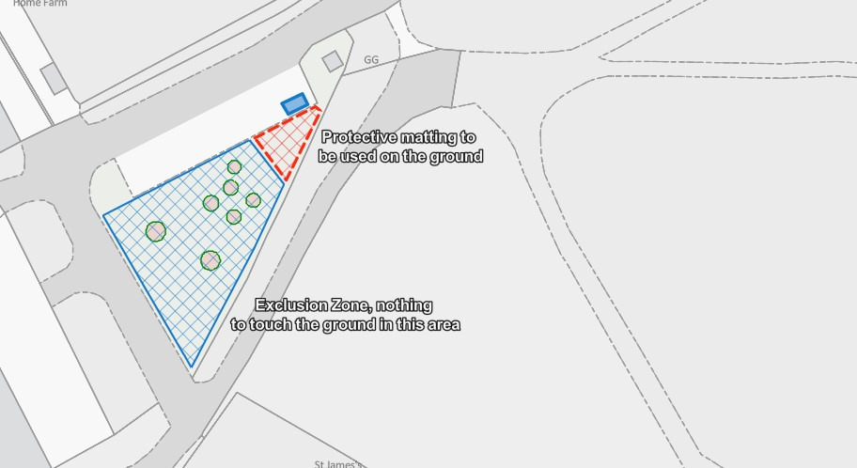
Wentworth Castle Gardens Tree Protection Map, prepared by Matt Watson, 14.07.23

Key:
: Shed

: Scots Pine Trees
: In this area, if anything needs to go onto the grass then protective matting will be put on the ground to protect the grass and any underlying tree roots.

: This area is an exclusion zone for the protection of the Scots pine trees. Nothing will be placed onto the ground in this area. The area will be cordoned off with a tree protection barrier.

The location of the Shed does not pose any risk to the trees, as it will be installed onto a tarmacked surface.
We are aware that care will need to be taken during the installation to protect the trees in the vicinity and have made the following assessment.

- In our opinion, there is really no need for any equipment, machinery or materials to be placed onto the grass during the installation of the Shed. It can all take place on the tarmacked surface.
- In the event that the installation team do deem it necessary to walk on the grass or place tools on the ground, we would set out protective matting in the area which is coloured red on the map.
- There is no need for anything to be placed on the ground in the area which is coloured blue on the map. This will be marked out as an exclusion zone with tree protection barriers. The barriers will be comprised of cones or pins with netting to clearly define the exclusion zone and ensure it is not encroached into.
This document will be shared with the contractors prior to the installation taking place. In addition, a member of the Wentworth Castle Team will oversee the installation.
We are confident that given these measures, the risk to the Scots Pines is negligible.

Ruth Carrington, Partnerships & Participation Manager
Matthew Watson, Area Ranger

Wentworth Castle Gardens. 31 July 2023

