PROPOSED RESIDENTIAL DEVELOPMENT

At

LAND ADJACENT
‘CHEVET’ THURNSCOE ROAD,
BOLTON UPON DEARNE

For

Mr & Mrs SWIFT

OUTLINE APPLICATION

DESIGN AND ACCESS
STATEMENT

Prepared by

WHITE AGUS LTD

Background
This Statement has been prepared in support of an Outline Planning Application for residential development on land adjacent ‘Chevet’ Thurnscoe Road, bolton upon Dearne. An earlier application for similar proposals ref 2022/0885 was withdrawn.

the site
The site is situated to the west of Thurnscoe Road between existing dwellings, Chevet to the south and Quarry House to the north.
Thurnscoe Road runs along the western site boundary and is a one way highway with traffic travelling in a north-south direction.

Traffic calming measure are in place and the carriageway is defined by kerbs and white lining and associated signage.

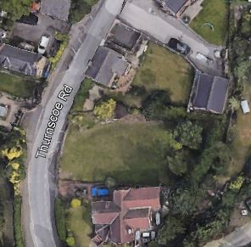

There are trees on the site and if approved, details of the trees, protection and the impact of a new dwelling will be dealt with a reserved matters application.

There is a low stone retaining wall with low hedge along the boundary with Thurnscoe Road.

The area is residential and the properties are of mixed styles in traditional construction

PLANNING POLICY
The site is located within a Housing Policy Area within the Local Plan, as such; residential development on the site would be acceptable in principle.

It is proposed that a new access will be formed into the site with visibility splays and pedestrian inter-visibility splays as shown on the submitted drawings.

Provision will be made for a car to be able to enter and leave the site in a forward gear.

This is an Outline application with all matters, other than access to be reserved.

The proposal is a self- build or custom housing as defined by The Self-build and Custom Housebuilding Act 2015.Therefore BNG does not apply. Pro-former included with the submitted documents.

SoCIAL & ECONOMIC CONTEXT
In the context of the existing, adjacent properties it is considered feasible that development on the site would not result in significant harm to the local environment or amenity of existing residents.

assesment

The new access has been designed to meet Highway requirements and will not prejudice highway safety. Provision for the turning of vehicles within the site is shown on the submitted drawings

The proposal is within an existing settlement and therefore complies with Local and National policies relating to residential development.

The development is within an existing settlement, close to existing amenities and public transport links.

Because the scheme is small in scale it will not impact on the community infrastructure, services or facilities.

