**2023/0160**

Mr James Whipp

Extension to existing warehouse (east)

Morgan House, Goldthorpe Industrial Estate, Commercial Road, Goldthorpe, Rotherham, S63 9BL

**Planning History**

2023/0174 - Extension to existing warehouse (west) – Under consideration

01/1460 - Erection of new storage building – Approved with conditions

00/0230 - Erection of two-storey unit for warehouse/storage, office and call centre – Approved with conditions

**Description**

Morgan House is a large commercial building located on Commercial Road, Goldthorpe, within an existing industrial estate with similar style buildings. The large Aldi distribution centre is located to the south west of the site.

The site is occupied by Ken Mallinson & Sons Ltd national/international transport and warehousing company with sites in Barnsley and Rotherham. The existing use is classed as B8 Storage and Distribution. The applicant is active in multiple industries, operating primarily in the construction, retail and manufacturing industries. The company distributes an extensive range of commodities including construction products, agricultural products, electrical goods and food and drink products. Their Goldthorpe site currently provides their warehousing facility where goods are stored and distributed.

The buildings are of a typical industrial design with grey or black metal cladding over a red brick base. The site has car parking areas to the frontage and a HGV turning and parking to the eastern edge of the site. A band of trees/landscaping can be seen to the south of the site.

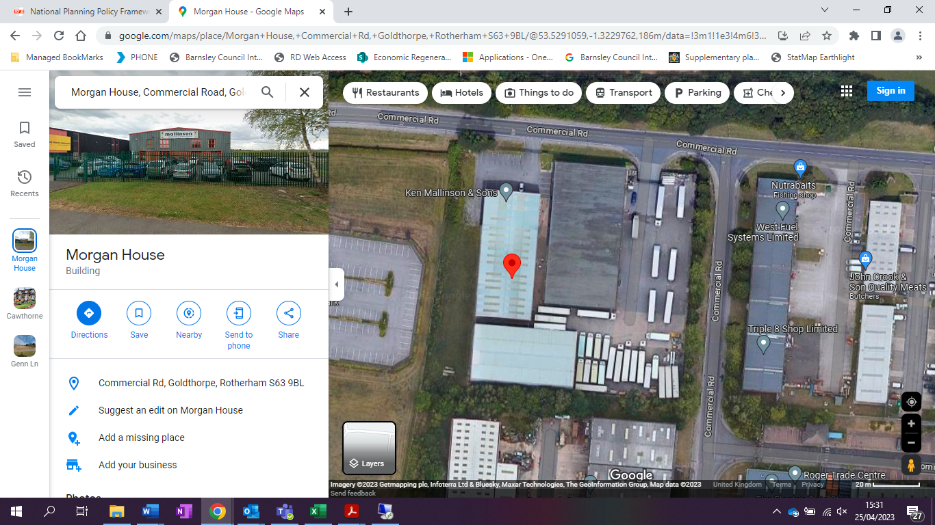

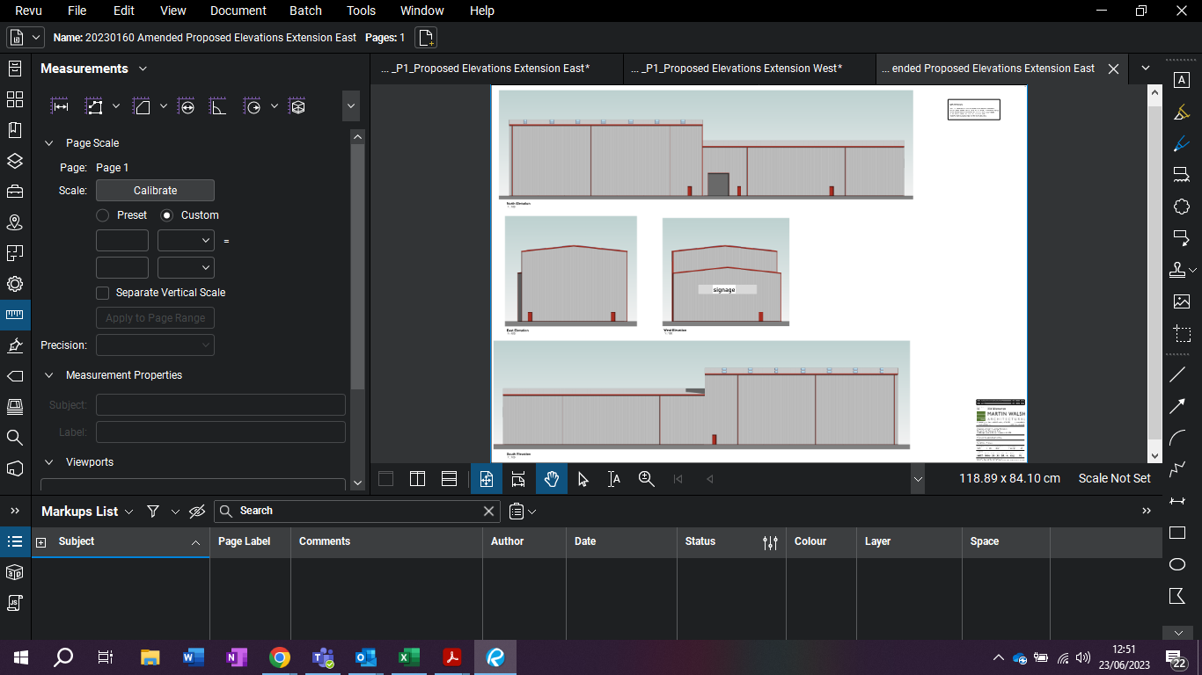

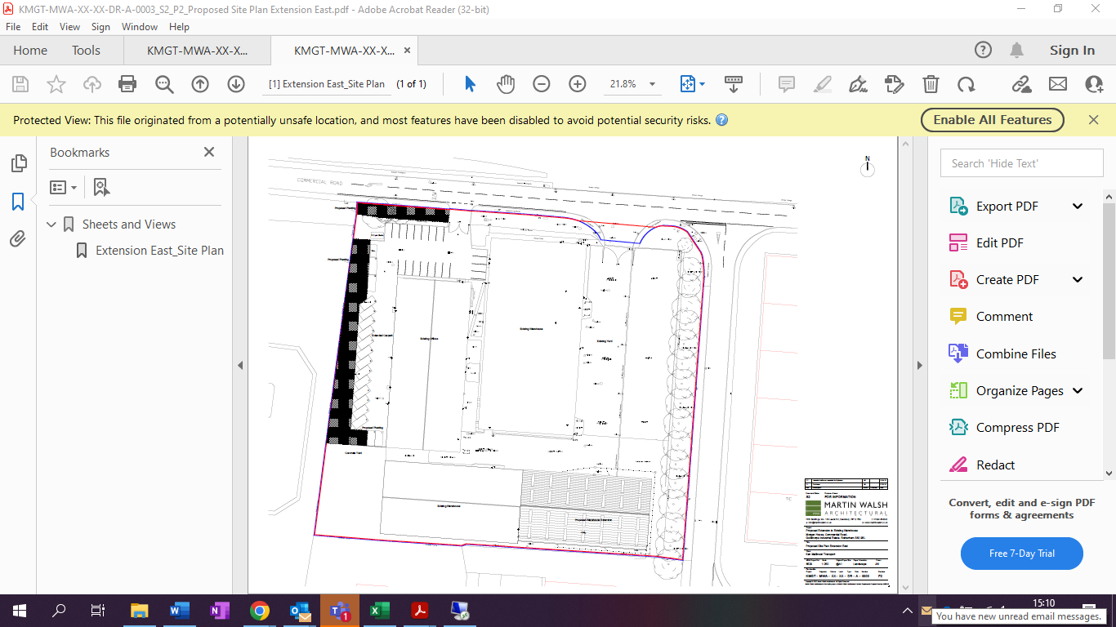

**Proposed Development**

The proposal involves the extension to an existing warehouse building, to the eastern end elevation. There is also a corresponding application for the western elevation which is currently being assessed separately as part of planning application 2023/0174. The existing use of the building is classed as B8 Storage and Distribution and the proposed extension will be for the same use class and will be used as warehousing.

The existing warehouse has a GIA of approx. 1024m2/11,018 sq ft and has a 10.8m eaves. The proposed eastern extension will create an additional 956m2 of internal floor space providing the capacity for 153 no. new 2700mm wide pallet bays.

The extension will be off the existing eastern side of the building on land that is currently part of the concrete yard. The proposed extension will have a footprint of 42.85m x 23.26m. The plans have been amended during the processing of the application to reduce the overall height of the extension. The extension will now have eaves at 15.4m high and 17m to the pitch. The external materials are to match the existing building.

The new personnel doors will match the existing maintaining the buildings proportions. The new proposals seek to extend the existing car park to provide 17 new spaces. The access is to remain as existing.

Proposed landscaping has been indicated on the proposed site plan to the western and northern boundary which will be utilised for new planting/landscaping.

A Tree Survey, Arboricultural Method and Impact Assessment, Design and Access Statement and Coal Mining Risk Assessment have been submitted in support of the application.

**Policy Context**

Planning decisions should be made in accordance with the development plan unless material considerations indicate otherwise and the NPPF does not change the statutory status of the development plan as the starting point for decision making.  The Local Plan was adopted in January 2019 and is also now accompanied by seven masterplan frameworks which apply to the largest site allocations (housing, employment and mixed-use sites).  In addition, the Council has adopted a series of Supplementary Planning Documents and Neighbourhood Plans which provide supporting guidance and specific local policies and are a material consideration in the decision-making process.

The Local Plan review was approved at the full Council meeting held 24th November 2022.

The review determined that the Local Plan remains fit for purpose and is adequately delivering its objectives. This means no updates to the Local Plan, in whole or in part, are to be carried out ahead of a further review.  The next review is due to take place in 2027 or earlier if circumstances, require it.

 Local Plan

The site is allocated in the Local Plan as Urban Fabric. The following Local Plan polices are relevant to this site:-

SD1 Presumption in favour of sustainable development

GD1 General Development

LG2 The Location of Growth

E1 Providing Strategic Employment Locations

E2 The Distribution of New Employment Sites

E3 Uses on Employment Land

T3 New Development and Sustainable Travel

T4 New Development and Transport Safety

D1 High Quality Design and Place Making

BIO1 Biodiversity and Geodiversity

Poll1 Pollution Control and Protection

SPD’s

-Parking

NPPF

The National Planning Policy Framework sets out the Government’s planning policies for England and how these are expected to be applied. At the heart is a presumption in favour of sustainable development. Development proposals that accord with the development plan should be approved unless material considerations indicate otherwise. Where the development plan is absent, silent or relevant policies are out-of-date, permission should be granted unless any adverse impacts of doing so would significantly and demonstrably outweigh the benefits, when assessed against the policies in the Framework as a whole; or where specific policies in the Framework indicate development should be restricted or unless material considerations indicate otherwise.

**Consultations**

Highways DC – No objections subject to condition

Ward Councillors – No comments received

Tree Officer - No objections from an arboricultural perspective subject to the arboricultural method statement being conditioned as one of the documents to be complied with.

Drainage – No objections

Coal Authority – No objection subject to condition

Pollution Control – No objection subject to condition

SYMAS – No objection subject to condition

Enterprising Barnsley - Enterprising Barnsley actively support this application that will help to create much needed extra warehousing space at this strategically important area of the borough. Such investment will not only help the applicant (KMS) to increase their operational capacity (by increasing the cubic footprint of their facility), but also create meaningful employment opportunities ,both at this site in Goldthorpe ,but also at the companies head office as well.

Simultaneously , this expansion will have wider supply chain improvements for (KMS) customers, a number of which are based in and around Goldthorpe, thereby helping to increase their 3PL route and that of their customers, helping to facilitate a range of employment growth in the borough.

Enterprising Barnsley are actively working with KMS via the Goldthorpe Towns Fund , this application forms part of their application and is one of a number of schemes that are seen as important to helping to Regenerate, Renew and Revitalise Goldthorpe, Thurnscoe and Bolton upon Dearne as part of this Towns Fund.

A key part of the Towns Fund is to improve skills, digital and transport connectivity, create new jobs, raise aspiration and revitalise the economic prospects of the area. Economic growth is a key part of the deal something that this application clearly support both directly and indirectly.

This development is also essential in helping BMBC and SYMCA to create future employment opportunities (jobs) as per the existing strategic economic and corporate plans.

**Representations**

A site notice was posted adjacent to the site; no comments have been received.

**Assessment**

Principle of development

The proposed extension is located within an existing Industrial Estate and would provide an extension to the building to provide further warehousing and additional car parking. The agent has confirmed that the extension would be used for B8 Storage and Distribution as is the current use. The proposal is therefore acceptable in principle, subject to policy GD1 and the impact of the proposal upon visual amenity and highway safety.

Residential Amenity

The closest residential properties are some 300m away to the north east, therefore there should not be any significant impact upon residential amenity. The Pollution Control Officer has confirmed that there are no objections to the proposal subject to a condition regarding construction working hours. The proposal is therefore acceptable in terms of Local Plan Policy Poll1.

Visual Amenity

The proposed extension will be constructed of matching cladding, with matching openings. The extension will therefore appear as part of the original development once constructed. The extension is set on an area of hard standing and would not remove any areas of soft landscaping. Whilst the extension is taller than the existing building, it has been reduced in height from the original submitted proposal and it is set back within the site so should not appear obtrusive. In addition there are a row of large trees on the eastern boundary, between the site and the road, which will help to soften the impact of the extension when viewed from this side.

The proposed extension is therefore acceptable in terms of visual amenity and will not harm the appearance of the industrial unit or the site as a whole in accordance with policy GD1 and D1 of the Local Plan.

Highway Safety

The Highways Officer has been consulted and has provided the following comments:- ‘Whilst this application is considered on its individual merits, it is noted that an additional application (2023/0174) is also applying for a western extension to this warehouse. As such, the cumulative impact should both applications be approved has also been accounted for.

The proposal increases the warehouse floor space of Ken Mallinson & Sons Ltd Transport; the existing use is classed as B8 Storage and Distribution and the proposed extension will be for the same use class and will be used as warehousing. The existing warehouse has a GIA of approx. 1024m2/11,018 sq ft and has a 10.8m eaves. This proposed eastern extension will create an additional 956m2 of internal floor space providing the capacity for 153 no. new 2700mm wide pallet bays.

Additional car parking is to be created that exceeds the levels required when considering the additional staff numbers anticipated from the extension quoted in the application form. The main access for commercial vehicles into the site remains unchanged and therefore remains acceptable; however, Highways DC would ask that this access and internal turning facility are kept free from obstruction in perpetuity. Whilst it is acknowledged that the extensions have a vehicular route to the public highway included within the red line boundary, this is only suitable for private cars and other smaller vehicles. It may therefore be required to include larger commercial access and yard within the red line boundary rather than the blue line.

Aside from the above, the scheme is acceptable from the perspective of highways.’ The redline boundary has now been amended in line with the comments from the Highways Officer and the proposal is now acceptable, subject to the imposition of a condition which requires the proposed turning facilities to be provided prior to the occupation of the extension. The proposal is therefore acceptable when measured against policy T4 of the Local Plan.

Impact on Trees

The extension is to be set on an area of existing hardstanding to the east of the existing building. There is a line of trees along the southern boundary, however the Tree Officer has been consulted and has no objections to the proposal from an arboricultural perspective subject to the arboricultural method statement being conditioned as one of the documents to be complied with. The proposal is therefore acceptable when measured against policy BIO1 of the Local Plan.

**Recommendation**

**Grant** subject to conditions