PLANNING CONSULTATION RESPONSE
Application No | 2026/0127
Proposal | Re-discharge of conditions 3 (Biodiversity Net Gain), 4 (HMMP), 10 (Drainage Details), 12 (Soft Landscaping Works), 13 (Hard Landscaping Works), 14 (Central Pathway Design), 15 (Street Furniture and Signage), 16 (Lighting Scheme and CCTV), 17 (Ecological Lighting Scheme), 18 (Biodiversity Enhancement Scheme), 21 (Highways Signing and Lining) and 22 (Landscape Management and Maintenance Plan) relating to applications 2024/1060: Alterations to existing car park and provision of new public open space and landscaping with associated works.
Address | Lower Car Park, The Seam, County Way, Barnsley.
Date of Consultation Reply | 13/03/2026
Consultee | Highways DC

Consultation Assessment and Justification
Thankyou for consulting Highways Development Control in respect of Condition 21.

Having reviewed the proposed lining and signing scheme, I have identified several amendments to the lining that would improve the layout and provide a more user-friendly arrangement within the car park. I recommend introducing a hatched area to better align the give-way markings with the end parking spaces and to bring the give-way lines forward, as illustrated in the sketch below.

With regard to the signing proposal, the signs should be positioned so that they do not interfere with existing signage or compromise visibility splay requirements.

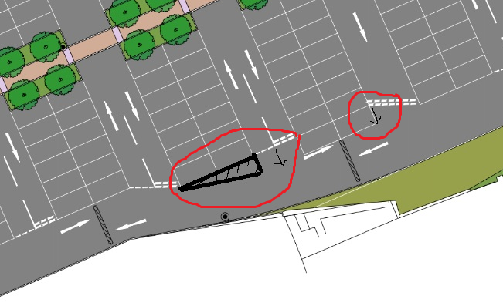

Subject to these amendments I have no objection to the discharge of this condition.

Defer for Further Information
Consultation Informative(s):

None at this stage

Planning Obligations required:

None at this stage.

