Proposed Car Park - Darton Park

Issue identified
As part of the BMBC Principal Towns project consultation was undertaken with elected members, local businesses/community groups and residents of the area to seek suggestions for a business case submission to Principal Towns to secure funding for Darton.

All parties agreed that the Park did not fulfil its potential or offer enough facilities to attract people to the area. Main obstacles were lack of facilities/activities, lack of access to the park (car parking) and throughout the park (pathways suitable for pushchairs/disability scooter/wheelchairs).

It was agreed that the focus should be on improving facilities/activities within the Park to create an attraction that would encourage local residents to use the Park on a regular basis for a decent length of time. In addition to improvements to the park this would be facilitated by the addition of a car park area, however, so has to preserve the look and feel of the park grid systems would be used rather than a tarmac parking area being created.

Proposal
A Steering Group was established consisting of local elected members, community groups, residents and businesses who met regularly to develop a business case for submission to Principal Towns.
The business case focusses on developing the park through commission of a masterplan to create an attractive and functional park for all elements of the community. Rather than ad hoc additions to the park which have been carried out previously it was decided that a bold approach needed to be taken to cover the entirety of the park and therefore a masterplan is needed to plan for an inclusive, fit for purpose park for the future. In total a package equating to £300,000 has been put together for the Park.
Potential additions would include pathways, additional play equipment, picnic areas, older children’s equipment and woodland/nature areas. These are the most popular suggestions from numerous consultations events however are subject to change dependent in the outcome of the masterplan. However it was strongly felt that there would be little point developing the park if appropriate access was not developed through the addition of car parking.
Funding has been secured for the masterplan and car park area (£102,000 Principal Towns) an application for developing the park has been submitted to Wren (£99,000) and a further £100,00 would be sought from Section 106 following production of the masterplan.

Justification
Darton Park is one of 24 key parks within the Barnsley Borough and is therefore a priority for improvement, to ensure the Park is accessible to all and sustainable for the future the addition of a car park is necessary. This would ensure that families, older people and disabled individuals would be able to access the facilities in the park.
The provision of a parking area to serve the users of the park will help to increase accessibility to the new and improved facilities within the park, for everyone.
We are trying to encourage families, and members of the community that may have access issues due to a mix of disabilities.
Extensive consultation and development has been carried out in the area, a summary is provided below;

Consultation
Communication Method
Communication Method | Date | Stakeholder | Purpose | Who
Meeting | 3rd April 2017 | Darton West Ward Alliance | To gain initial ideas | Darton West Ward Alliance
Consultation Event | 20th June 2017 | Darton community groups and businesses | To gain initial ideas & form Steering Group | Darton community groups and businesses
Meeting | 29th June 2017 | Cllr Burgess, Area Team | Develop Registration of Interest | Cllr Burgess, Darton West CDO
Consultation Event | 5th July 2017 | Darton community groups and businesses | Approval of Registration of Interest | Project Steering Group
Meeting | 2nd August 2017 | Darton community | Development of project | Project Steering Group
Meeting | 24th August 2017 | Darton community | Development of project & development of brief for plan for Park | Project Steering Group
Public Consultation outside Darton Co-op | 6th Sept 2017 | Darton Community | Approval of proposals and to gain further suggestions | Fiona O’Brien/ North Area CDO
Public Consultation at Darton Gala | 10th Sept 2017 | Darton Community | Approval of proposals and to gain further suggestions | Fiona O’Brien/ North Area CDO
Meeting | 20th Sept 2017 | Darton community | Development of project | Project Steering Group
Meeting | 4th October 2017 | Darton community | Development of project | Project Steering Group
Meeting | 25th October 2017 | Darton community | Development of project | Project Steering Group
Questionnaires | 27th October 2017 | Darton Businesses | Approval of proposals | Fiona O’Brien
Meeting | 9th November 2017 | Darton community | Development of project | Project Steering Group
Meeting | 6th December 2017 | Darton community | Development of Business Case | Project Steering Group
Meeting | 20th December 2017 | Darton community | Development of Business Case | Project Steering Group
Meeting | 8th January 2018 | Darton community | Development of Business Case | Project Steering Group
Meeting | 1st February 2018 | Darton community | Development of Business Case | Project Steering Group
Meeting | 22nd March 2018 | Darton community | Development of Business Case | Project Steering Group
Meeting | 26th April 2018 | Darton community | Development of Business Case | Project Steering Group

Options

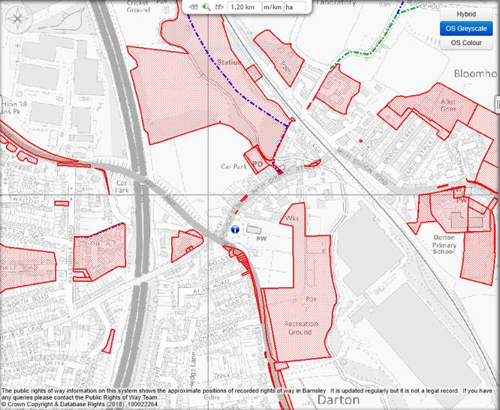

C

A
D

B

The location of the park, makes it difficult for visitors to park on the street, as it’s adjacent to the busy trunk road (A637), and not a suitable parking location for vulnerable people/children accessing the park. Parking is available at the Coop supermarket however there is now a 3 hour restriction.

Site A – Privately owned, owner has been approached and unwilling to sell land.

BMBC Owned;
Site B – Land is extremely sloped and although there is an entrance to the Park it is the Trunk road (A637) and therefore too busy a road to allow access to and from Park.

Site C - Access to Car Park

Site D - Health Centre

All other BMBC owned sites would be too far away to provide accessible parking.

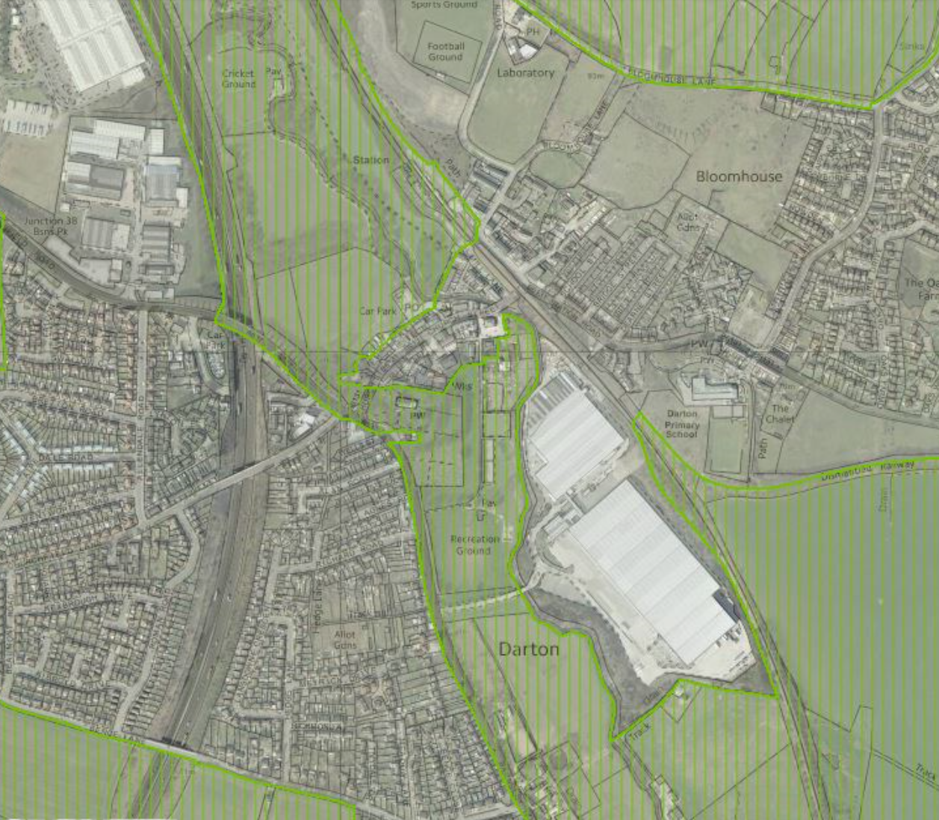
Greenbelt

Unfortunately as demonstrated on this map all potential sites are within the green belt, this issue would be negated by use of sympathetic materials to compliment the aesthetics of the park rather than installing a permanent tarmac car park.

Flood Zone

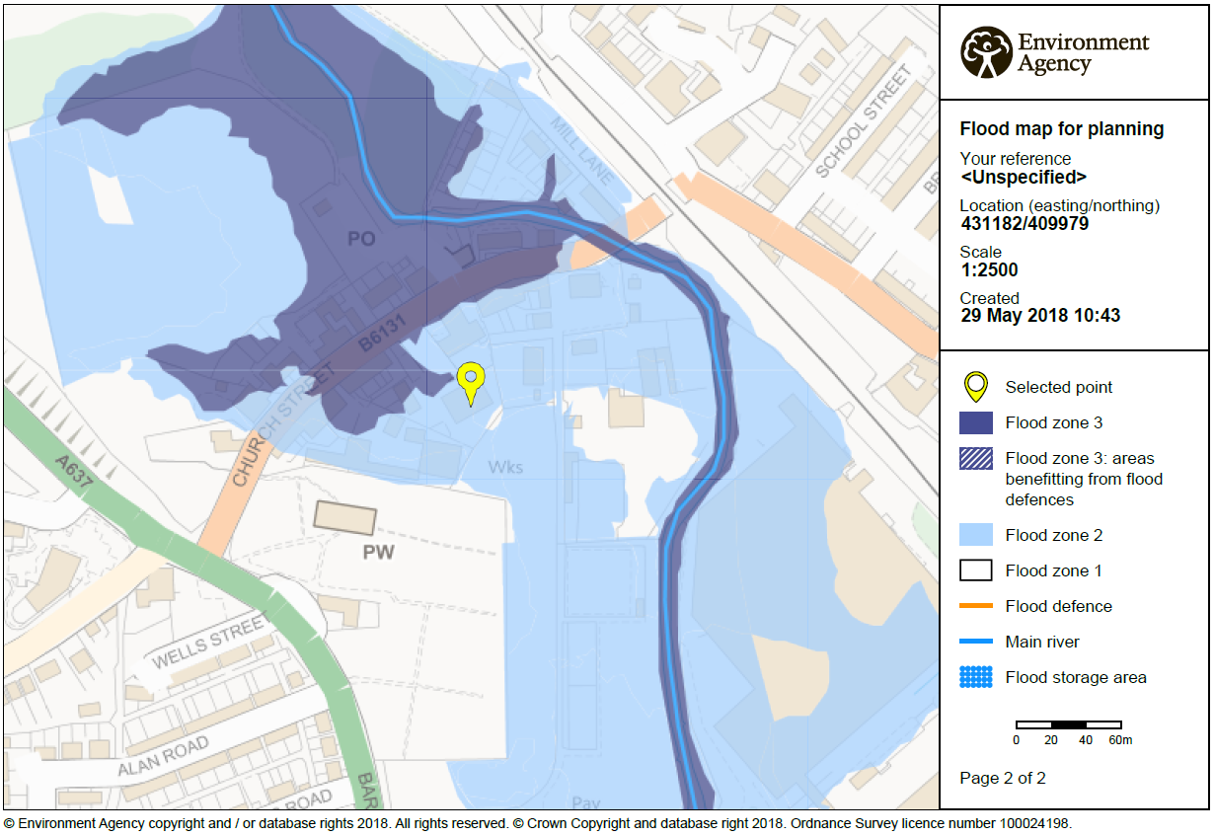
The area is classed as Flood Zone 2 however all potential suitable sites are Flood Zone 2.

