Construction & Environmental Method Statement
High Street, Shafton
Date 06.09.22
Ref – HIGHVIS001 Rev A

Site Access

Site access for the construction traffic will be made from High Street. This will be used for site operatives, plant machinery and deliveries.
Site operatives and plant machinery will access site with the working hours and materials being brought to site on a ‘just in time’ basis to ensure safe routes around site are maintained at all times. These will be carefully timed by the Site Manager for off peak times to minimise disruption and inconvenience which could possibly be caused to local residents and general traffic in the area.
Deliveries will be from 7.30am to 8.30am and then from 9.30am to 2.30pm avoiding school time peak traffic, this will be monitored and reviewed on a weekly basis.

Working Hours

We propose construction working hours for the development shall be as set out in the Planning Decision Notice, 8am-6pm Monday to Friday and 9am-2pm on Saturdays. No working on Sundays or bank holidays.

Route of Traffic

The route of traffic to and from site will be as shown on the traffic routing plan.

Parking for Site Operatives

Please see site set up plan for reference. A site operative’s car park area will be formed initially providing 8 spaces. This number shall be increased if necessary as works progress and additional areas of hard standing formed. Safe pedestrian routes will be formed from the car parking/site welfare area to other parts of the site. Once the time comes for us to construct plots 19-24 (current site parking location), we will utilise the drive ways of the other plots that have already been constructed for our operatives parking.

It is envisaged that up to 20 operatives may be working on site at peak periods during the build. Operatives (and Sub-contractors prior to appointment) will be encouraged to make use of public transport and/or share transport to site to minimise the number of vehicles arriving at site.

We operate a car sharing policy within the business to ensure all Vistry Partnerships Yorkshire staff share journeys to site, this is policed by the Directors of the business and we regularly challenge attendees at site meetings on their transportation arrangements.
Due to the size of the site, parking onsite will not be possible for all operatives. Therefore, some will be required to park considerately offsite.

Deliveries/Unloading

Materials will be brought to site on a ‘just in time’ basis to ensure safe routes around site are maintained at all times.

All deliveries will be made onto site via High Street. These will be carefully timed by the Site Manager for off peak times to minimise disruption and inconvenience which could possibly be caused to local residents and general traffic in the area.
The access to site is identified in the CMP and adequate visibility splay will be available from the point of access.

All deliveries to the site will be carried out using suitably sized vehicles and will enter the site in a forward direction. Once within the site the need for reversing will be minimised. Where reversing is required a competent banks man will be in attendance at all times.

All delivery vehicles entering or leaving site will be suitably covered to prevent escape of materials during transportation.

On-site traffic will be limited to 15mph on surface roads, 10mph on unmade roads. The speed limit will be enforced by the Site Manager who will operate a ‘Red Card’ system where persistent offenders will be cautioned and ultimately refused entry to the site. All records will be maintained in the site office.

All materials will be stored safely and securely in designated area, sand and other aggregates will be stored in dry bunded areas which will be monitored and any damaged/spilled materials will be cleaned up, removed to prevent misuse.

All bulk cement will be stored in silos with suitable emissions controls fitted in accordance with supplier’s/manufacturers recommendations

Security

Site security is paramount on two fronts, one to prevent loss / theft from site and two to prevent accidents on the site by visitors (un-authorised). The working area and the site compound will be secured with 2m high Heras type anti climb security fencing which will be double clipped at the joints and secured to posts with debris netting attached. All fencing is to be fully seated within moulded feet and rakers attached where required to provide stability installed at suitable intervals internally to prevent trips.

All heras fencing is to be suitably secured and fixed securely to prevent possible accidental or deliberate displacement. Suitable individual access gates will be installed within the perimeter fencing to provide both vehicular and pedestrian access to various areas.

A main contractor’s compound is to be created on site in a designated area this will be secured using 2m high Heras fencing to segregate it from the working areas of the site. A specific pedestrian access route is to be created from the compound area to the individual working areas using suitable interlocking barriers, this route will have designated crossing points with red topped hooped barriers where vehicles routes are present. The Site Manager is to ensure that the site compound, both working areas and all access routes to all areas of the site are secured at all times and free of obstruction.

The Site Manager will inspect the hoarding daily to ensure the security of the site is maintained. Due to the nature of the works being undertaken, we will position the following safety signage on the site compound fencing:

- Work in Progress
- No Unauthorised Access
- Children Disclaimer
- Do Not Enter
- Site Office
- Emergency Contact Numbers
- Wearing of PPE is mandatory No Hard Hat, No Safety Boots, NO ENTRY

The wording on notices posted on site may differ to those above but will portray the same message, and will minimise interaction and endeavor to prevent accidents and any unauthorised access.

Site Power

The site has the benefit of mains power supply to the site accommodation, limiting the need for diesel powered generators.

Lighting
Works will be carried out during daylight hours. The only artificial lighting used on site will be within the cabin and compound. The artificial lighting is on dusk till dawn sensors/timers meaning they only come on when the daylight begins to fade and will therefore be as unintrusive as possible. Said lighting will only be installed to light the site compound, directed as per the site set up plan. Vistry do not intend to implement security lighting, instead we will be using security cameras and a physical man guard. During the winter months, internal localised task lighting to enable operatives to work inside the plots may be required, we will however, aim to keep this to a minimum. The lights will turn on and off as per the average sun up/sun down times across the year.

Wheel Wash Facilities & Run Off Mitigation

During periods of wet weather mud may well pose an issue during the project. To minimise the inconvenience site roadways will be established during the early stages of the project to provide clean access for vehicles. On-site traffic will be segregated from delivery vehicles to further reduce the spread of mud. The site roadway will be kept clear and scraped/swept on a regular basis. The Site Manager will carefully plan the project including bulk loading and tipping areas to ensure that road going vehicles remain on the site road at all times to prevent the transfer of mud from working areas.

Where water is likely to pond or run off the site area we will ensure an earth bund is in place to contain mud and surface water on site. This bund will be inspected and maintained regularly by the Site Manager. Where slurry has collected behind the bund, this will be removed to a stockpile and allowed to dry out. Please see MSJ Engineers temporary run off management document for further details.

Once we have installed all of our new surface water drainage which will be around spring time 2023 we intend to utilise it to assist with our site construction surface water run off. This will run alongside our existing temporary measures.

Drivers will check their wheels for possible trapped stones or objects within rear wheels prior to leaving the site and vehicles carrying waste will be adequately sheeted and measures will be taken to ensure that mud and detritus is not swept into gullies. An area close to the site exit will be provided to allow vehicles wheels to be washed down by a jet wash (detergent free) prior to entering the public highway. The jet wash will be connected to our temporary water supply and will be provided with a lance to ensure all wheels can be reached and adequately cleared of any debris.

The Site Manager will check the weather forecast for the area on a regular basis and prepare as necessary for poor weather and the possible transfer of mud from the site.

The on-site haul routes will be constructed and where mud transfer becomes an issue a road sweeper will be deployed to maintain the access road in good condition. The Site Manager will request this sweeper on an as required basis.

The condition of the haul roads will be inspected regularly, and any necessary repairs/actions undertaken immediately and recorded within the site diary.

Vehicle Details

Due to the works being undertaken the following vehicles will access site –
- Mechanical excavator’s
- Mechanical Dumpers
- Lorry Mounted Crane and associated lifting equipment
- Lorries
- Small plant machinery
- Telescopic Forklift
This list is non exhaustive and will / may be added to throughout the duration of the project.
These vehicles will access site via the route on the below plan, during working hours.

Dust Control

The emission of dust and dirt will be controlled via the following methods during construction works:
- Site Manager will plan works to limit dust causing activities and ensure they are kept away from sensitive receptors
- The development will be fenced securely. However, where our strategy needs amendment to prevent dust issues in sensitive areas (due to prevailing winds for example) we will amend and re-erect solid fencing to mitigate the dust risk.
- All fencing will be maintained and cleaned (hosed down) as required and determined necessary by the Site Manager.
- Where activities are such that there is potential for dust generation the Site Manager will produce a method statement for the suppression of the same, and action the implementation.
- Haul roads will be formed and hard surfaced wherever possible
- All vehicles to switch off engines – no idling vehicles
- All loads entering and leaving site will be covered
- An appropriate speed limit will be enforced on site
- Use of water as dust suppressant where applicable
- Stockpiles will be enclosed or securely sheeted

Our H&S procedures (held on site) requires dust suppression techniques to be applied when cutting or sawing. Externally whilst cutting any masonry materials the Site Manager is to ensure that suitable dust suppression is used at all times such as water spray. All operatives

associated with dust creating works are to wear respiratory protection to FFP3 level i.e. either half face mask, full face mask or disposable mask and have a current Face Fit Test Certificate. In addition to this operative will also wear suitable eye and ear protection.

Internally when commencement of proposed works, natural ventilation will be used, i.e. windows and doors opened to minimise the amount of airborne dust. Where practical equipment will be fitted with suitable dust suppression, areas will be dampened down to minimise the amount of dust becoming airborne and we will continuously sweep the areas.

This is policed by our Site Manager, Contracts Manager and also by our independent Safety Advisors who report to the Board.

Our Site Manager is responsible for carrying out daily checks on the site and surrounding areas to determine whether the dust suppression techniques we have adopted are adequate and are working. The frequency of these inspections may be increased in periods of hot / dry weather and where site activities are such that dust is more likely to be generated.

If further amendments to our strategy are required, we will update and educate our site staff through toolbox talks. There are demolition works on this project therefore specific control measures will be in place.

Control of Noise and Vibration

- The site shall work under the guidelines as set out in the Considerate Constructors Scheme.
- Stationary noise sources should be sited as far away as possible from neighbouring properties.
- All workers on site must be made aware of the need to keep noise and disruption to a minimum from building works, equipment, plant and machinery, radios, music, vehicles or any other sources.
- Radios will not be allowed on site.
- Construction process and traffic movement noises will be controlled to the maximum ensuring that they conform to all the health and safety legislation.
- Noisy operations will be carried out using appropriate equipment by specialist contractors. All potential noise emitting works will be carried out at suitable times as to minimise any possible disruption to the area. Wherever possible it is our intention to reduce noise and vibration caused as part of the works, where the method of reduction does not impose undue risks to operatives. It is our intention to monitor noise and vibration levels on the site and where necessary take action in accordance with statutory guidance.
- Where vibratory equipment is used we will wherever reasonably practicable ensure that they are of “low vibration” and are within the HSE’s Exposure Action Value. The Site Manager will ensure that job rotation amongst suitably trained operatives is carried out when using vibratory equipment to reduce their “trigger time”. Operatives will be issued with gloves in order to keep their hands warm and to encourage good blood circulation to the hands and fingers. Vibratory equipment will be used in accordance with the manufacturer’s guidelines and any defective equipment will be quarantined

Plant and Equipment

Due to the works being undertaken we will utilise the following plant, tools and equipment –
- Heras Fencing
- Site Cabins – lockable steel cabins for Storage and Office Accommodation
- Mechanical excavator’s
- Mechanical Dumpers
- Piling rig
- Lorry Mounted Crane and associated lifting equipment
- Lorries
- Small plant machinery
- Small/Large Hand Tools
- Independent Access Scaffolding
- Mobile tower scaffolds
- Fall Arrest Systems / Safety Crash Deck Systems
- Telescopic Forklift
- Stihl saw (abrasive discs and diamond tipped blades)
- Electrically Operated Tools
- Battery Operated Tools, Apparatus
- Transformers
- Wheelbarrows

The above list is non exhaustive and will / may be added to throughout the duration of the project.
It is not envisaged that the use of conveyors, loading shovels or hoppers will be required during this project therefore no control measures are required.

All works will be undertaken using a combination of basic hand held tools, all hand tools will be in a good state of repair, and battery operated equipment which will be tagged with its maintenance/inspection date.
The majority of mobile plant will be provided by subcontractors and it will be a condition of the ‘Terms and Conditions’ of the order that machinery must meet the highest emission standards and be maintained in accordance with current statuary regulations.
All plant machinery tool and equipment will be inspected daily and a full recorded inspection carried out every 7 days in accordance with the PUWER Regulations. All plant machinery will be maintained in good condition and be operated by competent person at all times with any defective equipment removed from service until repaired or replaced. All attachments will be fully compatible with the equipment.
All mobile plant and vehicles will have full all round vision available i.e. mirrors, CCTV etc. and these will be in good condition and set correctly.
Subcontractors deployed to the works will be informed of the above and on commencement of works the Site Manager will make a visual inspection of their equipment and tools. Any found to be out of test date or in poor repair will be confiscated and replaced accordingly. Copies of maintenance records will be obtained for all hired plant/machinery. The relevant test certificates will accompany all lifting gear and crane.
All mobile plant including MEWPS etc., will be operated by competent plant operators trained to CPCS / C.I.T.B / C.T.A. standard or the equivalent. The above will apply to all subcontractor and hire company supplied plant/machinery.
The Site Manager or nominated plant operative will complete the appropriate Plant Inspection Register every seven days whilst the plant is on site. All plant/equipment will be in good a good state of repair and the maintenance of the site plant will be undertaken within the site compound area so as not to contaminate the construction area of the proposed property. When plant is left unattended at the end of the working day the keys will be removed and the plant made secure with lockable shuttering. This will prevent joy riders accessing the plant.

Fuel Storage and Handling

- Tanks, drums or other containers must be strong enough for the weight of oil, fuel etc., must be in good and leak-proof condition, and properly supported (both the container and all vulnerable pipework)
- Be bunded to contain 110% of the contents; the bunds to be impermeable to leaks
- To have drip trays or bunding to catch oil drips and spills from any vulnerable points, particularly at the filling and delivery points
- Be checked regularly for leaks and damage
- Permit only authorised and competent persons to re-fuel plant/vehicles; nominate authorised key-holders
- Fuel delivery orders must be carried out only by Site Manager
- All deliveries must be under the control of a competent person
- Any drips or spills (even minor) must be contained quickly and removed (using an absorbent material, e.g. sand, if necessary).
- Remember that materials used to soak up spills will be “Special Waste” in significant quantities.
- Major spillages must be notified to the EA immediately – EA Hotline No. 0800-80 70 60. Do NOT wait; the EA can help contain or control the effects.

The Site Manager will induct all plant operatives into the procedures for delivery and/or re-fuelling, instruct that all drips and spills must be contained, cleared up and notified immediately.

We will display Emergency Contacts List which includes EA Hotline number on the site notice board.

A spill kit will be located in the storage area, suitable signage displayed and the following will be followed in the event of a spillage
- STOP WORK immediately
- Inform Site Manager immediately
- If spillage is flammable, extinguish all possible sources of ignition
- Identify the source of the spill and remedy
- Contain the spillage – on land use earth/sand to construct a bund around the spill to stop it spreading. Use booms to contain oil spills that have already entered a water course
- Wear appropriate PPE
- Protect sensitive areas (e.g. watercourses or surface water drains – use drain covers or construct a bund
- Clean up the spill. Use absorbent granules/pads to mop up spills. Large pools of oil or spills which cannot be absorbed should be removed by gulper
- Dispose of all contaminated materials (soil/absorbent materials) correctly those containing substances such as oil, diesel or paint will be classed as hazardous waste.
- Ensure any contaminated water is taken to an appropriately licensed disposal site

Site Waste Management

A full Site Waste Management Plan will be implemented on the project in line with our company policy. All waste will be transported from the work areas to external waste skips positioned within the agreed designated area and all operatives will practice good housekeeping and maintain the site clear from rubble, debris and redundant waste, therefore minimising the chances of an accident / incident occurring.

All waste will be removed from site by an approved waste carrier and where, due to site constraints the segregation of all waste will take place off site.

The Site Manager will ensure that the SWMP is updated regularly and all waste transfer notes retained on site for the duration of the works.

It is the policy of Vistry Partnerships Yorkshire that there will be no bonfires or burning of waste on any construction project under our control as Principal Contractor.

COVID-19

Activities on site will be undertaken in accordance with prevailing Government and Public Health England guidance as is issued and in place from time to time. Clearly these are unprecedented times and matters evolve on a daily basis such that a position adopted on one day can be overtaken by events the following day. Against that problem, we will continually seek to adopt the most safe and sensible stance in the face of this changing environment.
The health, safety and well-being of all our employees, clients, supply chain, customers, other site visitors (if necessary to the operations on site) and the general public continues to be of paramount importance, and we shall (for any period the site shall remain operational) ensure that we follow Government Guidelines and statutory powers.

Health and Safety Management

We are committed to promoting a positive safety culture. The enforcing authority for health and safety on construction sites is the Health and Safety Executive who will be notified of all construction works prior to their commencement on site.

Vistry Partnerships Yorkshire, the main contractor will maintain a register of accidents, incidents, near misses and complaints. Contractors failing to maintain the required safety standards may be excluded from site and removed from the approved tender list for future work.

All works will be legally compliant and all Codes of Practice and site rules relating to the works will be observed.

Stakeholder Communication Pamphlet

Prior to the development commencing we will engage with local residents by means of an information pamphlet.

The pamphlet will be distributed to all local residents by means of letter drop prior to start on site. We also have copies of the pamphlet available on site to distribute to stakeholders who approach our site team.

Point of Contact

Site Manager – TBC

Site manager contact details will be displayed on the signage to the entrance to site, along with the head office contact details. The scheme will also be registered with Considerate Constructor and the site-specific registration will also be displayed on the front signage.

Complaints/Comments

Any complaints from stakeholders will be logged in the site diary and recorded on the Complaints/Comments /Compliments Record located on the site notice board, a copy will be forwarded weekly to the head office.

All logs and reports are held on site and are available for inspection by the LPA as required.

All complaints will be investigated and the root cause of the issue will be identified and mitigation measures will be put in place to ensure no reoccurrence.

The site manager for the site is TBC. The site manager will be contactable via the below correspondence address:
Vistry Partnerships Yorkshire
Strategic Business Centre,
Thunderhead Ridge,
Glasshoughton,
West Yorkshire,
WF10 4UA

Via email - TBC
Or telephone – 01977 555 550

The site manager will send correspondence out to the neighbours before works commence and will be the point of contact onsite.

Perimeter/Security Fencing

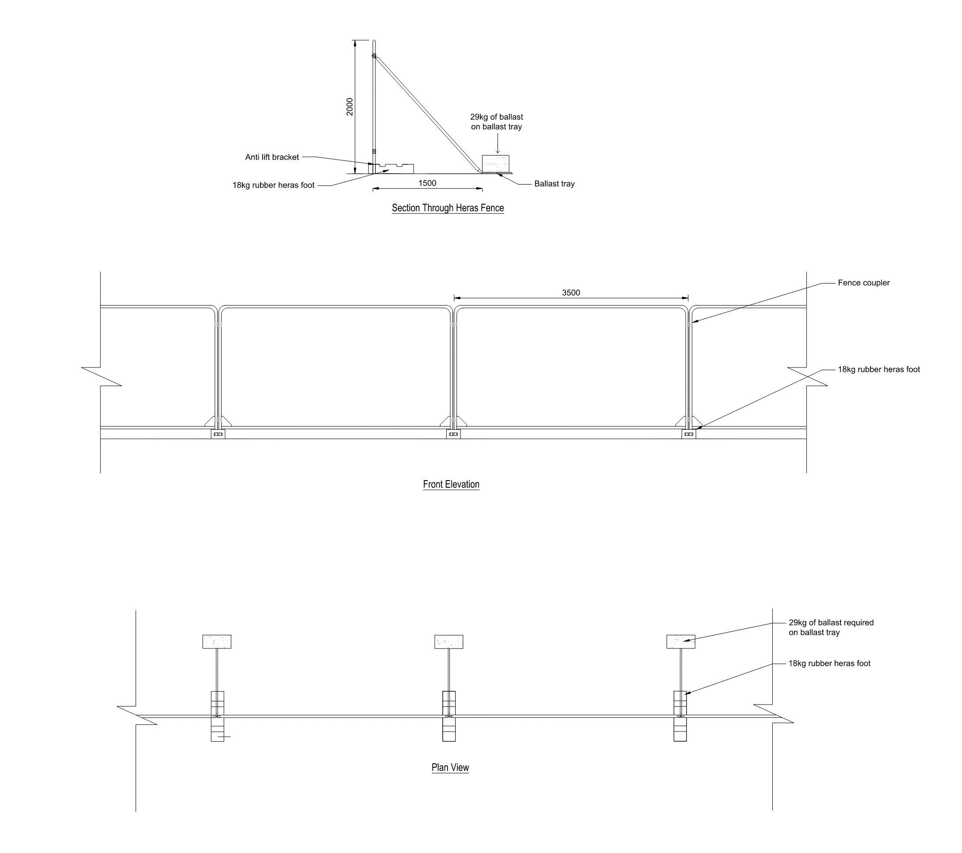

Liaison with Developers

Where required we will liaise with other local construction projects (within 500m) and ensure that all activities that are likely to cause excessive disruption to the local infrastructure of local residents are coordinated to minimize any joint disruption our activities may present.

