Briefing Note
Acoustic Appraisal
Hand Car Wash, Pontefract Road, Cudworth, Barnsley, S72 8YA
Waterman Infrastructure & Environment Limited
Pickfords Wharf, Clink Street, London, SE1 9DG
www.watermangroup.com
Date: | 08 March 2017
Client Name: | Ltd
Document Reference: | WIE11561-100-1.1.3_BN
This document has been prepared and checked in accordance with Waterman Group’s IMS (BS EN ISO 9001: 2008, BS EN ISO 14001: 2004 and BS OHSAS 18001:2007)
Issue | Prepared by | Checked & Approved by
001 | Laurence Evans | Mark Maclagan
001 | Associate Director | Technical Director
001 | 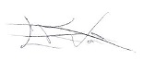 | 

Introduction
  - Temporary planning permission was granted on appeal (APP/R4408/A/14/2215170) for the operation of a Hand Car Wash and Valet Centre (HCW&VC) on Pontefract Road, Cudworth, Barnsley, S72 8AY (hereafter ‘the Site). The Planning Inspectorate stated in the Appeal Decision Notice that the facility “is unlikely to give rise to unacceptable noise and disturbance”. Because of the concerns of the Council and neighbouring residents in relation to the potential for water spray drift and noise disturbance, a precautionary approach was taken with planning permission granted for a temporary period of 18 months.
  - Planning permission for permanent operation of the facility is currently sought, however, the Environmental Health Department of Barnsley Metropolitan Borough Council (MBC) have expressed concern over noise.
  - The applicant is committed to effectively managing and controlling noise from the Site to an acceptable level so as to avoid and minimise adverse noise impacts on health and quality of life; set within the context of the Government’s policy on sustainable development.
  - In the effective management and control of noise from the Site, Waterman has reviewed the current noise control measures employed at the Site, with a view to enhancing their effectiveness. As part of this exercise, a three-dimensional noise model of the Site was constructed using the acoustic software package CADNA-A to test and optimise enhanced noise control measures proposed at Site. Mitigation strategies comprising:
- extension of the eastern screen nearest to Garden Cottages to a linear length of 9.5 m, allowing for 2 m screening to the front and rear of an average sized car (4.8 m);
- inclusion of a solid, imperforate roof affording a minimum sound reduction of 20 dB R_{w};
- inclusion of a cloth, rubber sponge, rubber foam (or similar) layer to the lower half (~1.1 m) inner surface of the bays to dampen the response of the bay enclosure and reduce the build-up and outward radiation of noise; and
- employment of minimum 6 mm thick Perspex panels (or equal and approved product) that are cut and installed in to smaller bay sections (approximately 1.2m x 2.4 m) to minimise the response and outward radiation of noise from the side screens separating the two car wash bays.

Results
  - A noise contour plot of existing operations is provided as Figure 1 providing an overview of the spatial extent and absolute level of operational noise radiating from the site. The noise model is calibrated to a specific sound level of 51 dB L_{Aeq,T} within the garden area of 15 Garden Cottages as measured on 9th October 2016 when the HCW&VC was operating at maximum capacity, with both car wash bays in constant, simultaneous use to identify the ‘greatest’ environmental impact that might reasonably be expected.
  - A noise contour plot with proposed enhanced mitigation measures is provided as Figure 2, whilst Table 1 summarises the predicted specific sound level within the garden area of 15 Garden Cottages and the reduction in sound achieved between the existing and proposed operational scenarios.
Table 1: Predicted Reduction in Sound with Enhanced Noise Mitigation
Assessment | Measured/Predicted Specific Sound Level, dB L_{Aeq,T}
Existing Scenario | 51
Proposed Scenario | 45
Predicted Reduction in Sound | -6
  - As highlighted in Table 1, a worthwhile reduction in specific sound of 6 dB is predicted with implementation of the proposed enhanced mitigation measures. Measures reducing specific sound to a level in the region of 45 dB L_{Aeq,T} such that a good level of amenity would be provided.
  - Whilst not explicitly clear from the noise contour plots, with enhanced mitigation, specific sound from the Site is predicted to be attenuated to 10 dB below typical prevailing ambient noise levels (~55 dB L_{Aeq,T}) at the nearest noise sensitive property as not to materially contribute or prejudice the noise climate and people’s amenity.

Conclusion
  - The findings of our study leads us to be satisfied that:
- the applicant is committed to ensuring that there is no reasonable cause for disturbance to persons beyond the Site boundary;
- a worthwhile reduction in specific sound from the Site (~6 dB) can be achieved through implementation of proposed enhanced noise mitigation measures;
- proposed measures will reduce specific sound from the Site to a level in the region of 45 dB L_{Aeq,T} at the nearest property as not to be of a magnitude that will materially prejudice the existing noise climate and people’s amenity;
- should the Council be minded to grant planning consent then the safeguarding of amenity could be secured by way of suitably worded conditions.
  - The results of our appraisal lead us to be satisfied that a high quality Development has been inherently designed that can co-exist with occupants at neighbouring residential properties without materially impacting amenity or quality of life.

We trust our comments to be clear and of assistance. Should you wish to discuss any aspect in further detail, please do not hesitate to contact us and we’ll be happy to help.
For and On Behalf of Waterman Infrastructure & Environment Limited

FIGURES
Figure 1: Noise Contour Plot of Existing Specific Operational Noise Levels
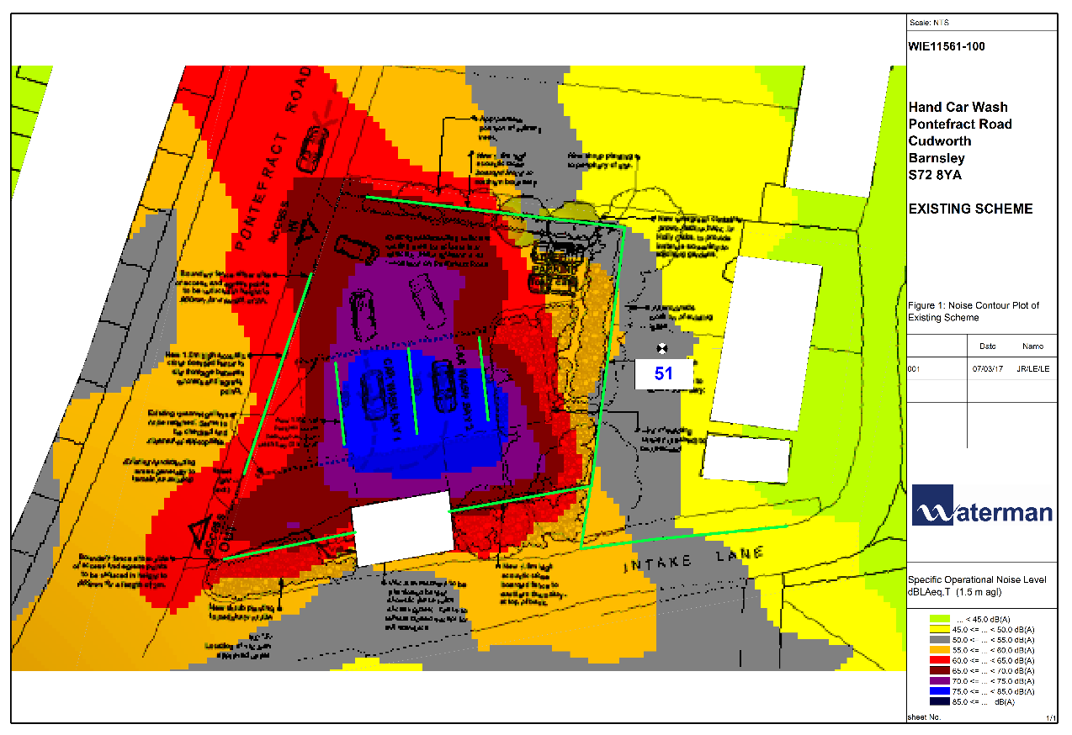
Figure 2: Noise Contour Plot of Predicted Specific Operational Noise Levels with Enhanced Mitigation
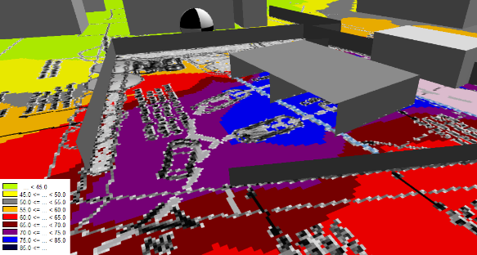
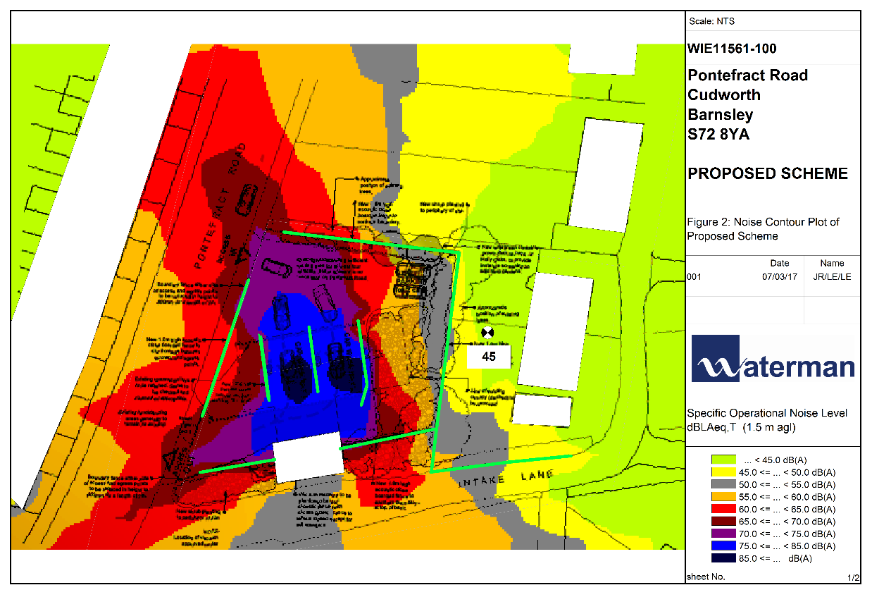

Annex 1: Acoustic Terminology
- Ambient sound | - The totally encompassing sound in a given situation at a given time, usually composed of sound from all sources near and far.
- Assessment period | - The period in a day over which assessments are made.
- A-weighting | - A frequency weighting applied to measured or predicted sounds levels in order to compensate for the non-linearity of human hearing.
- Background noise | - Background noise is the term used to describe the noise measured in the absence of the noise under investigation. It is described as the average of the minimum noise levels measured on a sound level meter and is measured statistically as the A-weighted noise level exceeded for ninety percent of a sample period. This is represented as the L₉₀ noise level (see below).
- Broadband | - Containing the full range of frequencies.
- Decibel [dB] | The level of noise is measured objectively using a Sound Level Meter. This instrument has been specifically developed to mimic the operation of the human ear. The human ear responds to minute pressure variations in the air. These pressure variations can be likened to the ripples on the surface of water but of course cannot be seen. The pressure variations in the air cause the eardrum to vibrate and this is heard as sound in the brain. The stronger the pressure variations, the louder the sound is heard.  The range of pressure variations associated with everyday living may span over a range of a million to one. On the top range may be the sound of a jet engine and on the bottom of the range may be the sound of a pin dropping.  Instead of expressing pressure in units ranging from a million to one, it is found convenient to condense this range to a scale 0 to 120 and give it the units of decibels. The following are examples of the decibel readings of every day sounds;  Four engine jet aircraft at 100m 120 dB  Riveting of steel plate at 10m 105 dB  Pneumatic drill at 10m 90 dB  Circular wood saw at 10m 80 dB  Heavy road traffic at 10m 75 dB  Telephone bell at 10m 65 dB  Male speech, average at 10m 50 dB  Whisper at 10m 25 dB  - Threshold of hearing, 1,000 Hz 0 dB
- Free Field | - Free field noise levels are measured or predicted such that there is no contribution made up of reflections from sound reflecting objects (e.g. buildings),usually taken to mean at least 3.5m away.
- dB(A):  A-weighted decibels | - The ear is not as effective in hearing low frequency sounds as it is hearing high frequency sounds. That is, low frequency sounds of the same dB level are not heard as loud as high frequency sounds. The sound level meter replicates the human response of the ear by using an electronic filter which is called the ‘A’ filter. A sound level measured with this filter switched on is denoted as dB(A). Practically all noise is measured using the A filter. The sound pressure level in dB(A) gives a close indication of the subjective loudness of the noise.
- Façade Noise Level | - A noise level measured or predicted at the façade of a building, typically at a distance of 1m, containing a contribution made up of reflections from the façade itself (+3 dB).
- Noise Level Indices | - Noise levels usually fluctuate over time, so it is often necessary to consider an average or statistical noise level. This can be done in several ways, so a number of different noise indices have been defined, according to how the averaging or statistics are carried out.
- L_{eq} | - A noise level index called the equivalent continuous noise level over a specified period of time, T. This is the level of a notional steady sound that would contain the same amount of sound energy as the actual, possibly fluctuating, sound that was recorded.
- L₁₀ | - The sound pressure level that is exceeded for 10% of the time for which the given sound is measured. The L₁₀ can be considered to be the “average maximum” noise level and is generally used to describe road traffic noise.
- L₉₀ | - The level of noise exceeded for 90% of the measurement time interval, T. The L₉₀ can be considered to be the “average minimum” noise level and is often used to describe the background noise.
- L_{max} | - The maximum noise level over a specified period of time, T, and unless described otherwise, it is measured using the ‘fast’ sound level meter response. The L_{AFmax} is sometimes used for the assessment of occasional loud noises, which may have little effect on the overall L_{Aeq} noise level but will still affect the noise environment.
Rating Noise Level (L_{Ar,Tr}) | The equivalent continuous A-weighted sound pressure level during a specified time interval, plus specified adjustments for tonal character and impulsiveness of sound.
Loudness | A rise of 10 dB in sound level corresponds approximately to a doubling of subjective loudness. That is, a sound of 85 dB is twice as loud as a sound of 75 dB which is twice as loud as a sound of 65 dB and so on. That is, the sound of 85 dB is 400% times the loudness of a sound of 65 dB.
Noise | Sound which a listener does not wish to hear.
Sound | A fluctuation of air pressure which is propagated as a wave through air.
Sound level meter | An instrument consisting of a microphone, amplifier and indicating device, having a declared performance and designed to measure sound pressure levels.
Specific Noise Level | The monitored/calculated noise level as a result of a noise source excluding the impacts of any extraneous noise sources.
Weighted Sound Reduction Index (R_{w}) | The weighted sound reduction index (R_{W}) is a single figure number rating used to describe the sound reduction of a material or building element. The R_{W} is calculated from the measured values in each one-third-octave band. A laboratory measurement and so may be used to compare building elements.  As with all single figure indices the specified acoustic performance is not always achieved when applied to real noise exposure. Consequently, the R_{w} cannot be used directly to estimate the noise level in the room. However, where noise from road traffic, low speed railway traffic and/or aircraft traffic at large distances exists, the spectrum adaptation term, C_{tr}, can be added to the R_{w} to take account of the low frequency spectrum of the noise and provide a more accurate indication of the sound reduction of the building element (e.g. window) (in dB).

The model calculates noise propagation according to the guidance provided in ISO 9613-2 ‘Acoustics – Attenuation of sound during propagation outdoors’, accounting for geometrical spreading, local topography, ground absorption, screening and meteorological effects, as appropriate.

