Design & Access Statement
E021014 - COSTCUTTER, 98 DODWORTH ROAD, Barnsley, S70 6EY

This Design and Access Statement has been prepared on behalf of Cashzone in support of an application submitted for:

The retention of an Automated Teller Machine and Installation of Illuminated signage & 2 user protection bollards

We have consulted Circular 01/2006.

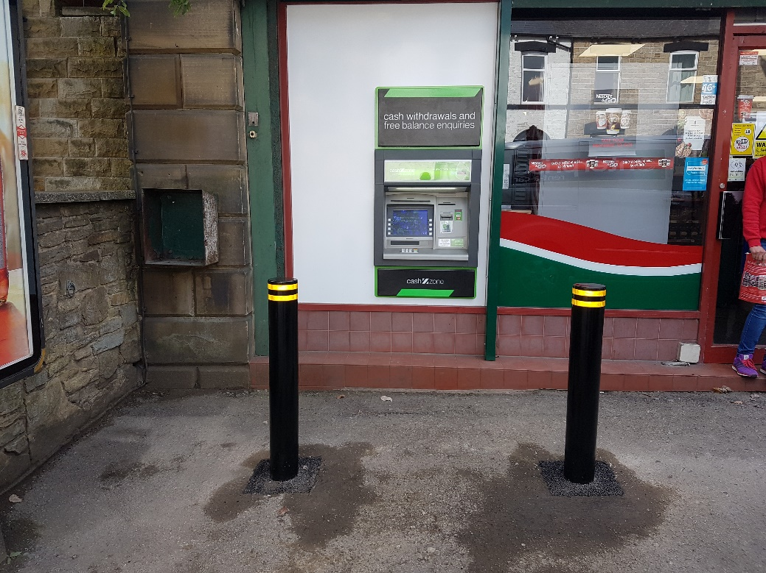

Appearance

We have installed an ATM to the left hand side of the main entrance at 98 Dodworth Road. The ATM has been installed through an existing glazing panel as a through laminate installation.

The property is situated within a commercial and residential area, we consider that the installation of this ATM would not be detrimental to the existing street scene.

The site is not within a Conservation Area and is not a listed building.

Use
The purpose of the installation of this Automated Teller Machine is to provide a 24 hour banking facility for the local community and visitors to the area.

Scale
N/A

Layout
The installation of the ATM has not altered the basic design of the building. We have removed an existing glazed panel and installed an external security wall (see NW0207 External security wall construction in attachments) with a laminate finish. The colour of this panel is white and was chosen to best blend with the existing shop front design.

Amount
This is not a new structure, but the installation of an ATM in an existing shop.

Landscaping
Due to the nature of the proposal, we feel the application will not benefit from any landscaping.

Design Principals
The ATM is of standard design as located in many areas throughout the UK and is accepted as a necessary facility. There are a number of mandatory standards which apply, relating to the position of the ATM, it’s visibility, ambient lighting, building structure, building security features, ATM anchoring, safe strength.

Designing out Crime
We install and anchor the ATMs in accordance with National Guidelines.

Site approval by the Cash In Transit Company has been obtained. They have considered routes to and from the ATM, ensuring there is protection of their staff and of any staff or customers at the site. Paramount in their review has been the welfare of their staff and the persons they come into contact with.

The area where the ATM has been installed is in a well-lit open area in full view of pedestrians aiding natural surveillance. There is a dome camera overlooking the ATM area.

Access
The access to the site and other properties has not been affected. In designing this application, we have taken into account the needs of able and disabled users. The ATM is set at a height that makes it accessible for all users and has space to the front for a wheel chair. Key 5 has raised markings for blind persons to identify the centre key.

