Heritage Statement for new windows
at
National Union of Miners, 1 Victoria Road, Barnsley, S70 2LS

Site Address:
NATIONAL UNION OF MINERS,
1, VICTORIA ROAD
BARNSLEY
S70 2LS.

Heritage Category:

Listed Building Grade: II

List Entry Number: 1151125

Date first listed: 13th January 1986

List Entry Name:
PREMISES OF THE NATIONAL UNION OF MINERS
Statutory Address 1:
PREMISES OF THE NATIONAL UNION OF MINERS,
1, VICTORIA ROAD
BARNSLEY
S70 2LS.

Legacy System number:
333761
Legacy System:
LB
Listing NGR: SE3426406847

SE3406 BARNSLEY VICTORIA ROAD (north side), Barnsley 8/72 No 1

Listed on the National Heritage List for England
This building is listed under the Planning (Listed Buildings and Conservation Areas) Act 1990 as amended for its special architectural or historic interest.

Building Structure

The building is situated on the corner of Victoria Road and Huddersfield Road. The area has a mixed occupation of offices, shops, further education facility and some housing.

The area is a busy thoroughfare, leading from Barnsley town centre to outlying areas.
The building was erected as the Headquarters of the South Yorkshire and North Derbyshire Miners' Union. (Premises of the National Union of Miners) II Premises of National Union of Miners (Yorkshire Headquarters). 1874 by Wade and Turner.

The construction comprises of:

Pitch-faced stone with ashlar dressings.

Welsh slate roof.

Two storeys and attics.

An ordered but asymmetrical composition comprising 4 bays to Victoria Road, 4 rounded corner bays and 7 bays to Huddersfield Road.

The Huddersfield Road facade has a single-storey square stone porch to bay 3 with arched entrance, engaged colonnettes and small parapet. Ground-floor windows are segmental-headed. 1st-floor windows are round-arched with hoodmoulds.
Above the doorway the window has elaborate ashlar work to the head and is surmounted by an attic gable. Bay 1 has a round, 1st-floor oriel window on an ashlar pedestal. Bay 4 has an attic storey with 2-light, pointed-arched windows with pavilion roof which has a broad stack to its right side and large corner finials. Bays 5, 6 and 7 are treated slightly differently, with central doorway, paired lights to left and a 3-light canted bay to right. The windows have shouldered heads and deep triangular hoodmoulds. Bay 7 breaks forward slightly and is gabled. The Victoria Road facade is treated similarly to bays 5, 6 and 7 on Huddersfield Road, apart from bay 4 which is a round tower with narrow windows and a conical roof. The 4-bay rounded corner has segmental-headed ground-floor windows, round-arched lst-floor windows with hoodmoulds and a conical roof with 3 round dormers with scrolled supports and iron cresting to apex.
Moulded stone gutter brackets (parapets to rounded bays with iron cresting).
Tall ornamental stacks.

The Proposed Works
The project involves the replacement of thirteen windows. The existing windows are painted softwood frames and are in a poor condition. Despite some remedial works over recent years, the windows can no longer be maintained.

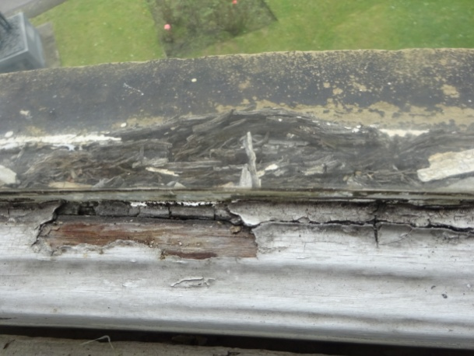
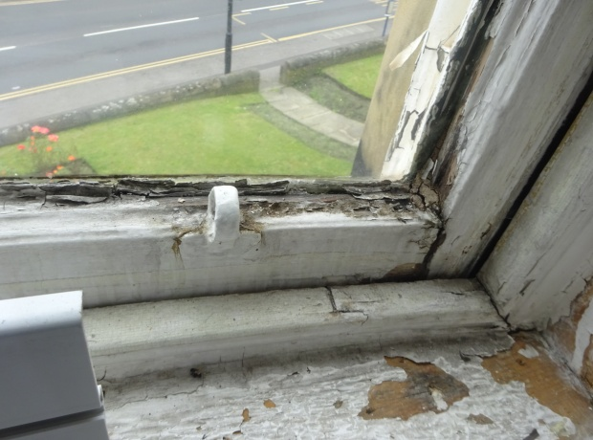

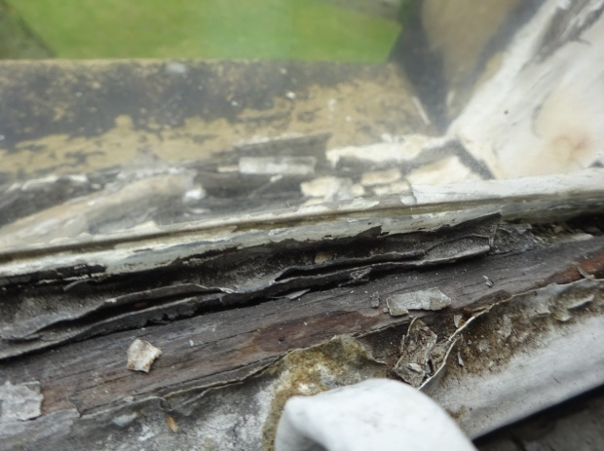
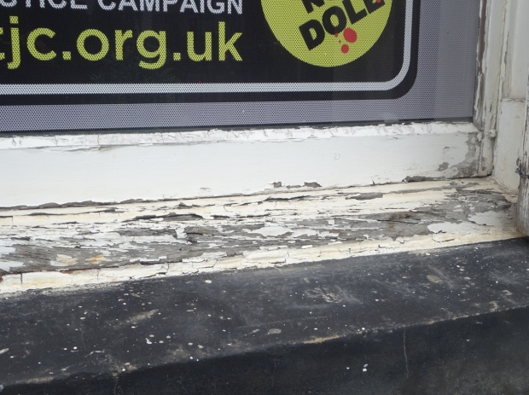

Existing window construction
2 No. flat windows, 11 No. curved
Painted softwood frames
Single glazed – bent square
Sash window with lead weights on sash cords
Ironmongery: white standard quality sash lifts and fitch fasteners
Traditional parting beads and staff beads
Fitted into the masonry reveal
Window bottoms, moulded architraves and softwood linings are painted softwood.

Proposed window construction
The new windows have been carefully designed to match as closely as possible the existing details and frame sections, accordingly it is proposed the new windows will incorporate bent square double glazed units, this will reduce energy consumption and reduce sound transmission from the adjacent roads. The draught proofing elements, incorporated into the new frames, will also assist with these two elements, The proposed DG units will be as slim as possible to be in keeping with the heritage of the building. All timber sections and details will match as near as possible the existing apart from modifications to accommodate the double glazed units.

Proposed window construction
2 No. flat windows, 11 No. curved
Painted Accoya frames
Double glazed units – white warm edge spacers, argon filled
Sash window with lead weights on sash cords
Ironmongery: brass good quality sash lifts and fitch fasteners - TBC
Traditional staff beads
Parting beads – Parflip composite
Draught seal / brush pile seals
Fitted into the existing masonry reveal
The existing window bottoms, moulded architraves and softwood linings will be carefully removed and refixed.

The replacement window units shall replicate the existing windows in all respects (other than the single glazing). This shall include:

- The use of timber in their construction
- The replication of the overall design, proportions and appearance of the windows
- The position of the meeting rail
- The replication of any internal or external moulding details,
- The replication of the appearance and profile of the horns,
- The operation of the window utilising traditional cords and weights
- Decoration – being white / off white
- The use of traditional brass window furniture of the same design as the original
- The spacer bar shall be white to match the frames.

Impact on the asset
There will be no impact on the fabric of the building. Indeed the new frames will prolong the life of this historic building.

Location
Statutory Address:
PREMISES OF THE NATIONAL UNION OF MINERS, 1, VICTORIA ROAD

District:
Barnsley (Metropolitan Authority)

Parish:
Non Civil Parish

National Grid Reference:
SE 34264 06847

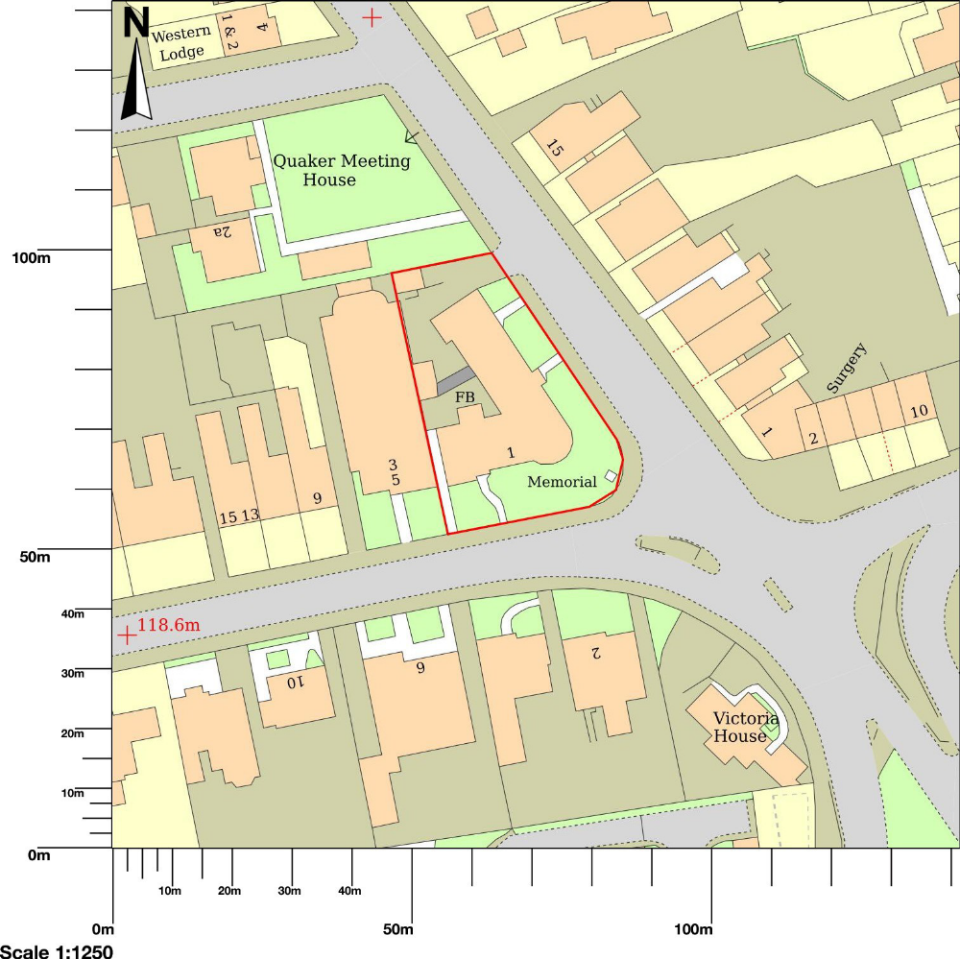

Location Plan
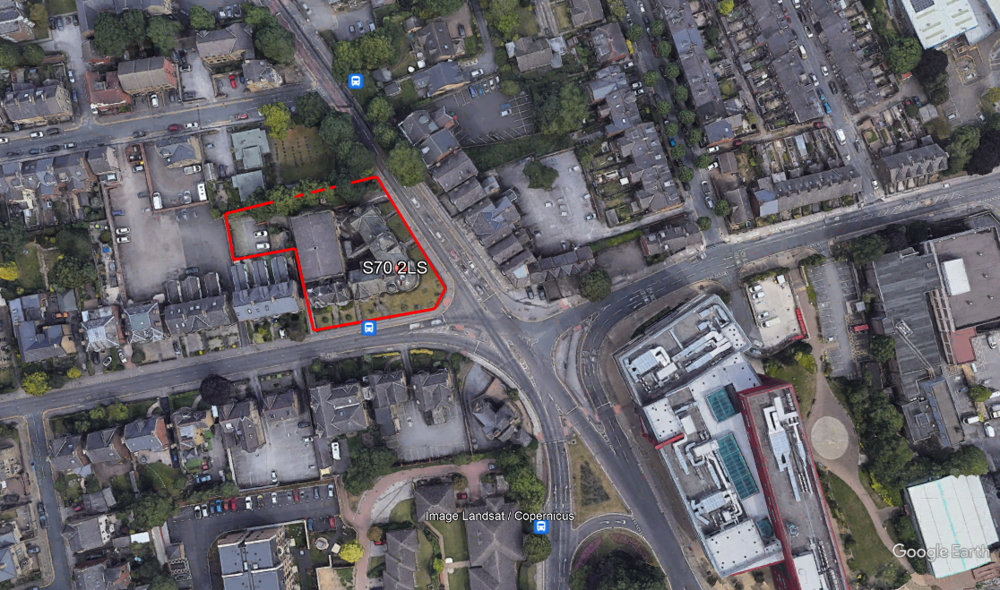

PREMISES OF THE NATIONAL UNION OF MINERS
Located on the intersection of Huddersfield Road & Victoria Road

