



Arboricultural Method Statement (AMS) for
Granville Oil & Chemicals

Site Address: | Unit 28, Goldthorpe Industrial Estate,  Rotherham, S63 9BL | Client: | Granville Oil & Chemicals  F.A.O James Todd
Report Ref: | (AMS)GR02-19 | Report Date: | 19th June 2019
Author: | Laurence Smith BSc (Hons) Arb, M Arbor A | Signed: | 

- Executive Summary 3
- Introduction 3
  - Client Instruction 3
  - Purpose of the Method Statement 3
  - Project Background 3
  - Assumption and Limitations 4
- Tree Preservation Orders 4
- Method Statement 4
  - Status of the Method Statement 4
  - Introduction 5
  - Arboricultural Monitoring and Timescales 5
  - Relevant Contact Details 5
  - Methodology 6
  - Tree Protection Barriers 6
  - Tree Works Prior, During and Post Construction 7
    - Tree Works Prior to Construction 7
    - Tree Works During Construction 7
    - Tree Works Post Construction 7
    - Recommendations For Tree Works 7
  - Location of the Site Compound 8
- Landscaping Plan 8
  - Planting Locations and Species 8
  - Site Preparation 8
  - Planting 9
  - Planting Schedule 9
- Landscaping Management Plan 9
  - Period of Maintenance 9
  - Weed Control 10
  - Replacement of losses 10
  - General maintenance Schedule 10
References 12
Appendix 1: Site Plans 12
Appendix 2: Example of Protective Barrier 17
Appendix 3: Example of Protective Barrier Notice 18

Executive Summary

James Todd of GGP Consult has requested an arboricultural report in order to provide an arboricultural method statement for tree protection methodology. This also includes a landscape management plan post development, in order to comply with planning conditions.

The development proposal consists of an extension to Unit 28 with 2 additional units to the south; Unit28a and Unit28b. Along with the unit extension there are 3 areas which are to be modified into regions of hard standing. The details of these plans can be seen in Appendix 1.

Retained trees are to be protected during the development with the use of protective fencing which complies with the recommendations sent out in the British standards document BS 5837:2012.

It is the opinion of Key Tree Solutions that although the volume of tree stock will decrease as a result of this development, by employing better management practices, the quality, longevity and value of the remaining tree stock can be significantly increased as part of the mitigation.

Introduction

Client Instruction

Key Tree Solutions was instructed by James Todd to produce an Arboricultural Method Statement (AMS) relating to the proposal for an extension at Unit 28, Goldthorpe Industrial Estate.

Purpose of the Method Statement

The purpose of this document is to provide reference to and clarification on tree protection and any necessary tree management works relating to the impact on any trees, in order to ensure good practice in the protection of retained trees throughout the proposed development.

Project Background

Planning permission on APPLICATION NO. 2019/0105 has been granted for the proposed development provided a number of conditions are met. This includes an AMS, Landscaping Plan and Landscaping Management Plan.

Key Tree Solutions have previously been commissioned to undertake an arboricultural survey and impact assessment report (GR01-19) which conforms to the most recent specifications outlined in BS 5837: 2012 Trees in relation to design, demolition and construction - Recommendations.

This report was used to guide the AMS along with the landscaping and landscape management plan.

Assumption and Limitations

A topographical map plotting the exact tree locations has not been undertaken due to the high volume of trees which fall outside of the threshold for inclusion, ie those with a diameter of 150mm or below. Thus tree locations for those included within the report, ie trees with a diameter of over 150mm, have been approximated. The accuracy of this method is considered to be adequate for this project. All trees within the Tree Protection Plan contained in Appendix 1 have been plotted according to this information.

Tree Preservation Orders

Local Planning Authorities (LPAs) have the power to preserve selected trees and woodlands through the making of Tree Preservation Orders (TPOs). Similarly, special provision is provided to trees located within Conservation Areas (CAs) which are not the subject of a TPO. The LPAs powers to do this are provided by the following Act of Parliament and its associated regulations:

Town and Country Planning Act 1990

Town and Country Planning (Determination of Appeals by Appointed Persons) (Prescribed Classes) (Amendment) (England) Regulations 2008

Town and Country Planning (Trees) (Amendment) (England) Regulations 2012. The principle effect of a TPO is to prohibit the cutting down, uprooting, topping, lopping, wilful damage or wilful destruction of trees without first obtaining the consent of the relevant Local Authority.

Unauthorised works to trees either protected by a TPO or those that are located within a CA, could result in a fine of up to £20,000 per tree.

The LPA have confirmed that the trees on site are neither protected by a TPO nor fall within a Conservation Area.

Method Statement

Status of the Method Statement

This Arboricultural Method Statement should be included as part of the specification and schedule of works issued to the building contractor and can form part of the contract.

This Arboricultural Method Statement should be available on site for inspection by the local authority, contractors and other relevant persons.

Introduction

Throughout the proposed development, a number of tasks need to be undertaken at specific intervals so that work can be undertaken in a logical order.

There are no foreseeable Root Protection Areas (RPA’s) which extend beyond the fencing. As such, there is no recommendation for the use of temporary ground protection.

The approach to tree protection for this scenario is outlined in the following methodology, approval of which must be confirmed in writing by the LPA prior to the commencement of works.

Arboricultural Monitoring and Timescales

The LPA will be given notice of the planned dates of the construction works to facilitate the on-site presence of a Tree Officer should they be wish to attend.

The following Arboricultural Sequence of Events can also be referenced during the works process:

Timescale | Action | ✓
Stage 1 | All requirements listed in the planning consent are approved by the Local Authority planning office.
Stage 2 | Complete tree works to facilitate the development.
Stage 3 | Install the temporary protective fencing around the trees (as detailed in Section 4.7 and as shown on the Tree Protection Plan in Appendix 1).
Stage 4 | Invite the Local Planning Authority to inspect the fencing measures prior to any on-site construction. Once inspected, the protective fencing must not to be moved or breached.
Stage 5 | Undertake the construction phase.
Stage 6 | Following the completion of the construction phase and when all site traffic and machinery has left, the protective fencing can be removed.
Stage 7 | Post construction remedial tree works to be undertaken (if required)
Stage 8 | Commence the landscaping scheme.

Relevant Contact Details

Contact Name | Organisation/ Detail | Contact
Laurence Smith | Key Tree Solutions | 07716 638 613
TBC | Tree Officer | TBC
Site Manager | TBC | TBC

Methodology

Exclusion zones will be clearly communicated to the on site Arborist who will remove the tree population that falls outside of this region. Heavy machinery is excluded from these zones with the exception of tracked wood chippers. In addition to these removals outside of the exclusion zone, tree population within the exclusion zone will be thinned by 20%. The thinning process will focus on the Birch, Willow, and Laurel trees or trees in poor condition i.e. defects which can not be improved with formative pruning. Wood can be chipped to the floor within the exclusion zones and used as a weed suppressant and mulch provided it is evenly spread and not left in heaps deeper than 10cm.

The Exclusion Zone will be set back from the proposed finished retaining wall location by 3 metres to ensure that any RPA’s of retained trees are protected.

Exclusion Zone 1 and 2 will not have any form of protective fencing as the level that the trees are growing on will be considerably higher than the finished ground level of the proposed development. The difference in height will form a natural barrier which will prevent machine access.

Exclusion Zone 3 will have tree protective fencing erected along the exclusion zone boundary as illustrated on the Tree Protection Plan (Appendix 1) and detailed in Section 4.8

Once the Exclusion Zones have been established and the protective fencing erected and inspected, the excavation of the ground will be conducted in order to lower the ground to the proposed development level.

Post construction phase and after all development traffic has left site, the protective fence can be removed and the landscaping plan undertaken provided the season is suitable.

Tree Protection Barriers

Tree protection barriers must be fit for the purpose of excluding construction activity and providing adequate protection to retained trees. It is proposed that they will consist of 2m tall welded mesh panels supported on concrete feet. Each panel will be secured to its neighbour with a minimum of 2 anti-tamper couplers secured so that they can only be undone from inside the Exclusion Zone. The panels will be further supported by stabiliser struts which will be pinned to the ground. An example of this type of barrier is contained in Appendix 2. The location of the tree protection barriers is provided on the Tree Protection Plan contained in Appendix 1.

Inside the tree protection barriers the following prohibitions will be complied with:

No excavations, including by hand; unless agreed with the retained arboricultural consultant;

No storage of machinery;

No storage or handling of building materials, fuel, chemicals or spoil;

No fires;

No vehicular access;

No pedestrian access; unless agreed with the retained arboricultural consultant;

No alteration, increase or decrease, to existing ground levels;

No excavation or installation of services.

The tree protection barriers will not be moved. To enable site operatives to appreciate the purpose of the protective fencing and reduce the risk of operatives attempting to move them, all-weather notices will be erected on the barriers similar to the example in Appendix 3. The barriers will only be adjusted or removed if prior written approval is obtained from the retained arboricultural consultant.

Tree Works Prior, During and Post Construction

Tree Works Prior to Construction

Trees which need to be removed to facilitate the development have not been individually listed for this AMS due to the volume of trees which fall under the 150mm diameter and were not included on the Arboricultural Survey. Additionally, the potential for inaccuracy in tree location plotting may result in inaccuracies for marking trees for retention or removal.

As such, the Exclusion Zones will be marked out by a competent person or arboricultural consultant/contractor with Eco Marker spray. This also includes marking up of any trees scheduled for removal as part of the thinning program of works.

Trees outside of the Exclusion Zones or those marked within them can then be safely removed by the arboricultural contractor.

Tree Works During Construction

In this case, no above ground tree works are envisaged to be required during the construction phase.

Damage to the retained tree population during the construction phase should be entirely preventable. This will be achieved by the use of Exclusion Zones which will prevent machinery access due to the temporary protective fencing or the differences in elevation. All persons on site must be aware of limitations that apply within the Exclusion Zone (please refer to Section 4.7).

If any trees on site are damaged, this must be immediately reported to Key Tree Solutions to agree on appropriate remedial action. Contact numbers for all parties can be found at Section 4.5.

Tree Works Post Construction

No destructive tree works post construction have been envisaged.

Recommendations For Tree Works

All work must be undertaken to BS 3998: 2010 - Recommendations for tree work and carried out by qualified, experienced and, ideally, Arboricultural Association approved contractors who must be adequately insured.

Any defects observed by a contractor or the client that were not apparent to the consultant must be brought to the attention of Key Tree Solutions immediately.

No liability can be accepted by Key Tree Solutions in respect of the trees unless the recommendations of this Method Statement are carried out under our supervision.

Location of the Site Compound

The site compound, typically including the site office, mess facilities, toilets, storage of materials and parking, must be located away from and outside the RPA of retained trees. Areas designated for the storage and/or mixing of chemicals, including petrol, diesel and oils must also be located away from and outside the RPA of retained trees. Such areas should be constructed with consideration to, and contingencies for, the occurrence of spillages, preventing the leaching of chemicals into unprotected, open ground.

Landscaping Plan

Planting Locations and Species

Post development and after the removal of the protective fencing the new landscaping plan can be implemented. This will involve the new planting of young tree whips in the region between the retaining wall and the exclusion zone as illustrated in Appendix 1 - New Tree Planting Plan (Locations not to scale). Planting in this region will be undertaken with species with a small maximum height such as; Birch, Hawthorn, Crab Apple and Rowan which will minimise the likelihood of heavy limbs extending over the new development, while bringing diversity to the location.

In addition to the new planting of smaller specimens above the retaining wall, new trees will also be planted in the construction exclusions zones where there are gaps in the overall canopy from thinning or other naturally occurring regions where there are currently less trees, such as close to the southern boundary. Planting in these locations will be undertaken with trees that have a larger potential for growth such as Oak and Beech. These species have been selected due to their ability to accommodate a high biodiversity and can add longevity to the finished site.

Site Preparation

All weeds shall be cut down and where necessary and removed from site to a facility found by the contractor. Any arisings left from tree removals will be evenly distributed and where applicable a contact herbicide spray shall be applied to all new planting areas on site to reduce competition by weeds on new plant growth. The weed free area should surround each new planting location should have a radius of at least 0.5m

All stone, brick, concrete, wood, wire, pipes debris, rubbish, weed roots and foreign matter of any kind above a maximum dimension of 150mm shall be removed from the planting areas.

Planting

All trees should conform to BS 3936 for Nursery stock and BS 5236 for Advanced Nursery Stock. Trees should have a sturdy and well-defined straight leader. All plants must have a good root system, vigorous with a good fibrous growth. Plants must meet the sizes stated in the planting schedule (Section 5.4).

Protection of plants until final planting should comply with the industry best code of practice for plant handling during lifting, packaging and transportation to site.

Holes will be dug out large enough to receive the roots of the plant fully extended and well spread out. Top-soil should be carefully worked among roots and backfilled. Plants should be well firmed by heeling and the surface left neat and even. Planting must be to the same depth as in the nursery. Care must be taken not to disturb the root balls of pot grown plants and not to let any roots dry out at any time. For small seedlings and whips, notch planting may be undertaken where the notch will provide a slit of sufficient size to accommodate the roots of the plants without any trimming or being forced into the slits. Tree will be staked using 90cm bamboo canes and protected with spiral tree guards no less than 0.5m in height.

Unless otherwise specified, all transplanting shall be carried out between the end of October and the end of March. The transplanting shall be carried out when the weather is dull and the ground is moist and workable. On no account must the planting take place when there is freezing wind.

Planting Schedule

Tree Species | Size | Type | Density | Location
Birch, Hawthorn, Crab Apple and Rowan | 0.5m - 1.0m | Whip | 2.5m spacing. | Exclusion zone perimeters
Oak, Beech | 0.5m - 1.0m | Whip | 3m x 3m spacing where applicable. | Within Exclusion Zones

Landscaping Management Plan

Period of Maintenance

The contractor will be responsible for the programme of maintenance for all new planting. The maintenance work is to ensure that all plantings that fail to make active growth are replaced during the first available planting season for the first 12 months.

Weed Control

During March, an application of Glyphosate will control competitive weeds and grass around trees for the first 5 years after planting. A weed free zone of 0.5m radius around each plant is to be provided. Glyphosate is a non-selective herbicide that is absorbed through leaves. The chemical should be applied by someone who has a relevant pesticide application certificate.

Weed control should be conducted through spring and summer as required with a minimum of 2 applications per year.

Replacement of losses

During the first 12 months from the date of planting, the contractor will be responsible for all deaths of newly planted trees and shrubs. Replacement will be at the contractor’s expense.

General maintenance Schedule

General maintenance is to commence during the first year after completion and should be used as a guide in order to ensure that newly planted trees are given the best chance of survival and managed for long term retention.

After 5 years has elapsed it will be necessary to develop a new maintenance schedule in order to manage the trees in a satisfactory manner.

Maintenance Operation | Year 1 | Year 2 | Year 3 | Year 4 | Year 5
Planting of new trees | Oct-Mar As required | N/A | N/A | N/A | N/A
Weed control | Apr-Jul As required | Apr-Jul As required | Apr-Jul As required | Apr-Jul As required | Apr-Jul As required
Watering | Jun-Aug once per month  minimum as required. | Jun-Aug once per month  minimum as required. | Jun-Aug once per month minimum as  required. | Jun-Aug once per month  minimum as required. | Jun-Aug once per month  minimum as required.
Replacement of losses | N/A | Oct-Mar As required | Oct-Mar As required | N/A | N/A
Monitoring of existing tree stock | N/A | Arboricultural Survey | N/A | N/A | Arboricultural Survey
Formative pruning where applicable | N/A | N/A | Oct-Mar As required | N/A | N/A

Signed



Laurence Smith BSc (Hons) Arboriculture, M Arbor A

References

British standards document BS 5837:2012 ‘Trees in relation to design, demolition and construction – Recommendations’

British standards document BS 3998:2010 ‘Tree work - recommendations’

Management of the risk from falling trees or branches - Health & Safety Executive (HSC) Document

2018 National House Building Council (NHBC) standards

Appendix 1: Site Plans

Site Plan as Existing

Site Plan as Proposed

Tree Protection Plan

New Plating Plan

NOTES

Extent of Land Ownership

Extent of Proposed Site

Boundary Legend

1 : 1000

0m 5m

10m 20m

Scale Bar

1 : 200

UNIT 29

Commercial Road

2.5m High Palisade Fence

UNIT 29

30no. Staff Vehicle Parking

8no. Cycle Parking

28.01
Covered Storage Area (Limited Access)

28.02

Gully 28.01

28.01

28.15
28.06
28.07
28.04

28.14

28.02

28.12

28.11
28.00
Tarmac Path

28.01

1.8m High Mesh Gate
MH3 14
CL28. 20
7.
Inv.2
28.05

28.06

27.86

27.89 27.88
27.98

te

28.09

27.99

1.8m High Mesh Fence
27.91 28.03 28.11

28.20

28.18
Tarmac Path

28.06

28.26

28.25 28.36
28.23

Gully

1.8m High Mesh Gate
28.31

28.40
28.54

2.5m High Palisade Fence

28.25 28.21 28.14
28.05
Beam Underside 32.72
28.33 28.27
28.39
28.51

28.10
28.04

28.08

28.21

27.98
28.10
Ga

27.91

28.02

27.95

28.08
Tarmac Path
Mesh Fence Ht. 1.8m

28.09

28.21

28.35

28.33 28.29

28.27

28.35

28.22

28.20 28.12 28.16 28.27
28.18
Hedge
28.34
28.43
28.57
28.58 28.69

28.24
Block Paving
28.25
28.27
28.12
28.13
28.19
28.26

28.26
Mesh Fence Ht. 1.8m
28.27

28.17

28.38

29.43
Gate

28.14 28.27
Shrubs
Shrubs
Gate
Gully
28.05

28.15
28.34
28.53
29.11

28.44 Gully
28.43
28.43
28.05
Palisade Fence Ht. 2.5m 28.59 28.57
28.46
28.44
28.13

28.69
28.84
Covered Storage Area (Limited Access)
28.49

28.63
Gully
28.66
28.79 28.65

28.14
28.43
28.11

28.14
T
28.12
28.14

28.12

28.11

28.39
28.24
Wall Top 29.27

Pipework

Bund Wall

28.31
28.88

28.56
28.66

28.54 28.60 Gully

UNIT 28

Commercial Road
Ta
28.61
28.54
16no Staff Vehicle Parking

28.71 28.66
28.55
28.58

28.71

2.5m High Palisade Fence

Steps
rmac

28.65
28.40
armac 28.42
28.40
28.65
28.13
5no Commercial Vehicle Parking
28.70

28.82

28.51
28.46 28.44
Pipework
28.45 28.42
28.83

28.70
28.72 28.68
28.85 28.79
28.12
28.11
28.79

28.91

28.42

28.41 28.41

28.41
28.13

28.78
28.45 28.43

28.95

28.96
28.80

28.26 28.63 28.90
28.85
28.97
28.87
29.00
28.12
Bund Wall
28.93
28.93 28.82
28.82
28.85

28.98
28.82
28.96
Gully28.09
28.13
28.89

28.42
28.75
29.02

28.95 28.90 29.11
29.19 29.20
29.32
28.41 28.47
28.97
29.11

28.47

28.96 28.93

Bund Wall Gully

28.92 28.91 28.90 28.91

28.93

28.97 28.93

28.80
28.89

28.47

28.46

28.40

29.56

Storage Area (Limited Access)
28.97

Bank Btm

29.05

29.5
30.0
30.5

Storage Area (Limited Access)

29.03

29.02

B 18.02.19 Boundary Lines amended JHT JH A 21.01.19 Parking identified JHT JH Rev Date Description DR CH c copyright
31.98

2.5m High Palisade Fence

32.15

Bank Top
Bank Btm 33.28

33.09
CONSULTING ENGINEERS ARCHITECTS
PROJECT MANAGEMENT
2 Hallam Road Priory Park East
HULL HU4 7DY
United Kingdom
Telephone (+44) 01482 627963

Fax
(+44) 01482
641736

Email info@ggpconsult.co.uk

2.5m High Palisade Fence

Client

Granville Oil & Chemicals Ltd.
Job Title

Proposed Extension Unit 28 Goldthorpe Industrial Estate Rotherham

Drawing Title

Site Plan As Existing
A0 - ORIGINAL SHEET SIZE

Status

PLANNING

As indicated 02/01/2019
Scale
Date

Site Plan As Existing
1

1 : 200

Drawn By

Drg. No.

JHT

Checked

JC

Approved

AT

Rev

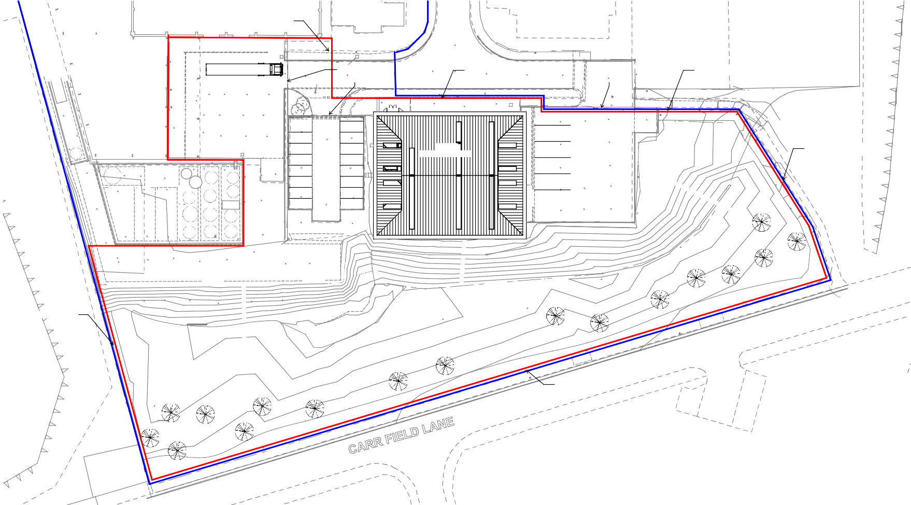27988 AA_(100)_02 B

NOTES

Extent of Land Ownership

Extent of Proposed Site

Boundary Legend

1 : 1000

0m 5m

10m 20m

Scale Bar

1 : 200

UNIT 29

Commercial Road

UNIT 29

30no. Staff Vehicle Parking

8no. Cycle Parking

28.01

28.02
Covered Area Top 33.14 Covered Area Btm 32.99

Gully 28.01

28.01

28.15
28.06
28.07
28.04

28.14

28.02

28.11
28.00
Tarmac Path

28.01

1.8m High
05

28.06

27.86

27.89 27.88
27.98

Gate

28.09

27.99

28.20

28.18
Tarmac Path

28.06

28.26

28.25

28.36

28.23

2.5m High Sliding Security Gates
28.54
28.40

28.12
Covered Storage Area (Limited Access)
28.04
28.

Mesh Gate
27.91 28.03 28.11

28.31
Gully

28.25
28.05
Beam Underside 32.72
28.33 28.27
28.39

28.14 28.10

28.35

28.08

28.21

28.22 5088

28.20

27.98
28.10
28.18

5000

27.91

28.02

28.510200 5021

27.95

28.08
Tarmac Path

28.150600 5124
Mesh Fence Ht. 1.8m

28.27

28.09

28.21
28.51
Hedge

28.24
Block Paving
28.25
28.27
28.12
28.13
28.19
28.26
29.43
28.57
28.58 28.69

Shrubs
Shrubs
28.14 29.11
Gully 28.05 28.05
28.27

28.17
28.17
28.15

28.44
28.43
28.43
28.59 28.57

28.46
28.44
Overhang Top 35.31
Overhang Btm 34.88
4860
Overhang Top 35.31
Overhang Btm 34.90
28.13
28.13

28.43
Overhang Top 35.19
Overhang Btm 34.85
28.14

IC 75 CL28.

28.14

28.12

28.11
Covered Storage Area (Limited Access)
Covered Area Top 33.18 Covered Area Btm 33.02

28.39
Overhang Top 35.19
Overhang Btm 34.84
Wall Top 29.27 Pipework
28.24
28.40

Bund Wall
28.12

28.31
28.88

28.56
28.66

Commercial Vehicle Circulation
28.65
28.54
28.13

UNIT 28

Commercial Road
1
6
. 8
2
28.55
28.58

28.71
28.49

28.63
4840
28.14
28.11
Gully
3no Commercial Vehicle Parking

28.51
28.46 28.44
Pipework
28.45 28.42
28.83
28.70
28.85
28.71
28.66
4860
28.12
28.11

28.42

28.41 28.41

28.41

28.78
28.45 28.43
4840
28.95
29.06
Bund Wall
28.93

DN
28.96
28.85 28.87
28.97
29.00
28.93 28.82
28.82
28.80
28.98
28.82
4850
Gully28.09

Waste & Recyclable Storage Area
28.12

28.47

28.96 28.93

Bund Wall Gully

28.92
28.41

28.91 28.90 28.91

28.93
28.97
29.11

Storage Area

B 18.02.19 Boundary Lines amended A 21.01.19 Parking identified

JHT JH
JHT JH

Rev
Date
Description
DR CH

c copyright

TOW = 31.00
32.15

CONSULTING ENGINEERS ARCHITECTS
PROJECT MANAGEMENT
2 Hallam Road Priory Park East
HULL HU4 7DY
United Kingdom

TOW = 31.00
Telephone (+44) 01482
627963

Fax
(+44) 01482
641736

Email info@ggpconsult.co.uk

TOW = 31.00

Client

Granville Oil & Chemicals Ltd.
Job Title

Proposed Extension Unit 28 Goldthorpe Industrial Estate Rotherham

Drawing Title

Site Plan As Proposed
A0 - ORIGINAL SHEET SIZE

Status

PLANNING

1 Site Plan As Proposed

Scale

As indicated

Date

02/01/2019

1 : 200
Drawn By
JHT
Checked

JC
Approved

AT

Drg. No.

27988 AA_(100)_10

Rev

B

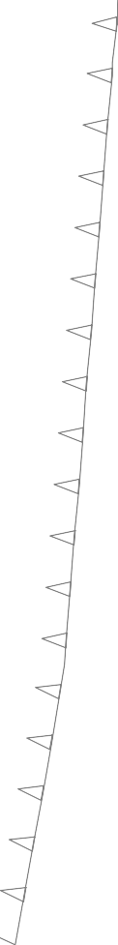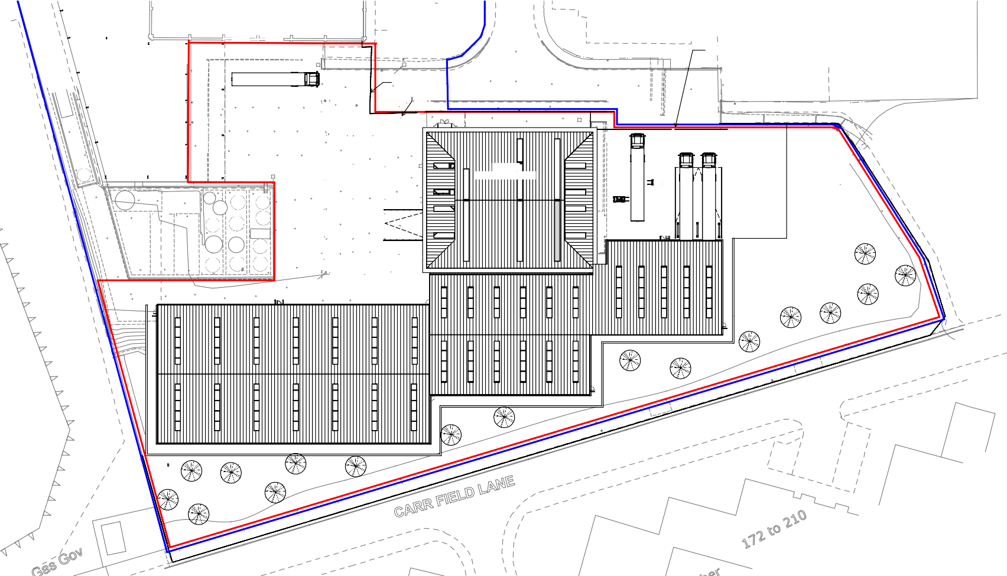

UNIT 29

Commercial Road

2.5m High Palisade Fence

UNIT 29

30no. Staff Vehicle Parking

8no. Cycle Parking

28.01

28.02

Gully

28.01

28.01

28.15
28.06
28.07

28.04

28.14

28.02

Tarmac Path
28.11
28.00

28.01

1.8m High

28.06

27.86

27.89 27.88

28.09

27.99

1.8m High Mesh Fence

28.20

28.18
Tarmac Path

28.06

28.26

28.25

28.36

28.23

1.8m High

28.54
28.40

2.5m High Palisade Fence
Gully
28.31

28.12
Covered Storage Area (Limited Access)
28.04
Me28.s05 h Gate
27.98
27.91 28.03 28.11

Mesh Gate

28.25 28.21 | 28.14 | 28.10 | 28.08 |  |  | 27.98 |  |  | 27.91 |  |  | 27.95 |  |  | 28.09
 |  |  | 28.21 |  |  | 28.10 |  |  | 28.02 |  |  | 28.08 |  |  | 28.21 |  |  | 28.35

28.33
Mesh Fence Ht. 1.8m
Beam Underside 32.72
28.33 28.27
28.39
28.51

28.29
28.05

28.27

28.35
Tarmac Path
Hedge

28.22
28.20 28.12 28.16 28.27 28.34
KEY- Site plan to be read in conjunction with Key Tree

28.24
Gate
Block Paving
Shrubs
Gully
28.05
28.25
28.57

28.58 28.69
28.27
28.12
28.13
28.19

28.26
28.26
Mesh Fence Ht. 1.8m
28.27

28.17
28.15

28.38

29.43
Gate
Solutions AMS ref: GR02-19

28.44
28.05
Palisade Fence Ht. 2.5m 28.59 28.57
28.46

Gully
28.44

28.14 28.27
28.43
Shrubs
28.18

Gate

28.53
28.43
28.43
29.11
Protective Barrier
- BS5837 (2012), clause 6.2.2
Construction Exclusion Zone (EZ)

28.69
28.84
Covered Storage Area (Limited Access)
28.49

28.63
28.13
Gully
28.66
28.79 28.65

28.43

28.14
28.14
28.11

28.12

28.11

28.39
28.24
Wall Top 29.27

Pipework

Bund Wall
28.12
28.70

28.82

28.31
28.88

28.56
28.66

28.54 28.60
28.61

Gully

UNIT 28

Commercial Road
28.54
16no Staff Vehicle Parking
28.55
28.58

28.71

2.5m High

Steps
28.40
28.65
28.66
28.13
5no Commercial Vehicle Parking

28.51
Pipework
28.83

28.70
28.71
28.72 28.68

28.85 28.79
28.12
28.11
28.79
28.91

28.42

28.41

28.41

28.41
28.13

28.78 28.95
28.44
28.43
28.42
28.93 28.82
28.82

28.96
28.80
28.82
28.96
Gully28.09
28.13
28.89

28.26 28.42
28.85
28.97
28.87

29.00
28.12
Bund Wall
28.93
28.85

28.98

28.63

28.75

28.90
29.02

28.95 28.90 29.11
29.20
28.45
28.45
28.97
29.11

28.47
28.46

28.96 28.93

Bund Wall Gully

28.92 28.91 28.90 28.91
29.19

28.93

28.97

28.93
29.32

28.80
28.89

28.47

29.56
28.41
28.47

28.46

28.40

EZ3

Storage Area (Limited Access)
28.97

29.05

Storage Area (Limited Access)

29.03

29.02
31.98

Bank Btm
29.5
30.0
30.5

High Palisade Fence

32.15
Bank Top
Bank Btm 33.28

33.09

EZ2

2.5m High Palisade Fence

EZ1

Site Location
Unit 28, Goldthorpe Industrial Estate, Rotherham,
S63 9BL

Job
Arboricultural Method Statement GR02-19

Title
Tree Protection Plan
N

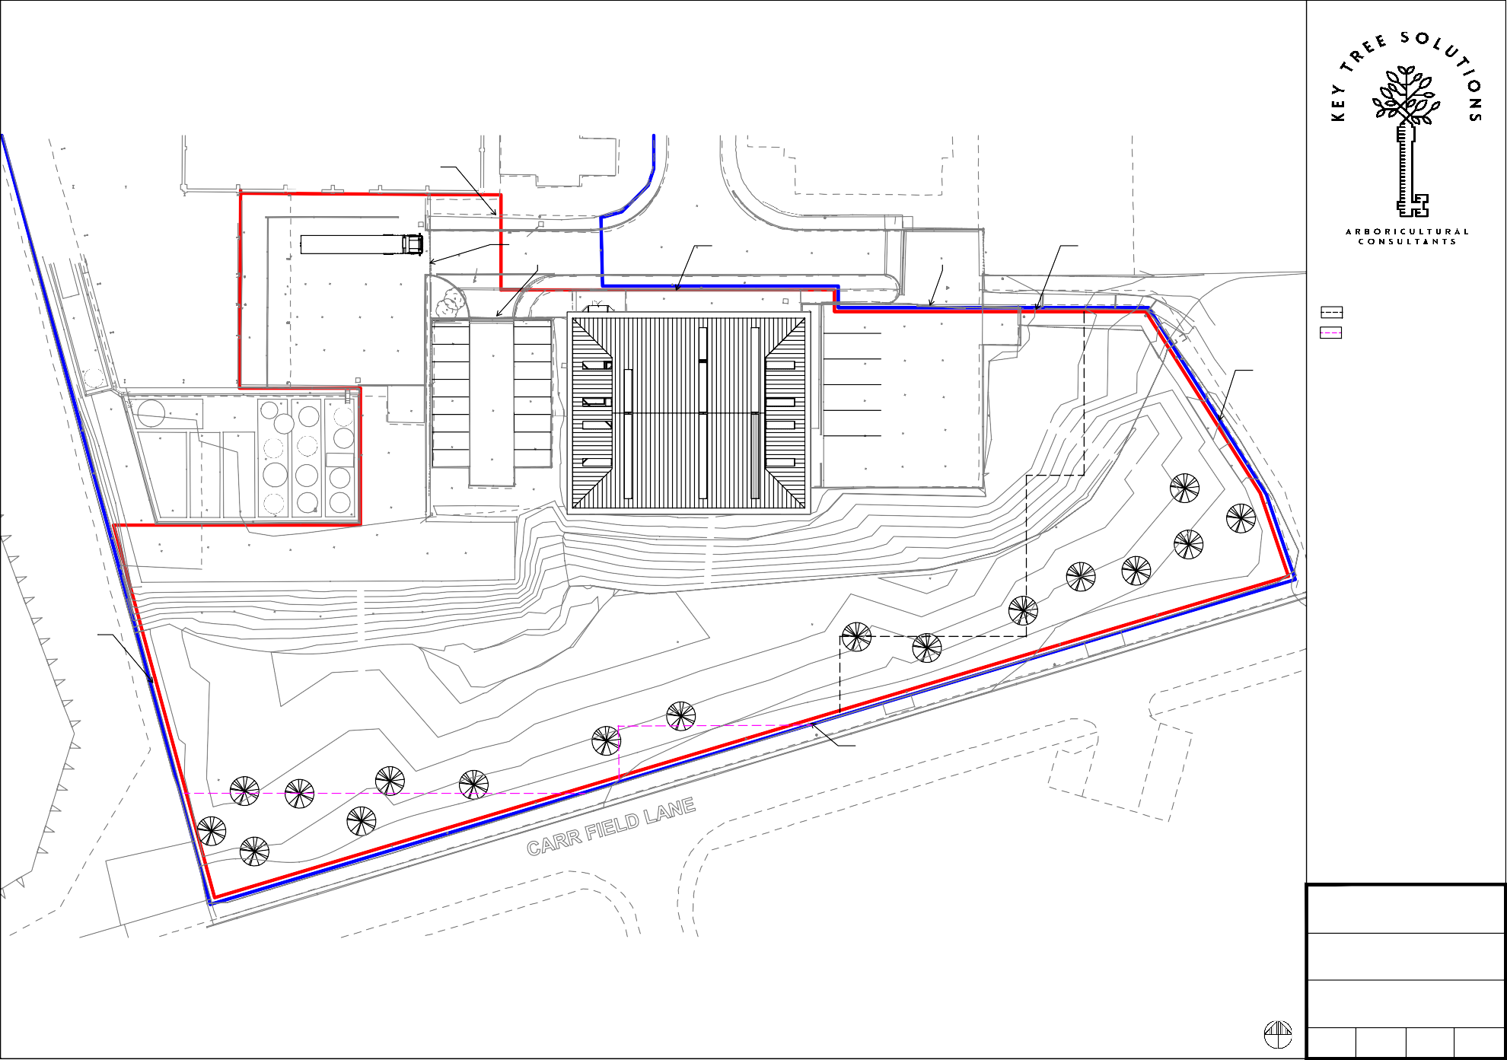
Drawn by L.Smith

Date
Jun 2019

Scale @ A1 1:250

Drg. no. 1/2

UNIT 29

Commercial Road

UNIT 29

30no. Staff Vehicle Parking

8no. Cycle Parking

28.01

28.02
Covered Area Top 33.14 Covered Area Btm 32.99

Gully

28.01

28.01

28.15

28.04
28.06

28.14
28.07

28.02

Tarmac Path
28.11
28.00

28.01

1.8m High
28.05

28.06

27.86

27.89 27.88

28.09

27.99

28.20

28.18
Tarmac Path

28.06

28.26

28.25

28.36

28.23

2.5m High Sliding Security Gates

28.40
28.54

28.12
Covered Storage Area (Limited Access)
28.04
27.98

Mesh Gate
27.91 28.03

28.11

28.31
Gully

KEY- Site plan to be read in conjunction with Key Tree

28.25 28.14 28.10
28.05
Beam Underside 32.72
28.33 28.27
28.39

28.08

28.21

27.98

28.10
Gate
28.18

27.91

28.02

27.95

28.08
Tarmac Path

28.09

28.21
Solutions AMS ref: GR02-19

Protective Barrier
Hedge
28.51

28.35
28.22 5088
28.20
5000
28.510200 5021
28.16
5000
Mesh Fence Ht. 1.8m
5124
28.27

28.24
Block Paving
Gully
28.05
28.25
28.57

28.58 28.69

Shrubs

28.27

28.12

28.13

Shrubs

28.19

28.14
28.27

28.17
28.17
28.15

29.11

29.43
28.26
- BS5837 (2012), clause 6.2.2
Construction Exclusion Zone (EZ)

28.44
28.43
28.43
28.05
28.59

28.46
28.57
28.44
Overhang Top 35.31
Overhang Btm 34.88
4860

Overhang Top 35.31
Overhang Btm 34.90
28.13

28.43
28.61

28.14

28.12
Overhang Top 35.19
Overhang Btm 34.85

28.11
Covered Storage Area (Limited Access)
Covered Area Top 33.18 Covered Area Btm 33.02

28.39
Overhang Top 35.19
Overhang Btm 34.84
Wall Top 29.27 Pipework
28.24
28.40

Bund Wall
28.12

28.31
28.88

28.56
28.66

Commercial Vehicle Circulation
28.65
28.54
28.13

UNIT 28

Commercial Road
28.55
28.58

28.71
28.49

28.63
4840
28.14
28.11
Gully
3no Commercial Vehicle Parking

28.51
Pipework
28.83

28.70
28.85
28.71
28.66
4860
28.12
28.11

28.42

28.41

28.41

28.41
28.13

28.78
28.44
28.43
28.42
4840
28.95
Bund Wall
28.93

DN
28.96
28.93 28.82
28.82
28.80
28.98
28.82
4850
Gully28.09

28.85 28.87
28.97
29.00
28.12

28.47
28.46

28.96 28.93

Storage Area

Bund Wall Gully

28.92 28.91 28.90 28.91
28.41
28.45
28.45

28.93
Waste & Recyclable Storage Area
28.97
29.11

EZ3

TOW = 31.00
32.15

TOW = 31.00

EZ2

TOW = 31.00

EZ1

Proposed new planting locations for Birch, Hawthorn, Crab Apple and Rowan

Site Location
Unit 28, Goldthorpe Industrial Estate, Rotherham,
S63 9BL

Job
Arboricultural Method Statement GR02-19

Title
New Planting Plan
N

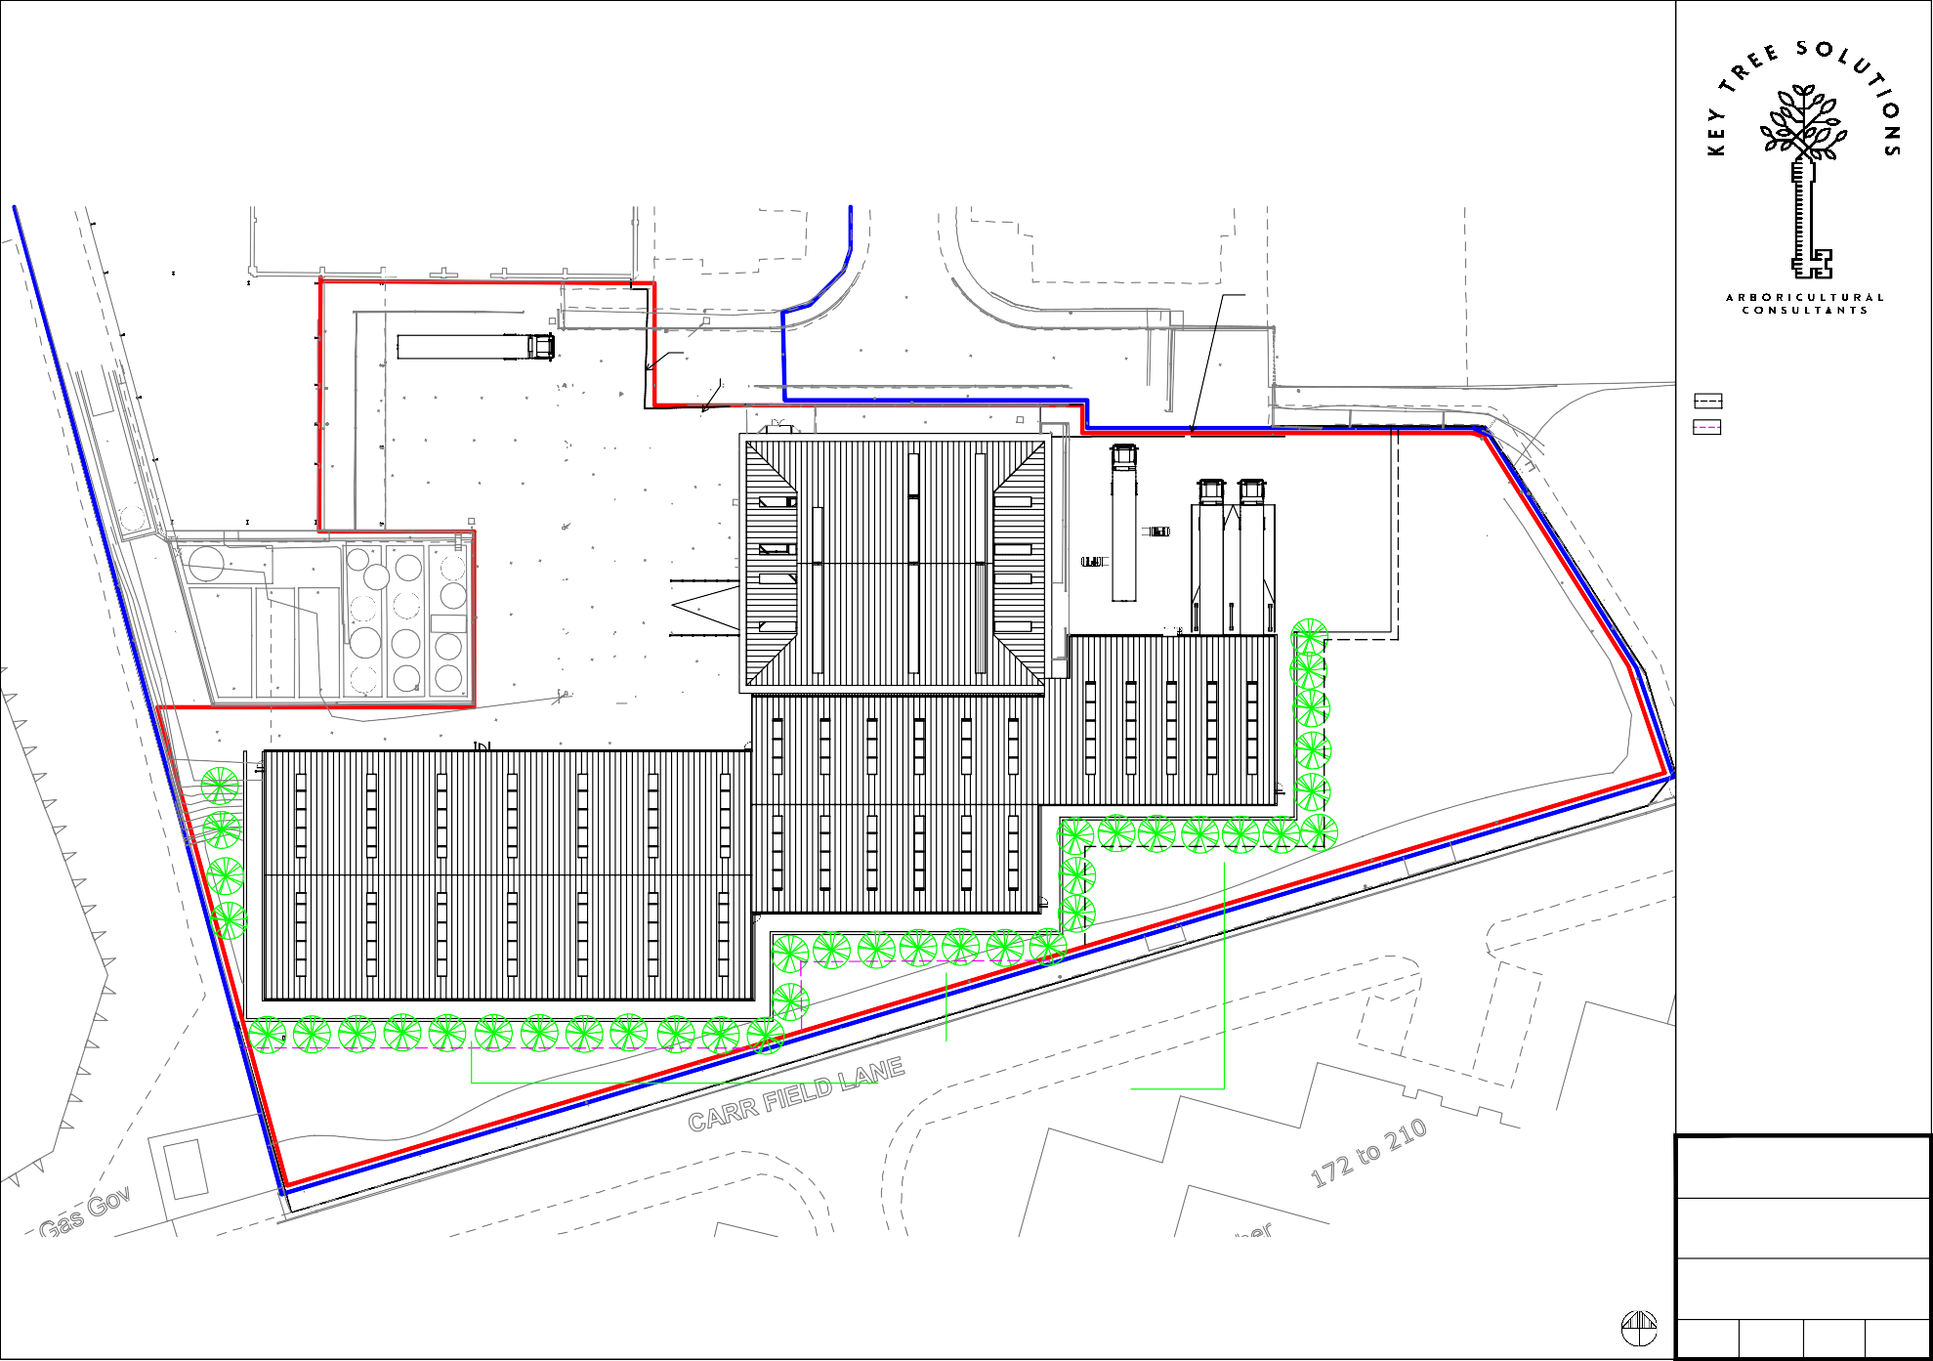
Drawn by L.Smith

Date
Jun 2019

Scale @ A1 1:250

Drg. no. 2/2

Appendix 2: Example of Protective Barrier

The protective barrier will be installed in accordance with BS5837: 2012. The default specification of BS 5837: 2012 (pictured below for reference) recommends a vertical and horizontal, scaffold framework, well braced to resist impacts, with vertical tubes at no more than 3m intervals. These should be driven into the ground. Weld mesh panels should be affixed to this framework with scaffold clamps.
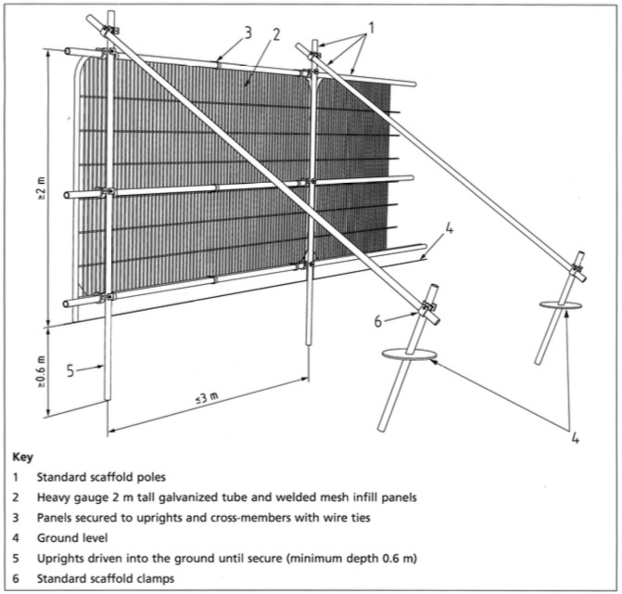

Appendix 3: Example of Protective Barrier Notice

Tree Protection Zone
KEEP OUT
TREES ENCLOSED BY THIS FENCE ARE PROTECTED BY STRICT PLANNING CONDITIONS

ANY DAMAGES CAUSES TO THESE TREES MAY RESULT IN CRIMINAL PROSECUTION

RESTRICTED AREA
THE PROTECTIVE FENCE MUST NOT BE MOVED OR BREACHED

NO PERSON, MACHINERY, VEHICLE OR PLANT IS PERMITTED WITHIN THE TREE PROTECTION ZONE

NO MATERIALS SHALL BE STORED WITHIN THE TREE PROTECTION ZONE

NO EXCAVATIONS ARE PERMITTED WIHIN THE TREE PROTECTION ZONE

NO SPOIL IS TO BE DEPOSITED WITHIN THE TREE PROTECTION ZONE

NO FIRES ARE TO BE LIT WITHIN THE TREE PROTECTION ZONE

ANY DAMAGES MUST BE REPORTED TO THE SITE MANAGER

