2019/1311
Mrs Rachel Chester
Demolition of outbuildings and erection of single storey extension to side/rear, two storey rear extension, enlarged detached garage, new vehicular entrance gates, increase in height of boundary walls and new pedestrian entrance path to front door
15 Carr Furlong, Athersley North, Barnsley, S71 3NS
Site Description
The application relates to a semi-detached dwelling located on a corner plot at the intersection of Carr Furlong and Stoney Royd. The property is of a red brick and render construction with a roman tile hipped and gable roof
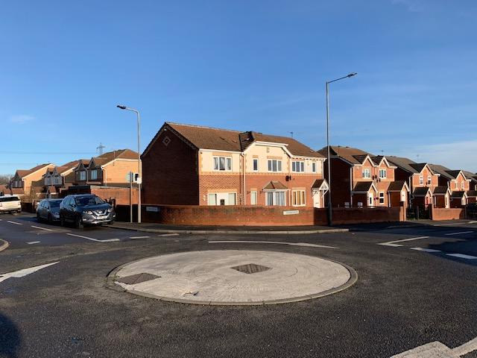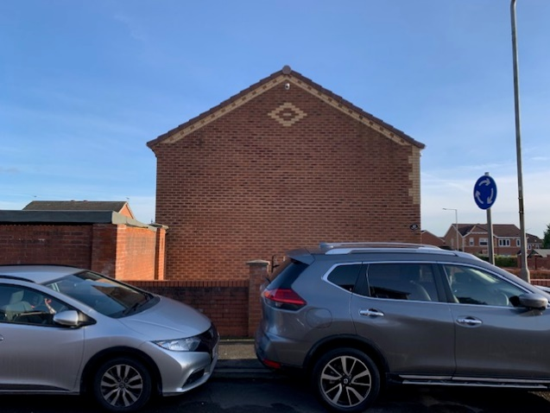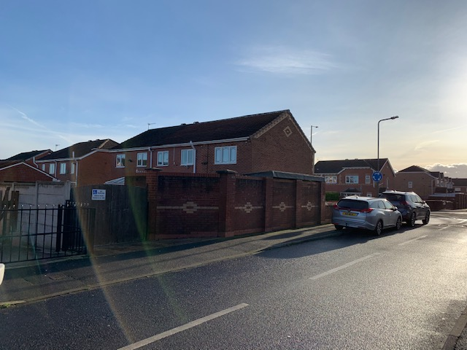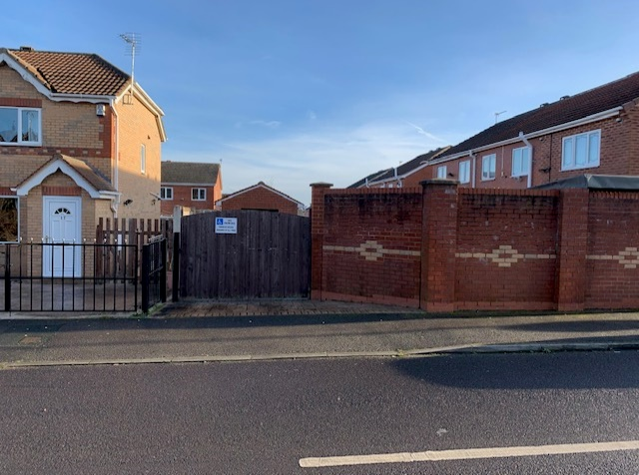
Planning History
B/03/0236/BA – Erection of two storey side extension.
Proposed Development
The applicant is seeking permission for the erection of a two-storey side extension to the dwelling; enlargement of the existing detached garage; new vehicular entrance gates; an increase in height of boundary walls and new pedestrian entrance path to front door.
N.B.: On 20/1/20, the proposal was amended. The two-storey side extension was replaced with a single storey side extension and small two storey rear extension. No other changes were made.
The side extension will have a sideways projection of 3.15m and a rearward projection of 9.2m, extending 2m beyond the rear elevation of the original dwelling. The extension will have a gable pitched roof; with eaves and ridge of 2.3m and 4.4m respectively.
The rear extension will have a rearward projection of 2m and project along the rear elevation by 6.5m. The extension will have a gable pitched roof, with eaves and ridge of 5m and 7.2m respectively.
The footprint of the garage will be enlarged from 7.81m² to 16.14m² and the design will remain unchanged; the eaves will remain at 2.2m but the ridge height will increase from 3m to 3.4m. The side boundary wall will increase in height from 1m to 1.5m, with new pedestrian access being created at the front of the property.
Policy Context
Local Plan Allocation – Urban Fabric
Planning decisions should be made in accordance with the current development plan policies unless material considerations indicate otherwise and the recently revised NPPF does not change the statutory status of the development plan as the starting point for decision making.
The new Local Plan was adopted at the full Council meeting held 3rd January 2019 after it was found to be sound by the appointed Planning Inspector following the examination process. This means that it now takes on full weight for decision making process in planning law terms as the development plan for the Borough, superseding the remaining saved policies from the Unitary Development Plan (adopted 2000) and the Core Strategy (adopted 2011).
Local Plan Policy GD1 – General Development – states that proposals for development will be approved where there will be no significant adverse effect on the living conditions and residential amenity of existing and future residents. Development will be expected to be compatible with neighbouring land and will not significantly prejudice the current or future use of neighbouring land. Policy GD1 below will be applied to all development.
Local Plan Policy D1 – High Quality Design and Place Making supersedes Core Strategy Policy CSP 29 and sets out the overarching design principles for the borough. Policy D1 States that development is expected to be of high quality design and will be expected to respect, take advantage of and reinforce the distinctive, local character and features of Barnsley
Supplementary Planning Document (SPD) – House Extensions sets out the design principles that specifically apply to the consideration of planning applications for house extensions, roof alterations, outbuildings & other domestic alterations. The general principles are that proposals for extensions should:
- Be of a scale and design which harmonises with the existing building
- Not adversely affect the amenity of neighbouring properties
- Maintain the character of the street scene and
- Not interfere with highway safety.
SPD – House Extensions and other Domestic Alterations states that to combat the problems of loss of light, as well as loss of privacy and outlook, the size and projection of rear extensions need to be strictly controlled. Extensions to the rear of detached houses will be considered on their design merits where no adjacent properties are affected.
SPD – House Extensions states that the design of a single storey side extension should reflect the design of the existing dwelling in terms of roof style, pitch materials and detailing and should not have an excessive sideways projection (i.e. more than two thirds the width of the original dwelling).
SPD – Outbuildings and Annexes states that detached garages should relate sympathetically to the main dwelling in style, proportions and external finishes. In most cases, it will not be appropriate for a garage to be sited between the house and the road.
These policies are considered to reflect the policies set out in the revised NPPF, which relates to high quality design and good standard of amenity for all existing and future occupants of land and buildings.
Consultations
Highways DC – Comments raised about proximity of extension to the side boundary and the provision of visibility splays at the access.
Representations
Notification letters were sent to surrounding properties. No comments or representations were received.
Assessment
Principle of Development
The site is allocated as Urban Fabric in the adopted Local Plan. As such extensions and alterations to a domestic property are acceptable in principle, providing they remain subsidiary to the host dwelling, are of a scale and design which is appropriate to the host property and are not detrimental to the amenity afforded to adjacent properties.
Extensions to residential properties are considered acceptable where they do not have a detrimental impact on the amenity of surrounding residents, visual amenity and on highway safety.
Residential Amenity
The dwelling is located to south and west of adjacent properties and so there is potential for a detrimental increase in levels of overshadowing. The extension will be located approx. 10m from the dwelling to the north and so it is unlikely that any adverse overshadowing will occur. Furthermore, it would most fall onto the driveway rather than private amenity space.
The two-storey extension has modest rear projection and is set in 2.7m from the side boundary with the adjoining dwelling. Any overshadowing would likely occur toward the end of the day and its distance from the boundary means that it won’t have a detrimentally overbearing effect.
Visual Amenity
Extensions to dwellings are considered based on overshadowing, loss of privacy and outlook. The sideways projection of a two-storey side extension should not exceed more than two thirds the width of the original dwelling.
Given that the dwelling already has a two-storey side extension, the addition of a further two storey extension would result in extension that are 150% the size of the original dwelling, contrary to SPD guidance. Furthermore, it would have projected right up to the side boundary, which extension on corner plots should not do.
The altered design; with a single storey extension set in 1m from the boundary and a small two-storey rear extension, has a much better appearance in the street scene and do not dominate the existing dwelling.
Both extensions are designed to harmonise with the original dwelling in terms of materials, detailing, design and roof style and pitch and so are considered acceptable.
The enlarged garage is reflective of the existing and is set well back from the highway. As such, it is unlikely to adversely affect the street scene. The increase in wall height will not detract from the visual character of the area and so is acceptable.
Highway Safety
Carr Furlong is not a classified road and so the access could be altered without the need to submit a planning application. Furthermore, there is no through access and Carr Furlong terminates further north of the site. As such, it is not considered necessary for a visibility splays to be provided at the drive entrance.
Other Issues
A complaint was received by the LPA regarding the applicants’ drive being blocked by a neighbouring resident,
The provision of parking restrictions would require a TRO for either double yellow lines or H markings to be painted. This would be at the applicants’ expense and is separate from the planning process. The applicant will need to contact highways to arrange this.
Recommendation
Approve – subject to conditions

