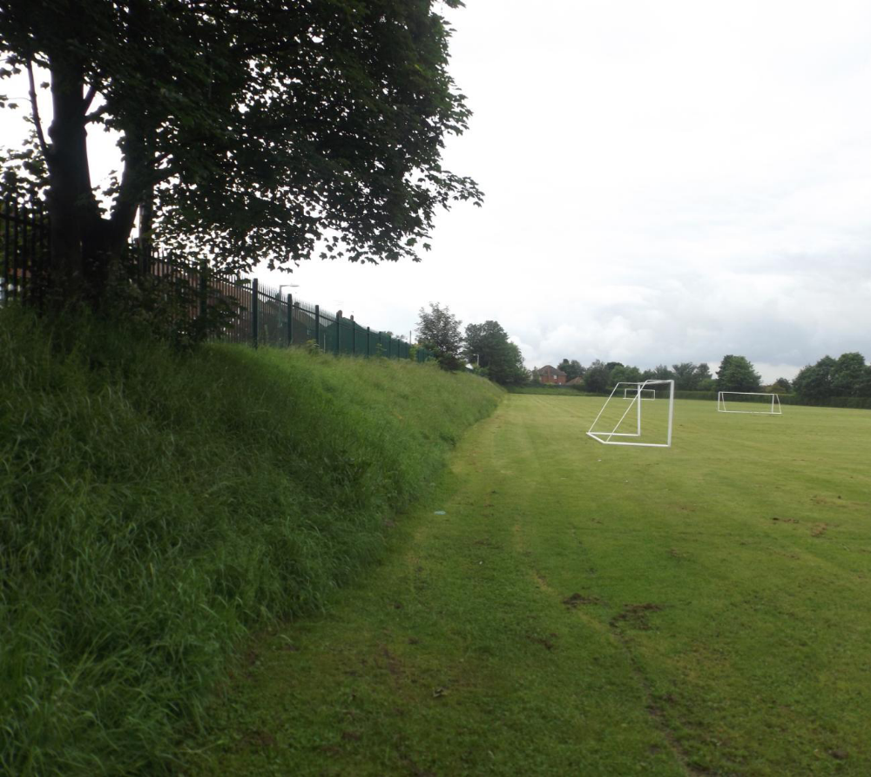

Barnsley College Carrington Avenue
Playing Pitch Assessment



CONTENTS

 |  | Page No.
SECTION 1 | INTRODUCTION | 3
SECTION 2 | THE SITE | 4
SECTION 3 | NATIONAL AND LOCAL PLANNING POLICY | 5
SECTION 4 | RELEVANT PLANNING  HISTORY | 7
SECTION 5 | SPORTS FACILITIES & USAGE AT BARNSLEY COLLEGE | 8
SECTION 6 | EVIDENCE ON SUPPLY OF PITCHES | 10
SECTION 7 | ALTERNATIVE PROVISION TO COMPENSATE FOR THE LOSS OF CARRINGTON | 12
SECTION 8 | CONSULTATION OUTCOME | 13
SECTION 9 | CONCLUSIONS | 14

TABLE 1 Usage of Carrington Fields
TABLE 2 Usage of 3G Pitch at Honeywell and Carrington

APPENDIX 1 Barnsley College Usage Data of Sports Facilities 2011 -2014
APPENDIX 2 Extract of Barnsley Council Playing Pitch Strategy – Football Pitch Quality and Quantity
APPENDIX 3 Alternative Locations for Mini pitches

APPENDIX 4 Football Association Response

SECTION 1 INTRODUCTION

  - Carrington Ave has been used as a sports facility by Barnsley College as playing pitches for a number of years and has been given over to use as two adult football pitches. In the last five years Barnsley College has made substantial improvements to their existing facilities, with a key part of the plan involving the centralisation of the College departments around the Old Mill Lane site within Barnsley Town Centre. Following the development of additional facilities at the Honeywell Campus and The Fleets site in 2012 as part of the overall creation of the Barnsley College Sports Academy, the pitches at Carrington Ave are now considered surplus to requirements. It is the intention of the College to obtain planning permission for residential development for the site and dispose of this asset.

  - The College has established an outstanding Sports Academy at the Honeywell site with the creation of a range of quality sports facilities. As a consequence of these developments, both Carrington Ave and the Belle Vue campus will become surplus to the College’s requirements.

  - Barnsley College, have appointed Capita to produce a Playing Pitch Assessment in support of the College’s planning application for housing development at the Carrington Avenue site.

  - This Assessment will set out the relevant government and local policy relating to playing fields This Assessment will consider the available evidence surrounding the supply and future need for football pitches in the area. As part of this Assessment Capita have undertaken consultation with a range of organisations and bodies including the Local Planning Authority, Sport England, the Football Association as well as numerous local football clubs.

SECTION 2 THE SITE

2.1 The site comprises the existing playing field area site ed to the north of the Honeywell Campus and is located in the North Neighbourhood Area of Barnsley town. The site is approximately 2.6 ha in area and is defined in the east by the Huddersfield to Sheffield railway line and by Carrington Avenue to the west. The district to the west is characterised by two storey family housing. There is a significant change in levels between Carrington Avenue itself and the playing fields.

2.2 The site is grassed with hedging and a number of trees forming the boundary along the railway line to the east, and small number of trees located to the north west fronting on to Carrington Ave. There are no buildings or facilities on the field. The site is enclosed by metal fencing with the only entrance being located at the south west corner close to the junction between Carrington Ave and Honeywell Lane.

2.3 There is no general public access onto the site or any wider community use of the pitches.

2.4 The land is identified as an Existing Community Facility on the saved UDP proposals map, it is also allocated on the Greenspace register under ref GS 874. The surrounding area is generally allocated as a Housing Policy Area.

SECTION 3 NATIONAL AND LOCAL PLANNING POLICY

National Planning Policy Framework
3.1 The Government has set out within the National Planning Policy Framework its policy in respect of development on open space and playing fields.

Chapter 8 of the NPPF which refers to , promoting healthy communities, sets out the guidance relating to playing fields. Paragraph 74 states that:

“Existing open space, sports and recreational buildings and land, including
playing fields, should not be built on unless:

- an assessment has been undertaken which has clearly shown the open
space, buildings or land to be surplus to requirements; or
- the loss resulting from the proposed development would be replaced by
equivalent or better provision in terms of quantity and quality in a
suitable location; or
- the development is for alternative sports and recreational provision,
the needs or which clearly outweigh the loss.”

Barnsley Core Strategy
3.2 Policy CSP 35 “Green Space” of the Barnsley Core Strategy states
“We will work with partners to improve existing green space to meet the standards in our Green Space Strategy.

Green space refers to any land within or close to towns and village that is or could be used by people for recreation or by wildlife.
We will only allow development proposals that result in the loss of green space where:
an assessment shows that there is too much of that particular type of green space in the area which it serves and its loss would not affect the existing and potential green space needs of the borough;
or
an appropriate replacement green space of at least an equivalent community benefit, accessibility and value is provided in the area which it serves;
or
the development is for small scale facilities needed to support or improve the proper function of the green space

We will assess the need for green space against the standards in our Green Space Strategy”

Sport England
3.3 Government policy on Playing Pitches is policed by Sport England who are a statutory consultee on planning applications relating to playing pitches.

Sport England’s Policy
3.4 Sport England Sport England will oppose the granting of planning permission
for any development which would lead to the loss of, or would prejudice the use of, all
or any part of a playing field, or land last used as a playing field
in an adopted or draft deposit local plan, unless,

- The playing fields, lost would be replaced by playing fields of an equivalent or better quality and of equivalent or greater quantity, in a suitable location and subject to equivalent or better management arrangements, prior to the commencement of development.

or

- An assessment of current and future needs has demonstrated to the satisfaction of Sport England that there is an excess of playing field provision in the catchment, and the site has no special significance to the interests of sport.

SECTION 4 RELEVANT PLANNING HISTORY

4.1 Carrington Avenue
B/97/0884/BA Permission for new fencing around the Carrington Fields in 18.09 1997

4.2 Honeywell Campus
2005/1507 Mixed use development of residential, offices and relocation of College sports hall and tennis courts. This application specifically included the Construction of a new sports hall and outdoor sports facilities

2009/0609 Mixed use development of Residential, Offices and relocation of College Sports Hall and Tennis Courts (Reserved Matters) Approved Subject to Legal Agreement 14-03-2012

2010/1464 Erection of two storey extension to Sports Centre Learning facility to create additional storage with classrooms and ancillary facilities above Approve with Conditions 10-02-2011

2013/0129 Refurbishment and extension to existing theatre to provide sports hall with fitness studio, gym and lounge Approved with Conditions 27-06-2013

4.3 The Fleets
2012/0330 Change of use from drinking establishment (A4) to non-residential institution (D1), internal alterations & alterations to elevations approved 08-05-2012

SECTION 5 SPORTS FACILITIES & USAGE AT BARNSLEY COLLEGE

5.1 In the last five years Barnsley College has developed an outstanding and nationally recognised Sports Academy and associated supporting Sports facilities at its Honeywell campus. These include the following facilities;
- Outdoor floodlit 3rd Generation Synthetic Turf Pitch
- Outdoor Multi Use Games Area
- Sports Hall with performance standard sprung flooring
- State-of-the-art Fitness Centre

5.2 In 2013 planning permission was granted for the refurbishment of the former theatre to create a new sports hall with changing rooms, gym and a fitness studio. Those works are currently underway and are due to be completed in August 2014. As with all the sports accommodation on the Honeywell site these new sports facilities are subject of Community Use Agreements which allow community groups to use the buildings and pitches outside normal College teaching hours.

5.3 In addition to the above facilities two years ago the College opened new sports pitches and changing rooms as well as teaching facilities at the Fleets site on Smithies Lane. There are now three adult football pitches as well as the new changing facilities provided at The Fleets site. Furthermore all these facilities at the Fleets are subject to Community Use Access Agreements that allow community use between 6-10pm Weekdays and 9-5pm Sat 9-8pm Sun.

5.4 The College have submitted details of the usage of the existing sport facilities which are included in Appendix 1 of this document. This shows the hours that each facility is or has been available every year since 2011 and the proportion of those available hours that are given over to teaching or community use.

The data shows that the Carrington pitches had the potential to be used 1320 hours per academic year.

Table1 Usage of Carrington Fields

 | Academic Year 2011/12 | Academic Year 2012/13 | Academic Year 2013/14
Carrington Available Hours of Use | 1320 | 1320 | 1320
Actual Percentage of use | 45% | 43% | 37%
No of Hours used per academic year | 594 | 568 | 488

Table2 Usage of 3G Pitch and Carrington

 | Academic Year 2011/12 | Academic Year 2012/13 | Academic Year 2013/14
3Pitches at The Fleets Available Hours Of Use | n/a | 1980 | 1980
Actual Percentage Of Use The Fleets | n/a | 0.08 | 4.5%
No Of Hours Used Per Academic Year  The Fleets | n/a | 2 | 90
Spare Capacity  In Hours  The Fleets |  | 1978 | 1890
The 3G Pitch  Available Hours Of Use | 5330 | 5330 | 5330
Actual Percentage Of Use 3G | 66% | 68% | 70%
No Of Hours  Used Per Academic Year  3G | 3518 | 3998 | 4105
Spare Capacity  In Hours  3G | 1882 | 1332 | 1225
Spare Capacity  Total for 3G and The Fleets | 1882 | 1332 | 1225  +  1890  = 3115 hours

5.5 These tables using data extracted for the College’s Sport’s Utilisation information in Appendix 2 demonstrate that whilst Carrington Fields are used for 488 hours over the academic year, The Fleets site and the 3G artificial pitch there offer over 3115 spare hours of usage during this latest academic year.

5.6 As part of the evidence base to show spare capacity on the existing pitches, the College has appointed an agronomist to carry out survey and analysis of the existing pitches at the Fleets. It is anticipated that this survey will demonstrate that these fields can accommodate the addition wear and usage after the closure of Carrington. This survey will be provided as an addendum to this Playing Pitch Assessment.

5.7 The evidence shows that there is more than ample capacity at other College facilities and that the Carrington fields are no longer required and are surplus to the requirements of Barnsley College. As there is not community use of the pitches there would be no net loss to the wider community.

SECTION 6 EVIDENCE ON SUPPLY OF PITCHES

Barnsley Council Playing Pitch Strategy
6.1 The Barnsley Council Playing Pitch Strategy was commissioned by Barnsley Metropolitan Borough Council (BMBC) to develop an Outdoor Sports Facilities and Playing Pitch Strategy and subsequently adopted in 2011. The Strategy has been used to inform the Council's Local Development Framework and take account of increased demand generated by planned housing growth.

6.2 The strategy provided policy guidance in relation to the future provision and delivery of playing outdoor sport facility provision, as well as more detailed analysis of what was needed, where and why.

6.3 Key recommendations were made, principally for the subsequent 5 years, but with some also consideration to likely changes to supply and demand for football pitches up to 2021.

6.4 The Strategy considered the provision and need for sports pitches for the five neighbourhood partnership areas of Barnsley and set out key findings in relation to pitch provision.

6.5 An extract of the Strategy is set out in Appendix 2 in relation to football pitches it identifies that currently there are a surplus of 37 Adult football pitches across Barnsley borough as a whole. This surplus will extend to the period of 2021 when it is estimated that there would be an over supply of more than 36 adult pitches. In the North Neighbourhood Area where Carrington is located there are currently a surplus of 6 adult pitches, and this is estimated to only fall to a surplus of 5 pitches by 2021.

6.6 In relation to mini pitches there is recognised deficiency of 3 mini pitches across the Borough and taking into increase demand of these type of facilities this deficiency is due to rise to 12 mini pitches by 2021. In the North Neighbourhood area there is a deficiency of 2 mini pitches and this deficiency is due to continue until 2021.

6.7 In addition to the actual numerical deficiency of mini pitches there is also an issue with quality of both adult but more specifically mini pitches across the Borough. From the surveys undertaken as part of the strategy it was noted from the responses that only 1 in 7 (14%) mini pitches were rated as ‘good’, and less than a quarter of junior and adult pitches fall into this category. The audit result, coupled with feedback from clubs themselves indicated that there was a significant issue with access to good quality changing facilities.

SECTION 7 ALTERNATIVE PROVISION TO COMPENSATE FOR THE LOSS OF CARRINGTON

7.1 The site is currently given over to two adult pitches to which there is recognised within the Barnsley Playing Pitch Strategy a surplus both in the North Neighbourhood Area and across the Borough.

7.2 The College are proposing to provide four mini pitches as replacement for the 2 Adult pitches at Carrington ,three pitches for under 8 players and one pitch for under 10 year old players. These new purposely constructed mini playing pitches will be laid out in accordance with Sport England standards. Two of the new pitches will be sited immediately adjacent to new changing room and teaching facilities at the Fleets. On site there is an ancillary parking area serving the adjacent playing fields. A planning application for the two pitches at the Fleet will be submitted shortly for the consideration of Barnsley Local Planning Authority. (See Site Plan Appendix 3)

7.3 The two other mini pitches including the pitch for under ten players are to be provided at the Honeywell Campus immediately adjacent to the new sports hall and changing rooms currently being constructed under planning permission 2013/0129, on land between the College and the Belle Vue Campus. Users of the two pitches at Honeywell will also be able to access the supporting range of sports facilities on site including the 3G artificial pitch, the Multi Use Games Area as well as the newly built indoor sport hall with changing facilities showers and accessible changing rooms for wet weather training. All of these existing facilities are available for community use through a Community Access Agreement and existing management arrangements. All facilities are currently used are available for the community between the hours of 6-10pm Weekdays and 9-5pm Sat and 9-8pm on Sunday. The planning application for the mini pitches and an adjoining scheme for residential development at the Belle Vue Campus is being submitted concurrently with this planning submission, for consideration by Barnsley Council. (See Appendix 4 for site plan for Belle Vue.)

7.4 The provision of these pitches and retention for the future use of the Community will be secured through a legal agreement and Community Use Agreement. They will be operated through the existing management arrangements. Surveys are to be provided from a specialist agronomist to identify whether the sites are appropriate for the provision of the new mini pitches and what works need to be undertaken to create suitable quality ground conditions for the pitches.

7.5 The four new pitches will address the quantitative issue of mini pitch provision for the North Neighbourhood Area by providing two more than the current and future Neighbourhood Area deficit, and additionally help address the overall anticipated deficiency across the borough. In addition the qualitative problems identified in Playing Pitch Strategy, in terms of players accessing changing facilities, will be addressed with the siting of the pitches adjacent to new purpose built accommodation.

SECTION 8 CONSULTATION OUTCOME

8.1 The proposals for reprovision have been drawn up following details and lengthy discussions with a representative of Sport England. The Agency has been formally consulted on the details of the proposal and the supporting evidence, and its response will be provided as an addendum to this report.

8.2 The Football Association have also been consulted and their comments have been fully considered. Whilst the F.A. identified various improvements to existing pitches, the works proposed could not provide the alternative and additional playing pitch provision required by Sport England. Ultimately the F.A. representative has responded with qualified in principle support of the proposals subject to a review of the evidence and final comments from Sport England. A copy of their response is appended. (Appendix 4)

8.3 Capita has undertaken consultation with the local junior football teams and obtained responses from the following; Redfearns, Barnsley Ladies, Junior Tykes and Wombwell’s. Whilst none of the teams consulted have verified an immediate desire to use the facilities, Junior Tykes are considering the proposal at their next AGM, and Barnsley Ladies have confirmed that they already use the facilities at Honeywell.

SECTION 9 CONCLUSIONS
9.1 With the creation of four mini pitches with quality supporting facilities at a suitable and sustainable location, the playing field lost as a result of the development would be replaced by equivalent and even better provision, in accordance with paragraph 74 of the NPPF.

9.2 This report has utilised the most up to date information been derived from the Barnsley Playing Pitch Strategy and therefore an assessment of current and future pitch needs has been undertaken. This information demonstrated that there is an excess of adult playing field provision in the catchment area both in the North Neighbourhood Area of Barnsley and in the Borough as a whole.

9.3 Furthermore the assessment of current and future needs has demonstrated that the proposals will provide in the catchment area where the playing field would be lost, playing fields of an equivalent or better quality in a suitable location, with better management arrangements and with community access secured.

9.4 It is therefore considered that the this Assessment has demonstrated that the proposed development at Carrington Playing Fields and the alternative arrangements for pitch provision meet the requirements of and accord with the NPPF, Sport England and Barnsley Core Strategy Policy CSP 35.

