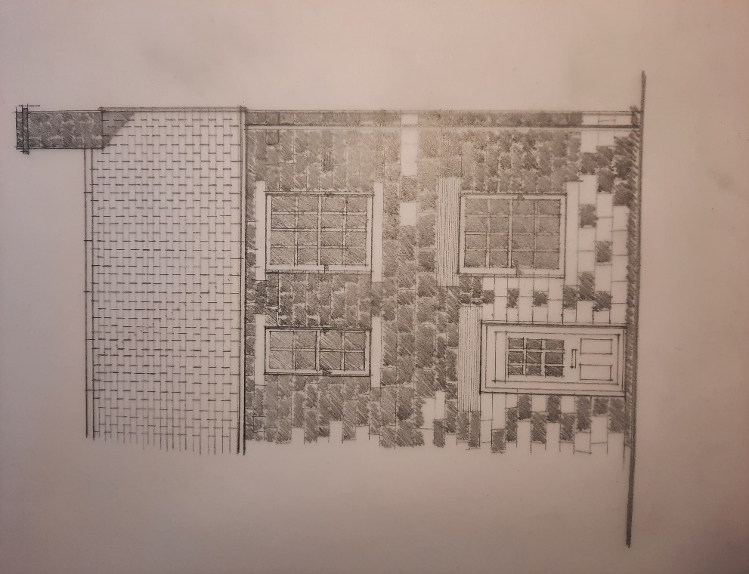

APPLICATION FOR PLANNING CONSENT
FOR ALTERATIONS AT 8 ARMROYD LANE ELSECAR S74 8ES
FOR MR + MRS M ALSOP

HERITAGE / DESIGN STATEMENT
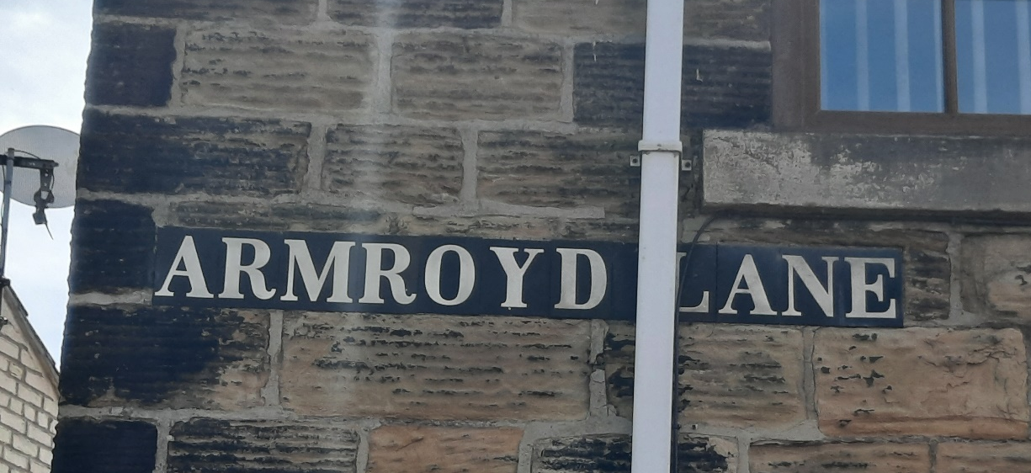
ELSECAR CONSERVATION AREA
Elsecar Conservation Area was designated in January 1974 by the former West Riding County Council. The Conservation Area is centred on the former Elsecar Colliery Workshops and associated housing, Wath Road and Fitzwilliam Street.
The development of Elsecar is related to the fortunes of the owners of Wentworth Woodhouse. The 4th Earl Fitzwilliam William Wentworth succeeded Charles Watson-Wentworth in 1782. William carried on and extended the interest in coal mining and was responsible for building the Newcomen Engine Old Row, Station Row and the Elsecar and Milton Ironworks. His son Charles Wentworth-Fitzwilliam (1786-1857), the 5th Earl Fitzwilliam, carried on his father’s philanthropy, building Reform Row, the Workshops, the Church, the Mill, the School, and the Miners Lodging House.
Fitzwilliam Lodge is the tallest building in the Conservation Area and provides a dominant presence of the view into Elsecar when approaching from Armroyd Lane. It was built as a lodging house for single miners from the Staffordshire coal field, in the early 1850’s. It has squared deeply coursed stone with horizontal tooling marks and welsh slate on the roof.
When approached from the west along Armroyd Lane the scene is quite rural. At this point the Conservation Area includes 2-8 Armroyd Lane which frame the view of Fitzwilliam Lodge, one of the buildings that act as landmarks in the Conservation Area.
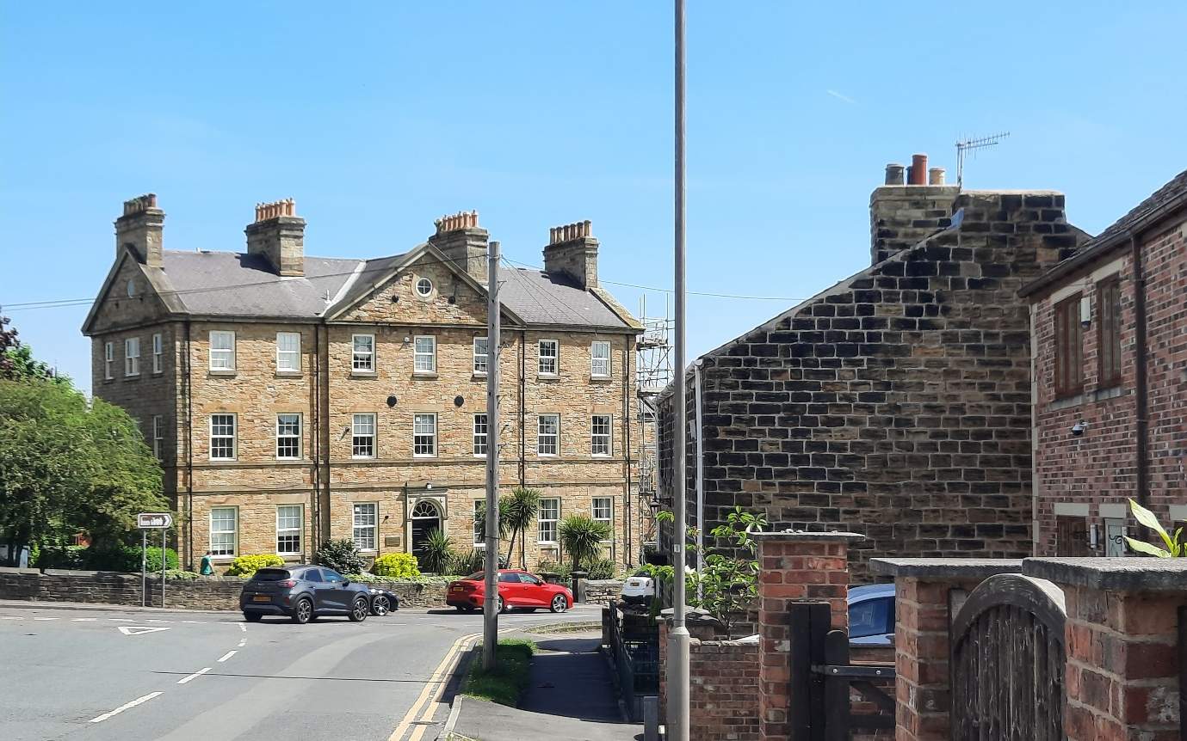
This is the best approach to Elsecar. As you travel along country roads with views to the south across a rolling landscape towards Wentworth, this gives way to 20th century detached houses before entering the Conservation Area
As in other parts of South and West Yorkshire, the traditional building materials for the area are local sandstone walls with stone slate roofs. Stone colour ranges from a light buff colour through to grey and brown but the predominant building stone in Elsecar is honey coloured sandstone.
8 ARMROYD LANE
DESCRIPTION OF PROPERTY
This small terraced house was built in 1857 of tooled, coursed sandstone elevations to front and side, with local red multi brick to the rear, and a slate roof. 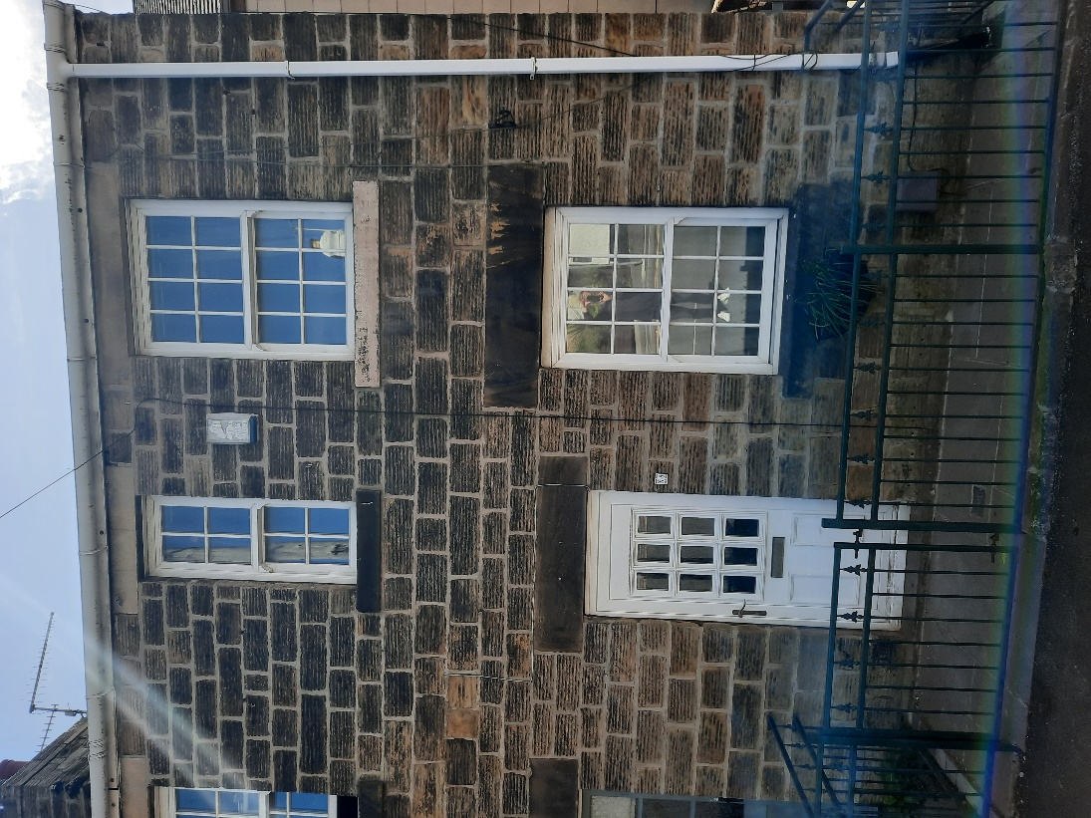
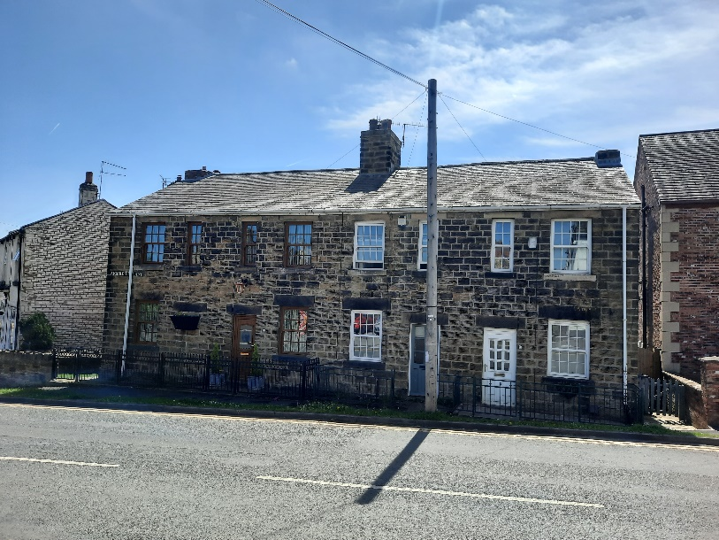

The house has been altered internally at first floor to provide a bathroom and a small bedroom, and later extended to provide a rear kitchen extension in a close match red brick and pitched slate roof.
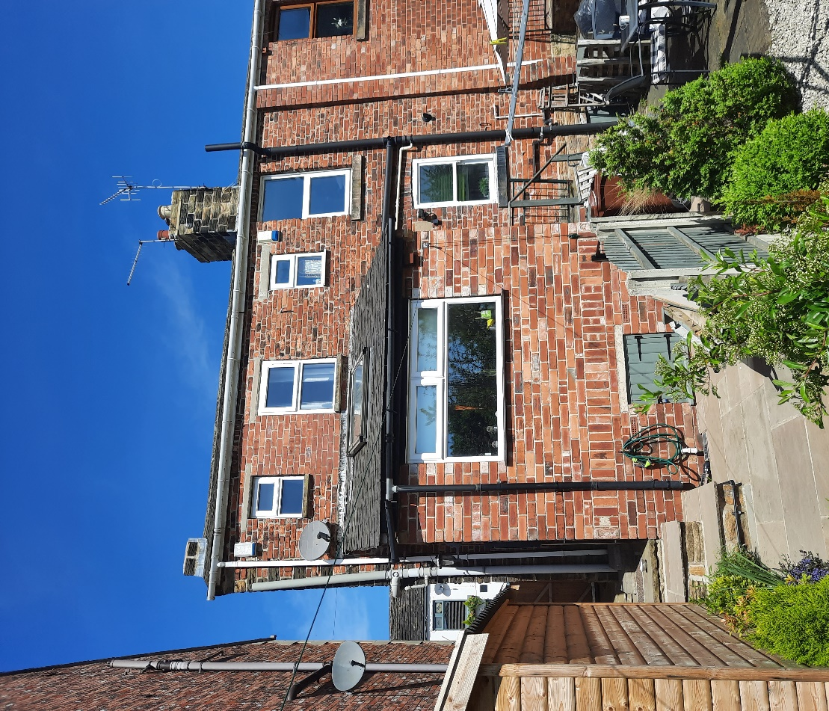
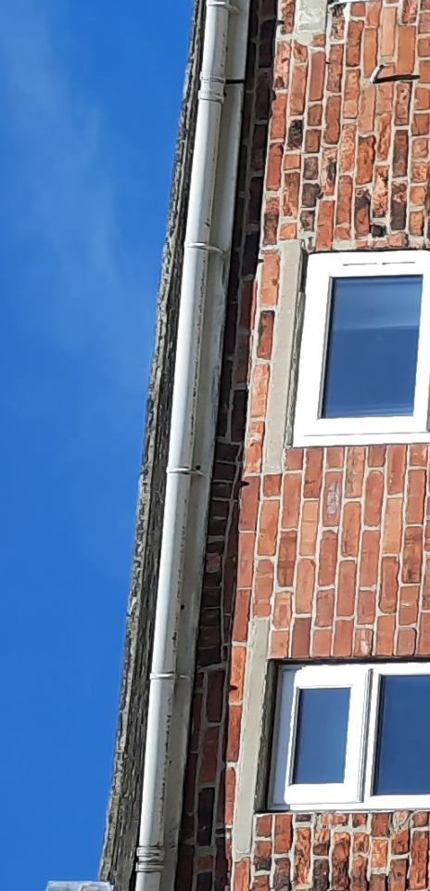
Evidence of the re-arrangement of the original first floor rear can be seen at eaves level of the original house where the voussoir headers of an arched window head can clearly be seen between the replacement windows with concrete lintols, possibly Spanlites, to suit the revised layout.
There is a small cellar under half of the front room.
The original chimney stack above the gable wall was removed in 2019 under former owners.
Windows have been replaced in white upvc although the pattern is probably original. The front door has also been replaced in white upvc.
There is a small area separating the front door from the footpath with metal railings which appear to be a replacement for original railings.
CLIENTS BRIEF
The property has been unoccupied for a few years and the owners wish to upgrade it for their own occupation.
The property is effectively a one-bedroom house, as bedroom 2 is kindly described as a small single. The only viable extension is into the roofspace to form an access stair and a double bedroom. A larger bathroom would be a benefit. Improved flow between kitchen and dining space. Clients have also considered replacing the missing chimney
- Attic Bedroom
- Larger bathroom
- Improved kitchen access
- Larger dining room window
- Replacement Chimney
DESCRIPTION OF SCHEME
A new bedroom is created within the existing attic space. An access stair from first floor at the rear of the original house is linked to the original stair.
In order to provide headroom a rear dormer with windows overlooking the cricket pitch to the South is provided. The dormer fits below the existing ridge and is set up the roof slope substantially. The dormer cheeks are set substantially in from the gable wall and party walls. The dormer cheeks will be clad in slate to match the existing roof material.
The part of the West elevation affected by the dormer is obscured by the 2 storey house built 2009 adjacent. This adjacent house also has a rear dormer which dwarfs the proposal.
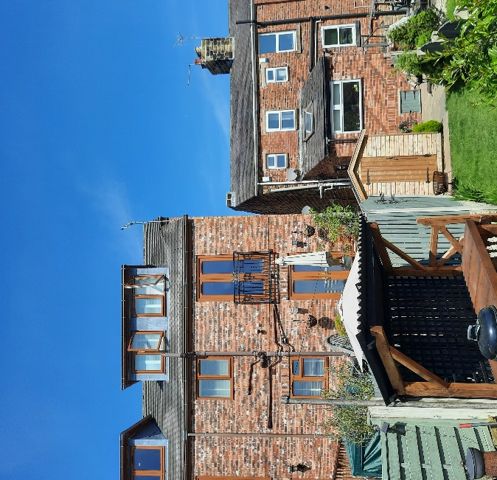
It is proposed to rebuild the Chimney which was removed for structural reasons in or shortly after 2019. Materials used will be coursed sandstone as original. The centre stack of the terrace is still intact and will form a pattern for the reconstruction.
The existing window in the West elevation will be enlarged to admit more light. It is not intended to use the Georgian pattern glazing for this replacement, although stone heads and cills will be re-used.
ANALYSIS OF PROPOSED NEW ELEMENTS
Number 8 Armroyd Lane is not a very important building within the Elsecar Conservation Area in itself but it’s West gable forms a component of the view from the West towards Fitzwilliam Lodge. It is noted as making a positive contribution to the Conservation area in The Conservation Area Assessment.
It is a small house in a terrace of 3, houses similar to many thousands of houses throughout the country. It is however pretty original. Built in 1857 of tooled local sandstone, with Welsh slate roof, using local brick for its rear elevations, it makes its contribution to the Conservation Area, providing authentic contemporary context and background to the more important components.
All such houses have been modified over the decades and continue to provide useful low cost first homes as well as suitable accommodation for a number of other population groups as long as they are adaptable to current demands.
They are essentially flexible and can absorb sensitive modification without damaging the local townscape fabric.
Changes to upgrade accommodation:
- Dormer window to rear 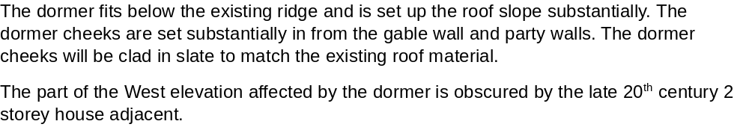
- Increased size of window to dining room
The larger window will not be visible from the highway.
Changes to correct previous harm:
- Rebuild chimney stack to match original shown below from Google 2019
The rebuilding of the Chimney stack to the original pattern, shown on the 2019 Google street view, makes a massive difference to the building, but also contributes to the view of Fitzwilliam Lodge from the West. It will give the house it’s self-respect back.

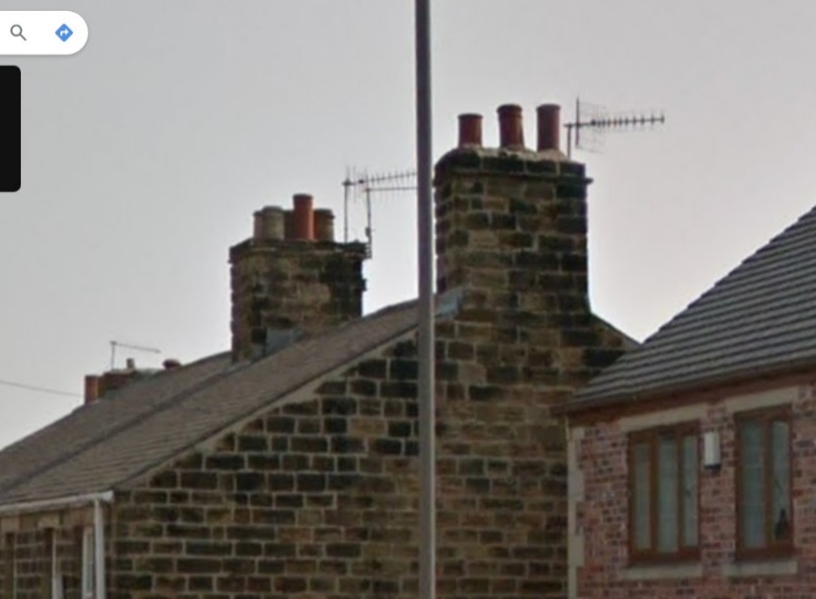

CONCLUSION
The proposal has been designed to minimise the impact of necessary upgrades to make this modest property suitable for 21st Century life. The Clients has not been over ambitious and are aware of the limitations of the Conservation Area.
They have consulted with the Local Planning Authority and have received a positive response from Bradley Sargeson ref.2024/ENQ/00144 dated 18/04/2024. For these reasons and the descriptions of the proposals given above, the Client requests that approval is given.
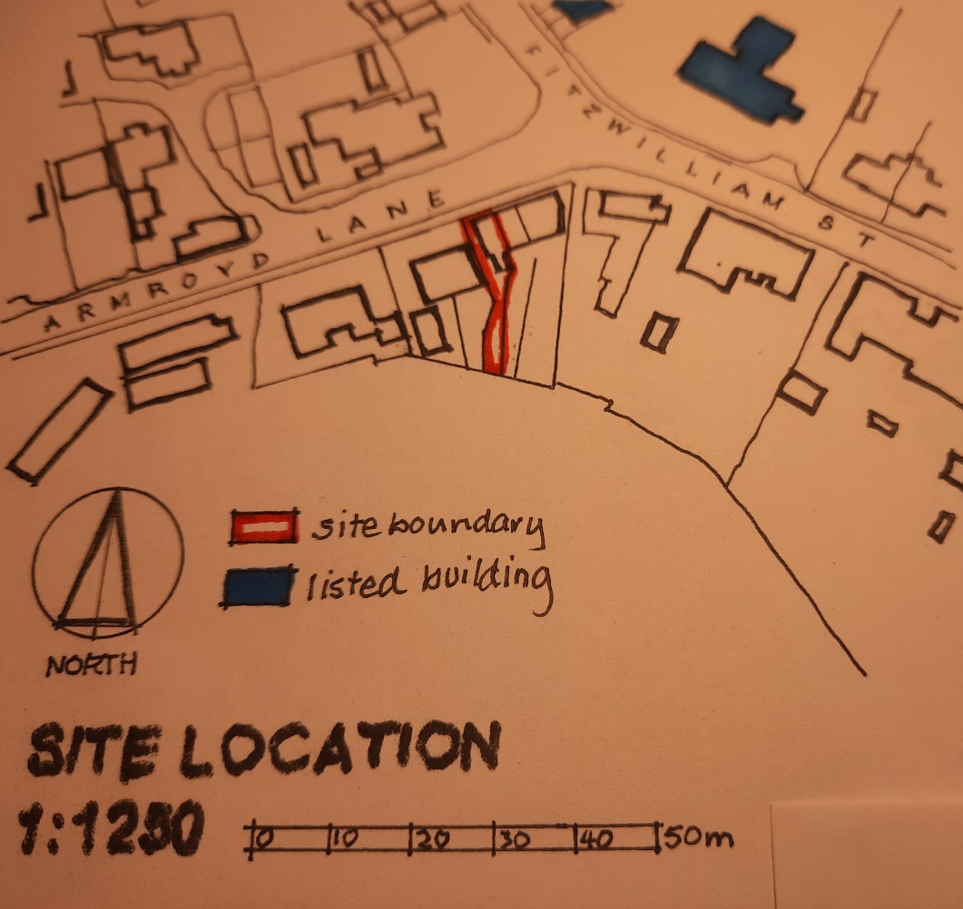

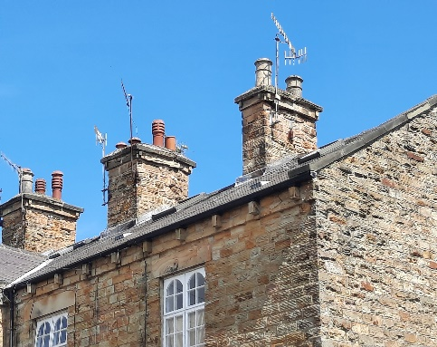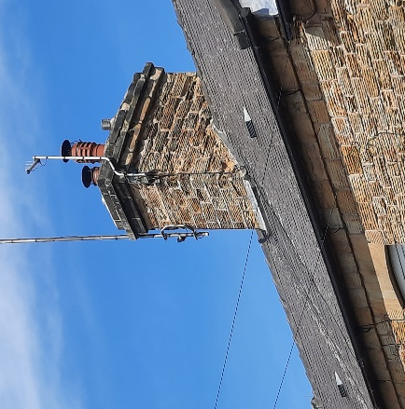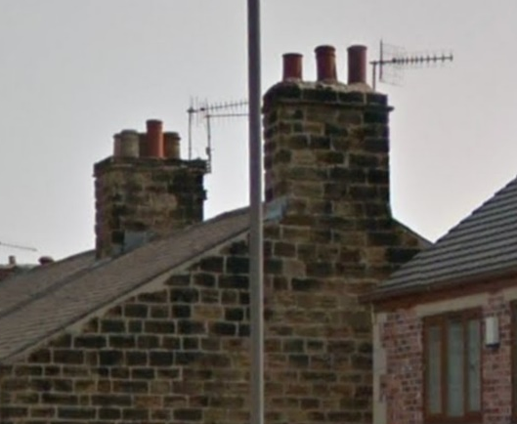
original chimney to no.8 in 2019
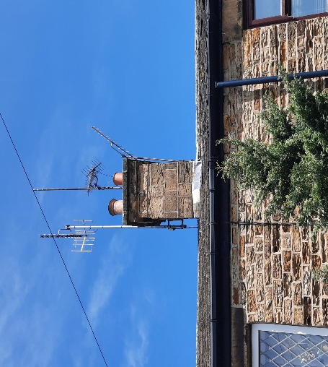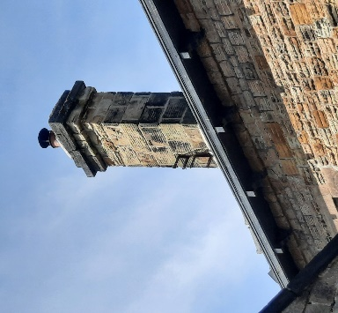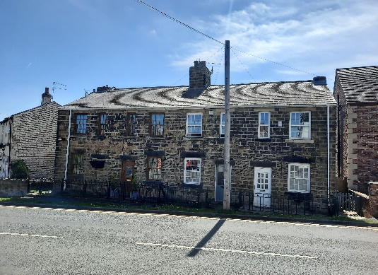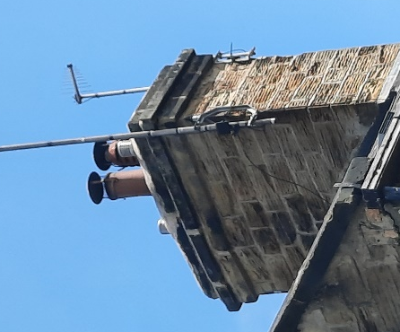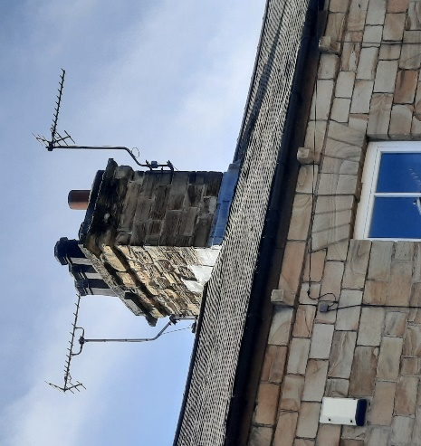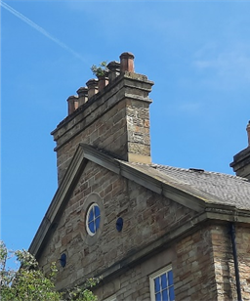
Samples of Elsecar Chimney types ranging from the modest to Classical Elegance, including the original stack sadly removed from 8 Armroyd Lane in 2019

