HERITAGE STATEMENT
THE GATE HOUSE
WINDHILL GATE FARM
WINDHILL LANE
STAINCROSS
BARNSLEY S75 5BU

This Heritage statement is part of the listed building consent application no. PP06361220 and supporting documents, The Location Plan, Planning Statement and design and access statement. The application is to request listed building consent to replace 11 existing UPVC windows from a Rosewood colour to Chartwell Green; replace 2 UPVC partially glazed Rosewood coloured doors with partially glazed Composite doors in Chartwell Green, including the set of Gothic arch patio doors, the replacement of 3 single glazed roof windows with double glazed Velux roof windows. (NB Figures referred to in this document are related to the Heritage Statement only)
Windhill Gate Farm was built approximately around 1780. It is a Grade II Listed building governed under the Listed Buildings and Conservation Areas Act 1990.

Windhill Gate Farm is described on the Historic England official register, List entry Number: 1313242 it was first listed on 27 Aug 1986. A recent Location Plan has been attached to this application. Windhill Gate Farm is not in a conservation area.
The Gate House is one of a number of buildings converted from Windhill Gate Farm’s attached outbuildings, which we believe were converted around 1997. As Windhill Gate Farm was listed on the historic England’s register in 1986 pre development, there is no reference given to the Gate House. A brief outline is mentioned of the outbuildings that once formed part of the listed Windhill Gate Farm.

The property is an end, two story, terrace, including a one storey kitchen extension to the rear. It is accessed from Windhill Lane into an open court yard.

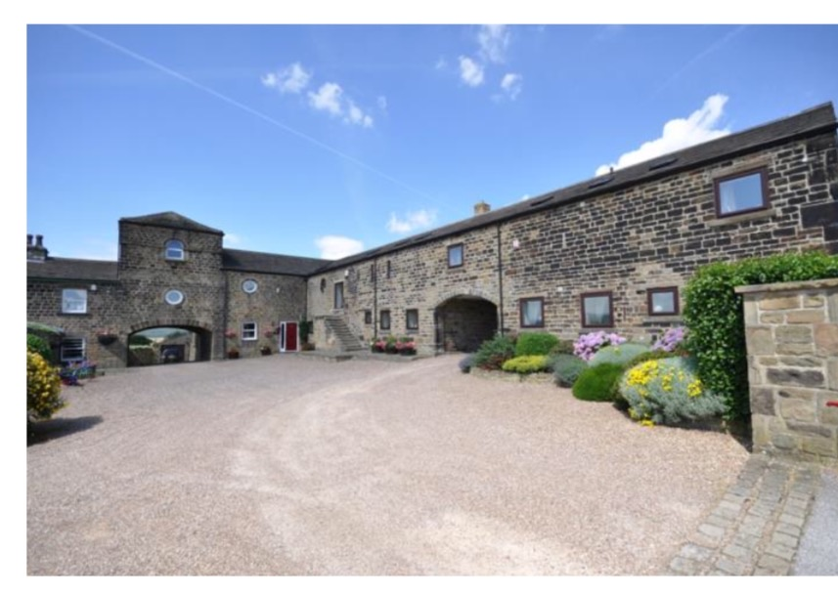
The front elevation of the Gate House faces on to Windhill Gate Farm’s court yard and is visible from the roadside. There are three other residences including; Emely View, The Dove Cotes and The old Farm House facing onto this court yard. A recent photograph of Windhill Gate Farm’ has been inserted. The Gate House which relates to this application, has been highlighted in a red box. (See Figure 1)
The Farm House
The Gate House
The Dove Cotes
Emely View
F1

WINDHILL LANE

The Gate House Front Elevation

The Gate House is constructed from Hammer-dressed stone, the roofing is stone slate and there are 3 single glazed roof windows which are highlighted in green. The roof windows are barely visible from the road side. (See figure 2)
There are 6 Existing UPVC double glazed windows at the front elevation in Rosewood, these are highlighted in green dots (See Figure 3)
All the windows and doors were replaced in UPVC double glazing (with the exception of the 3 roof windows), in 2007. Previous occupants, Mr & Mrs Peter Holland were granted Listed building consent on the 28 November 2007. The application number was: B071614LB.

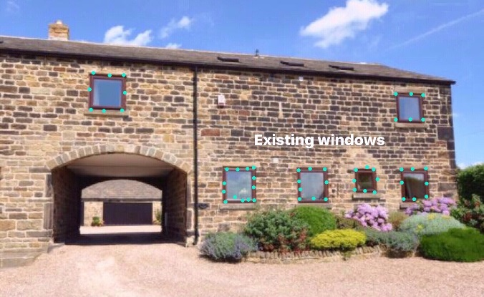
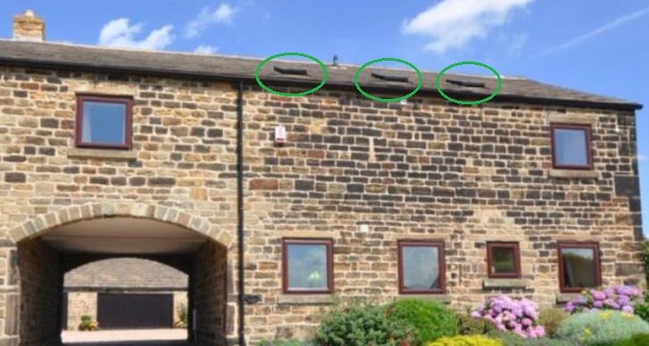
F3
F2
The rear of the property is accessed through a stone archway (flying freehold) to an enclosed open plan garden with a double stone garage. (See Figures 2&3) The Gate House is attached to ‘Emely View’ at the opposite side of the archway. (See Figures 1)
The back elevation to the Gate House is enclosed by a high stone wall and double garage and is not visible from the roadside (See Figure 4)
To the rear elevation, there are 4 UPVc double glazed windows, a set of UPVC double glazed Gothic Arch Patio Doors, and two entrance partially glazed UPVC doors all in Rosewood colour. These are all highlighted in green spots (See Figure 5)
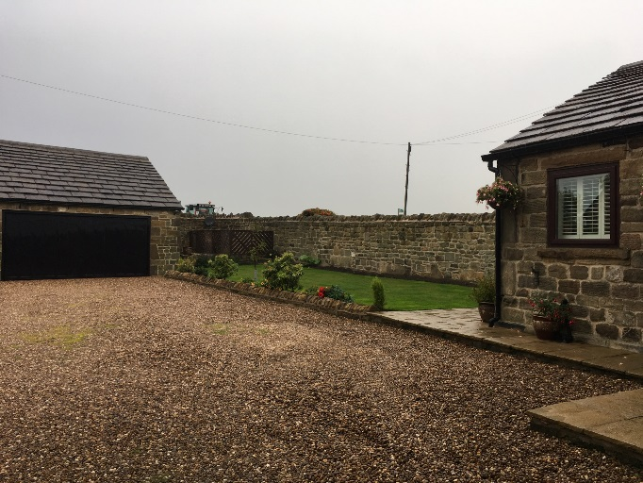
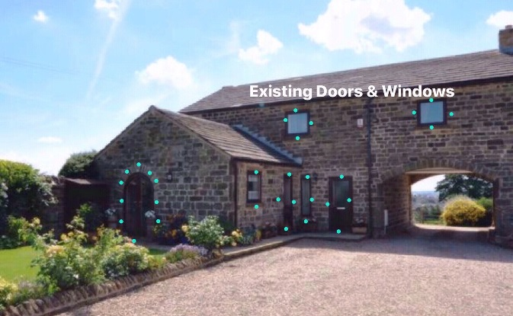
The Gate House Rear Elevation
F5
F4

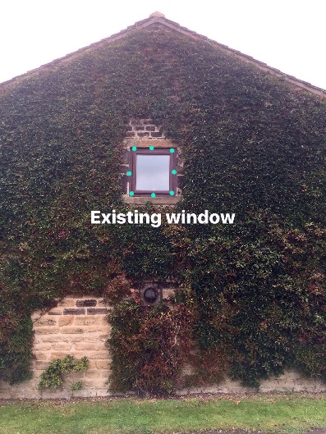
The Gable end of the property faces onto Windhill Lane. There is an existing UPVC window in Rosewood. (See figure 6)
F6

THE IMPACT ASSESSMENT
The final section describes the impact of the proposed replacement windows and doors and their proposed significance to the Gate House. It concludes with a statement of justification for the work. This application does not have any impact on the setting or site. The replacement of UPVC windows and doors are a minor change required as the existing doors and windows are beyond economical repair. This application therefore seeks to enhance the appearance of the building and attempt to preserve it.
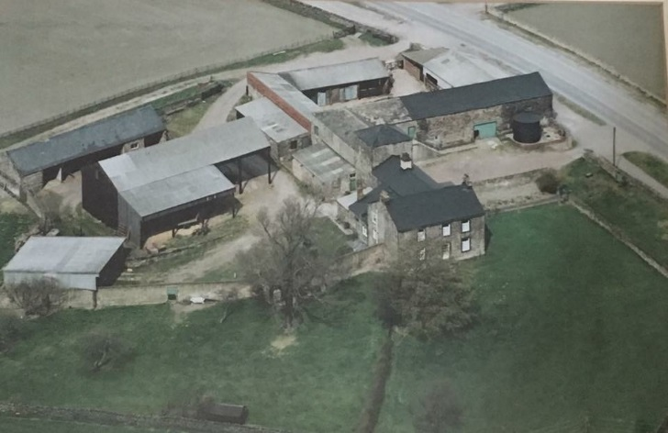
An historic image of Windhill Gate Farm and its outbuildings, pre development, shows there were no windows, specifically where ‘The Gatehouse’ now exists. This is highlighted in red (See figure 7). There is no official record (that we are aware of) that stipulates the style of windows and doors, their material finish or what colour of paintwork should be applied to the Gate House. Furthermore, the windows and doors of the neighbouring properties that make up Windhill Gate Farm, as figure 1, (The Farm House, The Dove Cotes and Emley View) sees a variety of window styles, materials, including UPVC and various finished colours. The historic image of the Gate House outbuilding however, clearly shows a barn door finished in green paintwork which influenced the request. The Chartwell green finish of the replacement windows and doors that we are proposing, is close to the colour of the original barn door. The proposed Chartwell Green Windows and doors in this application, will attempt to reproduce the same look of the original barn door.
The Gate House
F7

PROPOSAL IMPACT AND MITIGATION
Proposal | Impact/Mitigation | Comment
- Replace 11 existing UPVC windows from Rosewood to Chartwell Green  Including;  - 6 windows to the front elevation  - 1 window to the Gable wall  - 4 windows to the Rear elevation | - Existing windows are currently UPVC of poor quality. The windows have faded over time and are beginning to look tired lowering the appearance of the property. They are not authentic and are beyond repair.  - The proposed replacement windows have an authentic wood effect look which will enhance the appearance.  - The Chartwell Green colour proposed will reflect the original green finished paintwork of the original barn door as figure 7 p3  - The replacement windows will improve the aesthetic appearance of the building to the many people passers-by who can continue to enjoy the appeal of the historic building  - The glass seals have blown in most of the window frame units. There is loss of heat and fuel energy through the deteriorating gaps. The property is no longer energy efficient.  - The design and materials offer quality, security and durability. They will not fade or rot with the constant weathering, do not require sanding and painting or varnishing to keep them looking smart and will thus maintain a minimum of maintenance.  - This will help to sustain the beauty of the listed building. | - The proposed sealed units are described as follows: The 70mm lead free PVCu outer frame is fully reinforced for added strength and security. Window Frames Spec VEKA Group M70-launch (Northern Trade Windows)  - The windows will improve the levels of thermal efficiency, and enhance the carbon footprint.  - The Gate House at Windhill Gate Farm is located at Staincross, a popular rural village between Wakefield and Barnsley a busy connecting route for commuters in this area, with increased access and links to the M1/M62 motorway network.  - The property is exposed to the increased busy network of commuter traffic, including heavy goods vehicles that pass through Windhill Lane, at high speeds; despite the 40 mph speed limit restrictions. A changing environment to the properties historic past.  - The heavy traffic produces noise which rattles through the deteriorating windows day and night and this is very disturbing.  - We are also exposed to the increased transport fumes such as the increased carbon monoxide and traffic pollution through the windows and replacement will improve this from a public health perspective  - As we are at the highest position on windhill Lane, we are exposed to the cross-winds of which can reach up to 75 MPH across Emley moor. (wind speeds Recorded in Nov 2015). Efforts to reseal with draught excluders have failed  - The new sealed units will be quieter and more secure than the existing windows and will protect us from the carbon monoxide fumes, external elements and noise.
- Replace the 2 existing UPVC Rosewood entrance doors, including the kitchen and Hallway door.  (See figure 8 & 9 p7)  - Replace the kitchen entrance door with an authentic partially glazed cottage style composite stable door in Chartwell Green (See figure 10 p7)  - Replace the Hallway entrance door with a partially glazed authentic cottage style standard Composite Door in Chartwell Green  (See figure 11 p7)  Replace the 2 UPVC Rosewood Gothic Arch Patio Doors ( Right and Left ), with durable UPVC doors and with A graded sealed unit glass in Chartwell Green frame.  (See figure 12 p7) | - The existing UPVC doors are of poor quality which has led to weakness and warping. They are beyond economical repair. This shabby looking door, lowers appearance of the listed property. Existing Rosewood Doors at the Gatehouse  (See figure 9 p7)  Technology has advanced in the field of composite doors. The 44mm composite door is constructed from fibre glass skins for a timber-like appearance. the quality is far superior to those installed  - The cottage style door would seek to complement the character of the build. These are minor changes with heightened impact on the aesthetics of the building.  (See Figures 10 &11 p7)  - The proposed replacement doors look far more authentic than the existing UPVC doors and are of a wood like effect. This will enhance the appearance and the doors will look more traditional and compliment the hammer faced stone. This will, without any doubt, improve the appearance and appeal to passers-by and people with an interest in the farm buildings history. | - There is also difficulty with the locks and handles and as such we are now fearful for the security of the property and these need replacing as soon as possible.  - Composite Collection brochure and Spec supplied by Northern Trade Windows Pudsey West Yorkshire
- Replace 3 single glazed roof windows (See figure 2 )  - Replaced with double glazed Velux roof windows  (See Figure 13 p7) | - There are 3 roof windows as shown (figure 2 p2) which are in the ceilings of the main bathroom, the bedroom and the ensuite.  - The roof windows in the main bathroom and ensuite are the only source of ventilation to allow air and steam out when taking a shower or bath. This created condensation and mold spots on the internal walls.  - These windows became jarred and did not open, possibly due to constant exposure to moisture and aging. This would lead to increasing mildew and damp over time.  - The aim and in replacing these therefore, is prevention and protection from increased internal damp from the inability of being able to open the windows  - The roof windows will look exactly the same and therefore no visual impact see figure the roof windows are not visible from the road side.  - The roof windows are solar powered centre-pivot roof window in a high quality polyurethane finish. ( moisture-resistant) | - The proposed sealed units are described as follows: The 70mm lead free PVCu outer frame is fully reinforced for added strength and security.  - The windows will improve the levels of thermal efficiency, and enhance the carbon footprint.  - The fully programmable control pad with touch screen for easy operation to operate the roof window opening and reduces the burden of manual opening and these close automatically should rain fall on them whilst open.  - (See hyperlink for further information https://roofwindows.veluxshop.co.uk/velux-ggl-2060r21u )
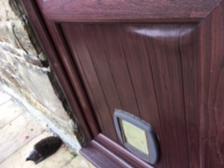
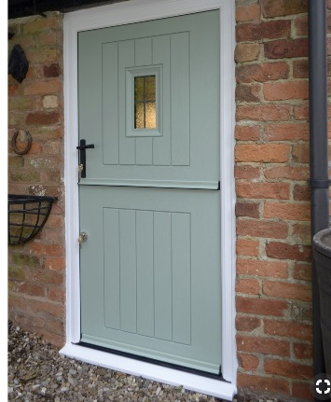
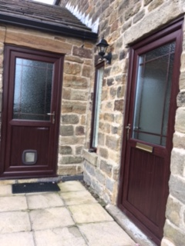
F10 Composite Stable door in Chartwell Green
F9 existing warped door
F8 existing Rosewood

F13 Velux roof window
F12 Existing UPVC Rosewood Gothic Arch Doors
F11 Composite standrad door in Chartwell Green

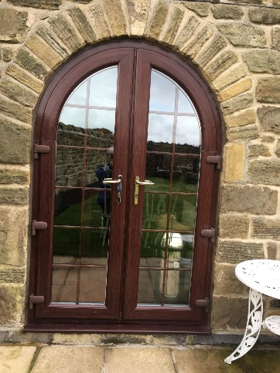
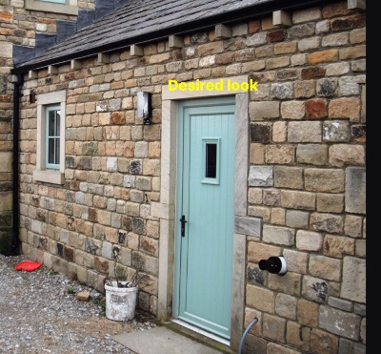
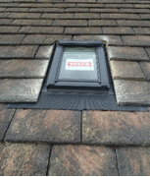

Conclusion
F12
We understand that Grade II buildings are of national importance and of special interest. We fully respect and support this and therefore replacing the proposed windows and doors will enhance the appearance and help to preserve the buildings inherent character. With this is mind, we have done our best to find a reputable company with experience in the installation of windows and doors to aging properties.
We have visited similar properties that have had the same installations and spoken to the home owners who have been very impressed by the workmanship, quality of the doors and windows and after sales service. If this consent is approved, we intend to instruct this reliable supplier, so that work will be carried out to a superior standard.
We hope the heritage statement provided makes a reasonable case for consideration and one which attempts to balance and protect the site's historic significance, with the busier changing environment of the current, including advanced technology (authentic and traditional looking materials) that will really enhance the look of the property.

