Heritage Statement
Address statement relates to
Keresforth Hill Farm, Dark Lane, Barnsley, South Yorkshire, S706RE. (postal name)
Date of statement
01.03.2026
Applicants
Mrs Lindsey Butterfield & Mr John Alexander Butterfield
Property Heritage Category
Listed Building
Grade
II
List Entry Number
1315011
Date first listed
16.08.1977
List Entry Name
Keresforth Hill Farmhouse
Location
Statutory Address: KERESFORTH HILL FARMHOUSE, DARK LANE
District:
Barnsley (Metropolitan Authority)
Parish:
Non Civil Parish
National Grid Reference:
SE 32956 05199
Details
SE30NW BARNSLEY DARK LANE (east side), 3/24 Keresforth Hill Keresforth Hill 16.8.77 Farmhouse II Farmhouse. C17, altered. Coursed rubble. C20 tile roof. Two storeys. Two room house with wing at rear, and C19 addition to right. The central doorway with moulded surround has been heightened. C20 door. 3-light double-chamfered windows to left and right on both floors. Remains of continuous dripmould to ground floor which rises over the doorway. Renewed gable stacks. Two-storey, lower, addition to right, with garage doors. Rear: central, gabled wing has one double-chamfered window to ground floor. Later, rendered addition to left of wing. Interior not inspected.
Listing NGR:
SE3295605199
Legacy System number:
333710
Legacy System:
LBS
Legal
This building is listed under the Planning (Listed Buildings and Conservation Areas) Act 1990 as amended for its special architectural or historic interest.
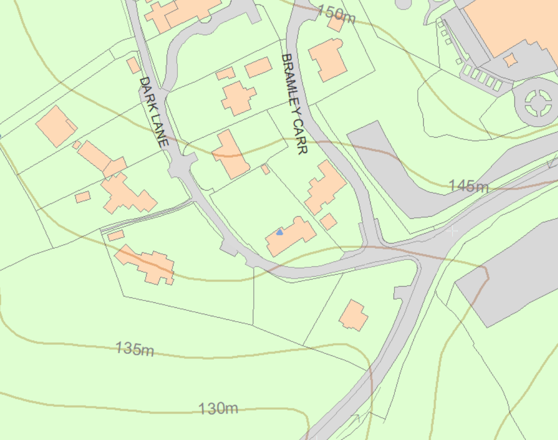

The applicants purchased this property on the 18th December 2024. The previous owners are believed to have had the property for a number of decades.
The proposed changes to the property are very minor in nature and intended to replace the current front door as this is not in the applicants view in keeping with the style and tone of this listed property.
The current door is a modern construction black in colour. We have not found any evidence that this current front door has had any form of listed building consent.
The applicants wish to remedy this.

The proposal is to replace the existing modern door with a traditionally crafted timber door that:
• Uses high-quality timber appropriate for a heritage building
• Reflects traditional proportions and panel detailing
• Incorporates historically sympathetic ironmongery
• Is finished in a heritage-appropriate colour
• Enhances the architectural integrity of the moulded stone doorway surround

The design has been selected to be visually appropriate to a 17th-century farmhouse and to reinstate a more authentic appearance to the principal elevation.

The proposed works will have a positive impact on the building’s significance by:
• Removing an inappropriate modern feature
• Reinstating a door more in keeping with the building’s age and architectural character
• Enhancing the visual coherence of the principal elevation
• Supporting the long-term conservation of the building through the use of durable, traditional materials

The intervention is:
• Minimal — affecting only the door leaf, not the historic stone surround
• Reversible — the new door can be removed without harm to historic fabric
• Sympathetic — designed to complement the building’s period and materials
There is no harm to the listed building or its setting. Instead, the proposal constitutes a clear heritage benefit.

In preparation for this application the applicants have sort guidance from the Senior Conservation Officer at Barnsley Council Mr Tony Wiles. The applicants have provided details of the proposed works. On the 03.02.2026 he has advised “Option 2 looks fine to me and seems an appropriate design given the existing door and the improvement it will be”.

The proposal also aligns with:
• The Planning (Listed Buildings and Conservation Areas) Act 1990, requiring special regard to preserving listed buildings
• National Planning Policy Framework (NPPF) guidance on conserving heritage assets
• Barnsley Local Plan policies relating to heritage conservation and high-quality design
The works follow established conservation principles of preservation, enhancement, minimal intervention, and respect for historic character.

