Barnsley Seam Application Reference :- 2024/1062
Proposal

Installation of three sculptures with lighting and acoustic features within proposed public open space.

Location:- Lower Car Park, The Seam, County Way, Barnsley

Condition 6 :- Prior to the commencement of development, full details of the proposed lighting and acoustic displays shall be submitted to and approved in writing by the Local Planning Authority. The information shall include (but not limited to):-
Exact timings
Regulatory of displays
- Details of special events
- Maximum acoustic levels
- Extent of lighting arrays
- Glint and glare impacts

The lighting display shall ensure that the safety of public highway users is not compromised at any time.
Once agreed, the development shall be carried out in accordance with the approved details and maintained as approved for the lifetime of the development.
Reason: To provide a high quality development in accordance with Local Plan Policy D1: High Quality Design and Placemaking, in the interests of highway safety and in accordance with Local Plan policy T4: New Development and Transport Safety.
--------------------------------------------------------------------------------------------------------------
Response from Regeneration and Culture
Introduction
The development of this signature, large-scale public artwork will be delivered with the neighbouring residential and business premises firmly in mind, in order to achieve a balanced approach.

The scale and scope of the animation of the sculptures, through lighting and sound, will be developed through ‘trial-and-test’ periods, to reach the perfected operational parameters.

The animation of the sculptures will take into consideration real-time feedback from key stakeholders, (which will include, but not be exclusive to):
- Local Members
- Venue Managers, such as Business owners/operators and tenants
- Facilities Management representatives, (from the council)
- Highways Development Control Officers
- Environmental Health Officers

The curating team/ officer (from the Culture and Visitor Economy section of the Council) will maintain a continuous feedback loop with these stakeholders, to help set the operational parameters and drive future animation commissions.

The operation of the artwork as a living entity and potential brand for the borough will require the inception and monitoring of a digital presence, such as social media accounts and an email address, allowing further engagement and responsiveness to the product delivery.

For information, the plan below shows the residential and employment buildings located closest to the three sculptures.

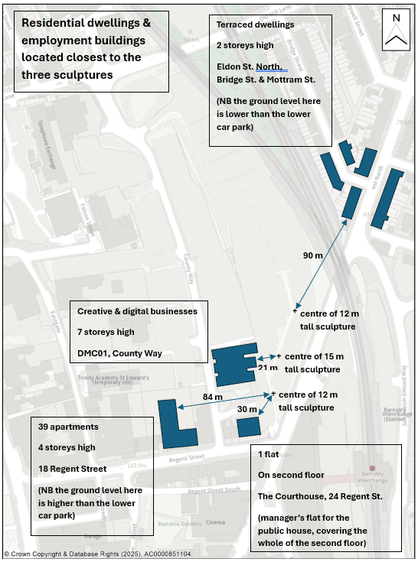

The location of the three sculptures within the new park

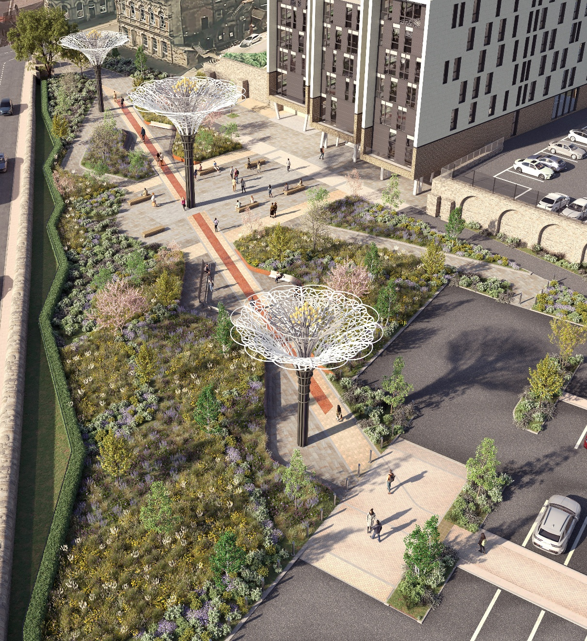

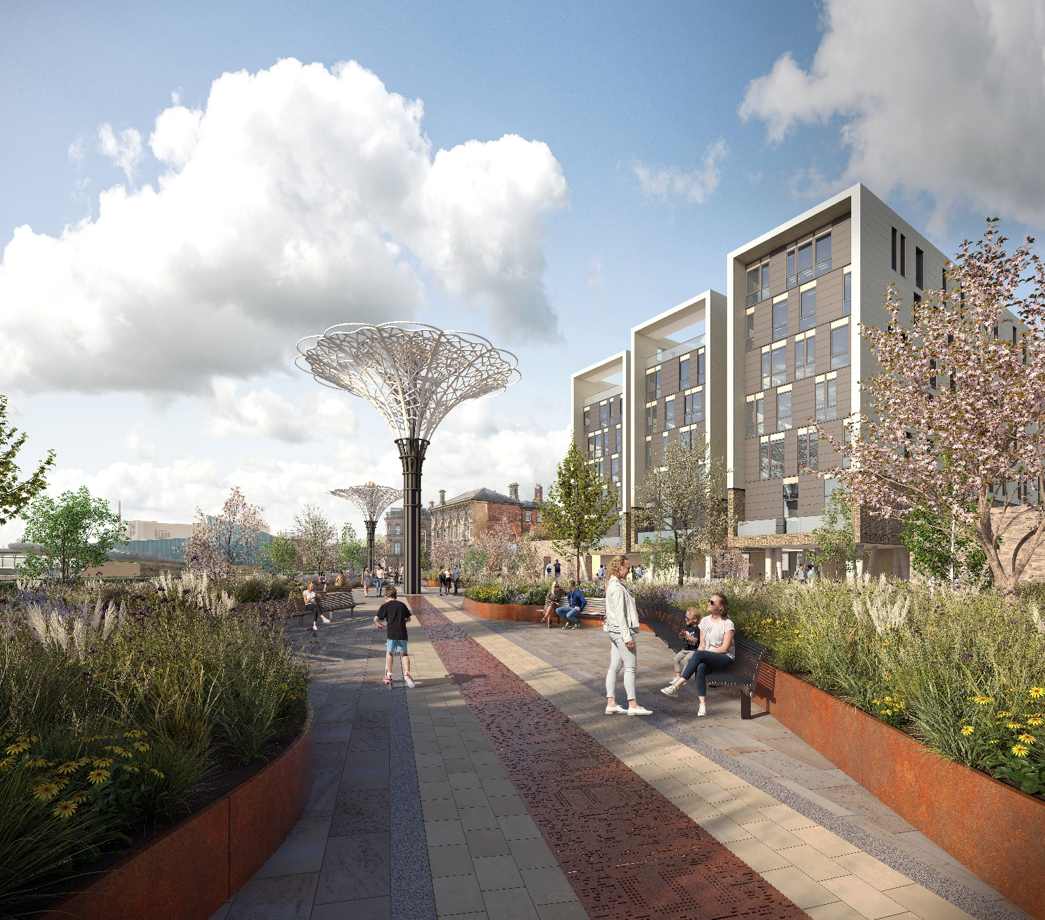

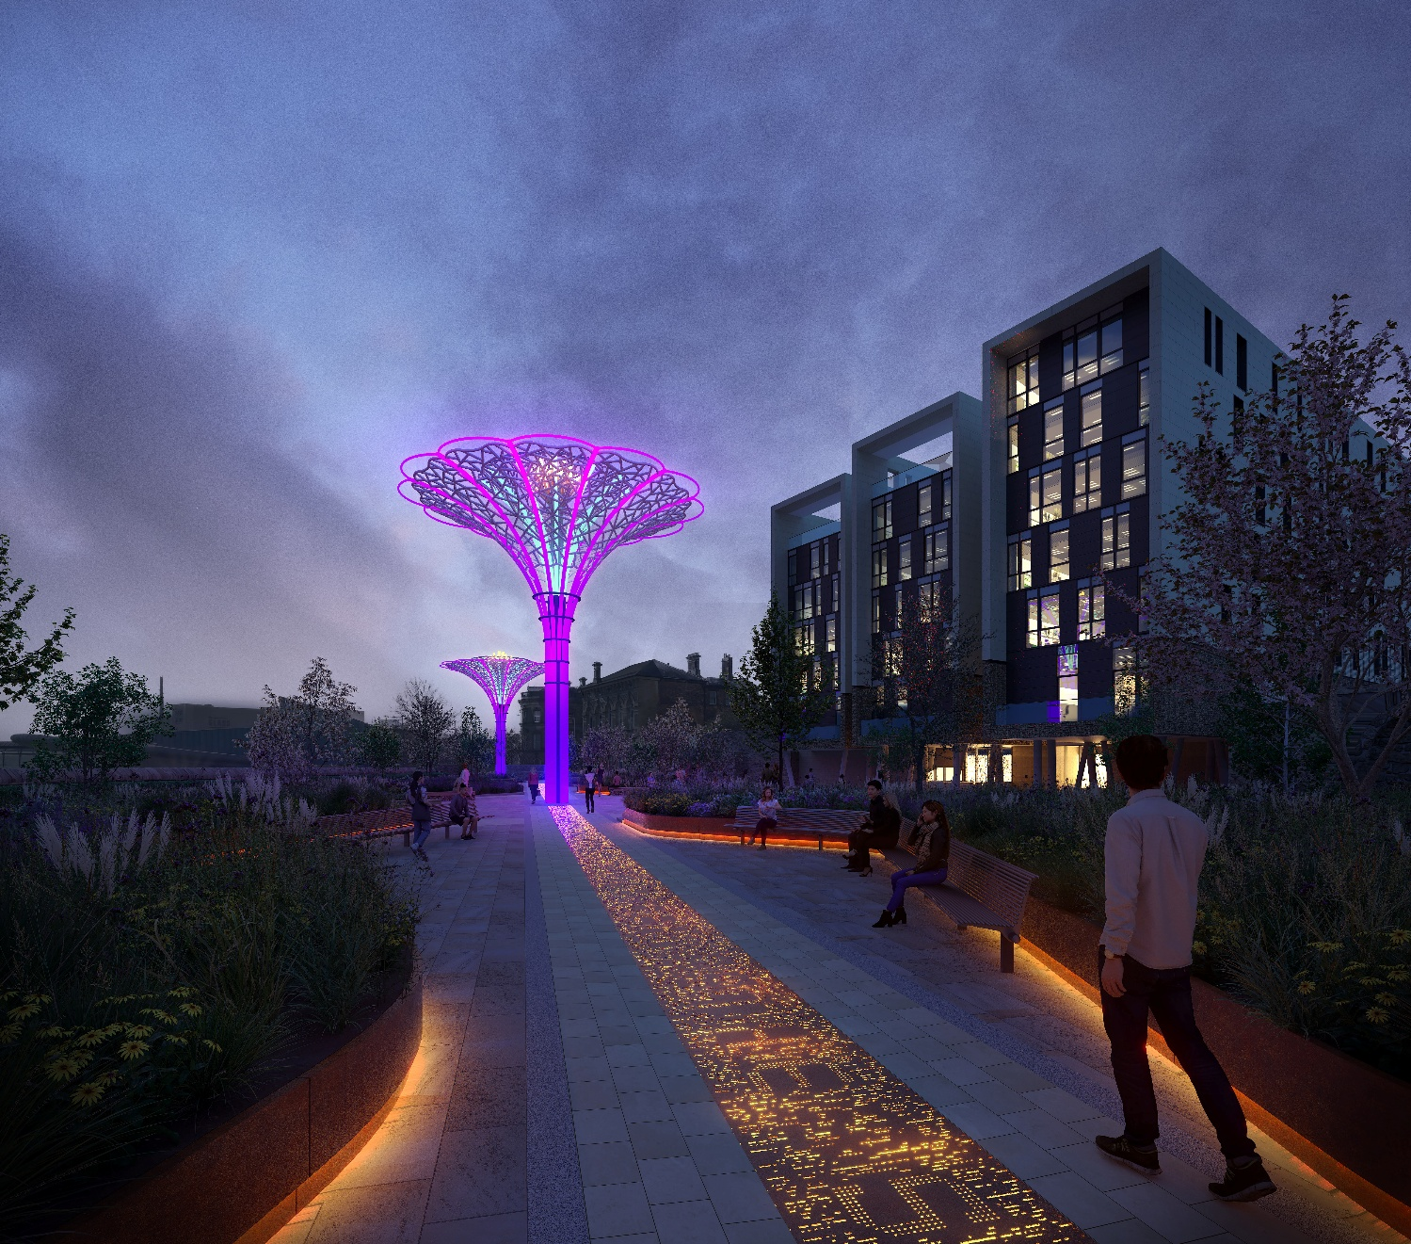

1. Exact timings and Regulatory of Displays
The animation programme will be a mix of "standard operational programmes/default settings and bespoke commissions.
Standard operational programmes/ default settings are currently being evolved. It is only intended to animate the sculptures during the hours of darkness. On some evenings animations may just involve lighting. If the animations involve both sound and lighting, later in the evening it will generally progress to just lighting, generally finishing by 10:30pm at the latest.
Bespoke Commissions will focus upon key dates/ periods/ events.
Regarding maximum usage – these occasions would be defined by the town centre events programme. For example, the Bright Nights festival, (currently held over two nights in December), would manifest:-
- 4.30pm – 8.30pm duration
- With shows (lighting and sound) at
  - 4.30pm - 4.37pm
  - 5pm – 5.07pm
  - 5.30pm – 5.37pm
  - 6pm – 6.07pm
  - 6.30pm – 6.37pm
  - 7pm – 7.07pm
  - 7.30pm – 7.37pm
  - 8pm – 8.07pm
  - 8.30pm – 8.37pm
The latest usage in the evening would subject to consultation. For the unique occasion of New Years Eve the sculptures would likely be animated from 11.50pm – 12.15am
2. Duration of the animations The duration of the animations (lighting and sound) would be limited, based on maximising engagement and user experience.- current thinking is between 6-9mins in duration. There is likely to be a maximum of two shows an hour when it is animated by both sound and lighting. This will help to balance the ‘attraction/ draw’ of the animations and appropriate ‘down time’ between activity, the latter especially enabling time for audiences to gather and disperse during special events.
The earliest activation will be primarily defined by seasonal sunset times(potentially 4pm in Winter). Generally, it is intended to have a period of full animation (lighting and sound ) followed later in the evening by preset ambient (lighting only) , generally finishing at the latest by10.30pm, (i.e. similar hours to the lighting of the Town Hall Tower).
3. Details of special events
The animations for special events will be either a default setting or a bespoke commission.
Default settings are more likely for nationally important days, such as Remembrance Sunday (which is likely to be a whole sculpture wash of colour) and for certain celebrations.
Bespoke Commissions will focus upon key dates/ periods/ festivals, for example:
- Barnsley Live (currently one evening in Summer)
- Pride/Big Weekend (currently two evenings in Summer)
- Bonfire Night (one night in Autumn)
- Bright Nights (currently two nights in Winter)
- Christmas (several days in Winter)
The bespoke commissions will be artist- led and subject to a robust brief and selection process, managed by the curatorial team and responding to feedback from previous commissions.
Sections 1, 2 and 4 provide further information about animation durations and sound levels.
4. Maximum acoustic levels
Day-to-day operation
A balance will be determined to identify and create the "routine" for the sculptures, which can be promoted and embedded in the locality. In its formative period this standard animation package will form the ‘test and response’ phase, in which the sound will be defined.
The final "day-to-day schedule" will be developed by council officers with external input from partners within ‘Light up the North’ (a network of five northern light festivals), who manage and operate other attractions such as Blackpool Tower, to ensure that the "Goldilocks zone" is achieved for the locality, i.e.: not too loud, not too quiet, not too often, not too long, not too short, not too dim, not too bright - but to be just right.
Sympathetic music styles will be chosen to deter anti-social behaviour and minimise deep bass /low frequency sound for example classical music.
Low-level frequency capacity is to be isolated from use, in order to minimise ‘sound creep’ and potential resonance impacts.
Speakers will be orientated to create a ‘sound curtain’- specifically focussing sound vertically down to the gathering space,(as opposed to traditional horizontal projection). This ‘sound curtain’ has been visualized in the attached noise report (Noise Impact Assessment Report Paceconsult 19th February 2025 Reference PC-25-0029-RP1)
Noise levels will be set in conjunction with Environmental Health Officers and a Db (decibel) limiter will be established within the operating systems.

Officers will remain in close liaison and check in with Environmental Health Officers on noise and lighting levels. There will be “testing” working sessions on the sound levels and lighting. As explained within section 3, the ‘reference case’ will be the attached Noise Impact Assessment Report, undertaken by Pace Consult on behalf of Willmott Dixon Construction Ltd. (19th February 2025 and Report Reference PC-25-0029-RP1)
It is noted that the Noise Report concludes:
‘The calculated noise levels of the proposed sculptures are below the pre-existing noise climate representative of the most affected noise sensitive receptors, and below the levels recommended by BS8233:2014, and WHO.
Finally, the overall noise impact of the proposed sculptures complies with the aims of the Noise policy statement for England as the noise emission from the proposal will not significantly increase the noise levels at the nearest noise sensitive receptors.’
The plan below shows the noise map of the study area, at a height of 1.5m
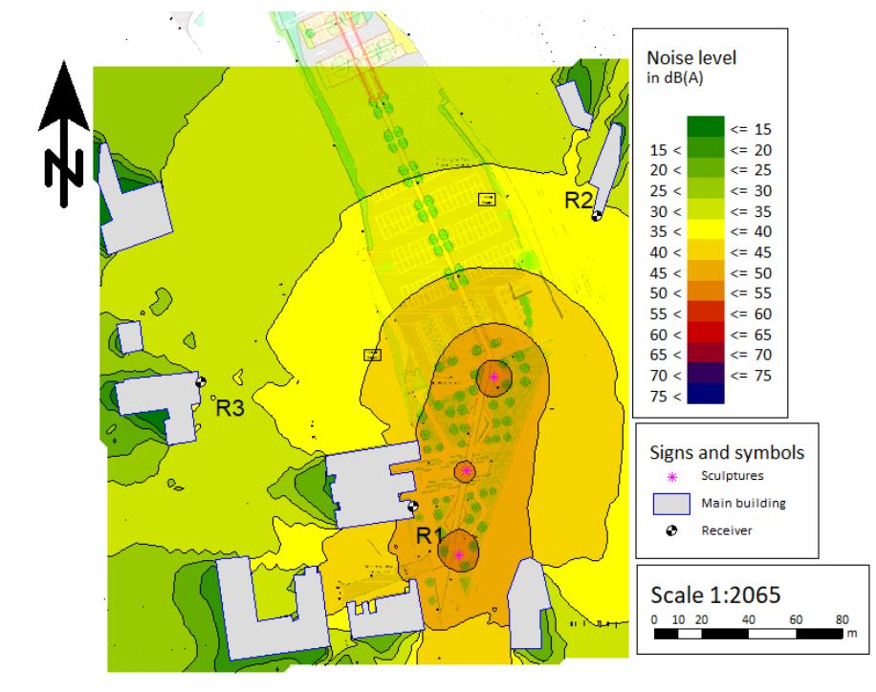
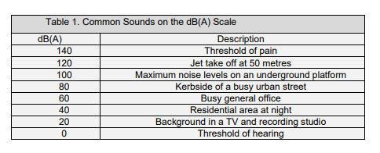
5. Extent of lighting arrays
Consultation will occur with Environmental Health and Highways Development Management Officers to reduce the visual impact on local residents and public highway users.
From the initial install, ‘check and challenge’ activities will be undertaken, to ascertain wider impacts via sight lines and action taken to augment brightness and pantone use (the defined visual colour and strength of the colour)
It is noted that there will be views of the three sculptures from the Dearne Valley, to the east of the site. Indeed, the DMC01 (Digital Media Centre, building 1) has previously had a laser show for two evenings from its balcony on the 7th floor, shining out towards the valley. (Named ‘Neon River’ it was part of the ‘Art of the Dearne Project’ organised by The Dearne Valley Landscape Partnership in 2018.)
However, it is noted that from some viewpoints in the Dearne Valley the lighting displays of the three sculptures may be partially diffused by the lighting of the new ‘youth zone’ building in the foreground. The youth zone is located close to the sculptures, on the other side of the Interchange, on Schwabisch Gmund Way. The building includes a roof-top sports pitch, located on top of the main building, which will be externally lit.
6. Glint and Glare Impacts
Information to be provided by Wilmott Dixon

7. Appendices

Appendix 1
Noise Report Pace Consult 19 February 2025
Appendix 2
Stage 1 Report Audio Visual Report 15 April 2025

