Dorothy Hyman Sports centre creation of new external 3G Artificial Grass Pitch (AGP) Transport Statement

Introduction

This document provides evidence as recommended during pre-application discussions, in support of this proposal; to confirm additional traffic movements generated by the proposals and to demonstrate that the proposed development will not have severe cumulative impacts on the highway network.

Transport Statement

This Transport Statement (TS) has been prepared by Barnsley Premier Leisure (BPL) on behalf of Barnsley Metropolitan Borough Council (the Applicant) and considers the transport aspects of the development proposal. This statement is divided into the following sections:

- Existing Situation
- Development Proposals
- Trip generation and analytics
- Summary and Conclusions

Existing Situation

This section considers the current site use, location and its surroundings.

This includes the cycling and walking facilities and public transport facilities available for the users of the site.

Site Use, Location and Surroundings

Dorothy Hyman Sports Centre is in Cudworth 4.3 miles NE of Barnsley Town centre

The Leisure centre which opened in 1972 has a 30-station fitness suite, studio, 2-court sports hall plus an athletics track & 3G pitch facility.

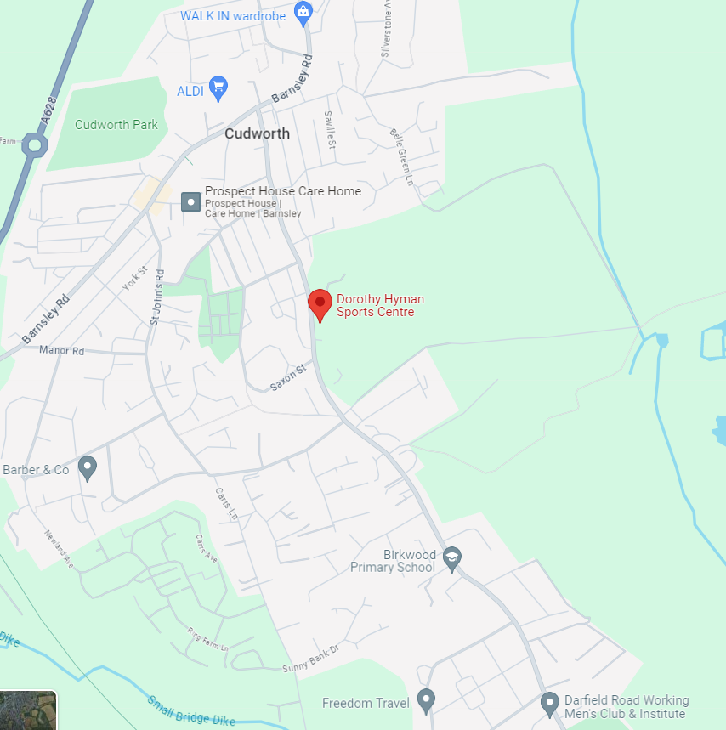

Highway Network

Vehicular access during the day and during evenings and weekends is provided from the existing vehicular entrance from Snydale Road.

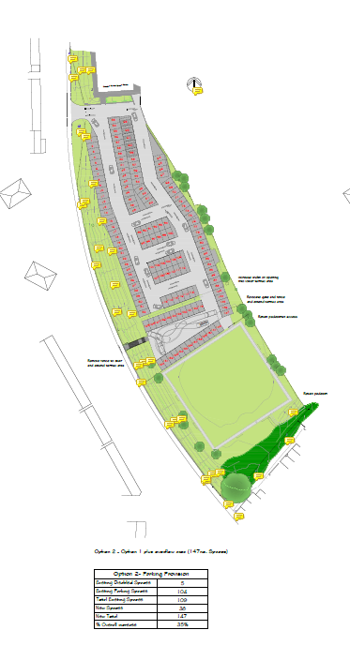

Existing Parking Facilities

DHSC enjoys an onsite parking area located to the south of the site that can accommodate 147 spaces. These are clearly identifiable in the image above.

Pedestrian Access

There are footways provided through the surrounding road network and on the adjacent Snydale Road.

Cyclist Access

Cycling is considered to be a reasonable alternative to the car over short journeys.

Former government policy (PPG13) has indicated that cycling can be an effective form of travel for journeys up to five kilometres (km).

This is supported in more recent Government lead research the ‘Smarter Choices Programme’ which has proven that significant levels of modal shift can be achieved for journeys up to this distance.

There are no formal cycling facilities/lanes along Snydale Road; however, it is considered cyclable.

Public Transport

The site is serviced by a bus stop located on Snydale Road which is 113 metres away from the site.

The nearest train stations to DHSC is Barnsley which is 4.3 miles away.

Summary

This section has demonstrated that the site is easily accessible by bicycle and public transport, which is in accordance with local and national objectives.

Development Proposals

This section covers the proposed creation of new external sports pitch (3G Artificial Grass Pitch (AGP)) to be located within the boundaries of DHSC to replace a proportion of an existing grass playing pitch.

Proposal Description

Planning permission is sought to create a new external sports pitch with associated features including:

- 3G Artificial Grass Pitch (AGP)
- Erection of perimeter ball-stop fencing
- Installation of hard standing areas around the AGP for pedestrians and maintenance access
- Installation of an artificial (flood) lighting system

Site Description

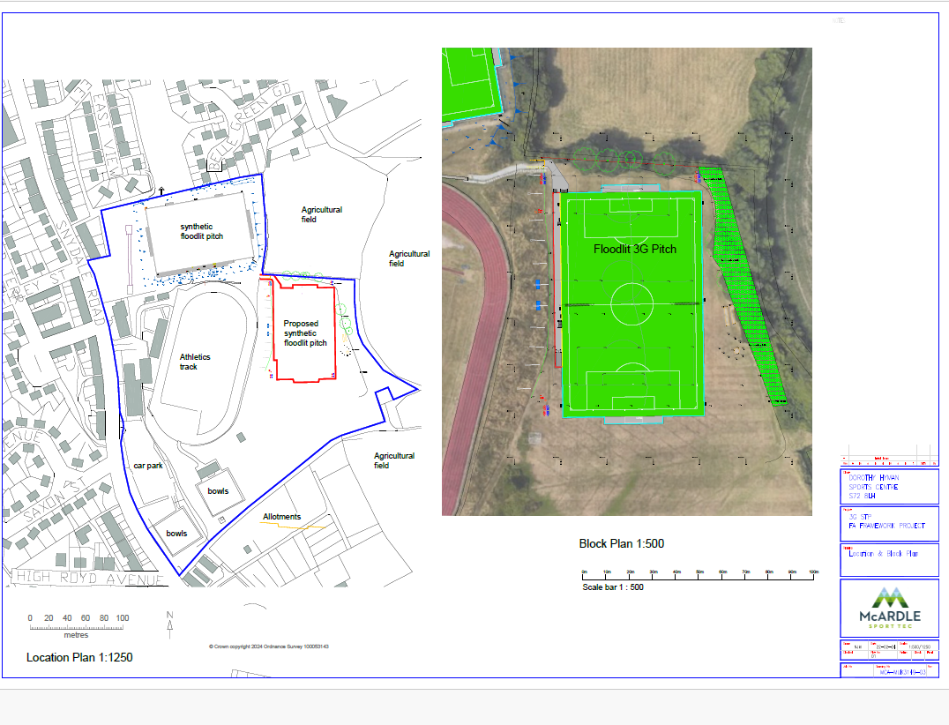

The proposed development site for the 3G Artificial Grass Pitch (AGP) is situated within the grounds of DHSC, Snydale Rd, Cudworth, Barnsley S72 8LH

The application site is located onto part of an existing grassed playing pitch used for football activities.

Existing Sports Pitch Usage

The current grass football pitch is used for fixtures throughout the week and predominantly at weekends.

During the football season period the majority of fixtures are played Saturday and Sunday commencing at 9.00am and finishing at 5.00pm.

The existing AGP is fully booked from 1700-2100 Monday Friday and 0900-1300 Saturday and Sunday.

Proposed Site Operation

A summary of proposed use for the AGP is as follows:

Monday to Friday 08:00 – 21:45
Saturday 09.00 – 15:45
Sunday and bank holidays 09:00-14:45

Trip Generation

Previous developments

In the Summer of 2023 additional bays were introduced which took the parking capacity from 109 to 147. This has provided ample parking for the site. With the closure of the function suite this also means there is less demand at weekends when large athletics events are held on site.

There is a traffic management plan for events, e.g. Yorkshire Athletics Championships; a member of staff manages the car parking at the entrance. If the car park does become full for this event, cars are directed to the BMBC car parking space close to the Pinfold pub and to use the side roads close to the centre

If pitch users all travel to site by car alone (or driven by parents), the expected maximum daytime, evening and weekend car parking demands are as follows:

- 60 spaces for each AGP based on full use inclusive of change over times

To ensure a robust assessment, full use of the AGP has been assumed. This means there are ongoing bookings throughout the weekday evening and throughout the weekend to maximise person trip demand.

Given the catchment area, such an assumption is highly improbable to occur.

However, it does ensure a robust assessment, particularly in terms of parking demand.

There is a cross over period of users departing after each session and users arriving for the following session, however we expect users to depart within fifteen minutes from each session ending, therefore there will be minimal crossing of vehicles on Moor Lane.

Also, we expect users to arrive no earlier than fifteen minutes prior to the start of each session.

This will result in a maximum accumulation of 140no. people on site at any one time within a one-hour period using the AGP.

Below are analytics taken from google on the peak times experienced by the site.

Monday

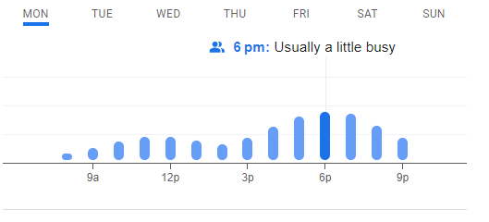
Tuesday

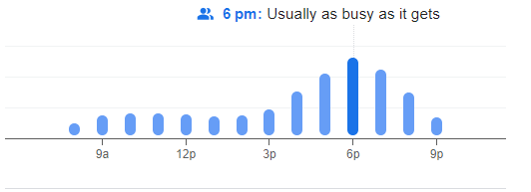

Wednesday

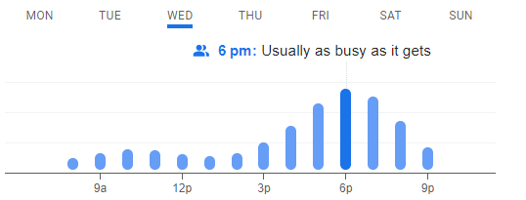

Thursday

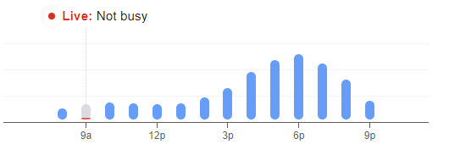

Friday

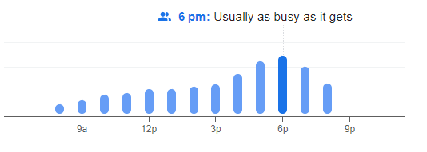

Saturday

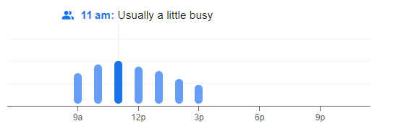

Sunday

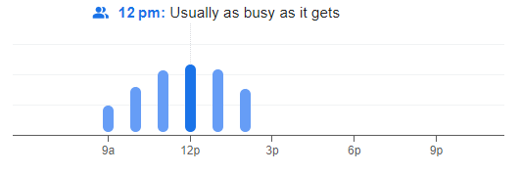

Parking Accumulation

The vehicle trips set out above have been used to calculate the parking accumulation at the site:

Hour | Weekday | Weekend  Car park fully utilised at weekends during day light hours currently, AGP use will be the only pitch used during dark on weekends
08:00 – 09:00 | 25 | N/A
09:00 – 10:00 | 40 | 120
10:00 – 11:00 | 40 | 120
11:00 – 12:00 | 40 | 120
12:00 – 13:00 | 40 | 120
13:00 – 14:00 | 40 | 65
14:00 – 15:00 | 40 | 25
15:00 – 16:00 | 40 | N/A
16:00 – 17:00 | 40 | N/A
17:00 – 18:00 | 140 | N/A
18:00 – 19:00 | 140 | N/A
19:00 – 20:00 | 130 | N/A
20:00 – 21:00 | 130 | N/A
Maximum parked | 140 | 120

The table above shows that the maximum number of cars parked on site at any one time would be 140no. vehicles; this is based on the most intense anticipated use using one-hour slots, arriving every hour. This is based on 60 cars per AGP and 10-20 other site users including staff and is aligned to the analytics above.

The demand for onsite vehicle parking could therefore be accommodated within existing parking areas onsite and would not lead to any overspill onto the local highway network.

Summary and Conclusions

All users of the AGP arriving by vehicles will park within established onsite parking areas, offering a maximum capacity of 147no. parking spaces.

All vehicles will enter and egress using the entrances on Snydale Road.

There will be increased traffic movement, during weekdays, because of the new facility, but sufficient car parking provision onsite is available and when weekend events such as Yorkshire Athletics Championships an overflow option is available at the BMBC car parking spaces next to the Pinfold pub.

The site is easily accessible by bicycle and public transport (bus and train), which is in accordance with local and national objectives.

To conclude, the proposed AGP parking arrangement will result in a negligible impact on the local highway network and local transport network and will not lead to car parking stress on the local roads.

