Block Plan Existing/Proposed

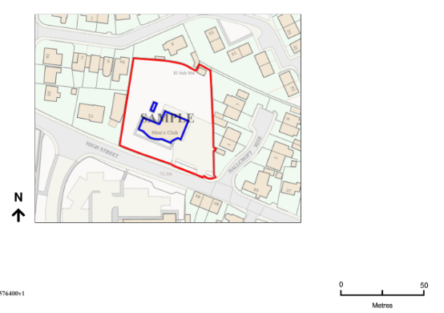
Red Line = Site boundary
Blue Line= Existing buildings to be demolished

Further survey required regarding the sub station at the top of the plan, it may be that the electric board would like this to remain if is serves other properties.

