Application to discharge Planning Condition 16 of Planning Application Number 2018/1569

- Introduction
Condition 16 states: Details of the car park management plan shall be submitted and approved in writing by the Local Planning Authority prior to the development being brought into use, and then shall be implemented at all times.
Reason: In the interest of highway safety in accordance with Local Plan policy T4 'New development and Transport Safety'
This document describes how the Multi Storey Car Park (MSCP) which serves the Glass Works will be managed.
- Background
The MSCP at the Glass Works forms part of the overall estate that the Landlord of the Glass Works is responsible for managing. The Glass Works MSCP will comprise 6 levels of car parking and in total will provide 485 spaces.
The MSCP will be managed via a dedicated team based on site. The site team will comprise a range of skills and will primarily be tasked with delivering the safe management of all the different elements that make up the Glass Works including the MSCP.
The site team will include a 24/7 control room which will act as the nerve centre for the development and will be where all life safety and security systems will be monitored from.
The MSCP has the ability to operate 24/7, but the exact hours will be determined by the operational needs of the Glass Works tenants’ and visitor demand. The MSCP will open early in the morning and will not close until 30 minutes after the last film has ended at the cinema.
- Specification
The MSCP has been designed to enable a safe and secure management operation to be followed at all times. This report will not discuss the design in detail, but it is widely accepted that a high-quality design provides the basis for successful and safe operational management.
The car park comprises the following key elements, all of which will influence the operational management:
- 485 spaces of which 28 are disabled bays
- 6 No Electric Vehicle Charging Points
- 2 No Entry and Exit Barriers
- 7 Number pay machines – 2 on level 2 and 1 on all other floors
- Roller Shutters – at the entrance and exit to the MSCP
The car park, which for the purposes of this document is taken to mean the road-ways, parking bays, lifts, stair cores, signage and parking equipment (including barriers and pay machines) will be managed by the Glass Works centre management team.
The MSCP has been designed with safety in mind including the provision of anti-climb mesh on Level 7 to aid suicide prevention. Dedicated pedestrian walkways, crossings and extra space around disabled bays all assist customer access.
The bays and road-way are delineated by white lining to support internal navigation and contrasting colours will be used to distinguish between bays and trafficked areas.
Appendix 1 includes drawings showing the finishes which will be provided at the MSCP for levels 2, 3 and 7. Note Levels 4, 5 and 6 mirror Level 3.
A customer wayfinding strategy has been developed which will assist customers when moving from the MSCP to the rest of the Glass Works and when returning to the MSCP to find their vehicle at the end of their visit.
- Operational Management
The following sections set out the key operational management strategies that will be adopted for the safe operation of the MSCP. The strategies reflect best practice and are standard for developments such as the Glass Works.
  - Security

Security Staff will monitor the MSCP via CCTV, linked back to the Glass Works Control Room and security patrols will also visit the MSCP at regular intervals.

The MSCP will provide a safe and welcoming environment for visitors enhanced by the design, which provides good visibility across decks which further provides a feeling of security.

The roller shutters installed at the Ground Floor Level entrance to the rotunda will reduce the likelihood of unwanted pedestrian access at this location, which will further increase the security protection of the MSCP. When the MSCP is closed the roller shutters will prevent unauthorised visitors gaining access to the MSCP.

  - Cleaning and Maintenance

The MSCP will be cleaned by the Glass Works cleaning team and will be maintained in a good condition so that it always presents well to users and remains a safe place to visit.

  - Lighting

The MSCP will be well lit, using energy efficient LED lighting. A high lux level increases the feeling of security and reduces the risk of accidents to people or vehicles.

  - Car Park Management System

Entry to and Exit from the MSCP is controlled by 2No sets of barriers located at Level 2 of the MSCP. The barriers dispense tickets which customers present at Pay Machines, located at every level of the MSCP, when they wish to leave.

The Car Park Management System calculates the tariff due, related to the length of stay. Upon payment the payment machine validates the customer’s ticket, which, when presented at the exit barrier permits the vehicle to leave the car park.

This system provides security and significantly reduces the risk of vehicle theft as any vehicle exiting the car park needs to have a validated ticket. All entry and exit barriers and Pay Machines are covered by CCTV which will ensure high quality images of any thefts are recorded which further reinforces the provision of a safe environment.

The Car Park Management System has a pre-set maximum occupancy level, which it uses to regulate and limit the number of vehicles entering the car park when it is approaching full capacity. This function ensures that the car park never becomes so full of vehicles that gridlock occurs, which can occur in an unregulated car park, and ensures the car park continues to function safely.

At peak times, such as Christmas and other pre-determined special events, the Glass Works management team may increase the maximum capacity threshold and will deploy resources to act as Car Park Wardens whose purpose it is to assist customers finding vacant spaces. This will help to ensure the car park operates at maximum capacity and reduce queuing on the access rotunda access ramp.

  - Customer Service

If a customer has a problem with their visit ie damaged or lost ticket, or they can’t find their vehicle, they will need to contact the 24/7 control room. This can be done from either the Pay Machine or the Exit Barriers, which both have voice communication links to the control room. The control room will be able to assist the customer to either make payment, exit the car park or potentially find their car.

Customers who arrive at the exit barriers having not paid for their parking stay, will be advised that they should have paid and their details will be recorded to avoid the same excuse being used as a tactic to avoid paying for parking in the future.

  - Cash Collection

The Pay Machines which customers use to pay for their parking visits will accept both cash and card. Whilst the Pay Machines are designed to hold and manage cash levels to ensure change can be provided as needed, they will need still emptying on a regular basis.

To ensure safe and auditable collections of the cash received, the Glass Works management team will appoint a specialist cash collection company who will visit the MSCP, remove the monies and pay them into a designated BMBC account.

Appendix 1
MSCP Level 2
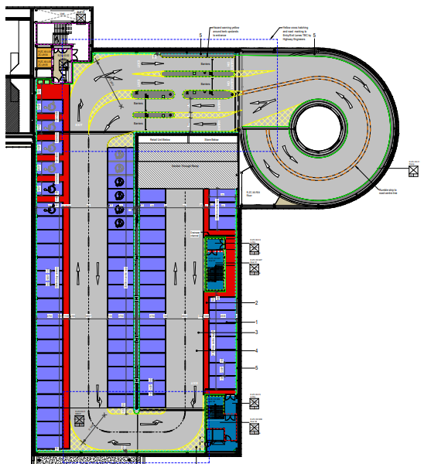

MSCP Level 3
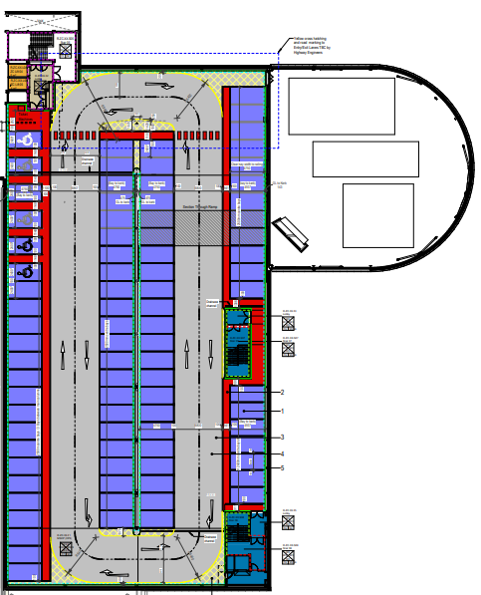

MSCP Level 7
