PROPOSED MITIGATION SCHEME

PROTECTED SPECIES AND
SPECIES OF NATURE CONSERVATION IMPORTANCE

in relation to

PROPOSED DEVELOPMENT at
LAND ADJACENT TO 1 GROVE STREET,
WORSBROUGH DALE, BARNSLEY S70 4SN

South Yorkshire

2025

Planning Application No. 2022/1307

REPORT PRODUCED ON BEHALF OF

MR. GAVOR DOBI & ASSOCIATES

ENTOTAX CONSULTANTS UK
ENTOTAX CONTRACT SCIENCE
REPORT No. EC/25/1220 (MARCH 2025)

Quality Assurance

This report has been prepared and is provided in accordance with :

(1) BS42020 : 2013 Biodiversity – Code of practice for planning and development.
(2) Guidelines for Preliminary Ecological Appraisal (GPEA) (CIEEM, 2017).
(3) Code of Professional Conduct (CIEEM, 2022).

Contents

 | Executive Summary
1 | Introduction
1.1 | Development Proposals
1.2 | Objectives
1.3 | Application Site Location
2 | Mitigation and Protected Species
2.1 | Context
2.2 | The Mitigation Hierarchy
3 | Legislation and Policy
3.1 | Caveat
3.2 | Legislation, National Policy & Guidance
3.3 | Local Policy & Guidance
3.3.1 | Barnsley Local Plan 2019
4 | PEA Survey Methodology
4.1 | Choice of Survey
4.2 | Desk Study
4.3 | Ecological Walkover Survey Methodology
4.4 | Caveat
4.5 | Survey Constraints
5 | Results and Evaluation
5.1 | Statutory Sites for Nature Conservation
5.2 | Habitats
5.3 | Flora
5.4 | Protected and Notable (Barnsley BAP) Species
5.4.1 | Mammals
5.4.2 | Birds
5.4.3 | Reptiles
5.4.4 | Amphibians
5.4.5 | Terrestrial Invertebrates
6 | Limitations of Survey
7 | Prediction Impacts
7.1 | Rationale
7.2 | Intrinsic Identification Phase
7.3 | Pre-Construction Phase
7.3.1 | Vertebrates
7.3.2 | Invertebrates
7.4 | Construction Phase
7.4.1 | Site Access
7.4.2 | Site Excavations
7.5 | Post-Construction (Aftercare) Phase
8 | Appendices
 | Appendix 1 – Previous Ecological Assessment
 | Appendix 2 – Application Site Boundary
 | Appendix 3 – Location of Bird Nesting Boxes, Integral Bat Tubes & Hedgehog Access Points
 | Appendix 4 – Method Statement 2 – Tree Removal and Scrub Clearance

EXECUTIVE SUMMARY

This summary should be read in conjunction with the final report to Mr. Philip Fletcher (Entotax Contract Science Report EC/25/1220) covering the period up to and including 23 March 2025.

A Preliminary Ecological Appraisal (PEA) was undertaken at land adjacent to 1 Grove Street, Worsbrough Dale, South Yorkshire S70 4SN by Entotax Consultants UK (ecological consultants) on behalf of Mr. Philip Fletcher (agent acting on behalf of the landowner/s Mr. Gavor Dobi and Associates). The purpose of the PEA was to inform a planning condition requirement (Mitigation Scheme) aimed at avoiding impacts upon protected species and/or species of nature conservation importance that could potentially be present at the site.

The development proposals include controlled habitat destruction of all existing vegetation across the site (predominantly a mosaic of tall trees, bramble/buddleja scrub and rank grassland). Surprisingly, the only ecological information for the site is that contained in a single-page, undated report (see APPENDIX 1) that does not describe the site as in appears in its present condition. It also states that the site is 5 miles south of Barnsley town centre when the current (Worsbrough Dale) site is approximately 1.8 miles (~2.5 km) to the south-southeast.

Mitigation for the development proposals (‘the scheme’) is sub-divided into 4 distinct phases :

- Intrinsic Identification Phase (identification of potential ecological receptors to the scheme);
- Pre-construction Phase (site clearance and other pre-construction works);
- Construction Phase (the building program);
- Post-development Phase (landscaping and aftercare etc.).

1 | INTRODUCTION
1.1 | DEVELOPMENT PROPOSALS

Mr Gavor Dobi and Associates are proposing to undertake development works on land adjacent to to 1 Grove Street, Worsbrough Dale, South Yorkshire S70 4SN. The site comprises a small area (approximately 0.07 ha) of tall trees (mainly young); bramble/buddleja scrub, and rank grassland situated between Bank End Road and Grove Street. The development proposals constitute the erection of two residential dwellings together with hard and soft landscaping and are therefore subject to a planning decision notice. Planning permission subject to condition was granted on 8 August 2023 :

Erection of 2no detached two storey dwelling houses and associated works

Planning Application Number: 2022/1307
Application Received by Planning Department: 19 December 2022
Application Validated by Planning Department: 22 December 2022
Status: Approved with conditions (8 August 2023)

1.2 | OBJECTIVES

During March 2025 Entotax Consultants UK (ecological consultants) were commissioned by Mr. Philip Fletcher (agent acting on behalf of the applicant Mr Gavor Dobi and Asociates) to undertake a Preliminary Ecological Appraisal (PEA) and to provide a Mitigation Scheme for protected species and species of nature conservation importance in order to ensure that these species (if present at the site) would be unaffected by the development proposals. The aims of this report are to inform the proposed development by :

- Determining the ecological baseline biodiversity value of the site by undertaking appropriate survey of all the habitats present;

- Determining the likelihood of the presence/absence of species of biodiversity/nature conservation importance at the site (wherever possible), and the provision of appropriate mitigation (as necessary) prior to commencement of the proposed development works;

- Provision of a report to Barnsley Metropolitan Borough Council (Planning Services) outlining the results of the Preliminary Ecological Appraisal (PEA) and the proposed mitigation (Mitigation Scheme) aimed at ensuring that species of biodiversity/nature conservation importance are unaffected by the development proposals. The full PEA report is available upon request but only breeding birds were determined as being at high risk from the proposed development works.

1.3 | APPLICATION SITE LOCATION

The application site lies approximately 2.5 km to the south-southeast of Barnsley town centre and towards the centre of Worsbrough Dale village (to the immediate south of Bank End Road and the immediate north of Grove Street. The site centroid is to the immediate east-southeast of the Bank End Road/Grove Street road junction within 1 km national grid reference square SE 3604 (Central National Grid Reference: SE 36106 04181 = 436106E 404181N) at an altitude of approx. 100m Above Ordnance Datum (AOD).

Figure 1: Application Site Location
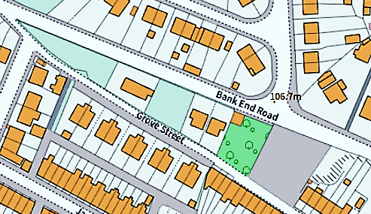

The application site lies within an urban landscape and is surrounded by residential development to the immediate north, south, east and west but with significant areas of agricultural land to the south, east and west beyond. Although there is limited natural habitat within the immediate environs, there are many gardens that offer a wide range of resources to wildlife

2 | MITIGATION AND PROTECTED SPECIES
2.1 | CONTEXT

Mitigation is a legal requirement wherever a development has the potential to impact upon a protected species; a designated site for nature conservation, or any other resource of ecological value.

2.2 | THE MITIGATION HIERARCHY

The Mitigation Hierarchy is a widely used good practice framework that guides users towards limiting (as far as possible) the negative impacts from development proposals upon biodiversity. It is based upon a sequence of four iterative actions: avoidance; minimization of negative impacts (e.g. prevention); remediation (restoration etc.) and finally compensation offsetting any residual impacts.

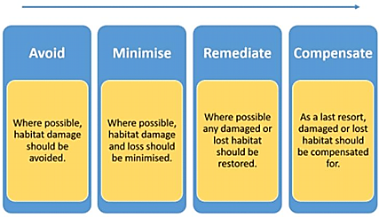

The Mitigation Hierarchy approach has been adopted in the production of this report.

3 | LEGISLATION AND POLICY
3.1 | CAVEAT

This report has been prepared and provided in accordance with British Standard 42020: Biodiversity – Code of practice for planning and development 2018 and CIEEMs Code of Professional Conduct. The report takes into account the legislation and policy protection afforded to specific habitats and species. Entotax Consultants UK does not provide specialist legal advice and where necessary the reader should consult the original legislation (referenced below). Legislation, planning policies and planning guidance relevant to the protection, conservation and enhancement of sites of nature conservation interest are detailed below :

3.2 | LEGISLATION, NATIONAL POLICY AND GUIDANCE

Potential ecological receptors to a development scheme including habitats and species of nature conservation importance, receive legal protection under a wide range of legislation and planning policies. These include :

- The Environment Act 2021.
- The National Planning Policy Framework (NPPF, revised 2023).
- The Conservation of Habitats and Species Regulations 2017 (as amended).
- The Wildlife and Countryside Act (WCA) 1981 (as amended).
- The Countryside and Rights of Way (CRoW) Act 2000.
- The Natural Environment and Rural Communities Act (NERC) 2006.
- The Hedgerow Regulations 1997; and
- The Protection of Badgers Act 1992.

3.3 | LOCAL POLICY AND GUIDANCE

Local planning policies relating to ecology and biodiversity are generally based upon national planning policy; conservation of those species protected under the respective legislation (above) and the protection of designated sites. However, relevant local policy and guidance documents are outlined below :

- Barnsley Local Plan (adopted January 2024).
- Barnsley District Biodiversity Action Plan (BAP).
3.3.1 | BARNSLEY LOCAL PLAN 2019
POLICY BIO1 – ECOLOGICAL AND GEOLOGICAL CONSERVATION

Policy BIO1 Biodiversity and Geodiversity Development will be expected to conserve and enhance the biodiversity and geological features of the borough by:

- Protecting and improving habitats, species, sites of ecological value and sites of geological value with particular regard to designated wildlife and geological sites of international, national and local significance, ancient woodland and species and habitats of principal importance identified via Section 41 of the Natural Environment & Rural Communities Act 2006 (for list of the species and habitats of principal importance) and in the Barnsley Biodiversity Action Plan;

- Maximising biodiversity and geodiversity opportunities in and around new developments;

- Conserving and enhancing the form, local character and distinctiveness of the boroughs natural assets such as the river corridors of the Don, the Dearne and Dove as natural floodplains and important strategic wildlife corridors;

- Proposals will be expected to have followed the national mitigation hierarchy (avoid, mitigate, compensate) which is used to evaluate the impacts of a development on biodiversity interest;

- Protecting ancient and veteran trees where identified;

- Encouraging provision of biodiversity enhancements.

3.3.2 | BARNSLEY BIODIVERSITY ACTION PLAN (BAP)

The Barnsley Biodiversity Action Plan (BAP) is produced by Barnsley Biodiversity Trust and is reviewed periodically (http://www.barnsleybiodiversity.org.uk/introduction.html). The BAP lists key species and habitats targeted for specific conservation action in the borough. The list draws from nationally-approved BAP targets but also includes species and habitats which the Trusts’ partners consider to be locally important. The BAP details conservation actions which should be implemented to help protect key species and habitats and/or allow them to recover. Barnsley Council has adopted the BAP as part of the evidence-base supporting Local Plan decisions.

The presence of local priority habitats and species identified in the BAP is a material consideration in planning decisions.

 | 4 |  | PEA SURVEY METHODOLOGY
4.1 |  | CHOICE OF SURVEY

The initial visit made to the proposed development site on 22 February 2025 determined that the habitats present on-site were of sufficiently limited size (0.07 ha in total) and were sufficiently uniform (lacking structural complexity) as to be easily surveyed by an Ecological Walkover Survey & Evaluation or by visual assessment (using binoculars) from the adjacent roads (Bank End Road and Grove Street).

4.2 | DESK STUDY

A data search for internationally, nationally and locally designated statutory sites for nature conservation was undertaken using the Multi-Agency Geographic Information for the Countryside (MAGIC) website. A search radius of 6 km from the site centroid was undertaken for internationally designated statutory sites and a corresponding search of 2 km from the site centroid for nationally and locally designated statutory sites. A search for Habitats of Principal Importance (HPIs) on or near the proposed development site was also undertaken using MAGIC. Close proximity aerial photographs were screened for presence of any waterbody within 500m of the application site boundary in order to assess the application site for potential presence of protected amphibian species.

4.3 | ECOLOGICAL WALKOVER SURVEY METHODOLOGY

The Ecological Walkover Survey was undertaken on 22 February 2025 by two Entotax ecologists (between 09:30hrs. and 13:30hrs.) when the site was mapped, and the habitats present at the site were systematically surveyed and assessed. A plant survey was also undertaken at the site and the national, regional and local status of the plant species recorded. A semi-quantitative assessment using the Standard DACFOR methodology was also undertaken for the species recorded. On-Site habitats were also surveyed for the presence (or field signs indicating presence) of protected or notable (e.g. Barnsley BAP) species of mammals, birds, reptiles and amphibians.

All on-site habitats were mapped and classified using the standard UK Habitat Classification and methodology (UK Habs Ltd., 2023). The list of plant species was compiled in accordance with methodology required to establish UK Habitat Classification types up to at least level 3 (to levels 4 or 5 wherever possible). Plant species nomenclature followed that of Stace (2010).

Habitats of priority importance were recorded (where present) and habitats were classified and assessed in terms of both their nature conservation importance and their potential to support protected and/or notable species. Invasive plant species were also mapped as recorded.

The full results of the Ecological Walkover Survey & Evaluation are not fully discussed in this report but can be provided in a separate report upon request i.e. for the ecological record. This report focusses upon the Mitigation Scheme required to discharge the planning condition attached to the (granted) planning permission.

4.4 | CAVEAT

The baseline conditions described in this report were accurate at the time when the walkover survey was undertaken. Should conditions on-site significantly change prior to the commencement of the development proposals, an updated survey will be required.

4.5 | SURVEY CONSTRAINTS

There were no limitations to the survey in terms of weather conditions.

22 February 2025
Weather conditions throughout the duration of the survey were fine & dry with no survey constraints.
Temperature: cold (10.5°C);
Cloud cover: passing cloud with mainly clear skies and sunny spells;
Wind: light breeze (approx. 14.5 mph) more or less constantly from southwest;
Humidity: 80-85%.
Environmental Data: environmental data was generated throughout the survey by a
Ubibot WS1-PR-GSM WiFi Cloud Data Logger
Temperature sensor (-20°C to +60°C);
Humidity sensor (0-100%);
Ambient light sensor (0 to 83 klux).

The survey was undertaken at sub-optimal time of year for identification of many plant species and some species will have been missed due to seasonal constraints. However, most of the application site comprised a mosaic of tall trees; bramble/buddleja scrub, and rank grassland with a common, typical associate ground flora. As a consequence, misidentification of on-site habitats is not considered to be a significant constraint but there were limitations to the survey in terms of access (the Ecological Walkover Survey was undertaken within the red line site boundary which is surrounded by hardstanding (buildings and roads), but difficulties were encountered in accessing internal parts of the site due to obstructive vegetation, especially within the central reaches.

 | 5 |  | RESULTS & EVALUATION
5.1 |  | STATUTORY SITES FOR NATURE CONSERVATION

No nationally or locally designated statutory sites for nature conservation lie within 2 km of the site centroid and the extended search radius of 6 km shows no internationally designated statutory sites. There are no Habitats of Principal Importance (HPIs) on or proximal to the proposed development site.
As such, statutory sites for nature conservation are not considered to be receptors to the development scheme and mitigation is not required.
5.2 |  | HABITATS

- There are numerous tall trees including several Ash Fraxinus excelsior around the site periphery earmarked for removal, together with several tall ornamental conifers within the southern reaches of the site.

- Buddleja Buddleja davidii and bramble Rubus fruticosus agg. cover approx. 50% of the site and will be lost during site clearance. Buddleja is considered to be an invasive pest in the wider natural environment but can easily by included in garden landscaping proposals since it provides a summer (although brief), nectar and pollen resource for hoverflies, bees, butterflies and moths etc.

- A tall mixed species hedgerow is present along the southern Grove Street site boundary. This should be retained other than the area of agreed formal access.

- There are no waterbodies within the red line boundary of the application site or within 500m of the application site boundary that could potentially support protected mammal species e.g. water vole Arvicola amphibius or protected amphibian species e.g. Great Crested Newt Triturus cristatus.

5.3 | FLORA

A Plant Survey was undertaken in order to determine the plant species present at the site. The primary aim of the Plant Survey was to identify important plant communities or scarce species present within the site boundary. Only common and widespread habitats and 32 common plant species were recorded from the site. No specific mitigation is therefore required.

5.4 | PROTECTED & NOTABLE (BARNSLEY BAP) SPECIES
5.4.1 | MAMMALS

There is the potential presence of Badger Meles meles at the site and badgers could therefore be a receptor to this scheme. Although this is highly unlikely, any excavation discovered during site clearance works suggesting the possible presence of badgers will be evaluated by the site ecologist.

There is a potential presence of Hedgehog Erinaceus europaeus at the site and hedgehogs could therefore be a receptor to this scheme. Hedgehogs are primarily nocturnal and often go unnoticed during daylight hours. A fingertip search for hedgehogs is therefore recommended during the site clearance activities (see APPENDIX 4 Working Method Statement 2).

Scrub clearance should commence from the site centroid and progress radially outwards to the site periphery. This will allow small mammals disturbed by the clearance works e.g. shrews to move outwards to safety.

5.4.2 | BIRDS

Potential breeding birds such as Robin Erithacus rubecula and Blackbird Turdus merula were recorded from the site during the Walkover Survey. The site is only of value to birds at the immediate local level with the few (6) species recorded within the red line boundary being common and widely distributed. However, House Sparrow Passer domesticus was recorded from the adjacent houses (along Grove Street) and is red-listed within the current BoCC (Birds of Conservation Concern, 2021). Since house sparrows are likely to forage across at least some parts of the site, the POST-DEVELOPMENT landscaping proposals should include berry-producing species such as holly Ilex aquifolium and Rowan Sorbus aucuparia which will provide a winter food resource for this species. Furthermore, a sparrow terrace nestbox could be erected on each new building to encourage this species to nest should the existing breeding site/s on Grove Street be lost due to renovation etc.

Table 1: Bird species recorded from the Grove Street site (22 February 2025).

Species | BTO  No. | BoCC  2021 | No. | Status
Wood Pigeon Columba palumbus | 284 | Green | 4 | probably 2 pairs
Robin Erithacus rubecula | 369 | Green | 2 | single pair holding territory
Blackbird Turdus merula | 400 | Green | 1 | male bird holding territory
Blue Tit Cyanistes caeruleus | 464 | Green | 3/4 | small party passing through (S >N)
Great Tit Parus major | 465 | Green | 2 | foraging in adjacent garden to immediate east
Magpie Pica pica | 487 | Green | 1 | briefly in southern boundary hedge
House Sparrow Passer domesticus | 495 | Red | +6 | around houses along southern boundary
Chaffinch Fringilla coelebs | 504 | Green | 1 | briefly in southern boundary hedge
7 species

5.4.3 | REPTILES

There is no habitat suitable for reptiles such as Grass Snake Natrix natrix within the proposed development site boundary. The grassland/scrub habitat at the site offers very limited refugia for reptiles. It is therefore highly unlikely that reptiles will be a receptor to this scheme.

5.4.4 | AMPHIBIANS

There is no habitat suitable for breeding protected amphibian species such as Great Crested Newt Triturus cristatus within the proposed development site boundary although there is potential presence of Common Toad Bufo bufo that could take refuge under debris etc.. The lack of aquatic habitat features within the application site boundary precludes the presence of breeding amphibians with the nearest potential breeding habitat more than 500m distant. It is therefore highly unlikely that protected amphibians will be a receptor to this scheme.

5.4.5 | TERRESTRIAL INVERTEBRATES

A number of invertebrate species are likely to be receptors to this scheme, in particular flightless or weakly dispersive species. Noticeable species such as large ground beetles should be removed and released in nearby suitable habitat if encountered during the fingertip search for hedgehogs.

6 | LIMITATIONS OF SURVEY

This report has been prepared and provided in accordance with British Standard 42020: Biodiversity – Code of practice for planning and development 2018 and CIEEMs Code of Professional Conduct.

This report should not be seen in any way as the definitive ecological survey of the Grove Street site – it presents a description and assessment of the site on the basis of the data gathered. However, it is considered more than adequate to make a reasonable assessment as to the presence/absence of species of nature conservation importance, and the risk of any significant negative impact upon these species as a result of the development proposals.

7 | PREDICTED IMPACTS
7.1 | RATIONALE

Potential impacts upon protected species or species of nature conservation importance that could be present at the site have been determined in terms of :

- the species or species assemblage likely to be an ecological receptor to the scheme;
- the magnitude of risk and the respective phase where an adverse impact upon the species or species assemblage is likely to occur;
- the mitigation considered to be pre-requisite to avoidance of any impact so identified.

7.2 | INTRINSIC IDENTIFICATION PHASE

Potential ecological receptors of nature conservation importance that could be adversely impacted by the scheme are identified in the table below :

Table 2: Potential ecological receptors of nature conservation importance for the Grove Street site.

POTENTIAL RECEPTOR  TO THE SCHEME | RISK OF ADVERSE IMPACT | ACTION REQUIRED TO MITIGATE ADVERSE IMPACT IF DISCOVERED ON SITE
MAMMALS
Badger Meles meles | LOW | stop works, leave site and inform LPA ecologist
Hedgehog Erinaceus europaeus | MEDIUM | hand capture and remove (site ecologist)
bats | LOW | further assessment, appropriate licence?
shrews | MEDIUM | shepherd gently away from the works
BIRDS
nesting birds (Sched. 1) | V. LOW | stop works, leave site and inform LPA ecologist
nesting birds (other) | HIGH | retreat, stand-off determined by site ecologist
REPTILES
Common Lizard Zootoca vivipara | V. LOW | shepherd gently away from works
Grass Snake Natrix helvetica | V. LOW | shepherd gently away from works
AMPHIBIANS
Great Crested Newt Triturus cristatus | V. LOW | hand capture by site-licenced ecologist only
Smooth Newt Lissotriton vulgaris | LOW | hand capture and removal
Common Toad Bufo bufo | HIGH | hand capture and removal
TERRESTRIAL INVERTEBRATES | RISK | ACTION REQUIRED IF PRESENT
Red Data Book, BAP, LBAP species etc. | V. LOW | hand capture and removal

7.3 | PRE-CONSTRUCTION PHASE

It is understood from the information provided by Mr. Jonathan Fletcher (agent acting on behalf of the applicant Mr. Gavor Dobi and Associates) that the proposed development will necessitate complete clearance of all vegetation across the site with the exception of the southern boundary hedgeline.

Scrub clearance should commence from the site centroid and progress radially outwards to the site periphery. This will allow small mammals disturbed by the clearance works e.g. shrews to move outwards to safety. Other species encountered will be similarly shepherded away from the clearance works or will be removed to safety (see Table 2).

7.3.1 | VERTEBRATES

Badgers
There are no records for active setts within 500m of the development site. The northern site boundary
is inaccessible to badgers due to a retaining wall along New End Road. The southern boundary is accessible from Grove Street and will be checked prior to commencement of clearance works for paths into the site that could result from badger activity. Any large excavations observed on the site during clearance works will be further assessed (footprints, guard hairs any hole entrance etc.) for potential presence of badger.

Bats
Prior to removal, all larger trees will be assessed for cavities, loose bark etc. that could potentially support roosting bats. If such cavities are discovered, the respective tree will not be felled but will be re-assessed once the hibernation period for bats (November-April) has passed.

Hedgehogs
The predicted risk to hedgehogs is considered to be sufficiently high as to warrant mitigation. This will comprise stratigraphic removal of scrub by cutter followed by hand searching.

Shrews
(see Table 2).

Breeding Birds
The predicted risk to birds is considered to be sufficiently high as to warrant mitigation. The breeding season commenced at the beginning of March and mitigation should include a Breeding Bird Assessment immediately prior to commencement of any works (or within a maximum of 48 hours of such). If nesting birds are not considered to be a receptor to the works i.e. there is de minimis risk (no evidence of presence), the works can progress in accordance with the specifics of the respective Method Statement appended (see APPENDIX 4).

Reptiles and Amphibians
Amphibians (with the exception of toads), reptiles and mammals (with the exception of hedgehogs) are considered to be at sufficiently low risk as to warrant limited mitigation. However, a Breeding Bird Survey will be undertaken prior to commencement of any works during the breeding season together with a fingertip search for toads and hedgehogs and their removal to appropriate, suitable habitat if discovered at the site.

7.3.2 | INVERTEBRATES

The predicted risk to highly mobile invertebrates is considered to be sufficiently low as to warrant no specific mitigation. However, flightless or weakly dispersive species are likely to suffer significant impacts that are difficult to avoid.

7.4 | CONSTRUCTION PHASE

Once the site has been cleared of vegetation, Temporary Mesh Fencing (TMF) will be erected around the site perimeter (as appropriate). This type of fencing can be erected on ground with rubber feet or in ground on scaffolding tubes for greater security and durability. It can also be used to form tree protection to BS 5837: 2012.

A Temporary Amphibian Fence (TAF) will be attached to the inside of the TMF and will be sited within a shallow ditch and backfilled accordingly. This will prevent mammals, reptiles and amphibians from entering the site.

Upon completion of the fencing, a Walkover Survey will be undertaken to ensure no mammals, reptiles or amphibians remain within the site boundary.

7.4.1 | SITE ACCESS

A closeable section of TMF will allow machinery to ingress and egress the site. Upon closure, sandbags will be laid along the foot of the TMF GATE in order to prevent access to mammals, reptiles and amphibians.

7.4.2 | SITE EXCAVATIONS

Excavations for footings and facilities (drains etc.) will be checked first thing (daily) and will have wooden escape ramps placed within all trenches left uncovered overnight, in order to allow any mammals, reptiles and amphibians to escape should they fall into these features.

7.5 | POST-CONSTRUCTION (AFTERCARE) PHASE

Post-construction (aftercare) mitigation should comprise sympathetic landscaping with a number of native and non-native shrubs aimed at providing sources of nectar, pollen, berries and seeds over as wide a seasonal period as possible.

BATS
In keeping with the NPPF and Barnsley Local Plan, bat boxes will be incorporated into the scheme. The locations of these are shown in APPENDIX 3. Installation will be supervised by Entotax ecologists.

Integral Bat Tubes

A single 1FR Schwegler Bat Tube will be integrated on the upper south-facing elevation of each property as shown.

The 1FR Bat Tube is designed to be installed on the external walls of buildings, either flush or beneath a rendered surface. This makes it ideal for situations where the box needs to be discrete since only the entrance hole will be visible. It can also be painted to match the building with air-permeable paint if desired.

The 1FR is specifically designed to meet the characteristic behavioural requirements of the types of bats that inhabit buildings. It has an integrated wooden panel onto which bats can cling and a ridged entrance slope which makes it easy for them to enter and leave the box safely. The design maintains excellent climatic conditions inside providing bats with a safe and stable environment in which to roost and it requires no maintenance because droppings fall out of the entrance ramp.

NESTING BIRDS
In keeping with the NPPF and Barnsley Local Plan, bird nesting boxes will be incorporated into the scheme. The locations of these are shown in APPENDIX 3. Installation will be supervised by Entotax ecologists.

Sparrow Terraces

A 1SP Schwegler Sparrow Terrace will be integrated on the upper west-facing elevation of each property as shown.

The current UK sparrow population is declining due to habitat destruction and lack of suitable nesting sites. Sparrows are social birds and like to nest in the company of others. The 1SP Schwegler Sparrow Terrace is ideal for three pairs of sparrows. Made of Schwegler's wood-concrete mix, these terraces are durable, breathable and will last many decades. They may also occasionally attract tits, redstarts and spotted flycatchers.

The sparrow terraces will be fixed directly to the upper wall and are suitable for all types of houses in built-up areas. The terraces will be located more than 2m above the ground using the plugs and screws provided. Cleaning is advisable but not necessary, and the front panel can be removed by turning the screw hook.

Bird Boxes

Two 1SP Schwegler Nest Boxes (26mm access hole x1 and 32mm access hole x1) will be installed along the rear boundary walls of each property as shown.

Natural cavity nest sites have declined dramatically and provision of nest boxes can provide much-needed breeding and roosting space for cavity-nesting species. The Schwegler 1B is the bestselling nest box for garden birds and will attract a wide range of species and is available with different entrance hole sizes. Examples of bird species attracted to the different entrance hole sizes are :

- 32mm: great tit, blue tit, coal tit, redstart, nuthatch, tree and house sparrows (and bats).

- 26mm: blue tit, coal tit and possibly wren. All other species are prevented from using the nest box due to the smaller entrance hole.

Schwegler bird boxes provide a stable environment and mimic natural nest and roost sites with internal brood chamber dimensions that are similar to natural cavities. These are Woodcrete nest boxes and last for at least 20-25 years. Woodcrete is a breathable blend of wood, concrete and clay which will not rot, leak, crack or warp, whilst preventing condensation and maintaining more constant temperatures inside than wooden boxes.

Schwegler have a patented method of installation on trees that prevents the tree trunk from growing over the hanger from which the box is suspended. The nest boxes will be attached to a suitable retained tree or to the northern boundary retaining wall 2m above the ground.

HEDGEHOGS
In keeping with the NPPF and Barnsley Local Plan, hedgehog access points will be incorporated into the scheme. The locations of these are shown in APPENDIX 3. Installation will be supervised by Entotax ecologists.

Hedgehog Highway Fence Holes
Two Timloc Hedgehog Highway Fence Hole Frames will be installed at ground level between the two new adjacent properties as shown.

Highway hole are approximately 13cm square and will let hedgehogs move around freely without letting dogs escape.

Open access to and from the site will not be restricted due to the retained hedgeline along the southern boundary (Grove Street).

8 | APPENDICES
 | APPENDIX 1
 | PREVIOUS ECOLOGICAL ASSESSMENT
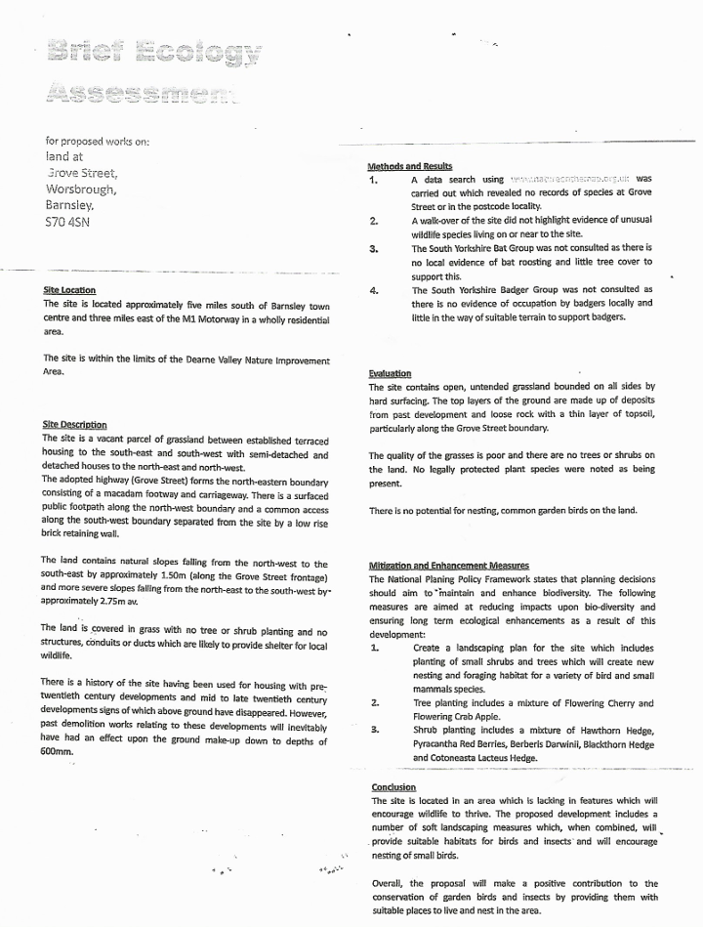

APPENDIX 2

APPLICATION SITE BOUNDARY
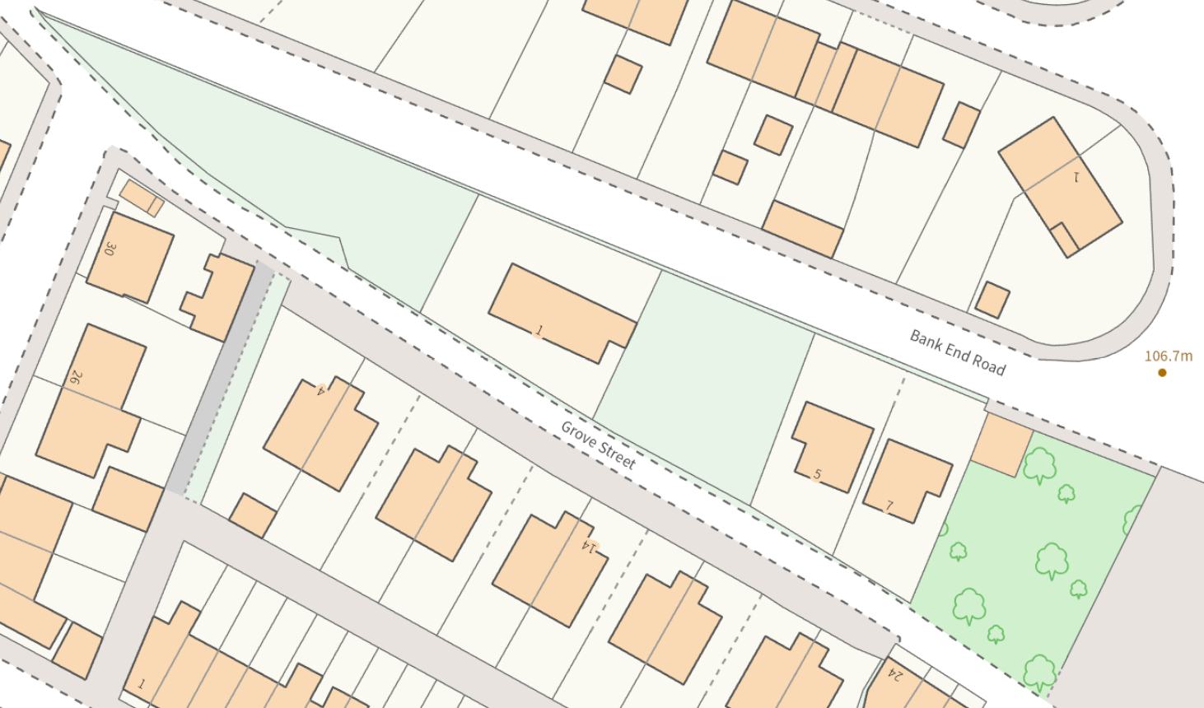

APPENDIX 3

LOCATION OF BIRD NESTING BOXES, INTEGRAL BAT TUBES AND HEDGEHOG ACCESS POINTS
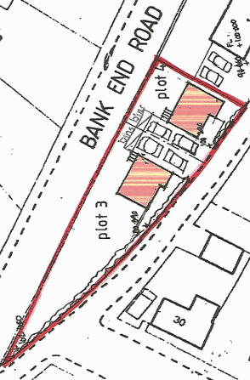
BIRD BOX

HOUSE SPARROW TERRACE

INTEGRAL BAT TUBE

HEDGEHOG ACCESS

LEFT BLANK FOR PLANNING ECOLOGISTS COMMENTS

APPENDIX 4

METHOD STATEMENT 1 – TREE REMOVAL

The following methodology will be adhered to throughout all tree removal activities and copies will be provided by the site ecologist to all site personnel in Method Statement format.

- No works will commence until the site ecologist arrives and briefs all site personnel.

- A qualified and licenced arboriculturist together with an appropriately trained banksman must undertake all tree felling works.

- Tree removal should be by sectional lowering, either from direct climbing and roping or by MEWP (Mobile Elevated Work Platform) and only in areas pre-cleared of scrub.

- Sectional canopy removal will commence at maximum height downwards and only for trees with no evidence of breeding birds. Nests or cavities discovered in the upper canopy must be immediately reported to the site ecologist who will make an informed judgement prior to continuation of works on any given tree.

- No cut vegetation (brash etc.) is to be left on-site but it can be chipped and bagged prior to removal.

METHOD STATEMENT 2 – SCRUB CLEARANCE

The following methodology will be adhered to throughout all scrub clearance activities and copies will be provided by the site ecologist to all site personnel in Method Statement format.

- No works will commence until the site ecologist arrives and briefs all site personnel.

- Scrub will be only be cut by strimmer or hedge cutter and on foot and not by any mechanical vehicle.

- For each patch or area of scrub, cutting and removal will be undertaken stratigraphically commencing at maximum height and descending layer by layer until a remnant vegetation with a minimum height of 0.5m above ground level is attained. The resultant exposed ground area and remnant vegetation will then be checked by fingertip search for hedgehogs prior to further cutting to ground level.

- Should any bird’s nest be encountered during the clearance works, the works in the immediate vicinity to a distance of 10m will cease and the site ecologist immediately informed. He/she will ascertain whether the nest is old, recent or occupied (eggs or chicks). Under no circumstances whatsoever is the nest to be examined other than by direct observation and only by the site ecologist. If the nest is considered to be active, the works in that area will cease and the ecologist will determine an appropriate stand-off distance for the foreseeable future i.e. until fledglings have left the nest. THIS IS A LEGAL REQUIEMENT.

- Should hedgehogs (or amphibians such as toads) be encountered during the clearance works, the site ecologist should be immediately informed. He/she will remove these animals to appropriate nearby (safe) habitat.

- No cut vegetation is to be left on-site but it can be chipped and bagged prior to removal.

