Design and Access and Heritage Statement

APPLICATION: Listed Building Consent.

PROPOSAL: Erection of two storey infill side extensions
to dwellings.

PROPERTY: Main building, Worsbrough Hall,
Worsbrough Village, Barnsley. S70 5LN

Preliminary Information

Although the extension is within the permitted development limits set out on the Town and Country Planning (General Permitted Development) Order 1995 (as amended) Listed Building Consent is required, as detailed in Part 1, Chapter 2 of the Planning (Listed Buildings and Conservation Areas) Act 1990 (as amended), as the proposal comprises of an extension to a listed building.

Design and Access & Heritage Statements are required to support applications for Listed Building Consent as is set out in Part 11, Article 8 of The Town and Country Planning (Development Management Procedure) Order 2010.

The Site and Surroundings

O.S Map – Hall ringed

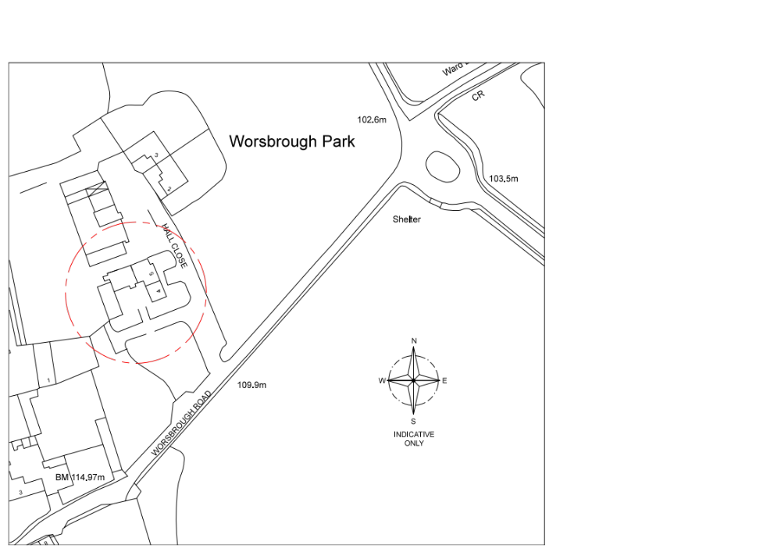

Worsbrough Conservation Area

The buildings in question form part of Conservation Area CA17 Worsbrough. Area CA17 is 3 miles south of Barnsley town centre, but set within a predominantly rural and agricultural landscape. The Conservation Area probably originated as a small farming community and has been closely associated with the 17th Century Worsbrough Hall which is a grade II Listed Building. The Conservation Area contains a large number of listed structures notably the grade I listed St. Mary’s Church. Properties range from detached, semi detached and terrace housing; ranging from one to three storeys. All properties within the Conservation Area are constructed from locally quarried sandstone, roofing material tends to be either stone slate, grey slate or Welsh slate. Architecturally, designs tend to be of the rural vernacular with some formalised elements, mixed with more modern developments. A large amount of residential development has taken place over recent years, along with an amount of encroachment of one and two storey housing and a large apartment complex has also been developed at the northern edge of the Conservation Area.

Extension Location

Worsbrough Hall is a 17C building lying to the north of Worsbrough Village and on the edge of the South Yorkshire Green Belt. Over the years various buildings have been added to the estate and the property has been in commercial ownership. These various changes have resulted in the current situation whereby the Hall and its annexed buildings have been converted into a number of dwellings comprising houses and apartments. These together with some relatively recent dwellings comprise a cluster of housing on the edge of the village and adjoining the Green Belt.

Conservation area map on this sheet

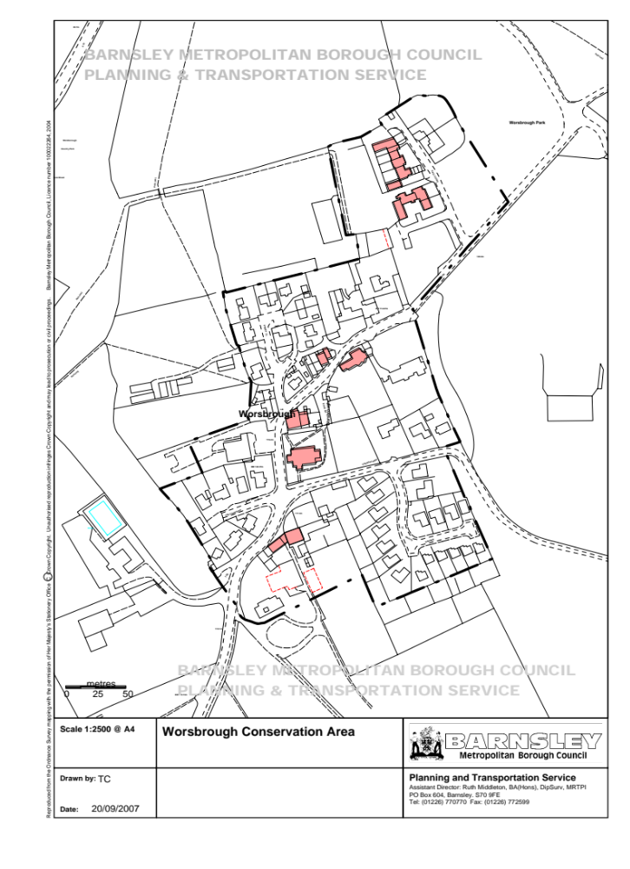

Description of Building

The listing for the Hall is as follows:

Worsbrough Village SE30SE 2/113 Worsbrough Hall (including Nos. 4 and 5 11.11.66 Worsbrough Hall) GV II Large house now 3 dwellings. C17 of 2 builds, partially refenestrated. Ashlar sandstone, stone slate roof. U-shaped plan having gabled front wings, 2 short wings to rear of central block. 2 storeys, with attics, part 3 storeys, 1 : 4 : 1 bays. Chamfered plinth, continuous dripmoulds to each floor, 2-storey porch to right of centre has Tudor-arched doorway beneath cross-window and coped gable with apex finial base. Flanking bays have 4-light mullioned windows, single light on far right; taller 1st floor windows are transomed. Wing on left: higher ground-floor dripmould covers transomed 3-light gable window, cross-window to 1st floor, altered attic window opening, shaped kneelers and gable copings, truncated ashlar ridge stack. Wing on right: similar but of 3 storeys with 2-light 2nd-floor window beneath eaves dripmould. Rear: later additions to rear-right corner with projecting stack above having rebuilt shaft. Lateral stack to rear of central block with truncated wing to rear left. Rear gable of left wing has early leaded lights in corniced cross-window. Left return: 5 bays, transomed 3-light windows beneath sashes with glazing bars in
square-faced surrounds. Right return: 6 bays, sashes with glazing bars except to ground-floor bay 3 having doorway and 2nd floor bay 5 having casement. Interior not inspected. Occupied in early C17 by Thomas Edmunds, secretary to Thomas Wentworth, the 1st Earl of Strafford of Wentworth Woodhouse. Colvin (p641) notes that in 1775 John Platt did work on the drawing room of the house for Francis Edmunds. Remained in the family until 1831 (Wright, p15). H. Colvin, A Biographical Dictionary of British Architects 1600-1840, 1978. J. G. Wright, Worsbrough: In Times Past, 1983.

Although this historic building retains many original features worthy of preservation its various uses over the years coupled with a lack of maintenance by various owners have lead to some significant works being required including roof repairs and partial replacement together with repairs and replacement of rainwater goods, the demolition and rebuilding of gable and chimney walls in reclaimed/new coursed stone, the reinstatement of five reclaimed stone mullion windows (now damaged) and one doorway among other things.

Flat 18 (and Flat 8 below) form part of the wing constructed around 1820 in matching style and materials and originally was linked to the Hall. The link was demolished in 1980.

Attached are sketches taken from an old drawing forming part of this application, which show the existing gap between the buildings (Appendix 2) and the proposed extension
(Appendix 3). To illustrate that the proposal returns the range of buildings to a close approximation of the original, I have also attached a photograph showing the original west elevation (Appendix 5 (b)).

The proposed new entrance hall will incorporate a solid stone staircase, which will abut the rear of the wall which used to house the cabinet and various accessories and papers of
King Charles I, prior to his execution. The proposed extension between units 6 and 18 will incorporate this new entrance hall and stone staircase

On further investigation, a fireplace has been found which will be incorporated in Bedroom 4 this is believed to pre-date the Dissolution of the Monasteries (1536 to 1541). Until the contractors demolish the existing gable to give full access to the face of the fireplace, this cannot be verified. It could well have come from Monk Bretton Priory or alternatively heresay has it that a place of worship existed on this site prior to St. Mary’s Church. The well, which archeologists are shortly to investigate and clear out may give us a better reading. It should be noted that the West Wing was the last portion of the Hall to be constructed at or around 1620. The central portion of the Hall and the lower sections of the East Wing all pre-date the West Wing.

A further discovery of an aged stone pier, believed to considerably pre-date the Hall, lends weight to the argument as to the accepted age of the Hall. One school of thought believes this pier was walled up for religious posterity as a “time capsule” in the 1830’s with hand made bricks, during the massive reconstruction of the Hall and Domestic Wing by the Edmunds family, who were staunchly Catholic.

The pier has plaster to the north face indicating that would have been an internal face of a previous building, also indicating that the well may have been internally situated, as expected in those times. The south face has a plain stone bench or seat carved into the stone … possibly a seat in the sun for a meditating monk? A sample of the plaster from the rear of the pier is to be removed and sent to Sheffield University for analysis with the hope of it giving a true date.

Further internal investigation on the first floor of the front porch, directly above the existing entrance, has found a large lintol stone with two wrought iron brackets which would indicate, along with hints from the carving of the stone surround, that wooden steps could be raised / lowered for access, not unlike a drawbridge, for security reasons. This would have been typical of properties of this type and age, for security, doors were often not on the ground floor. The existing porch was added in later years, which is illustrated and confirmed by the bonding of the stone, again this also would indicate that this section of the property is of a considerably earlier date than previously assumed.

Barnsley LDF Core Strategy

Referencing Barnsley LDF Core Strategy, under Item 8, Spacial Portrait, Section 8.42 Villages, it states that ‘The aim of the Core Strategy is to protect the character of the Villages’.
This project does just that.

Section 7 Core Policies ‘Building for Life’ paragraph 7.216 CSP 30 ‘The Historic Environment’ states (amongst other points), ‘Development which affects the Historic
Environment and Barnsley’s heritage assets will be expected to protect or improve:

- the character and or appearance of conservation areas
- the character and or appearance of listed buildings and their settings (including any local
listed buildings).’

Again, these proposals fulfil these requirements.

National Planning Policy

National Planning PolicyFramework

Chapter 12, Conserving and Enhancing the Historic Environment is relevant. This states at paragraph 132, that when considering the impact of a proposed development on the significance of a designated heritage asset, great weight should be given to the asset’s conservation.

Assessment

Principle of Development

Proposal to extend existing dwellings are generally supported where they do not adversely affect the amenities of any neighbouring residencies, in accordance with UDP Policy ENV 54.

New development is supported where it conserves and enhances the village in which it is located, in accordance with Core Strategy Policy CS2.

As detailed on the Architect’s drawings submitted with the Application, it will be seen that all proposed works will preserve and enhance the heritage value and character of the building as a whole.

This proposal which seeks to re-instate the demolished link in a sympathetic manner is therefore assumed to be acceptable in principle.

Impact of the Proposed Extension on the Listed Building

Albeit that the Hall and its environs have changed over the years, it retains its imposing position within the street scene of Worsbrough Road. The proposed extension has been carefully designed to read as a part of the continuing development of the Hall. This proposed extension reinstates the original building to the rear of the Hall itself, significantly improving the overall appearance of the range of buildings by returning them to a close approximation of the original appearance, the only marked difference being that the ground floor of the proposed extension will be open allowing the concealed installation of a disabled ramp into the building.

Impact of the Proposed Extension on the Conservation Area

The proposed extension will not be visible to the general public on the North elevation, but would not involve any loss or change to the original features. As previously described the extension would, in fact, be virtually reinstating the original character and setting of the building as a whole.

Impact on Residential Amenity

The extension will not directly overlook the roadway and a blank wall. There are no views into neighbouring gardens and this is not an issue. It is not considered that the extension will overshadow any of the adjoining properties.

Access

The extension has been designed to accommodate access and Rights of Way from the North face of the property.

Inclusions at the request of the Conservation Officer

Photographs of the North elevation prior to, and following, demolition in 1980.
Appendices 3(a), 3(b) and 3(c).

Photographs of the type of windows that are suggested for incorporation into the proposed extension. Appendix 4.

A panel of ashlar herringboned stone has been prepared and photographed to illustrate the construction of the proposed building. Appendix 5.

3
Conclusion

The design of the extension link is sympathetic to the design of the existing properties, is of an appropriate scale and preserves the key architectural and historic features. It will not be visible in any public views of the Hall.

The extension is designed to reflect and harmonise with the existing architecture. It will be constructed from matching materials, and key details such as the design of the windows, etc., will be replicated. It represents a sympathetic and seamless addition to the building and will have no significant adverse impact on the Conservation Area. The development is in accordance with the aims of Barnsley’s Core Strategy Policies.

Appendices

Appendix 1: Sketch taken from old drawing showing existing gap between the buildings
from the North elevation.

Appendix 2: Sketch taken from drawing 003 showing the proposed extension to the
North elevation.

Appendix 3 (a): Above photograph showing the original North elevation prior to demolition in
1980.

Appendix 3 (b): Close up photograph showing the original North elevation prior to demolition
in 1980.

Appendix 3 (c): Further photograph showing the North elevation following demolition in 1980.

Appendix 4: Photograph of an 1800’s sash window on the North elevation of Flat 18.

Appendix 5: Photograph of a typical panel of dressed stone.

Appendix 1
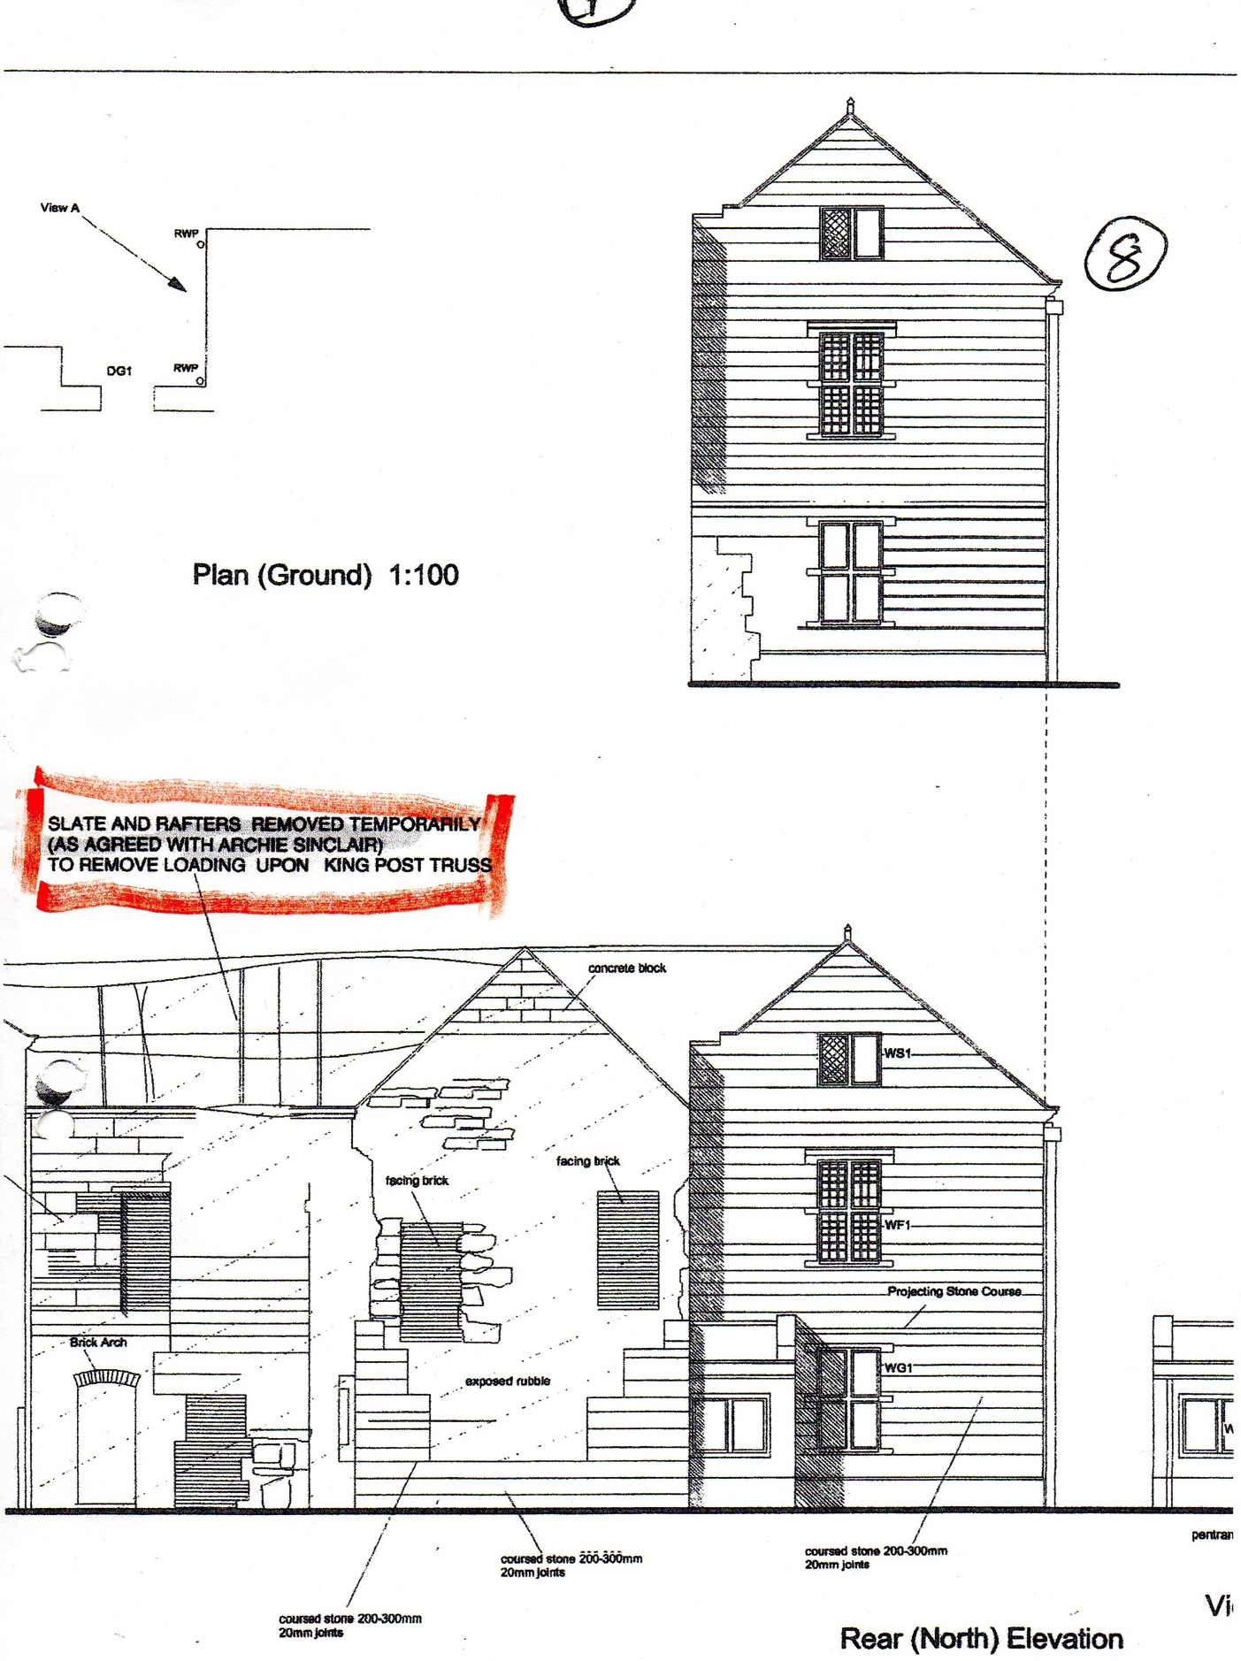

Appendix 2
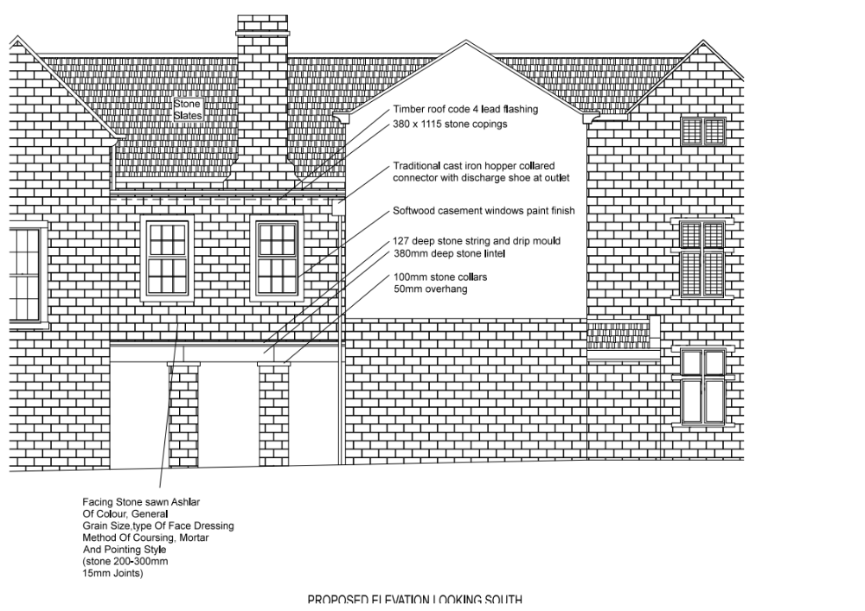

Appendix 3a

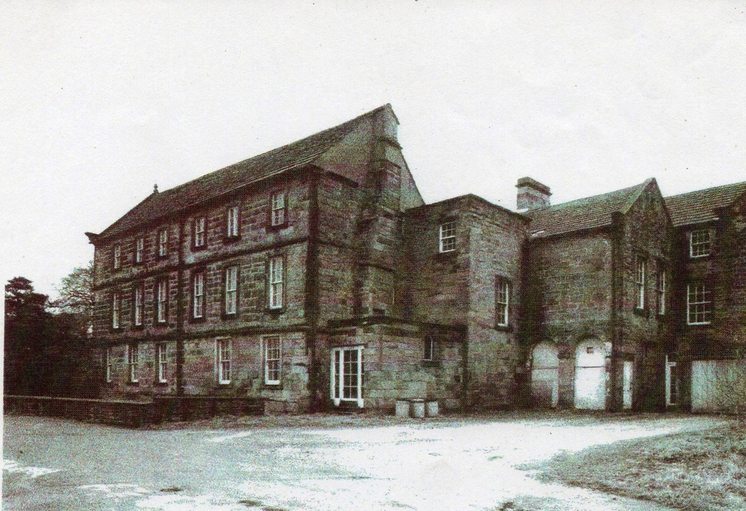
Appendix 3b

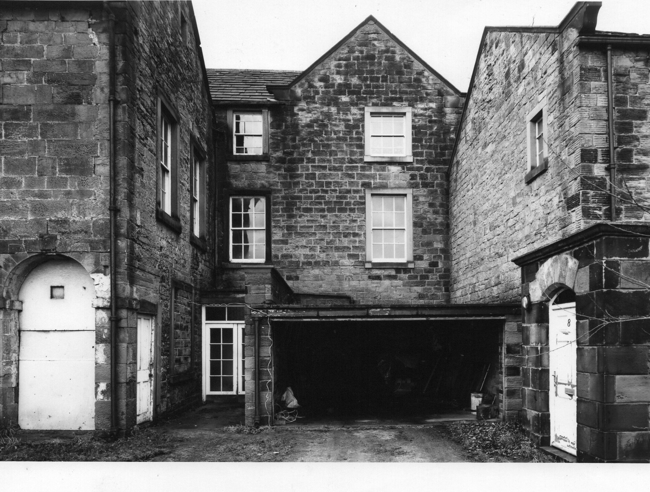

Appendix 3c

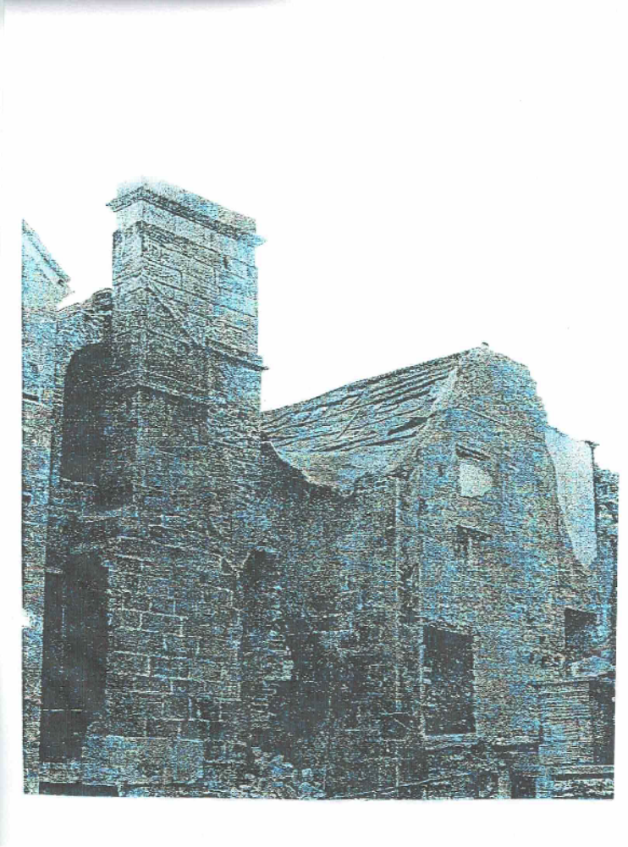

Appendix 4

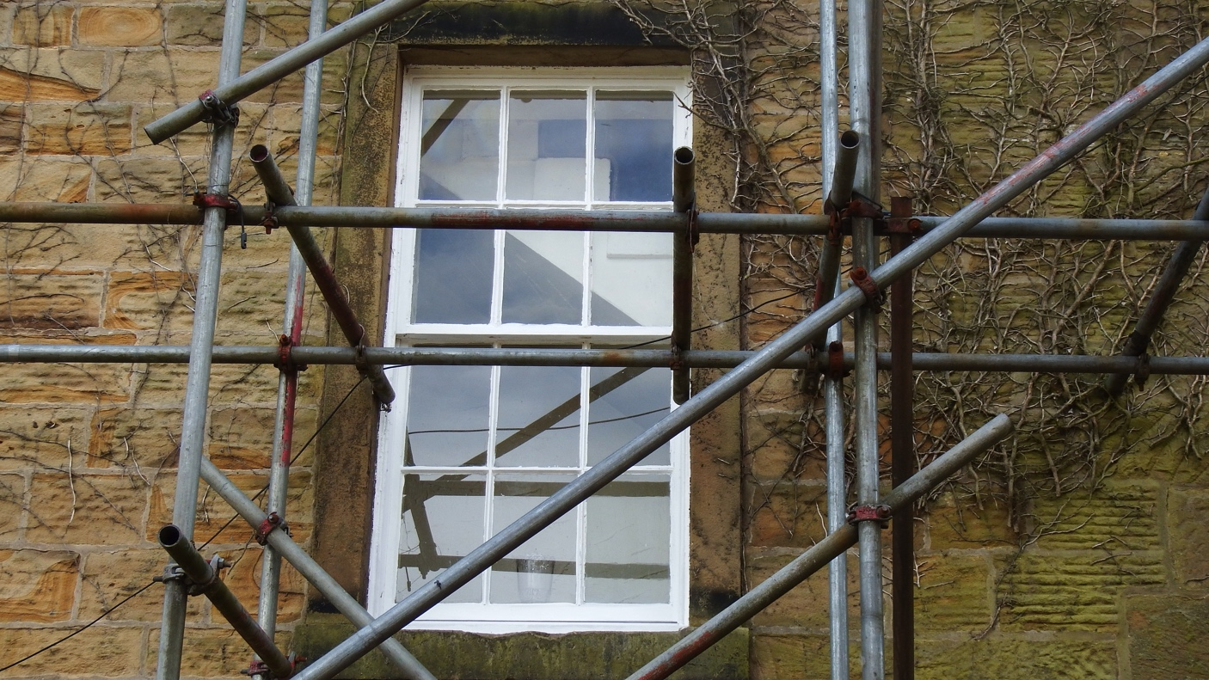

Appendix 5

