Design & Access, Heritage and Planning Statement: Cannon Hall Museum, Park and Gardens – Alterations and improvements to the stone entrance portico located on the rear elevation
Introduction
This Statement is to support the application for the proposed refurbishment of the entrance portico at Cannon Hall Museum.

Location & Site description
Cannon Hall Museum is located off Bark House lane in the village of Cawthorne.
The development area is located on the North facing rear elevation of the Museum. The site is surrounded by Parkland to the South and Woodland to the West. The site is accessible by car and on foot from Bark House Lane.
The main site pedestrian access to the site is from Car Parks sited off Bark House Lane. There is a car park located immediately outside the museum that is used solely for staff and Disabled parking.
Cannon Hall Farm and associated outbuildings including a farm shop is located to the North east of the development. The refurbishment of the porch poses no change to existing parking, or increased area of floor space.
Planning Policy (Heritage) Context

National Planning Policy Framework (NPPF)

It is recognised that a statement in support of this application will properly explain the design rationale of the proposal and how it is sympathetic and justified as it relates to the special interest of the asset. At paragraph 128 the NPPF suggests:
‘In determining applications, local planning authorities should require an applicant to describe the significance of any heritage assets affected, including any contribution made by their setting.’
The NPPF further indicates that there is a requirement to include an appropriate level of detail and description of any heritage assets affected by a proposal. The question of significance (for heritage policy) is defined as:

‘The value of a heritage asset to this and future generations because of its heritage interest………..significance derives not only from a heritage asset’s physical presence, but also from its setting.’
The NPPF sets out the Government’s vision and policies for the planning system in England and has at its heart the presumption in favour of sustainable development. The NPPF sets out twelve core planning principles including the need to:

- conserve heritage assets in a manner appropriate to their significance, so they can be enjoyed for their contribution to the quality of life of this and future generations;

Barnsley Core Strategy
Barnsley Core Strategy Policy CSP30 states that developments which affect the historic environment and Barnsley’s heritage assets will be expected to protect or improve their character an appearance. Assets specifically included in this list are listed buildings and historic parks, gardens and landscapes including Cannon Hall.
Best Practice Approach to Constructive Conservation Management.

Recent guidance from Historic England provides a clear approach in understanding how best to assess the impact of a proposal on heritage assets. This approach uses a four stage (SIPP) assessment by considering:

- Significance (identification of values which inform significance to best manage change).
- Impact (identification of what a change would result in on a scale between harm and enhancement).
- Policy (how a proposal accords with the hierarchy of - Legislation, Policy, Guidance)
- Position (Sympathetic / proportionate change or inappropriate proposal?)

General History & Context
A significant building was originally owned on the site in the 13th century by Gilbert Canun. It passed to the Bosville family in the following century and grew in importance and status. In 1650 Sir William Hewitt sold a manor, farm, land and ‘capital-messuage named Cannon Hall’ to Robert Hartley for £2,900 – a considerable sum. A few years later it was purchased by John Spencer. For almost 300 years Cannon Hall was home to the Spencer-Stanhope family who made their fortunes in the local iron industry.
In the 20 years from 1765 over £30,000 was spent on making major improvements to the Hall. Two single storey wings were added modelled on the ends of the old Hall. The rooms in the central section were remodelled in 1778 and the second stories to the two wings added in 1803-4. Final major additions to the house came in the late 19th century; they included the ballroom which was finished in 1891 and the Victorian Kitchens and Servants Quarters which were also built around this time, all of which survive intact.
The porch is located centrally on the rear elevation. The glazed Doric portico thought to be a much later edition to the original Architecture is the area of proposed refurbishment.
Cannon Hall sits in 70 acres of historic parkland looking towards the village of Cawthorne, to the west of Barnsley. In recognigition of its evident historic singificvance, the building is listed at grade II* and sits within the listed parkland (II) of Cannon Hall Park.
Heritage Values and Significance

Evidential value derives from the potential of a place to yield evidence and understanding about past activity. Often strongly associated with the archaeological record it is a value most likely to be diminished in proportion to the extent of removal or alteration. Cannon Hall its park and its associated ancillary buildings have clearly undergone extensive alteration evolution and adaptation. However, much of the original building and its setting is intact and will remain so. Moreover, the location of the proposal would not disturb any new areas (beyond the existing footprint of the porch) where archaeological remains may be present. Clearly, the removal of any historic fabric (C19 / C20 glazing and frame) risks diminishing this value. However as this value is likely to contribute minimally to the overall significance, this would need to be balanced against the ‘net gain’.
The historic built fabric of Cannon Hall and its overall arrangement offer us the opportunity for an understanding of past activities associated with the running and operation of a great estate and in a more direct and visual sense links to the historic (illustrative) value of the buildings. However, this is unlikely to be a unique example and so contributes less to our overall appreciation or understanding. In contrast to this, the aesthetic value of the listed building and its setting contributes strongly to its heritage significance. The Hall is a building of architectural quality, clearly intended to illustrate the owner’s aspirations and architectural fashion prevalent of the time. This value is recognised by the fact the house is a highly graded listed buildings which in turn reflects its ‘special interest’.
Communal values derive from the way people relate to a place and this is often related to the historic (associative and aesthetic) value a place may have. Meaning is often derived from the social value that comes from a place that embodies a source of identity, distinctiveness or coherence. Cannon Hall is obviously associated with Spencer Stanhope family who extended and adapted the buildings to their general present day arrangement. However perhaps more importantly, The Hall has a relatively strong associative value with the notable architect John Carr who was responsible for The Buxton Crescent and Harewood House and was a notable exponent of the Palladian style in England.
In summary the historic significance of Cannon Hall is derived mainly from its strong aesthetic and associative values with lesser evidential and historic values.
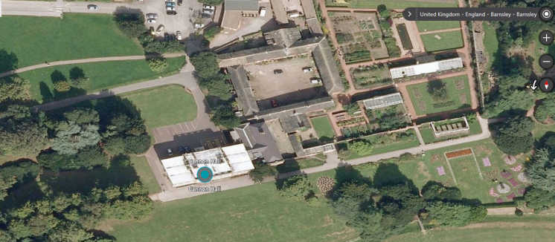
Aerial Photograph (NTS)

Design, its Impact and Mitigation
The Grade II* building is currently owned by BMBC and is currently a museum and gallery. The main entrance to the Museum is located through the timber and glazed stone portico. Due to the lack of maintenance the porch and single glazing is currently falling into disrepair and the condition of the existing stone work is poor. The stone frieze and cornice has become stained and biologically soiled from lack of maintenance and water damage.
Looking closely at the Rear elevation of the museum there is something of a mismatch in the architecture of the later porch and the house. Some of the relationships between the openings on the house and elements of the porch are for example quite uncomfortable. Generally there is a sense of a slightly ad-hoc appearance which is only heightened by the (later still) timber structure. It does have some historic value - it is after all at least 100 years old. However that aside the Victorian timber structure doesn't feel architecturally - truly sympathetic. The mouldings, panels and overall appearance of the framing are quite utilitarian. As such there seems an opportunity to replace it with a contemporary but respectful high quality design that makes the most of the structure. By virtue of a reduction in the structural timber framing, and careful positioning of glazing junctions around the columns we should actually bring the architecture forward and improve the overall aesthetics of the entrance for the viewer. This will result in an improved appreciation of the architectural form and details of the portico which itself will ultimately better reveal the heritage significance of the building. Obviously other benefits include security and vastly improved access, but a good contemporary solution could enhance the heritage significance of the building.

The proposed development is to refurbish the existing portico to form a more accessible secure and sympathetic entrance to the museum. The works will include strip out of the existing glazed timber frame windows that sit within the stone openings on all three elevations. The proposal includes for cleaning of the existing and sympathetic restoration of the stone work that forms the entrance. It is proposed that the stone/cement fillets currently located between the front facing Doric columns and stone ‘cills’ are removed to allow the provision of a more lightweight glass structure. Automatic entrance doors and automatic opening of the internal door will assist accessibility for all visitors and contribute positively both visually and economically to the building.
All the works are contained within the existing portico.
Advantages of refurbishment:
- The proposed glass structure aims to provide a more accessible, secure and sympathetic entrance to the museum. Provision of additional lighting will aim to highlight the existing stonework that is to be restored and cleaned by a specialist during the works.

- The proposal aims to use a minimal number of point fixings into the existing stonework. It is envisaged to reuse as many of the existing fixing points as possible.

- The provision of automated doors will encourage visitors to enter and increase accessibility for disabled visitors. This proposal aims to increase the revenue and the number of visitors to the museum.

- The proposed glass refurbishment aims to provide a modern and simplistic, yet bespoke solution to provide a lightweight structure set back from the front columns.

- Maintenance will be reduced.
Site constraints and protected species

The immediate site context is not located within a flood plain (See attached Flood Risk Map).

There is no immediate landscaping within a 17m radius of the porch. The proposals will not require external excavation and as such no root protection zones should be affected by the relatively light refurbishment.

Currently there is no knowledge of protected species on the site or in the immediate area.

Conclusion

In presenting this proposal were cognisant of the need to ensure the heritage significance of the asset is sustained but balanced with the need to put the building to its most viable use. With that in mind the proposals for the porch are intended to improve accessibility and legibility, but also better reveal the architecture of the portico (para 131, NPPF). We would offer that the proposal does represent some minor harm (para.132 NPPF) to the heritage significance (the loss of the Victorian timber frame), but that this is justified by the minimal contribution this element makes and the net gain that would be realised with the new access arrangements. In short we would conclude this is a good example of managed change that will contribute to the longer term sustainability and appreciation of the heritage.

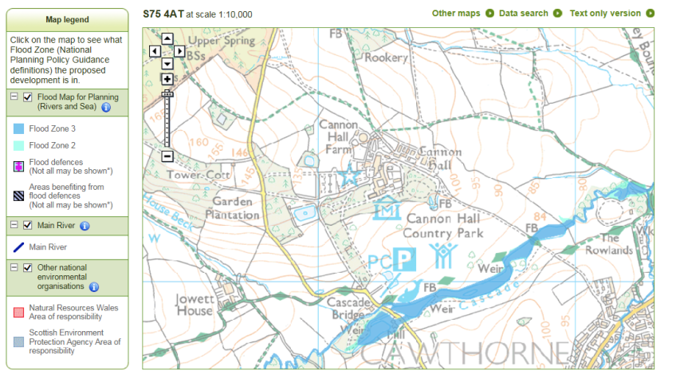
Environment Agency Flood Risk Map (NTS)

Appendix 1 – Photographs

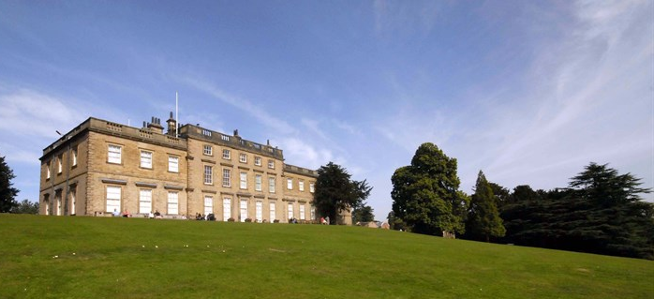
Museum Front Elevation (No works)
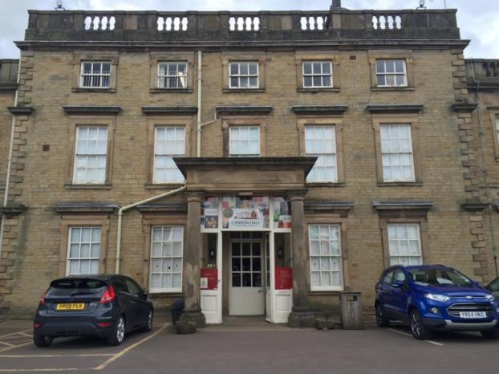
Museum Rear Elevation with a view of the centrally located Portico
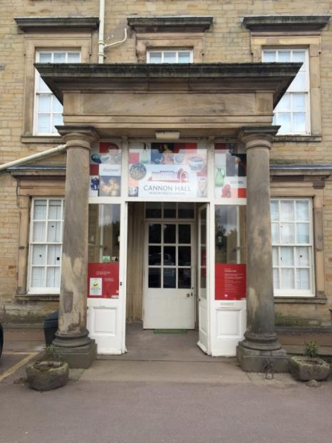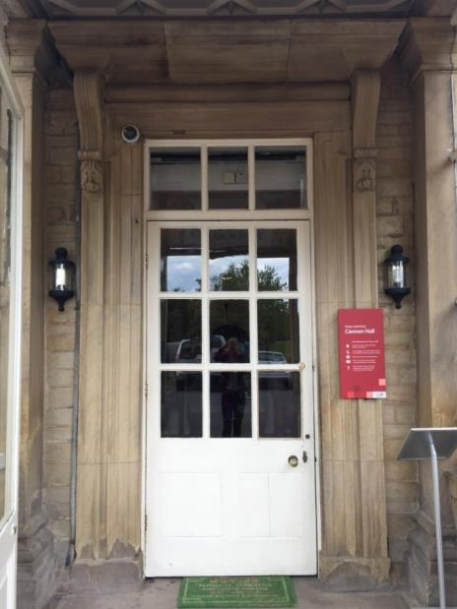
Photo of Entrance Portico (above) Existing inner door (above)

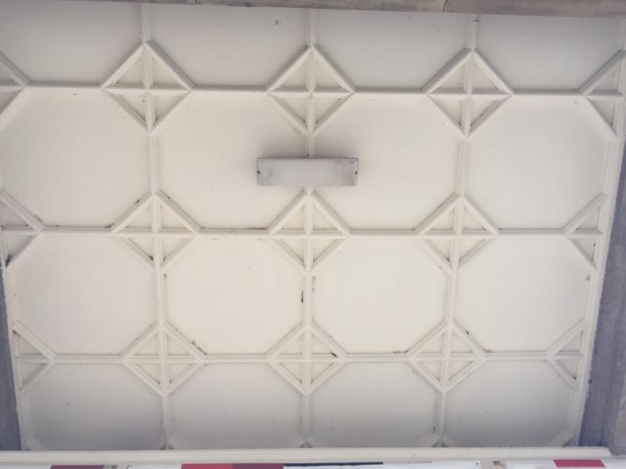
Existing Ceiling / soffit to entrance portico
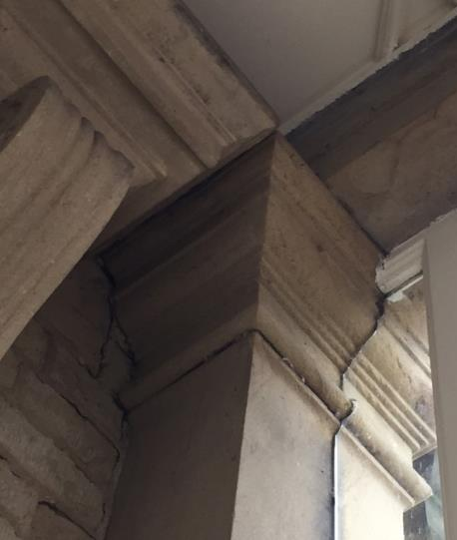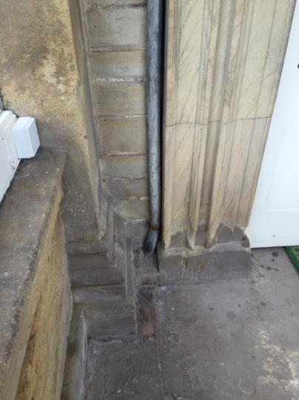
(view from inside the portico) Square columns on the building line and clash into the decorative stone door surround
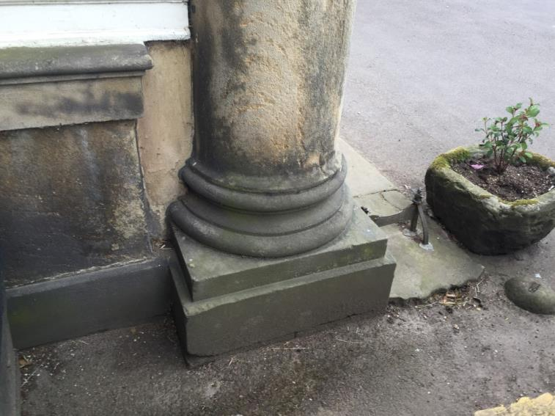
View from Side Elevation - Front Doric columns and stone cill abutment (stone cement fillet)
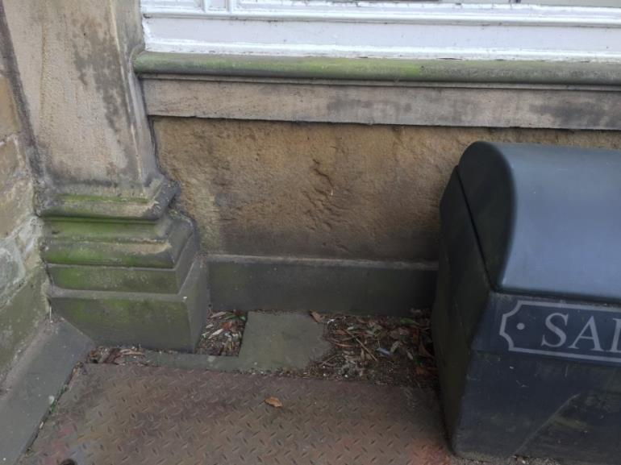
View from Side Elevation – Rear square portico columns on connected to the building façade. Apparent biological soiling on column base and stone cill is also visible on this image

Appendix 2 – Listing Description

CANNON HALL

List Entry Summary
This building is listed under the Planning (Listed Buildings and Conservation Areas) Act 1990 as amended for its special architectural or historic interest.
Name: CANNON HALL
List entry Number: 1151805

Location
CANNON HALL, BARK HOUSE LANE
District: Barnsley
District Type: Metropolitan Authority
Parish: Cawthorne
National Park: Not applicable to this List entry.
Grade: II*
Date first listed: 25-Feb-1952
UID: 334129

List entry Description

Details
SE 2708 CAWTHORNE BARK HOUSE LANE (North end, off Cawthorne)
9/3 Cannon Hall 25.2.52
GV II*
Large country house, now museum. Possibly late C17 in origin but heavily remodelled 1764-8 when single storey side wings were added. The C18 work by John Carr for John Spencer, the mason being John Marsden. The interior alterations in 1778 by John Carr i.e. the hall and dining room were stuccoed and the hall columns put in place. The side wings were heightened to two storeys in 1804 again by John Carr. The ballroom (north east wing) was added in 1890 to plans of Sir Walter Spencer Stanhope and the panelling and gallery completed by 1896. Restored 1965. Coursed dress sandstone with ashlar dressings. The symmetrical composition consists of a centre 3-storey block of 5 bays and slightly set back 2-storey side wings of 3 bays. Rusticated quoins. Sash windows in architrave surrounds, those to ground floor and 2nd floor of central block having pulvinated frieze and moulded cornice. The centre window has console brackets supporting the cornice and was once a doorway. The ground floor windows of the centre block extend to the ground and appear to have been altered and have sashes of 6 over 9 panes. Other sashes are mainly 12-pane, those to the shorter 2nd storey are of 6 panes and those to the first floor of the wings are of 3 over 6 panes. Moulded eaves cornice with balustraded parapet. Low, simple ashlar stacks set well back. The rear elevation is similar to the front but with a central, glazed Doric portico. The north-east wing projects to the left and is of 4 bays. Side elevations of the main house are of 3 bays.
Interior: The hall has Doric columns at rear with flanking pilasters. Good dog-leg stair at the rear of hall typical of the "York School". Excellent plaster ceiling in dining room of 1767, by James Henderson of York, has a centre rose, sinuous flowing foliage and musical instruments. The fireplace, of 1767, is of white and ochre marble with Ionic columns, full entablature and a central relief carving. The left room has an elaborate fireplace of 1767 from York with a C17 Dutch picture in the overmantle entitled "Still Life with Dead sane".
The house was owned by the Spencer and Spencer Stanhope families from the late C17 and was purchased by the County Borough of Barnsley in 1951. It was opened as a museum in 1957.
Barnsley MB Cannon Hall - official guide
Listing NGR: SE2721708332

Selected Sources
Other
Register of Parks and Gardens of Special Historic Interest in England, Part 37 South Yorkshire,
National Grid Reference: SE 27217 08332

