We carried out a test to check current light levels and then a test in identical locations with the sculptures outputting at full white and created 3 maps to show UNLIT/LIT/Difference (output of our lighting)
As you can see the perimeters of the site show a negligible lighting output in comparison to the local environmental lighting.
We have included the data points in the study to show the raw values and also a site photo showing it at night with the current lighting columns functional.
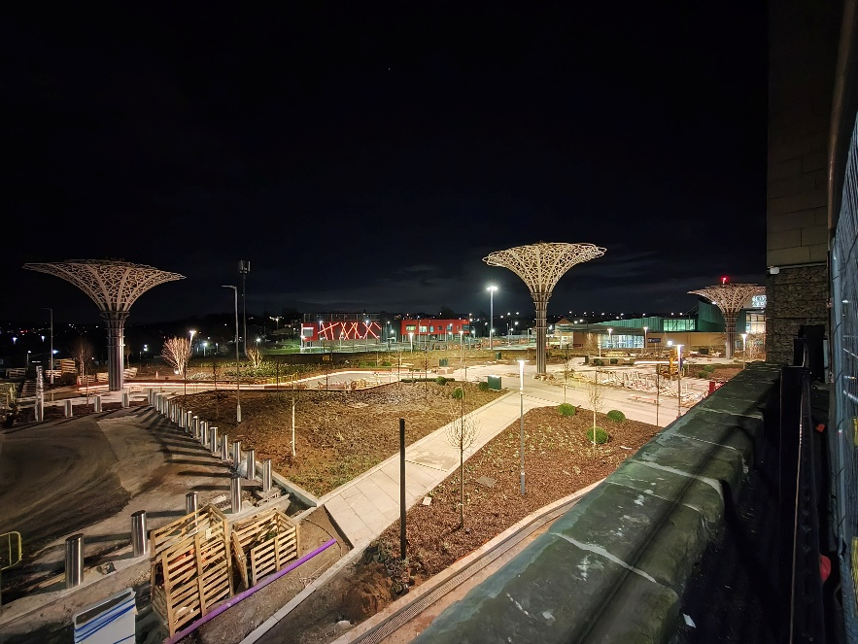

As you can see it is already quite well lit and our lighting does increase the levels in the direct area but it drops off quite significantly to the edges.
Please also see that the central sculpture levels are lower than the outer 2 due to the increased height of this sculpture.
Following our environmental light study using a calibrated lux meter, we have concluded that light levels on the nearby road are not affected by the installation. This is primarily due to the height difference between the road and the main area, where the roadside wall effectively blocks the majority of light from the adjacent north/south route.
Additionally, the existing lighting at the nearby transit station is sufficiently powerful that the impact of the three rose sculptures is negligible in comparison to the street lighting. During our testing, we did observe that current lighting levels up the ramp from the lower area are relatively low; however, we assume this may be addressed in a later phase of the project.

