**Design and Access**

**5G Electronic Communications Base Station**

**At the Existing Cellnex UK Site**

**Rooftop at 1 Market Hill**

**Barnsley**

**South Yorkshire**

**S70 2PU**

**Site Reference COL.MOD.UK.0004388**

**CELLNEX UK AND MBNL**

**23rd October 2024**

1. **INTRODUCTION**
   1. This statement is submitted in support of an application for planning permission for a 5G mobile base station for the mobile network operators (MNOs) EE Ltd and Hutchison 3G UK Ltd (the brand 3), in conjunction with Mobile Broadband Network Limited (MBNL)*.* The application site is operated by Cellnex UK, a radio site infrastructure provider.
   2. The application includes:

* A description of the site and surrounding area
* A description of the proposal
* A statement of community engagement
* A review of planning policy and heritage considerations
* A review of design and access considerations
  1. A number of other accompanying documents have been submitted in support of the application and these are referred to and should be read in conjunction with this statement.

1. **SITE AND SURROUNDING AREA**
   1. The proposal is for the upgrading of an existing rooftop site at the Exchange Building, a commercial building of approximately 13.5m in height to the top of the upper roof level. The building is situated on the southern side of Shambles Street at the junction with Market Hill and the purpose of the upgrade is to facilitate the delivery of essential improved service provision for the operator. The proposed upgrade site has been carefully selected in a position capable of providing the required coverage whilst minimising visual intrusion within the locale.
   2. The sharing of base stations between multiple operators is one of the key strategic policy principles contained within Government Guidance. H3G and EE Limited have a network sharing agreement and therefore these installations are fully compliant with the National Planning Policy Framework (NPPF).
   3. In keeping with the NPPF guidelines of using “high quality communications” (Section 10), the proposed design has been selected to minimise visual impact upon the street scene by integrating with the existing built environment.
   4. The presence of the existing replica flagpole mounted equipment sets a clear precedent for telecommunications development in this location and indicates that the principle of this proposal is acceptable in terms of siting. As stated above, the National Planning Policy Framework advocates site sharing, and as such we believe that there are no sequentially preferable locations within the defined site search area.
   5. The design of the proposed equipment is considered to be the least visually intrusive option available given the level of equipment required for 5G. Although it is accepted that there will be a marginal intensification in the amount of equipment, it is considered that such a minor increase would not detract from the character of the area with any visual effects being significantly outweighed by the immense benefits of the new 5G connectivity.
   6. It is important to note that in addition to being the sequentially preferable solution, the upgrading of an existing site will fit in within the existing network configuration thereby eliminating the need to introduce additional base stations within the cell search area. Any other proposal to satisfy the identified requirement would result in the addition of a separate ground-based column or additional rooftop mounted base station elsewhere in close proximity to the existing site. In our opinion, such a proposal would, in this instance, unnecessarily add to the clutter in the streetscene and result in a greater visual impact.
2. **THE 5G PROPOSAL**
   1. The development proposed is shown in detail in the drawings submitted and is for a new 5G electronic communications base station. The deployment of 5G will utilise the MNOs existing 3G and 4G networks such as the base station already existing at the application site. As such, the application site is likely to carry different mobile connectivity services in parallel, with high data uses operating through the new 5G higher capacity network apparatus subject of this application.
   2. Unlike earlier generations of mobile connectivity, 5G has more significant technical and operational requirements and this has implications on the amount, height, position and design of the new base station apparatus on the rooftop of the building. To help explain this important detail, we have set this out in the accompanying **“*5G Technical Support’*** document,which must be read in conjunction with this planning statement.
   3. The principal elements of the proposed development at the application site reflect these various siting and design factors within the technical support document:

* The removal of an existing flagpole antenna structure and associated ancillary equipment.
* The installation of a replacement upgraded flagpole structure and associated ancillary equipment.
* The installation of small-scale radio ancillaries at roof top level.
* The removal and replacement of equipment cabinets at lower rooftop level and behind an existing parapet wall.
* The installation of cabling and associated development.
  1. Paragraphs 16 & 17 of the Code of Practice for Wireless Network Development in England, published in March 2022, explain how mobile networks operate. In the annual network rollout information supplied, the operators will have explained their network requirements for 5G and the anticipated use of existing sites, including those owned by radio site infrastructure providers like Cellnex UK.
  2. The application site has been selected by the operator as this will provide the required level of 5G network coverage while properly meeting national town planning policy objectives for the shared use of existing electronic communication sites, in this case operated by Cellnex UK.

1. **PRIOR ENGAGEMENT**
   1. The recently revised National Planning Policy Framework (NPPF) and the Code of Practice for Wireless Network Development in England require a consultative approach to network development with the planning authority and local community, reflecting the particular sensitivities of any given site. The proposal received an Amber score when assessed against the traffic light rating model as referenced in the Code of Practice.
   2. The pre-application consultation in relation to the application site was undertaken with your Authority and Ward Councillors (Nicola Sumner, Martin O'Donoghue and Janine Moyes), Barnsley Sixth Form College (The Headteacher) and 1st Safari – Sandpit Nursery (The Manager). At the time of submission there has been no response to this pre-application consultation and accordingly we would be pleased to address any necessary matters within the determination period of the application.
2. **PLANNING POLICY**
   1. The relevant planning policy and best practice framework is found principally within:

* National Policy, especially the National Planning Policy Framework (NPPF)
* The local policy framework set out in the adopted Development Plan;
* The Code of Practice for Wireless Network Development in England.
* Regent Street / Church Street / Market Hill Conservation Area Appraisal
  1. From these documents can be discerned the general policy background that exists for electronic communications development, site specific policies and the key considerations relevant to the siting and design of appropriate electronic communications development. As planning authority, you will be familiar with this framework and so in the interests of brevity, we do not rehearse it back to you in detail but address instead the principal themes to demonstrate that the application accords with them.

#### National Support for Modern Communications

* 1. There is significant UK Government support for the delivery of 5G, particularly as this new connectivity will be a step change from earlier generations of mobile connectivity and will be critical to economic growth and sustainable communities. Our accompanying document of national policy ‘**National Policy -** **Delivering Ultra-Fast Broadband Mobile Connectivity’,** sets out how 5G mobile connectivity will underpin the UK Digital Economy and the significant social, economic and sustainability benefits of advanced modern connectivity. It is essential that the planning system looks to support and facilitate new 5G base station installations such as that proposed to meet the Government’s Digital Strategy. In addition, modern connectivity, such as 5G, will be essential to help the Government meet its wider sustainability and climate change targets and we explain this in more detail in our accompanying document ‘***5G – Helping tackle climate change’***.

**The Need to Conserve the Historic Environment**

* 1. In this case the site is situated within the Regent Street / Church Street / Market Hill Conservation Area and therefore a Heritage Statement has been provided in support of the proposal.

**Heritage Statement**

* 1. The upgraded telecommunications equipment will be located on the rooftop of the Exchange Building, a commercial property of approximately 13.5m in height to the top of the upper roof level situated at the junction of Shambles Street and Market Hill. The existing tri-sector antennas are discretely monitored in a replica flagpole structure and the proposal will involve replacement of the installation with a similar flagpole structure along with additional low level ancillary equipment in close proximity to the base of the pole.

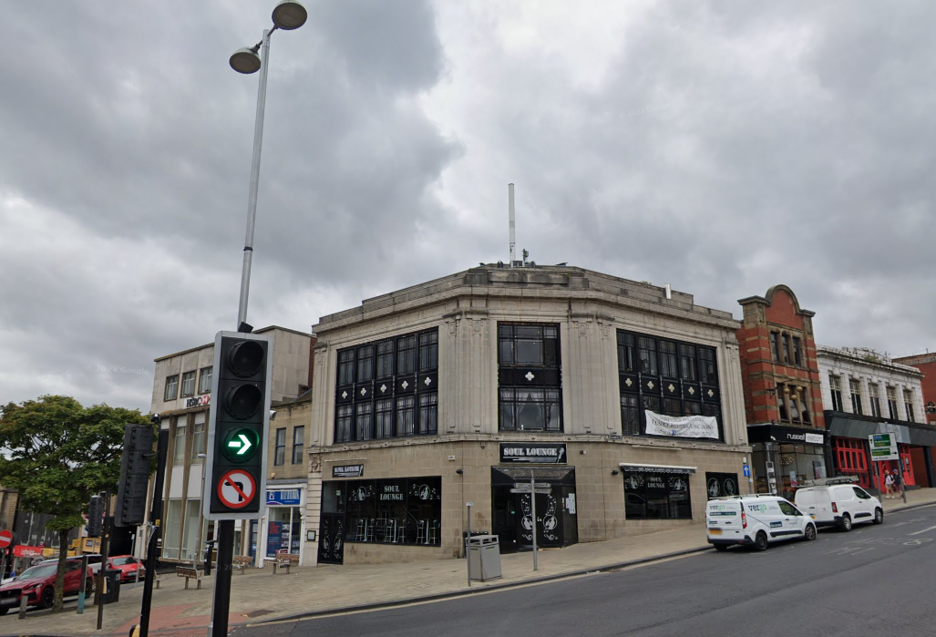

Figure 1: Exchange Building Tower from Church Street

* 1. The upgraded tri sector antennas will be installed in the same position as the existing that will be removed to facilitate the upgrade with a marginal increase in width of a short section below the central area of the flagpole structure to support the provision of essential new 5G coverage. The visual effects will be extremely minor due to the small scale of the replacement installation in comparison to the overall bulk of the host and surrounding buildings and minor changes between the existing and proposed equipment. The proposed upgrade is the least visually intrusive coverage solution available and has been carefully sited and designed to respect the aesthetics of the sensitive surrounding area. It is important to note that the proposed alterations will not have a negative impact on the Conservation Area and nearby listed buildings.
  2. As demonstrated by the comparison of existing and proposed east elevation extracts below the replacement flagpole structure will be mounted in the same position with similar proportions to the existing. The visual effects of the proposed upgrade will be negligible at ground level and will not harm the sensitive setting of the Conservation Area.

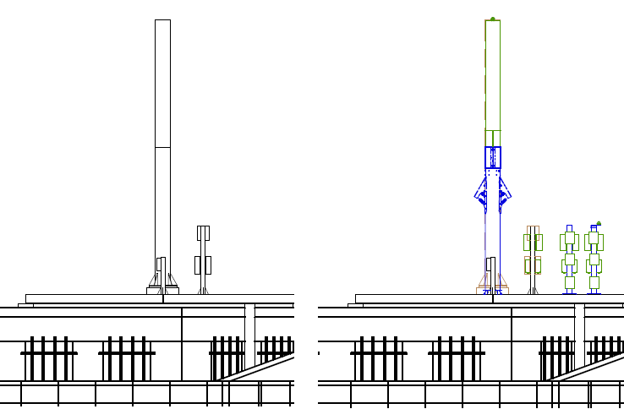

Figure 3: Comparison of Existing and Proposed South East Elevation

* 1. It should also be noted that the replacement equipment cabinets will be installed in similar positions to the existing with no changes being required to the mounting base arrangements. The small-scale ancillary radio equipment has been mounted away from the edge of the roof area and wherever possible below parapet level to eliminate any visual effects from ground level.

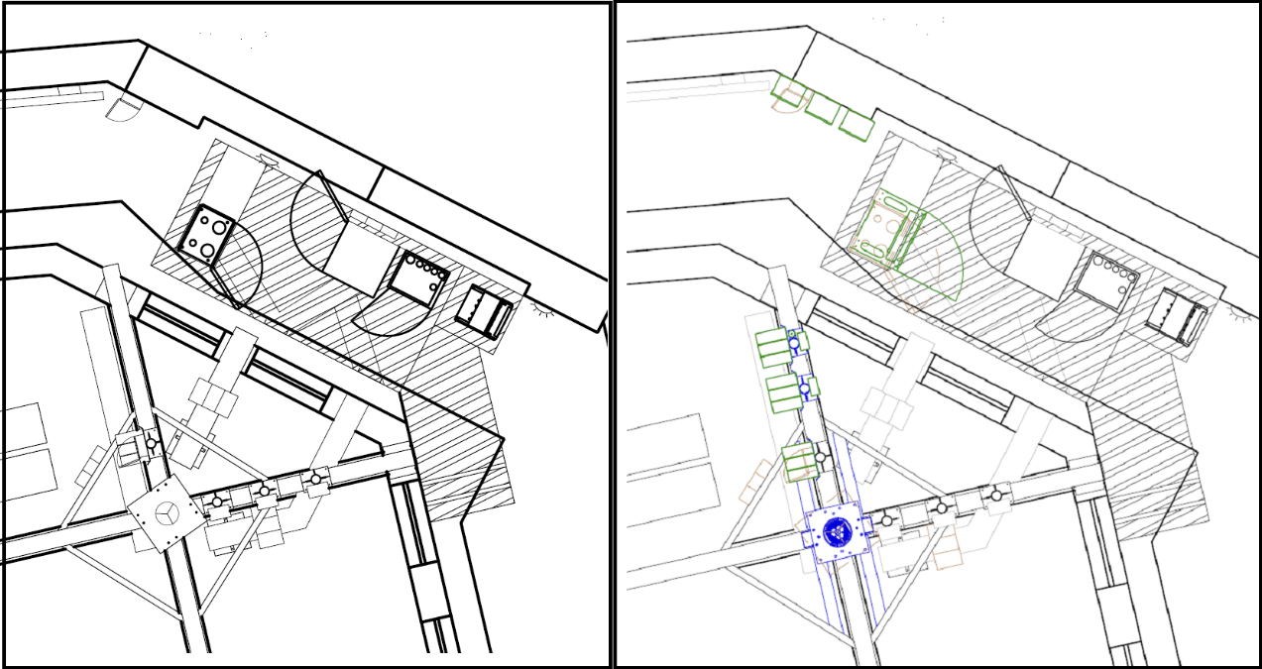

Figure 8: Ancillary Equipment Details

* 1. The proposed upgrade is the least visually intrusive coverage solution available within the sensitive Conservation Area setting and has been carefully sited and designed to respect the aesthetics of the sensitive surrounding area. It is important to note that the proposed alterations will not have a negative impact on the Conservation Area or setting of the nearby listed buildings.
  2. The general presumption in favour of allowing development for modern communications, and the special operational and technical factors that require siting of base stations within conservation areas, is balanced by the need to conserve or enhance their heritage qualities.
  3. However, there is now far greater emphasis that visual impact should not override significant radio planning requirements to achieve mobile coverage to a particular area, particularly with the need to support the massively growing and intensifying demand for mobile communications across the UK. Indeed, in terms of looking to meet operational needs, the NPPF now applies a reduced policy test compared to previous guidance. This helps clarify than an operator is only required to satisfy the normal test of acceptability having regard to all material planning circumstances, rather than looking for the ‘optimum’ solution as required under the former PPG8.
  4. In balancing these requirements, the starting point for planning new networks or the expansion of existing networks is to use existing electronic communications sites owned by other operators or radio site management companies, such as Cellnex UK. This policy objective is backed with the statutory obligation placed upon operators to share apparatus, where practicable under General Condition 3(4) of the Electronic Communications Code (Conditions and Restrictions) Regulations 2003, as amended.
  5. In this instance, the installation of upgraded apparatus on this existing telecommunications site hosted on a commercial building within the Regent Street / Church Street / Market Hill Conservation Area, rather than the introduction of an entirely new and separate base station***,*** aligns with this longstanding policy.
  6. Nonetheless, any potential harm the apparatus would cause to the designated heritage asset must be assessed, as set out in NPPF paragraph 201 and how to avoid or minimise conflict between the heritage asset’s conservation and any aspect of the proposal. In this case, all reasonable steps have been taken, through careful siting at an existing Cellnex UK site, to moderate the visual impact of the development, having regard to technical and operational factors. Accordingly, the proposal looks to conserve the heritage asset.
  7. In so far as there may be any perceived harm, the development proposal will have less than substantial harm to the significance of a designated heritage asset and as such, this harm has to be weighed against the public benefits of the proposal (paragraph 208). In this respect the base station is required as part of a national mobile communications network, necessary to extend and improve mobile connectivity to the local area and has wider public interests. As explained, the target coverage area falls within the designated area and the special operational and technical requirements necessitate siting of new apparatus within it.
  8. It should also be noted that in a recent appeal relating to proposed rooftop telecommunications equipment on Cabridge House, Cambridge Grove in Fulham the Inspector ruled in favour of the applicant (appeal decision ref: APP/H5390/W/20/3260941 - MBNL vs London Borough of Hammersmith and Fulham – allowed 21/03/2022).
  9. The Inspector set out the following conclusions regarding assessment of ‘substantial’ and ‘less than substantial harm’ and emphasised the need to avoid conflating change with harm:
  10. *‘It is important not to conflate change with harm, as the terms are not synonymous. The Council has not set out what aspects of the character and appearance of the area, or how the significance of the heritage assets, would be harmed by the siting and design of the proposed antennas. The Council suggest that the proposal would cause substantial harm to the heritage assets, however, substantial harm is a very high bar and the evidence provided by the Council does not bear this out. Nor does it demonstrate that less than substantial harm would occur.*
  11. *I therefore find that the proposal would not cause harm to either the character and appearance of the conservation area or the setting of the nearby listed buildings and would thus preserve their significance. These are the key components that define the character and appearance of the area around the appeal site.*
  12. *Consequently, I conclude that the siting and design of the proposal would not cause harm to the character and appearance of the area or the significance of the designated heritage assets.’*
  13. The Inspector’s Report for appeal ref: PP/P4605/W/21/3271311 (Telefonica UK Limited / Birmingham City Council - allowed 16/11/2021) sets out the following relevant conclusions within the ‘Planning Balance’ section:
  14. *The harm that would occur to the setting of the Listed Building would not be severe and therefore it would be ‘less than substantial’ within the meaning of the Framework. Paragraph 202 of the Framework requires such harm to be weighed against the public benefits of the proposal.*
  15. *In this instance, the proposed development would provide 5G telecommunications coverage, in addition to enhance 2G, 3G and 4G coverage. This allows for improved connectivity to modern mobile telecommunications services. This would be of benefit to nearby residents in the surrounding in the undertaking of household and recreational activities.*
  16. *In addition, the proposed development would be of benefit to businesses through the provision of an enhanced communications system. In consequence, the proposed development would offer some benefits by enabling increased amounts of economic activity to take place.*
  17. Whilst it is acknowledged that there will be some limited visual effects within the immediate vicinity of the Exchange Building, the proposal will result in less than substantial harm to the significance of the Conservation Area setting. The impact of any perceived harm, or change to the setting, should be weighed against the public benefits as set out in paragraph 208 referenced above. In this instance, the public benefits of the proposed upgrade site are significant, bringing essential new and upgraded mobile connectivity to a key district within the central Barnsley area.
  18. As a matter of principle, the development proposed is in accordance with the relevant policy framework and should therefore be acceptable. In the next section, the Design Considerations are reviewed to demonstrate that the detail of the development is also acceptable and that in accordance with the presumption in favour, planning permission should be granted.

#### Local Policy Considerations

1. At local level, the proposal has been considered against the Barnsley Local Plan (Adopted January 2019) Policy D1 High Quality Design and Place Making and Policy GD1 General Development.

Policy D1 High Quality Design and Place Making states:

*Design Principles:*

*Development is expected to be of high quality design and will be expected to respect, take advantage of and reinforce the distinctive, local character and features of Barnsley, including:*

*Landscape character, topography, green infrastructure assets, important habitats, woodlands and other natural features;*

*Views and vistas to key buildings, landmarks, skylines and gateways; and*

*Heritage and townscape character including the scale, layout, building styles and materials of the built form in the locality.*

*Through its layout and design development should:*

*Contribute to place making and be of high quality, that contributes to a healthy, safe and sustainable environment;*

*Complement and enhance the character and setting of distinctive places, including Barnsley Town Centre, Penistone, rural villages and Conservation Areas;*

*Help to transform the character of physical environments that have become run down and are lacking in distinctiveness;*

*Provide an accessible and inclusive environment for the users of individual buildings and surrounding spaces;*

*Provide clear and obvious connections to the surrounding street and pedestrian network;*

*Ensure ease of movement and legibility for all users, ensure overlooking of streets, spaces and pedestrian routes through the arrangement and orientation of buildings and the location of entrances;*

*Promote safe, secure environments and access routes with priority for pedestrians and cyclists;*

*Create clear distinctions between public and private spaces;*

*Display architectural quality and express proposed uses through its composition, scale, form, proportions and arrangement of materials, colours and details;*

*Make the best use of high quality materials;*

*Include a comprehensive and high quality scheme for hard and soft landscaping; and*

*Provide high quality public realm*

*In terms of place making development should make a positive contribution to achieving qualities of a successful place such as character, legibility, permeability and vitality.*

Policy GD1 General Development states:

*Proposals for development will be approved if:*

*There will be no significant adverse effect on the living conditions and residential amenity of existing and future residents;*

*They are compatible with neighbouring land and will not significantly prejudice the current or future use of the neighbouring land;*

*They will not adversely affect the potential development of a wider area of land which could otherwise be available for development and safeguards access to adjacent land;*

*They include landscaping to provide a high quality setting for buildings, incorporating existing landscape features and ensuring that plant species and the way they are planted, hard surfaces, boundary treatments and other features appropriately reflect, protect and improve the character of the local landscape;*

*Any adverse impact on the environment, natural resources, waste and pollution is minimised and mitigated;*

*Adequate access and internal road layouts are provided to allow the complete development of the entire site for residential purposes, and to provide appropriate vehicular and pedestrian links throughout the site and into adjacent areas;*

*Any drains, culverts and other surface water bodies that may cross the site are considered;*

*Appropriate landscaped boundaries are provided where sites are adjacent to open countryside;*

*Any pylons are considered in the layout; and Existing trees that are to remain on site are considered in the layout in order to avoid overshadowing.*

Policy HE1 – The Historic Environment includes the following relevant policy aspects:

*We will positively encourage developments which will help in the management, conservation, understanding and enjoyment of Barnsley’s historic environment, especially for those assets which are at risk*

*This will be achieved by:-*

*a - Supporting proposals which conserve and enhance the significance and setting of the borough’s heritage assets, paying particular attention to those elements which contribute most to the borough’s distinctive character and sense of place. These elements and assets include:-*

*18 designated conservation areas of special and architectural interest including three town centre conservation areas, as well as large areas incorporating Stainborough Park, Cawthorne, Penistone and Thurlstone.*

*c - By supporting proposals that would preserve or enhance the character or appearance of a conservation area. There are 18 conservation areas in the borough and each is designated for its particular built and historic significance. This significance is derived from the group value of its constituent buildings, locally prevalent styles of architecture, historic street layouts and its individual setting which frequently includes views and vistas both into and out of the area. Particular attention will be given to those elements which have been identified in a Conservation Area Appraisal as making a positive contribution to its significance.*

* 1. In accordance with the importance Policy D1 Design Principles and GD1 General Development place on minimising visual impact, the proposal is for a sensitively designed upgrade of an existing shared site housed within a flagpole structure on the rooftop of the Exchange Building at Market Hill. The visual effects of the proposed upgrade will be softened by the removal of existing equipment and the replacement tri-sector antennas and associated ancillaries will be installed in a similar position. It is considered that the proposed upgrade will not overly intrude into the locality and any associated visual impact will not outweigh the continued need and future demands to provide coverage to the surrounding area.
  2. In accordance with Policy HE1’s requirement for developments to preserve the *‘the character or appearance of a conservation area*, the visual effects of the proposed upgrade will be minor being of small scale in comparison to the overall bulk of the host building and of similar appearance to the existing. It is felt that the upgrading of an existing rooftop site will be a significantly less visually intrusive solution than introducing a new and entirely separate ground or rooftop-based facility within the cell search area.
  3. In accordance with policy requirements the visual effects have been minimised by keeping the height and bulk of the replacement tri-sector antennas down to the absolute minimum capable of achieving the required coverage and the visual effects of the upgrade will be softened by the removal of existing equipment. It is also worth stating that the equipment enclosure upgrades will be out of sight below parapet level. The visual effects of the proposed upgrade will be further reduced by the high density of surrounding buildings limiting the field of view towards the site.
  4. The proposed development is therefore considered to strike the best balance between meeting the specific network requirements for the operators and minimising environmental impact.

1. **DESIGN CONSIDERATIONS**
   1. The local development proposed is exempt from the requirement to provide a design and access statement under Article 9 of The Town and Country Planning (Development Management Procedure) (England) Order 2015, as amended. However, to assist your consideration of the detail, this section provides a description of the process adopted in the design of the proposals and explains the access considerations. Due regard has been given to the factors addressed from Paragraph 20 of the Code of Practice.

**Physical Context**

* 1. The proposed upgrade site has been carefully selected in a position capable of providing the required new essential 5G coverage within the setting of an existing base station housed within a replica flagpole structure on the rooftop of the Exchange Building at the junction of Shambles Steet and Market Hill.
  2. The site lies within the Regent Street / Church Street / Market Hill Conservation Area and the proposal is for the sensitively designed upgrading of an existing installation rather than introducing a new base station within the target area. The visual effects of the proposed upgrade will be extremely minor with the upgraded tri-sector antennas to be fitted to a replacement flagpole structure in the same position as the existing. The height and bulk of the upgraded flagpole structure has been kept down to the absolute minimum capable of providing the required coverage and the ancillary equipment enclosure upgrades have been positioned out of sight below parapet level. The upgrading of an existing shared existing facility will fit into the existing network configuration thereby eliminating the need to provide new and entirely separate additional base stations within the target area.
  3. The visual envelope of the existing and proposed equipment will be extremely constrained by the high density of surrounding tall buildings. These masking effects will be further enhanced at ground level by scattered tree planting housed within the pavement area on the northern side of Shambles Street. The site has been carefully selected in a position capable of providing the required essential upgraded coverage whilst being situated as far away as technically possible from the views of residential receptors and represents the least visually intrusive coverage solution within the sensitive conservation area setting.

**Amount, Layout and Scale of the Development**

* 1. The scale, layout and design of the development has been guided by the special 5G technical and operational factors affecting the need to provide coverage to the local area, having regard to the need to minimise visual impact. With regard to the main component elements of the development proposed***:***
* **Kept in proportion to the building or structure**

The scale of the apparatus is not large and when installed should look proportionate to the structure as a whole.The tri-sector upgraded antennas are similar to the existing electronic communications apparatus installed on the building and will therefore be seen in the context of this apparatus and will not appear as incongruous or jarring additions to the building.

* **Respect architectural style**

Within the severe technical constraints, the apparatus shall be installed in a manner that respects architectural style. The scale of the equipment has been kept down to the absolute minimum capable of providing the required coverage and elements of the existing building have been incorporated in the design to screen views of the equipment wherever possible.

* **Have minimal impact above the roofline commensurate with technical constraints**

The apparatus that projects above the roofline has been kept to the minimum having regard to the technical parameters and design considerations explained above. The impact on the apparatus remains contained and new views towards this apparatus from elsewhere within the Conservation Arearemain limited.

* **Not be detrimental to views and general skyline**

A combination of design, topography and natural and manmade features should help keep any perceived changes to views and the skyline to within acceptable limits. Indeed, within the context of this urban location the attention of the casual observer is likely to remain be focussed more upon the streetscape.

* **Avoid creating clutter**

The apparatus should not look unduly cluttered and insofar as it might be visible it will be viewed as operational electronic communications equipment compatible and now expected on a building designed and constructed exclusively for electronic communications purposes.

* **Use clean lines and maintain symmetry**

The apparatus has clean lines and has been sited to maintain symmetry with both the building and its different elements.

* **Painted to correspond with the background or to reduce contrast**

The replacement tri-sector antennas and associated replica flagpole housing will be finished in colouring designed to match the existing structure. If you consider alternative colours to be appropriate, please let us know.

**Antenna Array**

* The numbers of antennas and their size has been kept to the minimum necessary to provide 5G coverage and to link this site back into the operator’s network. The design of these features is very much driven by operational and technical factors.

**Equipment Cabinets**

* + The number of radio equipment cabinets and their size has been limited to what is required to meet the operator’s current and foreseeable network requirements. The location and design of the equipment cabinets, and the electronic communications equipment housed within them, reflects their functionality and the technical and operational requirement to be in reasonable proximity to the antenna systems and / or dishes that they support. This avoids exceptionally large runs of feeder cables and associated supporting trays, and the subsequent loss of signals.

**Access Considerations**

* 1. Access to the site will be provided from the existing rooftop access points. These established access routes do not require any amendment as part of the development proposed. Once constructed, the development will be unmanned requiring only periodic visits, typically once every two to three months for routine maintenance and servicing.
  2. In accordance with all relevant health and safety legislation and guidelines, access to the site will be restricted to authorised personnel and the routine maintenance and servicing of the apparatus will only be carried out by properly trained and qualified staff. Electronic communications base stations are specifically designed to prevent unauthorised access by members of the public and, therefore, there is no requirement to incorporate inclusive access arrangements into the proposed layout and design of the development.

**Landscaping**

* 1. The proposed siting of the development has been very carefully chosen to minimise environmental impact. The height of the apparatus on an existing rooftop means that any attempt to screen it in its entirety would be unrealistic in any event.
  2. The ancillary equipment enclosure upgrades will be out of sight set back from the edge of the roof to mitigate its impact in views from public vantage points nearby. The visual effects of the replacement upgraded trisector antennas will be extremely minor, and any impact will be softened by the removal of existing equipment as part of the upgrade proposal. For these reasons, additional landscaping is not considered necessary or appropriate to the setting and has not been included within the scheme.

**Appearance**

* 1. The sensitive approach to siting and design should minimise the appearance of the development proposed. In addition, as indicated above the local topography and natural features should help minimise views. Insofar as the apparatus may be visible, they should look straight forward in appearance and reflect its function. To that extent they should in time become accepted features of the local environment as with other forms of communications networks and essential public utility infrastructure, such as roads and railways.

1. **HEALTH AND SAFETY**
   1. In support of the application, we include a separate document called ***‘5G Health and Safety’*** which sets out in more detail the associated health and safety considerations. Every installation on a site owned or managed by Cellnex UK will be compliant with international standards adopted by the UK Government. A certificate confirming compliance with the relevant ICNIRP guidelines on public exposure has been supplied with this application.
   2. The ICNIRP guidelines seek to protect against the well-known thermal effects of radio emissions and include a significant precautionary factor. These guidelines apply to all forms of electronic communications and mobile technology is one of the lowest powered of these.
   3. National planning policy remains clear, provided an application is certified as ICNIRP compliant, local planning authorities should not seek to effectively set different guidelines through the refusal of planning permission.
2. **SUMMARY AND CONCLUSIONS**
   1. In summary, the application is in respect of a 5G electronic communications base station necessary to improve a vital network that provides public services.
   2. The service provided by the operator is in the public interest and is in very high demand, with 5G being the next and highly significant advancement in mobile connectivity. In the UK there are now more than 111 million subscriptions to mobile networks and mobile services now exceed fixed landlines in terms of customer numbers and usage.
   3. The public interest of the system is clear from the considerable benefits that will flow and it makes a significant and major contribution towards sustainable objectives.
   4. The operator’s requirement is in the context of network needs associated with a 5G cellular system. These impose particular locational and siting requirements which are even greater with 5G. The technical justification clearly demonstrates the need for this apparatus proposed within the context of the operator’s surrounding network.
   5. The operator(s) have followed national and local planning policy and best practice guidance in the siting and design of its apparatus in recognition of the need to minimise visual impact. This has included:
   * Network planning based upon existing sites, including those controlled by Radio Site Management companies like Cellnex UK.
   * Siting at an existing electronic communications site to minimise new sites and help avoid the unnecessary proliferation of new radio masts and sites for them.
   * Engagement in accordance with the Code of Practice procedures.
   * An examination of design options to try and minimise potential visual impact.
   1. The proposed antennas will comply with all relevant health and safety requirements and will be compliant with the ICNIRP guidelines. There are no exceptional circumstances in this case and therefore no need to consider health effects and related concerns such as the perception of risk further.
   2. This statement and the other accompanying material has demonstrated that the proposal is in accordance with local Development Plan policy and national policy set out in particular within the NPPF. In particular it is a form of development that is specifically encouraged as a matter of principle and in its detail complies with the policy objective of minimising potential environmental impact.
   3. In conclusion, the application is for sustainable development, acceptable as a matter of principle and appropriate in its detail and so one which the presumption in favour of granting approval applies.