PLANNING STATEMENT
IN SUPPORT OF APPLICATION FOR
LAWFUL DEVELOPMENT CERTIFICATE
FOR EXISTING USE OF SINGLE DWELLING
AT 10 HOPWOOD STREET, BARNSLEY S70 2BW
AS HOUSE OF MULTIPLE OCCUPATION

Prepared by:
Richa Rishiraj
58 Spire Heights
Chesterfield, S40 4BF

06th April 2021

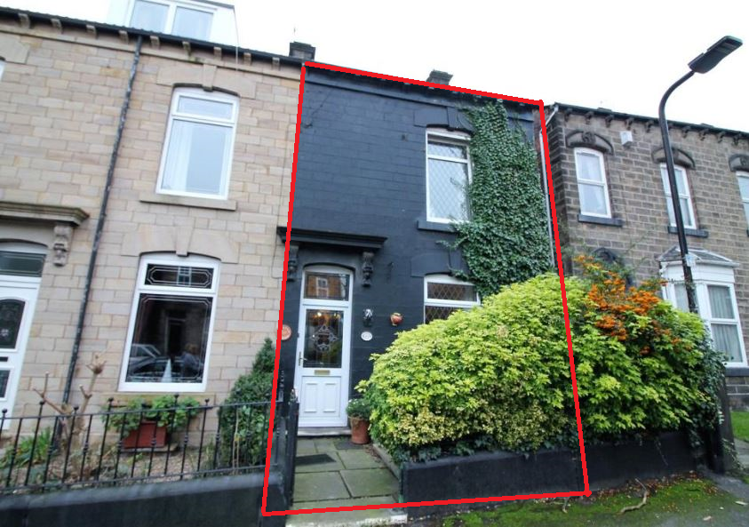

Introduction
This application seeks to establish the lawful use of the single dwelling terraced house located at 10 Hopwood Street, Barnsley, S70 2BW (shown on the location plan below) as a House of Multiple Occupancy.
The dwelling comprises of 5-ensuite bedrooms over 3 floors.

Statement of Case
The dwelling was being used as a residential property and was bought by HJPT Properties Limited on 15-Jul-2019 where applicant is the director of (Appendix A). The dwelling was refurbished (including adding en-suites to bedrooms) under standard Permitted Development rights to be used as 5-bed House of Multiple Occupancy (HMO) following standards set by HMO regulations and under Building Control’s supervision (Appendix B).
After refurbishment was completed in December 2020, an application (reference: 101000584753) for the property to be used as HMO was submitted with Barnsley Council on 04-Jan-2021. HMO licence officer inspected the property and was satisfied that the property meets the legal minimum standards set out in the Housing Act 2004 and national licencing and management regulations 2006 available with Barnsley Council. The HMO licence (reference: ML 533) was provisionally granted on 07-Jan-21 (Appendix C) and was issued on 24-Mar-2021. (Appendix D).
The property has been tenanted since 15-Feb-21 and is shared by 5 people from multiple households.

Property Description
The property is located at 10 Hopwood Street in Barnsley which is in the Yorkshire and The Humber region of England.

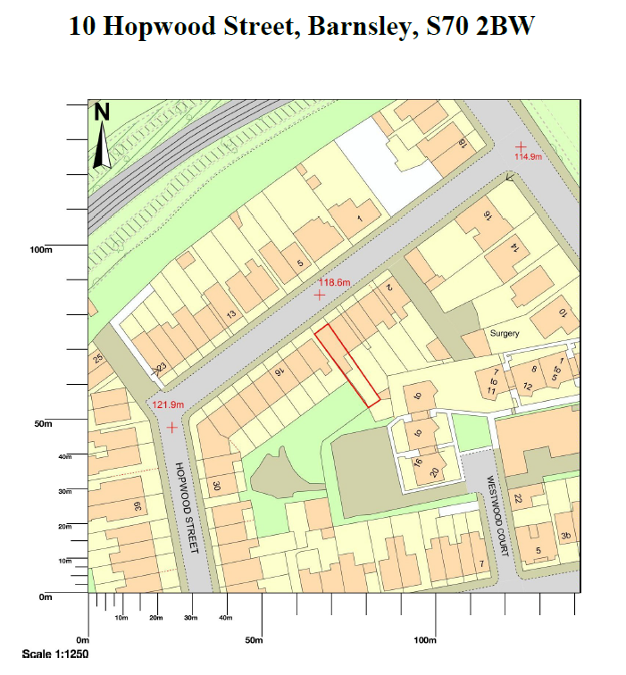

The 3-storey terraced property comprises of 5 en-suite bedrooms, a kitchen, living/dining room and a cellar over ground, first and second floors.

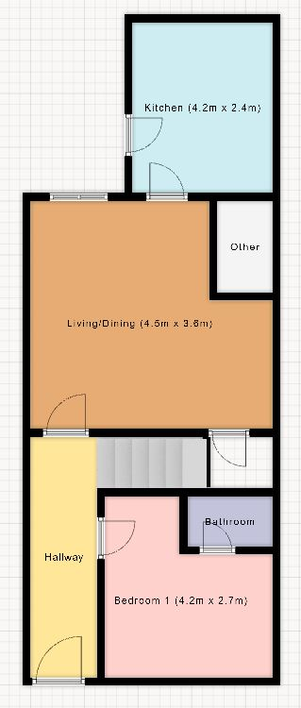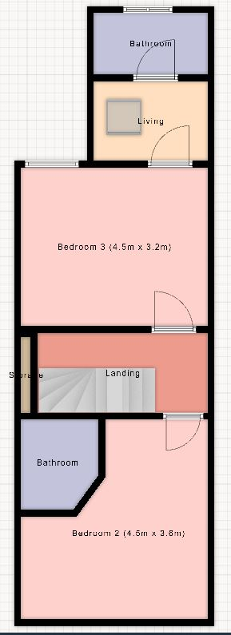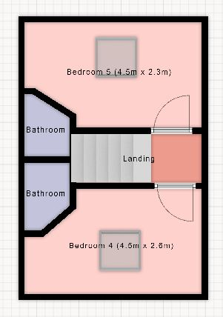
Ground Floor First Floor Second Floor

Conclusion
The Lawful Development Certificate should be granted for the proposal because it adheres to all the criteria as laid out in both the planning portal and in the 'Permitted Development Rights Technical Guide' document.

List of Appendices / Evidence attached to application
Appendix A: Land Registry Register – Proof of Ownership
Appendix B: Building Control’s Certificate
Appendix C: Provisional HMO Licence (reference: ML 533) granted on 07-Jan-21
Appendix D: HMO Licence (reference: ML 533) issued on 24-Mar-2021

