

84 Barnsley Road, South Kirkby
Pontefract, West Yorkshire, WF9 3QE
01977 219152 | 07468 535511
info@rbatownplanning.co.uk | www.rbatownplanning.co.uk

Mr F Myers

433 Rotherham Road
Barnsley
S71 1UX

Proposed change of use of domestic swimming pool for private hire
and associated carparking

Contents
Introduction……………. Page 3

Site & Surroundings……Page 4

Proposal ………………. Page 5

Policy……………………Page 6

Assessment……………Page 7, 8, 9

Conclusion……………...Page 10

Appendix A – Management Plan
Appendix B - Signage

Introduction
RBA Town Planning has been instructed by to prepare and submit a revised Planning Application to Barnsley Council for the change of use of a domestic swimming pool for private hire with associated car parking.

The application is submitted as a revision to a previously refused application for a similar proposal reference number 2017/0416. The revised proposal is submitted seeking to resolve reasons for the previous refusal.

This statement will set out the site, identify Local Plan Policies relevant to the consideration of the proposal and provide reasoned justification to outline the proposals acceptability.

Site & Surroundings
The application site is a two-storey semi-detached residential property located on the edge of Barnsley Town Centre. The pair of semis are within the same ownership and both benefiting from large garden rea to the rear, the application property has utilised part of the rear garden of the attached property to facilitate the proposal. An existing drop crossing and drive way along the south-eastern boundary provides vehicular access to the rear of the property and the pool.

Rotherham Road is wide carriage way with footpaths to each side, to one side of the carriage way there is designated on street parking provision, however the majority of the properties that line Rotherham Road have the benefit of off street parking provisions

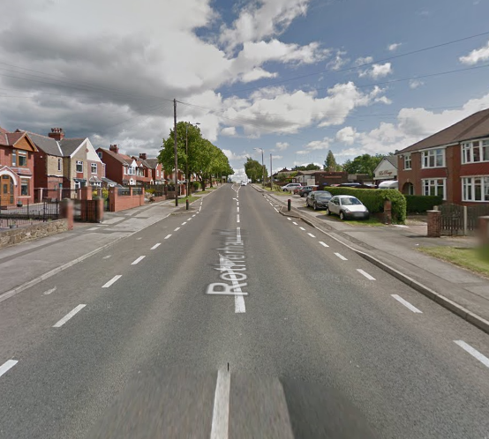Scene
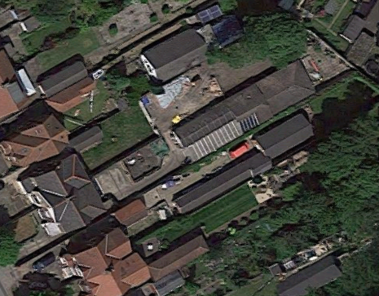
Application site

Street Scene

Proposal
The Applicant seeks Planning Consent for the material change of use of a domestic swimming pool for private hire use, the swimming pool has been in situ and used for domestic purposes for a considerable amount of time including the use by friends and family. The pool is proposed to be rented out on an appointments system as per the Management Plan submitted as part of this application and also attached as Appendix A of this statement. It has been identified that there is a local requirement for a private facility such as the proposed to be used by parents and toddlers, people with disabilities, and for purposes of physical rehabilitation and will be open to small pre-booked groups only as indicated within the Management Plan. The application is resubmission of a previously refused application and seeks to address and resolve the refusal reasons, the former application was refused for the following reasons.

The proposed change of use from a private domestic swimming pool to commercial premises fails to comply with Saved UDP Policy H8B in that it would have an unduly harmful impact on the amenity of neighbouring and nearby residents by way of increased noise, disturbance, loss of privacy and traffic congestion.

The access and proposed parking arrangements fails to comply with Core Strategy Policy CSP 26 in that the scheme only allows one-way traffic flow which may result in waiting on the heavily trafficked Rotherham Road to the detriment of the free and safe flow of traffic on the highway. The use of the premises as a commercial venture would increase the incidence of this occurring which is not acceptable in highway terms. In addition, no parking facilities have been show for the existing dwelling; facilities must be provided and located such that there is no conflict with vehicles using the access.

.

Policy
The following Policies have been cited within the Decision Notice reference 2017/0416

Unitary Development Plan Policy H8B - Planning permission will be granted for small scale, non-residential uses in housing policy areas, and for the expansion of existing uses, if:

a) There is no unduly harmful impact on the amenity of neighbouring and nearby residents by way of noise, disturbance, loss of privacy, traffic congestion or other forms of nuisance.

b) There is no unduly harmful visual impact on the character of the residential area; boundary trees, hedges and walls should be retained wherever possible; and the design of new buildings, or extensions should be to a good standard, relating to existing buildings in terms of appearance, siting, scale and materials.

c) There is no conflict with public safety on the highway and there is satisfactory provision where necessary for off-street parking, servicing and manoeuvring areas. where parking is to be provided in any area fronting a highway, that area should be provided with soft landscaping and screening where possible.

d) In housing policy areas in or adjoining Barnsley town centre the use is restricted to providing a service or facility specifically for residents, and

e) There is no conflict with other policies of the plan.

Core Strategy Policy CSP26 New Development and Highway Improvement - New development will be expected to be designed and built to provide safe, secure and convenient access for all road users. If a development is not suitably served by the existing highway, or would create or add to highway safety problems or the efficiency of the highway for all road users, we will expect developers to take mitigating action or to make a financial contribution to make sure the necessary improvements go ahead. Any contributions will be secured through a planning obligation or planning condition.

Assessment
The application considered under reference 2017/0416 was refused on the grounds outlined within the Decision Notice issued by the Council, within the reasons it was identified that the Authority considered the proposal would result in unduly harmful impacts on the amenity of neighbouring and nearby residents by way of increased noise, disturbance, loss of privacy and traffic congestion contrary to Policy H8B of the Barnsley Unitary Development Plan. A second reason for refusal outlined that the scheme only allows one-way traffic flow which may result in waiting on the heavily trafficked Rotherham Road to the detriment of the free and safe flow of traffic on the highway, and in addition, no parking facilities have been show for the existing dwelling contrary to Corse Strategy Policy CSP26. The submitted revised proposal seeks to address the reasons for refusal and in our opinion suitably mitigates the areas of concern in a way that would comply with the Policies cited within the Decision Notice. It is reasonable to assume that the proposal is acceptable in terms of all other material considerations and Policies contained within the Unitary Development Plan given the reasons outlined for the refusal, for the purpose of clarity I shall therefore only address each reason within this statement, each one in turn.

Reason 1 of the Decision Notice outlines Policy H8B of the Unitary Development Plan to support the contention that the proposal would have a detrimental impact upon the residential amenities of neighbouring uses by virtue of noise and disturbance, loss of privacy and traffic congestion. Policy H8B of the UDP is outlined in full under the Policy Section of this statement, in short it states that Planning permission will be granted for small scale, non-residential uses in housing policy areas, it does go further to identify specific requirements but for the purpose of this assessment the criteria outlined within the reason for refusal shall be assessed. Part A of the Policy states “There is no unduly harmful impact on the amenity of neighbouring and nearby residents by way of noise, disturbance, loss of privacy, traffic congestion or other forms of nuisance”. In terms of impacts upon neighbouring properties relating to noise and disturbance, the building in which the pool is housed is located some distance from any neighbouring dwelling house, the following picture is an excerpt taken from the proposed block plan and identifies the distances to the nearest dwelling houses. The excerpt is not to scale however the distances have been measured and taken form the scaled plans submitted as part of the application.

The swimming pool is housed within a Building Regulations approved building and is located a significant distance from the adjacent dwelling houses, any noise as a result of its use is in real terms unlikely to have any significant impacts upon the residential amenities of the dwellings occupants. The most likely event of noise disturbance would be from vehicle movements to and from the pool, however this will be limited to two cars using the pool at any one time as per the parking provision and Management Plan. Db limits of cars are set by The Vehicle Certification Agency, the following is taken from the Agencies web site which states “the external noise emitted by passenger cars has been controlled since 1929 when the Motor Cars (Excessive Noise) regulations were introduced. New cars are now required to meet Europe-wide noise limits. These have been progressively reduced from 82 decibels (dB (A)) in 1978 to the current limit of 74 dB (A) established in 1996. This means it would take 7 new vehicles to make the same amount of noise as one vehicle that just meets the pre-1978 limits”. The average Db level of a domestic electric lawnmower is 90Db considerably high than that of a car. The time it would take the vehicle to travel the boundary of the property
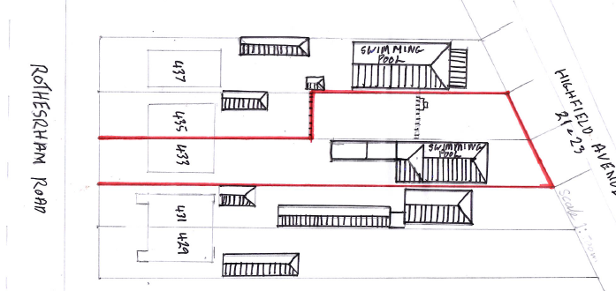

40m

37m
35m

39m

to the parking area would be approximately 10/15 seconds, at a Db level significantly lower than a domestic lawn mower, this in addition to the 2-metre-high fence along the whole of the drive length of the host property and that of the neighbouring property 431 which further along the boundary sees the introduction of a conifer hedge to a height of approximately 4 metres mitigating against noise and disturbance would have very little impact upon the residential amenities of the occupants. It is also proposed to erect signage in locations identified on the proposed plan to remind visitors to keep noise levels to a minimum, the signs are attached as Appendix B.

Reason 2 outlines concern in relation to traffic congestion and waiting upon Rotherham Road, the revised proposal is conserved to address this concern and provide a suitable solution to ensure the free and safe flow of traffic. It is proposed to widen the existing access to accommodate two-way traffic to and from Rotherham Road, it is acknowledged that the width along the side elevation of the host property will still only accommodate single traffic flow however this is only for approximately 12 metres and mitigation measures are proposed to eliminate any potential conflicts occurring. Firstly, within the Management Plan the appointment system is identified to reduce the likelihood of vehicles arriving and leaving at the same time as outlined below;

0800-0900 | 1530-1630
0930-1030 | 1700-1800
1100-1200 | 1830-1930
1230-1330 | 2000-2100
1400-1500

- Pool users must book their appointment at least 24hrs in advance and give notice if they are not going to attend for their pre-booked appointment.
- Pool users should be off site no later than 10 minutes after the end of their session.
This system will allow for a 15/20min gap in vehicle movement between uses, therefore no vehicle should be arriving or leaving at the same time. However, it is proposed to have the vehicle waiting area to the front of the property, this will also be supported by signage to outline vehicles entering the site have priority over vehicles leaving the site, the is marked on the proposed plan and signage details is provided within Appendix B. The appointment system in combination with the priority signage and holding area would significantly mitigate against any potential vehicle conflict. The proposal would therefore adhere to CSP 26.

Conclusion
The proposal is considered to comply with the principle aims of both Unitary Development Plan Policy H8B and Core Strategy Policy CSP26 and sufficiently overcomes reason for refusal outlined within the Decision Notice of application 2017/0416.
It is therefore with respect that we ask you to concur with the Assessment of the proposal and grant permission for the proposed development subject to appropriate conditions and in accordance with the Management Plan.

Appendix A
MANAGEMENT PLAN FOR 433 ROTHERHAM RD SWIMMING POOL
Site Manager: Mr Frank Myers.
Intro:
The swimming pool in the outbuildings at 433 Rotherham Rd S71 1UX is to be run by appointment only
for small groups with sessions being pre-booked.
Hours of business.
The appointment system will be used to control numbers using the pool.
The sessions will be:

0800-0900 | 1530-1630
0930-1030 | 1700-1800
1100-1200 | 1830-1930
1230-1330 | 2000-2100
1400-1500

Pool users must book their appointment at least 24hrs in advance and give notice if they are not going to attend for their pre-booked appointment.
Pool users should be off site no later than 10 minutes after the end of their session.

Traffic management.

A traffic priority system will operate on site.
All pool visitors coming by car will be given an arrival and departure time when booking their appointment to minimise any traffic congestion issues.
Vehicles entering the site have priority over vehicles leaving the site. (Signage to be provided)
A passing place will be also be provided at the front entrance
Cars are only to be parked in the allotted parking spaces for the pool.
No parking is permitted on Rotherham Road.

General Rules

Emergencies are to be notified to the management immediately.

The emergency muster point is at the front of the property on the grassed area.

Any damage or defects are to be reported to the pool manager as soon as possible.

Patrons are to be asked to keep noise levels to a minimum when entering or leaving the premises. (Signage required)

The plant room is for use by authorised staff only.

Pool chemicals and cleaning materials are to be stored in the plant room which is to be kept locked.

All waste from the pool is to be disposed of in compliance with all local authority directives on waste management.

Walkways are to be kept clear of obstructions and cleared of ice and snow in winter months.

Pool users are to sign a form that they are aware of the swimming pool rules and must comply with pool
safety signs and administration notices.

All existing fences and walls to be retained at the present height and maintained to ensure that there is no detriment to the privacy of neighbouring properties.

Appendix B – Signage
