Ref: 2016/0708

Applicant: Exemplar Health Care Ltd.
Description: Change of use from dwelling (Use Class C3) to ancillary care facility (Use Class C3) in connection with Dearnevale Care Home.
Site Address: 11 Elizabeth Street, Grimethorpe, Barnsley

One objection from a local resident and concerns raised by Cllr Higginbottom.

Site Description

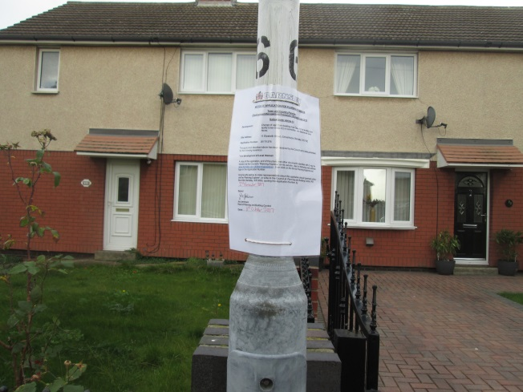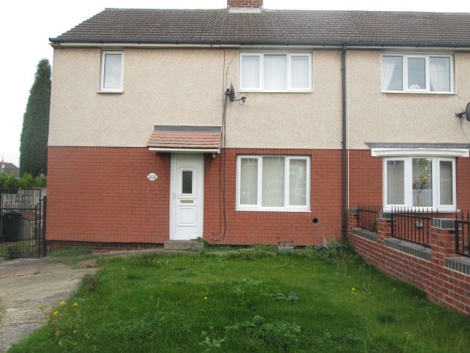
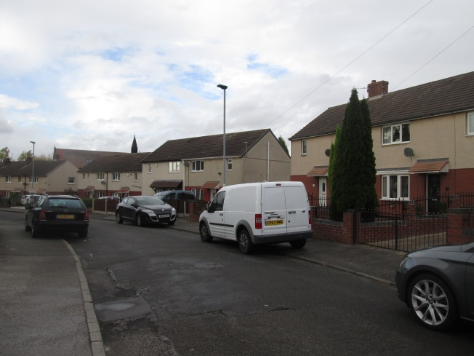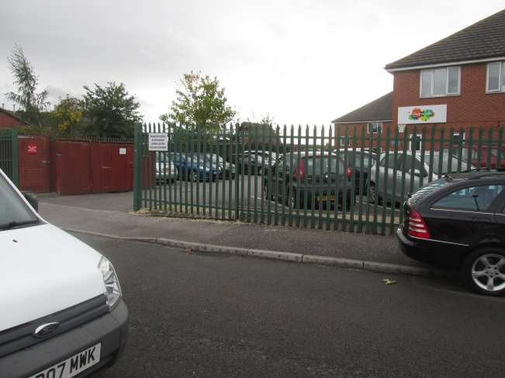

This is a semi-detached redbrick and render house on a heavily parked up residential street. The house is set back from the road behind a generous front garden and there is a driveway for about two cars. There is a care home with its own car parking opposite the site.

Proposed Development

This is a straight change of use with no external alterations. Internal changes on the first floor are to remove a small bedroom and create an opening to provide en-suite facilities. On the ground floor a storage room is proposed.

According to their web page Dearnevale offers specialist support for young adults who have complex physical disabilities resulting from trauma.

The home provides every individual and their families with a high standard of care to ensure that residents are treated with dignity and respect.

Residents receive care for a number of physical disabilities, such as spinal and head injuries and a wide range of neurological conditions and respiratory disorders

Previous Planning History

2017/0030 Change of use from dwelling (Class C3) to nursing care (Class C2) ancillary to adjacent care home 5 Elizabeth Street, Grimethorpe, Barnsley. Granted subject to conditions.

2016/0708 Change of use from 4 no. flats to unit to provide "Step out Care" C2 use ancillary to adjoining Dearnevale Care Home, 1-4 Elizabeth Court, Grimethorpe, Barnsley

This was a change of use to a ‘ Step Out Care’. The plans showed 6 bedrooms with shared living rooms. There were to be 4 full time members of staff.

Policy Context

Planning decision should be made in accordance with the development plan unless material considerations indicate otherwise and the NPPF does not change the statutory status of the development plan as the starting point for decision making. The development plan consists of the Core Strategy, saved Unitary Development Plan policies and The Joint Waste Plan. . The Council has also adopted a series of Supplementary Planning Documents and Supplementary Planning Guidance Notes, which are other material considerations.

Local Plan

The Council has submitted its emerging Local Plan to the Secretary of State but it is at an early stage in the examination process. It establishes policies and proposals for the development and use of land up to the year 2033. The document is a material consideration and represents a further stage forward in the progression towards adoption of the Local Plan. As such increasing weight can be given to the policies contained within the document although, in accordance with paragraph 216 of the NPPF, the extent of this will depend on:
• The extent to which there are unresolved objections to relevant policies (the less significant the unresolved objections, the greater the weight that may be given) and;
• The degree of consistency of the relevant policies in the emerging plan to the policies in the NPPF (the closer the policies in the emerging plan to the policies in the NPPF, the greater the weight that may be given).

SD1 Presumption in favour of sustainable development
GD1 General development
D1 Design
T4 New Development and Highway Improvement
Poll1 Pollution Control and Protection
CC4 Sustainable Drainage Systems (SuDS)

These policies carry little weight for the reason given above.

Core Strategy

CSP26 Highways issues.
CSP29 Design matters.
CSP40 Pollution protection.

Saved UDP Policies

Housing Policy Area

Saved UDP Policy ED4 ‘Economic Development and Residential Amenity’ states that proposals for economic development adjoining or close to housing will be assessed with particular regard to the likely impact on residential amenity.

SPDs/SPGs

None

Consultations

Highways- no objections.

Pollution Control-no objections

Food Safety-need to be aware of regulations.

Representations

One letter received

This raises the issue of what has happened to the front garden of no.5 since it changed use having a detrimental visual impact and parking issues on the street. Cllr Higginbottom has also raised concerns on parking issues.

Assessment

Principle of development

There are no external changes proposed just an internal re-organisation so that the two bedroom have en-suite facilities and storage is provided. This is part of the Dearnevale Care Home facilities but will operate like a dwelling and as such the proposal is appropriate and raises no issues of principle.

Residential Amenity

The proposal is to change the use of the existing 3 bedroom dwelling (C3) to ancillary accommodation associated with the neighbouring residential institution (C2) with 2 bedrooms and en suite facilities. The residential units would be for individual occupation but the occupants would have care provided by staff from Dearnevale, as such, the maximum occupation would not be significantly different to occupation levels of a standard 2 bedroom dwelling.

It is acknowledged that the residents of the property would be from Dearnevale, which caters for people with disabilities and mental health problems, however, they would be only moved into the property if they were deemed fit by the experts and it would enable the residents to integrate with a community on a more individual basis while still benefitting from 1:1 care and the associated facilities within Dearnevale.

In terms of further noise and disturbance, the properties would not require significantly more servicing/deliveries than a standard residential property and residential movements would be to a minimum given that the residents may not have vehicles and off street parking would be provided at the site, with additional available close by at Dearnevale.

It is considered that, given the scale of the units and the potential number of residents and users, residential amenity would be maintained to a reasonable degree and not significantly different than if the property was sold on the open market and so the proposal is considered acceptable.

Visual Amenity

There would be no external alterations to the building. 6There is no indication that the intention is to pave over the garden. The concerns of the neighbouring resident is noted, however, the garden could be paved over if a usual occupier wanted not to have to mow the grass or needed off street parking.

Highway Safety

Highways have commented as follows:

“The proposals reduce the number of bedrooms from 3 to 2, thereby requiring a provision of 1 no. off-street parking space. There is an existing off-street parking space which is currently accessed illegally, without the benefit of a dropped crossing. This must be applied for and constructed accordingly.”

It should also be noted that the premises operates as a dwellinghouse and it is not considered that the proposed use would generate any more significant traffic movements or parking requirements that could be applied to a dwelling.

No conditions recommended but I have attached those we put on 2017/0030

The local resident and Councillor have raised parking as an issue but there is also car parking across the road at the Care Home.

Recommendation

Grant subject to conditions

