

Listed Building Consent Application
Replacement of Guttering and Rainwater Goods at
Elsecar Heritage Centre

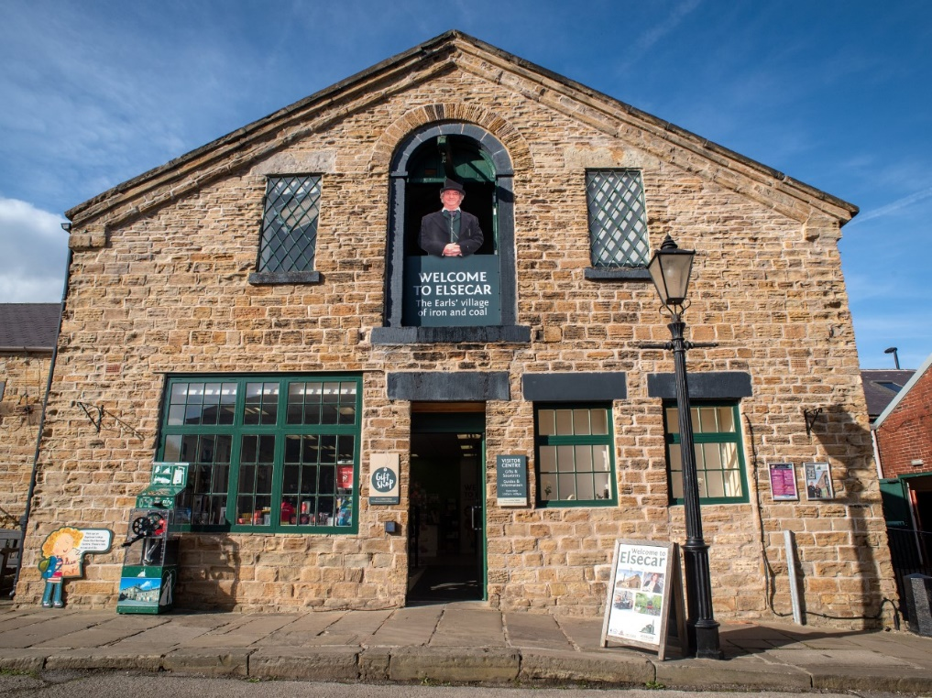

Contents

- Introduction
- Background
- Location Plan and Site Description
- Design and Access Statement
- Proposed Work
- Heritage Statement
- Planning Statement
- Listing Information
- Recent Planning Applications

Introduction
Barnsley Council operates Elsecar Heritage centre along with four other museum / heritage sites across the borough. Consent is sought to replace missing and failed guttering and rainwater goods along a stretch of the building along Forge Lane.

Background
Barnsley Museums welcome over £2M visitors annually to the council owned visitor attractions at Cannon Hall, Elsecar Heritage Centre, the Cooper Gallery, Experience Barnsley Museum and Worsbrough Mill.
During 2024-5 Elsecar Heritage Centre welcomed over 500,000 visitors, most of who access the site via the Forge Lane entrance. The visitor’s first impression of the site is back of the Heritage Centre Buildings 4-7, the missing / failed uttering, and the unmanaged water run-off. During the colder months this water run off falls onto the pathway along Forge Lane and freezes creating slippery and dangerous conditions.
Therefore, repairs are required to improve the appearance of this listed building and also reduce the risk of staff and visitors to the site falling on slippery ground.

Location Plan and Site Description
Elsecar Heritage Centre is in the village of Elsecar which is 6 miles south of Barnsley and 8 miles north east of Sheffield. It is near to the town of Hoyland and village of Wentworth. The Heritage Centre comprises of a visitor centre, shops, galleries and craft studios, an events hall, tea rooms and a play centre.
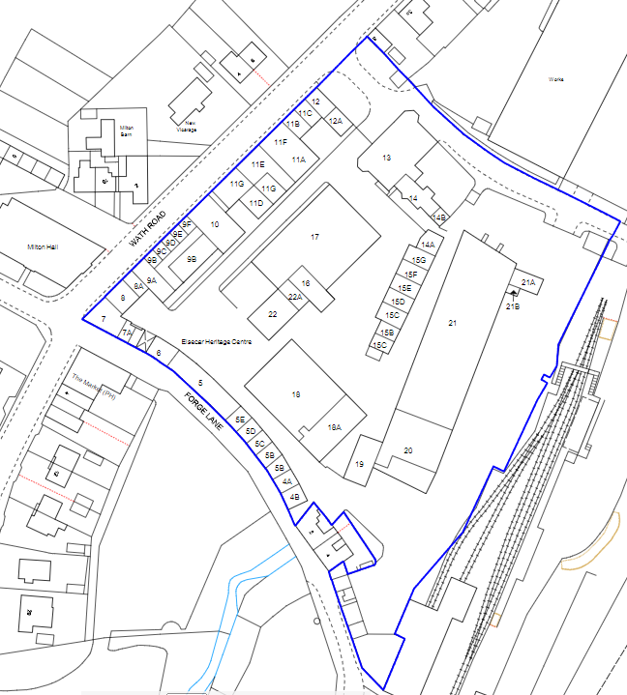
The buildings are listed Grade II*. Elsecar Heritage Centre is a named Heritage Action Zone (HAZ), which is a partnership between Barnsley Museums and Historic England to further explore the history of the site. As a result of the HAZ, there have been 6 new listings on the site and 9 existing Grade II listings have been upgraded to Grade II* status, which puts them into the top 10% of England’s most important historic buildings.

The Former Elsecar Ironworks Site, the boundary of which sits behind Building 15, was also recently given Scheduled Monument status, which further adds to the historic value of the wider site and the village of Elsecar.

Design and Access Statement
This statement is to support the application for the proposed replacement of rainwater goods along Forge Lane, affecting the Elsecar heritage complex.

Proposed Works
The proposal is to install 100m of guttering and 2 fall pipes to replace the existing sections along Forge Lane. These buildings (4 -7) are designated as Grade 11* listed in 1986.
The existing grey plastic guttering has failed in several places and several downpipes are now absent. This has caused rainwater run off down the walls of the listed buildings and along the access path which created dangerous patches of ice during the winter months.
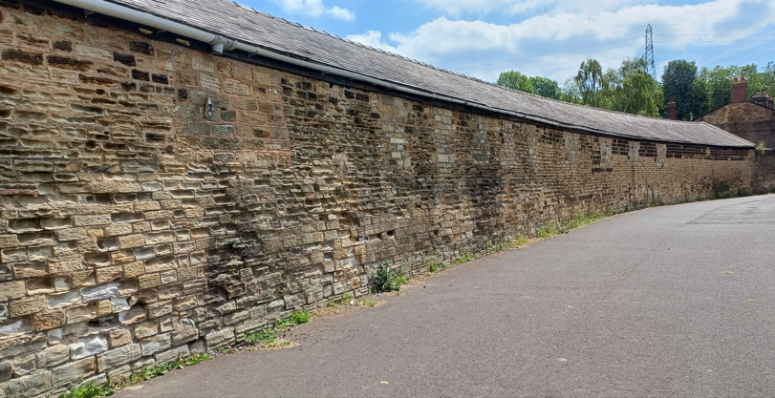
We are proposing to use black heritage aluminium gutters which offer a range of down pipes, hoppers, fixings and traditional gutter profiles which would enhance the visual profile of the site and match its heritage value. Although not made of traditional cast iron they are a convincing replica, and the design will match traditional rainwater goods seen across other buildings on the same site.
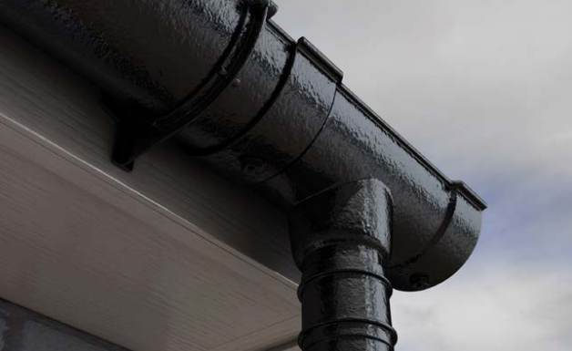

Image of the Heritage Beaded Half-Round socketed cast aluminium gutters, downpipes and fixings

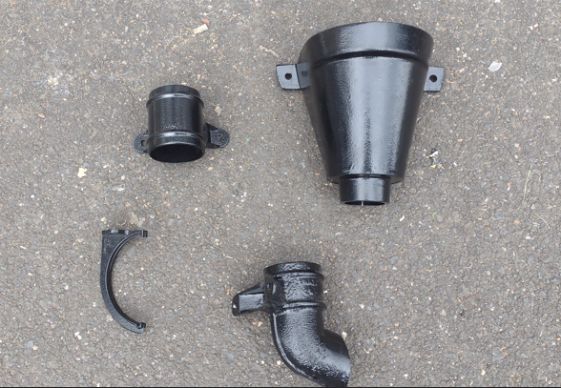
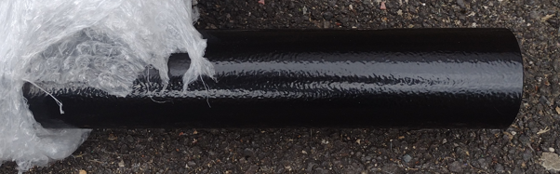
These products have also been successfully used on other heritage and listed buildings, and consultation with the Conservation Officer has taken place to confirm their suitability.
CD Potters will be contracted to install the rainwater goods on site in late Autumn / Winter.
The proposal has considered the conservation of the Elsecar Heritage Centre and would address the long term preservation of the buildings on site as well as the health and safety of those visiting and working at the site.
Overall, we would suggest the proposal is justified and represents no harm to the heritage significance of the listed building(s) and is therefore in accordance with local and national planning policy.

Planning Statement
Relevant Legislation/Planning Policy:
Planning (Listed Buildings and Conservation Areas) Act 1990
In terms of the impact on the special character and appearance of the listed building, Section 16 (2) of the Planning (Listed Buildings and Conservation Areas) Act 1990, states:
In considering whether to grant listed building consent for any works the local planning authority or the Secretary of State shall have special regard to the desirability of preserving the building or its setting or any features of special architectural of historic interest which it possesses

The National Planning Policy Framework (NPPF)
NPPF para 189 and 190: The NPPF requires applicants to describe the significance (heritage) of any heritage asset affected by a proposal including any contribution made by the setting of the asset. The level of detail should be proportionate to the importance of the asset and the degree of intervention the proposal represents. The local Planning Authorities will take the heritage significance of an asset into account and consider any impacts on the asset to avoid conflict with the conservation of the asset.
NPPF para 193: Great weight given to an asset’s conservation, irrespective of the degree of harm
NPPF para 194: Any harm to or loss of significance will require clear and convincing justification

Barnsley Local Plan Policies
Barnsley Local Plan Policy HE1: The Historic Environment: Positively encourage developments that help in the management, conservation and understanding of the historic environment
Barnsley Local Plan Policy HE3: Developments affecting Historic Buildings: Proposals involving historic buildings should conserve and where appropriate enhance, respect historic precedents, and capitalise on opportunities to reveal significance

Listing Information
Buildings 4-7, stores at former Elsecar Central Workshops
Heritage Category: Listing
Grade: II*
List Entry Number: 1465836
Date first listed: 4 Dec 1986
Date of most recent amendment: 19-Oct-2020
Location Description:
Range of storage buildings forming one side of Elsecar Central Workshops, the complex built in the 1850s to serve Earl Fitzwilliam’s collieries. In 2020 the range is in multiple retail and small business use.

Statutory Address:
Elsecar Heritage Centre, Wath Road, Elsecar, Barnsley, S74 8HJ

Recent Planning Applications For Elsecar Heritage Centre

