PLANNING APPLICATION
FOR
SIGNAGE
AT
MONTGOMERY HOUSE,
SHEEPHOUSE WOOD, STOCKSBRIDGE, SHEFFIELD S36 4GS
FOR
EQUI-TREK LTD
JULY 2020

NORTHERN DESIGN PARTNERSHIP
THE CHAPEL MILLMOOR ROAD
MELTHAM, HOLMFIRTH HD9 5JU

1.0 - EQUI-TREK LTD

1.01 - Equi-trek were founded in 1999 in Meltham, Yorkshire. The business rapidly developed, and outgrew their original premises. In late 2016 Equi-trek relocated to Montgomery House, a premises that had remained vacant since the demise of Foxwire Ltd. Equi-trek invested substantial funds in repairing the property and forming a base to continue expanding their business. They are now the largest horsebox manufacturer in the UK, and export all over the world.

2.0 - RECENT PLANNING

2.01 - Equi-trek Ltd submitted planning applications in July 2019 for signage, flagpoles and vehicle parking on the verge adjacent to the entrance. Both applications (19/0973 and 19/0862) were following concerns by the planning authority.

3.00 - PROPOSALS

3.01 - This application is to simplify the situation and apply just for the fixed signage. The flagpoles have therefore been omitted.

3.02 - The submitted plan demonstrates the location of the proposed signs, and the location of the signs that exist, such as Photograph 1.

3.03 - Montgomery House is set back behind a mature tree screen and it is barely visible from the road. Equi-trek Ltd are keen to ensure that their presence is better advertised, and these proposals offer the company that opportunity.

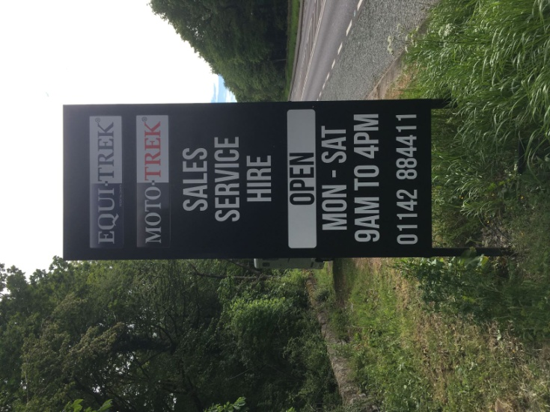
Photograph 1 - Sign 3

3.04 - In addition to the existing signage the applicants are proposing six signs that will be set back along the rear wall facing the road. These are identified as Signs 1, 2, 4, 5, 6, and 7 on the plans included with this application. These signs measure 2400 x 3600 and will match the existing signs in terms of style and materials.

3.05 - These signs will promote the business and will vary. We have included examples as part of this report, see images 1-3.


Image 1 - Example of Proposed Sign


Image 2 - Example of Proposed Sign

Image 3 - Example of Proposed Sign

4.00 - CONCLUSION

4.01 - This application seeks to gain planning permission for a range of signs. Equi-trek Ltd are a successful local business that wishes to promote their equine related products. The signage etc will be safely installed, respecting the safety of passing motorists.

4.02 - We therefore respectfully trust that Barnsley Planning Dept can support this application.

