Heritage Statement Supporting
Listed Building Consent for erecting of an agricultural building at
Gyn Race, Royd Lane, Millhouse Green, Sheffield S36 9NY

The property has the following listed building status and description:
PENISTONE ROYD LANE SE20SW (south side, off) 3/59 Barn approx. 30 metres 23rd June 1965 west of Royd Farmhouse
Heritage Category:
List Entry No : 1191998
Grade: II
Detail:
Barn. C17. Coursed, squared stone. Stone slate roof. Probably 5 internal bays. Quoins. Square-headed recessed cart-entry to centre with outshut to each side. Rear: opposing square-headed cart entry with roof raised above. C19 barn attached to right gable not included. Two entrances to left gable. Interior not inspected but is probably aisled at front and possibly at rear as well. Floor said to be on 2 levels due to sloping ground.
Listing NGR: SE2169403747
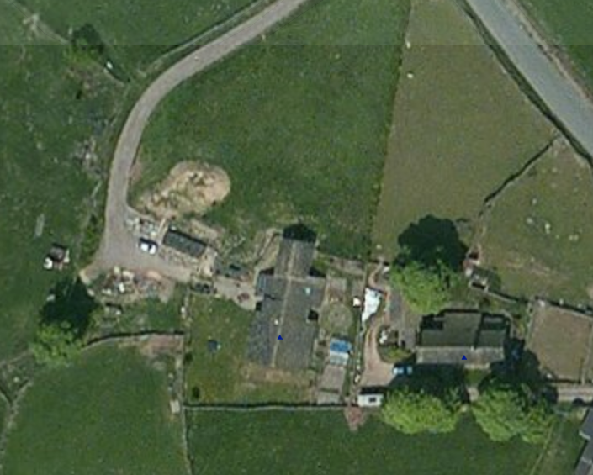
Gyn Race is the large barn approximately 30 metres west of Royd Farmhouse

Planning Request;
Planning permission, and listed building consent is sort to erect an agricultural building in the grounds of the above property.
The property, which was converted to a domestic dwelling from a farm building in 2001, sits in approximately 2.5 acres of land. The land is used for grazing a small herd of sheep.
The purpose of the new building is to provide shelter, and fodder storage for agricultural animals (sheep) farmed on the site. The site is elevated (approximately 300m above sea level) and relatively exposed. The barn is required to provide shelter during lambing and harsh winter weather, and for the storage of fodder and machinery.
The proposed design of the new timber framed building (shown below), with a Yorkshire stone roof and timber wall cladding, is very sympathetic to the existing property, and in-keeping with other buildings in the area. The footprint of the barn is modest in size at 10.5x5.5m, and the height is below 4m.

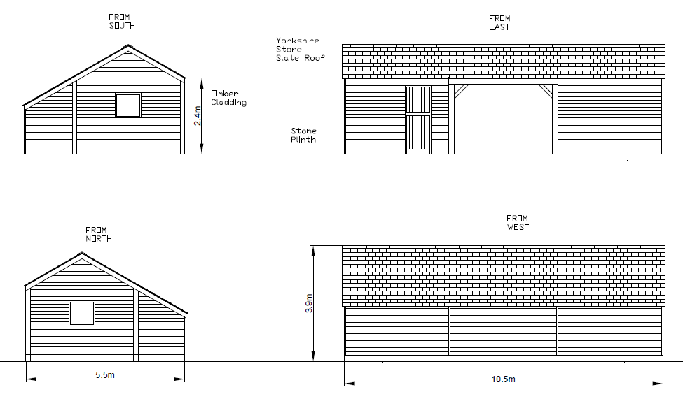

The proposed new barn is to be located approximately 30m from the listed property, in the grounds of the original farm yard, where it is surrounded by dry stone walls to a height of approximately 1.2m

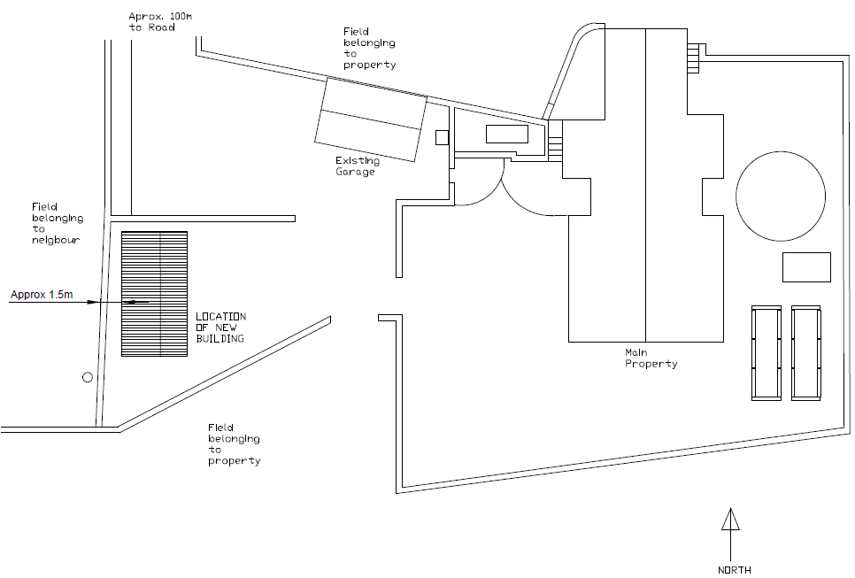
Photographs of the site are provided below.
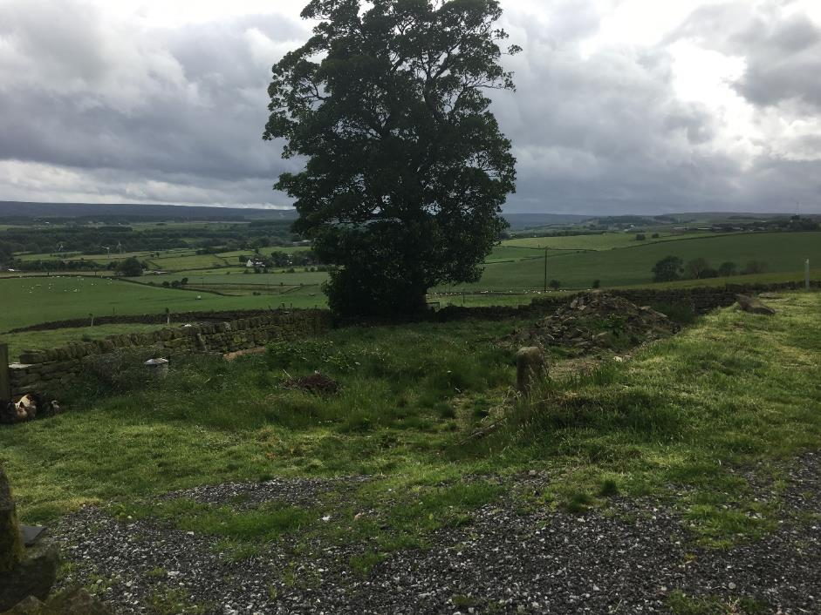
View from the existing property to the site of the new building.
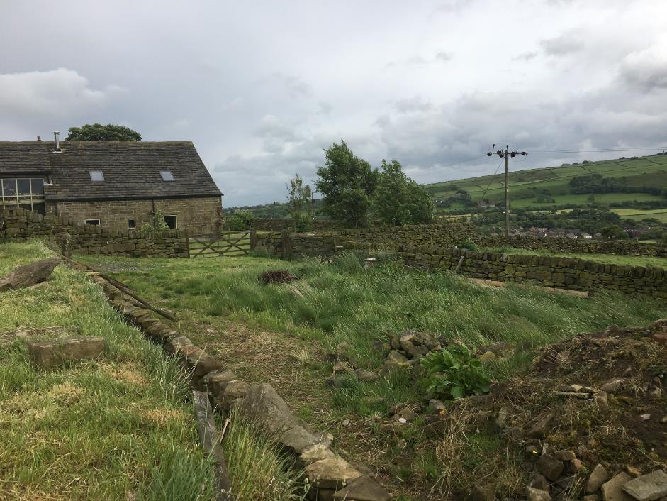
View from the proposed site of the new building towards the exiting property.

