Design and Access Statement  Site address: | The Recycling Centre, Shaw Lane, Barnsley, S71 3HJ
Applicant: | Stairfoot Metals Ltd
Proposal: | Change of use to scrap metal recycling yard.

Contents

- Introduction
- Design principles and concepts
  - Assessment
  - Amount
  - Scale & Appearance
  - Landscape
- Access issues
- Consultation
- Conclusion

This Design and Access Statement (DAS) accompanies a planning application for the proposed change of use of land at Shaw Lane, Barnsley.
The DAS has been written to meet the requirements of Article 4C of the Town and Country Planning (General Development Procedure) Order 1995 (as amended).

- Introduction
  - AC Environmental Consulting Ltd have been instructed by Stairfoot Metals to apply for a change in the use of land to a scrap metal recycling yard at The Recycling Centre, Shaw Lane, Barnsley, S71 3HJ.

  - The site is currently being used for general industrial storage of concrete block products.
  - This planning application seeks to allow for the change of land use and development of a scrap metal recycling yard.
  - Stairfooot Metals are an established waste management company that have been operating as a scrap metal recycler since 2016 at their other site in Wombwell Lane, Barnsley.
  - The proposal seeks permission for;
  - Change of use from general industrial use to operation of a scrap metal recycling facility.
  - Creating Legio block concrete walls to 3m high,
  - on the northern and eastern perimeter of the site to improve security and noise mitigation and;
  - to create storage bays for recycled metals
  - Permit the use of a shear for recycling of scrap metals.
  - This statement has been produced to demonstrate the methods by which the proposed operation will be managed to mitigate its effect on the local environment.
- Design Principles and Concepts
  - Assessment
        - The site is located at Shaw Lane Industrial Estate, Shaw Lane, Barnsley, S71 3HJ
        - The site is situated on the eastern edge of the industrial estate which is home to a number of other waste management companies and scrap metal recyclers including vehicle breaker yards.
        - To the North of the site is a concrete products manufacturer and beyond is a large vehicle breakers.
        - To the south west of the site is another scrap yard.
        - To the east lies the Carlton marsh Local Nature reserve
        - The nearest housing is approximately 230m north east of the site.
        - The village of Carlton lies 750m west of the site.
  - Amount
    - The new development will consist of:
      - Development of a scrap metal recycling yard incorporating;
    - Legio block concrete perimeter walls to 3m high on the northern and eastern boundary and,
    - Legio block bays for storage of recycled metals
    - Installation of a shear to aid in efficient recycling
    - Installation of an interceptor to improve site drainage

      - The operating hours of the site shall be:
Mon-Fri: 07:30 – 17:30
Sat: 08:00 – 13:00
  - Scale and Appearance
- The proposed site has an area of 2850m² (0.28ha)
- The site is currently surfaced with concrete with no soft landscaping. There are no proposals to change the existing landscape.
- It is proposed to replace the palisade fencing to the east with Legio block walls to 3m and to create a new boundary on the north with the same to split the site from the DTS Waste Management operations.

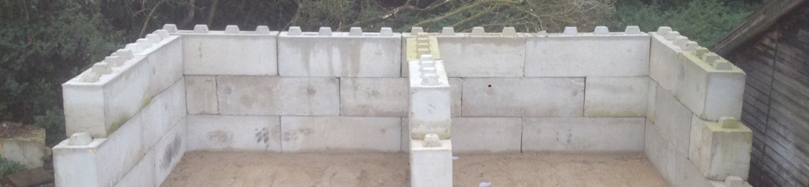
Image 1; 3m Legio block wall with retaining walls to create storage bays.
- Access Issues
  - Current access to the site is through the Industrial Estate via the existing access off Shaw Lane located north west of the site.
  - Traffic from the site will be limited to the applicants scrap metal business only. The site currently located in an Industrial Estate with good access off Shaw Lane. As such operations will be compatible with scale and nature of the site.
- Consultation
  - No consultations have taken place to date.
- Conclusion
  - The proposed development demonstrates the applicants desire to create a new facility consisting of the smooth and efficient operations of their business. Furthermore, the client’s willingness to improve the amenity of the area and reduce any potential impacts on neighbours have been clearly outlined above.
  - The proposed development is deemed to be of an acceptable scale and appearance which would complement its surroundings well.

