Planning Design & Access Statement 22nd August 2023

Planning application for the erection of 45 dwellings and associated works: - Land Off Paddock Road, Staincross, Barnsley.

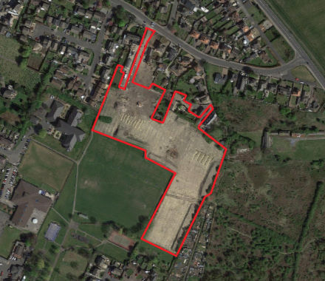

Applicant: RMH Properties LTD

1.0 Introduction

This Planning, Design & Access Statement has been prepared by Andrew Bailey Architects on Behalf of RMH Properties Ltd . The purpose of the statement is to assist Barnsley Metropolitan Borough Council (BMBC) in their determination of a full planning application for the erection of 45 dwellings on land to the south of Paddock Road, Staincross.

In addition to this Statement, the planning application should be considered in the context of the following supporting documents:

Table 1: Plans & Reports :

Plan / Report | Reference
Location Plan | RMH-P01
Site Plan | RMH-P02 Rev R
Landscape Plan | RMH-P03 Rev C
Street View (East to West) | RMH-P04 Rev C
Street View (North to South) | RMH-P05 Rev A
House Types | RMH-HT-A-01A;B-01; D-01; D-02A; E-01; F-01B; G-01; H-01A; I-01; J-01; K-01; L-01; M-01; N-01A; P-01C; Q-01; Q-02A; R-01; R-02; R-03A; S-01A; S-02; T-01A; U-01A; V-01A; W-01D; X-01A; Y-01A; Z-01A; Z-02A; AA01;BB01.
Topographical survey
Heritage Statement | TJC2020 154
Preliminary Investigation | C398 A
Geoenvironmental Appraisal | C398 A
Coal Mining Investigation Report | C398 A
Arboricultural Report | AWA4554
Drainage Strategy Report | 753/DSR1
Drainage Strategy | YH753/20D
Flood risk Assessment | 753/FRA1
Impermeable Areas | YH753/21C
Surface Water Exceedance Routes | YH753/22C
Ecological Impact Assessment | 200748/EcIA/REV1
Green Infrastructure Strategy | August 2023
Swept Path Analysis Review | 22015/ATR/01

This Planning Statement will describe the application site and the surrounding area, the proposed development, and assess the proposals against the relevant planning policy framework.

This Planning Statement provides an overview of the decision-making context including the National Planning Policy Framework (July 2021), the National Planning Practice Guidance, the adopted Barnsley Local Plan (January 2019).

In addition the Statement shall also outline the sustainability credentials of the development and clearly demonstrate that the benefits of the scheme outweigh any potential adverse impacts.

The statement should be read in conjunction with the submitted plans and technical reports referenced within table 1.

2.0 Site & Surroundings

The application concerns land to the south of Paddock Road, Staincross. The site is located to the west of the A61 Wakefield Road and is approximately 3.8km north of Barnsley Town Centre.

The site covers an area of approximately 2.1 hectares (1.94ha when discounting phase 1), it is irregular in shape with access taken between no. 30 and 26 Paddock Road. Levels fall across the site to the south by approximately 12 meters and there are elevated views towards Redbrook and central Barnsley .

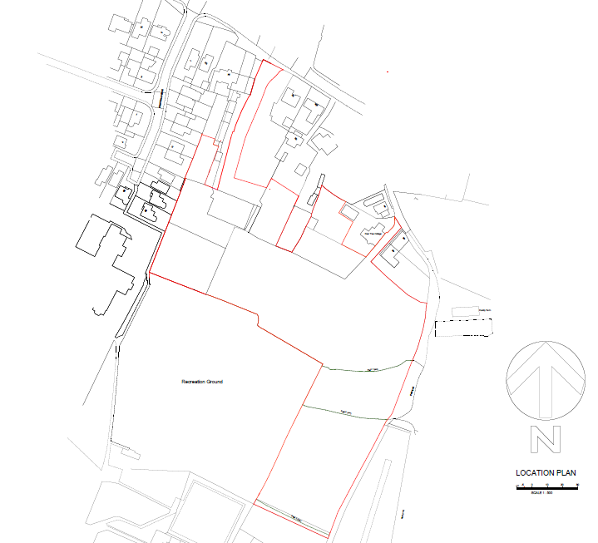
The site was formally occupied by no. 28 Paddock Road with land to the rear forming agricultural fields, the property has been demolished as part of phase 1 of the sites redevelopment. Phase 1 includes the construction of replacement property (28 Paddock Road), new vehicle access to adopted standards and construction of 2 detached dwellings. The properties are all nearing completion, they've been constructed to a very high standard using natural course stone. This phase of development is essentially the benchmark for the proposals which will follow.

Albeit for the north (Paddock Road) facing element of the site the remainder is largely cleared albeit for vegetation found to peripheral areas and site boundaries. A public right so way crosses the site linking allotments located to the east with Mapplewell Park to the west.

The site borders the rear boundaries of residential properties fronting Paddock Road to the north. The western boundary includes properties along Elliston Avenue and Mapplewell Manor residential care home, to the south is Mapplewell Park which along with the eastern boundary is defined by an established hedgerow, across the eastern boundary are allotments and open land.

Mapplewell centre is located to the south west of the site, the area supports a number of convenience and local services. Bus services are accessible from Mapplewell in addition to stop located on nearby roads, these provide regular services to Barnsley centre and surrounding area of the borough.

Aside from the open land to the east the surrounding area is typically suburban in character. The housing stock is varied both in terms of age and styles with no overall prevailing character.

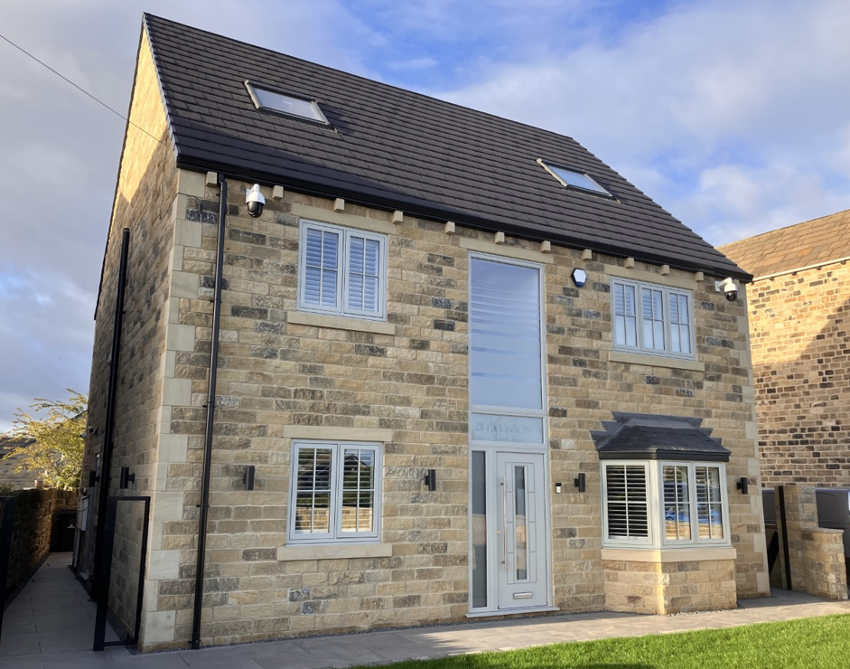
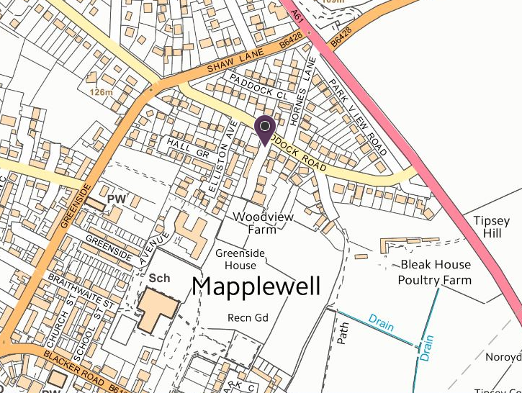

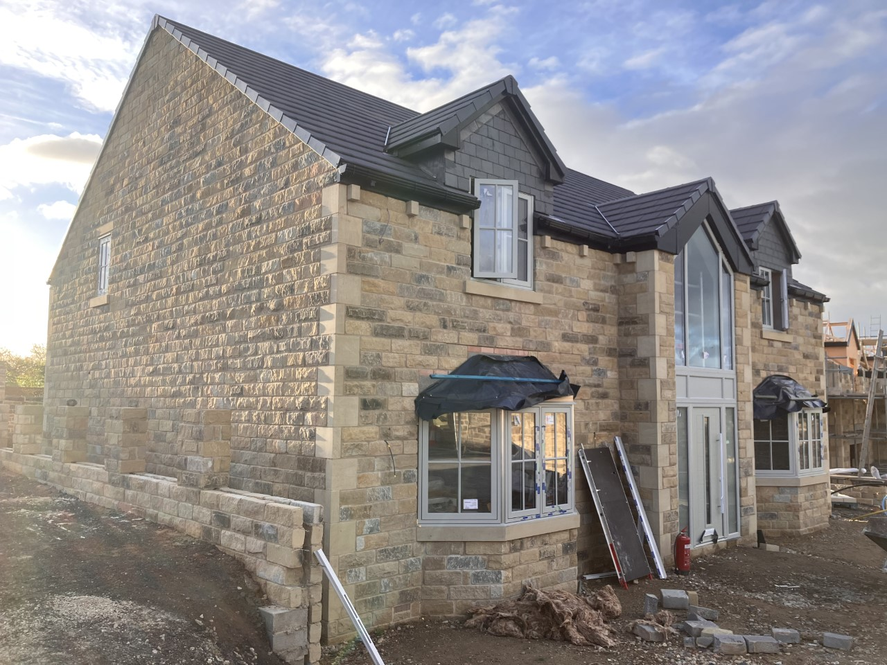
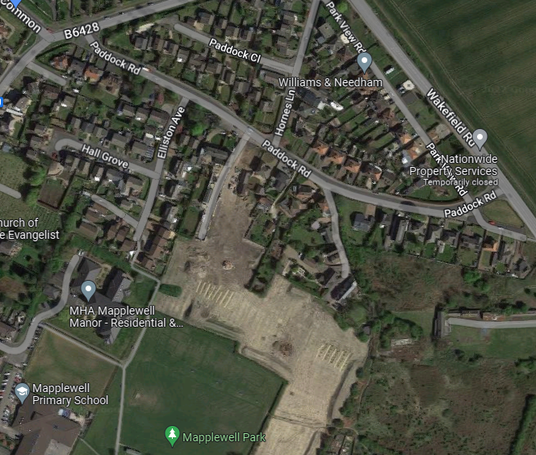

Above Top: No.28 Paddock Road
Above: Plot 1 nearing completion

3.0 Planning History
Search of the planning records identified the following applications:
2017/1387 - Demolition of existing dwelling and outbuildings and erection of up to 6 dwellings (Outline) - Approved 22/12/2017
2020/1453 - Reserved matters application for 3 dwellings (in connection with outline permission 2017/1387) - Approved 19/04/2021
2021/0596 - Discharge of conditions 6 (ground contamination report), 7 (Drainage details) and 8 (Drainage outfall) of application 2017/1387 (Outline for up to 6 dwellings) - Approved 30/06/2021
2021/1420 - Variation of condition 2 of application 2020/1453 (Reserved matters application for 3 dwellings (in connection with outline permission 2017/1387 to allow changes to site layout including alteration to road and addition of detached garage - Approved 11/01/2022

4.0 Proposal

The application seeks full planning permission for a residential development of 45 dwellings and associated landscape and access works. The proposals represent the next phase of development to access works established under previous planning approval 2017/1387.

Access would be taken form the adopted highway currently under construction as part of phase one works. This comprises of a 5.5m carriageway flanked by 2m wide footway (east) and 700mm margin (west).

Table 2: Accommodation mix:
House Type | Number
1 bed Apartment | 5
2 bed dwelling | 2
3 bed dwelling | 18
4+ bed dwelling | 20

A total of 25 house types hare proposed comprising of detached, semi detached, bungalows and apartments. The design and range of accommodation has been approached in a bespoke manner to address individual interest within the development.

The accommodation range would comprise of the following house types:

- 13 X Bungalows
- 17 x Detached
- 10 X Semi-detached
- 5 x 1bed Apartments

The proposed housing will range from 47sqm to 250sqm. The mix will meet the aspirations and housing need within Mapplewell/Staincross, as outlined in the 2021 SHMA; and offer the opportunity to provide housing for a cross-section of needs.

As part of the housing mix a total of 9 affordable homes are proposed to be provided on-site. This will comprise of primarily single bedroom accommodation aimed at key workers. It is proposed that the affordable dwellings are transferred to a Registered Housing Provider.

The highway would be constructed to adopted standards, this would comprise of a 5.5m wide carriage way and 2m wide footways. Turning heads would be provided to cul-de-sacs to allow the appropriate manoeuvring of refuse vehicles. Highway access would be taken to the eastern boundary between plots 28,29 &32 to allow continued access to adjoining land which is also allocated for housing. This follows the advice issued under pre-application correspondence from the LPA.

The bespoke approach to the design of the house types will make for a more interesting housing environment. The design and materials of the house types will be a continuation of the earlier phase of development currently under construction under planning approval 2017/1387. The materials will match those of the constructed properties.

Materials
Stone Work Yorkshire Black Rumbled & Tumbled

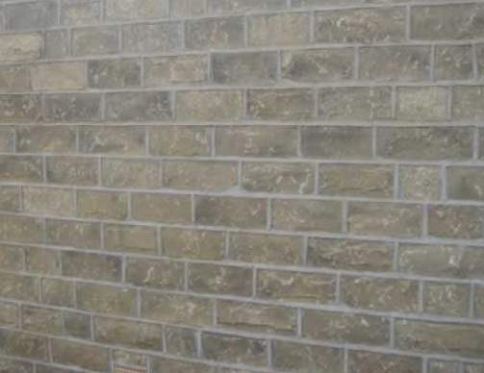

Roof Material
Sandtoft Rivius Antique Slate


The site layout will be complemented by 0.28ha of onsite public open space which is distributed across 5 areas within the site. This space will provide valuable amenity function and wildlife habitat. The associated landscaped in will be complement by structured tree lined streets.

Key Design / Layout Features
- High quality bespoke design to properties
- Continuation to the principles established by no.28 Paddock Road
- Highway design to adopted standards providing legible vehicle and pedestrian access
- Retention of trees and hedgerows to the site boundaries
- Active frontages to all highways providing passive surveillance to public areas
- In-curtilage parking largely to the side and rear of dwellings
- Street trees in line with NPPF requirements
- Well proportioned fronts and private rear gardens
- Provision of onsite amenity / ecology areas of public open space
- Layout facilities access to adjoining housing land
- Spacing standards observed within the site to properties beyond the redline boundary
- Read bin storage provision
- Internal accommodation exceeds minimum technical standards

5.0 Design Response

The principles of good urban design are well established and are reflected within the submitted layout. The proposed design solution can be assessed against the polices and guidance of the Local Plan and South Yorkshire Residential Design Guide. The site constraints, considerations and strategies have all influenced the submitted scheme, this includes:

- Positive response to the existing character and grain of properties within the locality
- Access response to adjoining allocated land
- Need to provide areas of on site public open space
- Observation of spacing standards
- Ability to serve the development with an adopted highway
- Observation of established rights of way across the site
- Building to perimeter block secure by design principles
- Fall in levels to the south of the site
- Retention of trees and hedgerows
- Response to onsite Biodiversity Net Gain
- Ability to meet onsite drainage capacity

Access
The new development will be served via a dedicated new access from Paddock Road into the development. The spine road would run centrally within the development and would be flanked by residential properties, cul-de-sacs would taper to shared surfaced private drives. The layout has been designed so that there is good natural surveillance to all areas of open space and roads from the proposed dwellings. All dwellings would have in-curtilage car parking.

Character & Design
The rationale behind the design for the development has been the desire to enhance the form of the housing layout, providing a pleasant and safe environment for future occupants whilst also creating a setting which helps to assimilate the site into the surrounding landscape. Open frontages to the plots allow for the inclusion of planting set within areas and the use of trees in key locations throughout the housing will help to break up the building line, filtering views of the housing and providing a structured landscaping response to the street scene.

The proposed development respects and maintains the character of the nearby existing settlement with materials and detailing carefully considered to ensure that the development would be a natural continuation to the initial phase of development at no.28 Paddock Road.
The use of a tumbled stone respects the historic vernacular of the townships of Barnsley, complemented with a slate roof the properties would relate positively with existing housing stock.

The drawing register includes a selection of street scenes which indicate how the proposals may look and how house types and scales are used to define spaces and create an aspirational environment. .

Streets within the development would be tree lined and there would be regular pockets of public open space. The careful consideration to car parking ensures frontages would not be car dominated with front garden area adding further to the character and structure of the streetscape. Existing ecological features are retained with complimentary planting adding to a landscape led design approach and creating a leafy environment and a development rich in character.

The scale of buildings is in keeping with the provision of accommodation and is tailored to site specific locations. The variation to house design and types provides interest and character. The housing mix appeals to a cross section of housing needs, the provision of bungalows being a particular benefit recognising the growing demand but shortage of supply to this house type.

The location and orientation of each dwelling respects the surrounding properties and relate well to one another. They are generally positioned parallel to one another, or at 90 degrees to their neighbours. There are also intimate dwelling clusters, typically at the head of the cul-de-sacs with some buildings located to create focal ends and vista stops. The new development respects the existing neighbouring property and any future development, by retaining existing boundary trees, hedgerows and planting to the perimeter of the site and creating a substantial stand-off to any of these properties.

Key features to the layout:

- Dwellings on corner plots are dual aspect, ensuring active frontages are achieved
- Long views within the development area framed with housing
- Structured landscaping including street trees to the main spine road
- Private garden area is clearly defined by landscaping
- Amenity of existing dwellings observed
- Pedestrian movement is clearly defined
- Areas of open space are accessible to dwellings throughout the development, space to include onsite community orchard
- Landscaped areas to be maintained under a private management arrangement

Sustainable Location
The site is located within a highly sustainable location with good access to local services. The site is located within short distances of services such as shops, pubs, post office and schools. The site provides an opportunity for residential development within easy reach of a range of education, employment, retail and leisure opportunities. The proposed site will provide high quality residential accommodation and will contribute towards the overall amenity, sustainability of the area and be an integral part of the delivery of the wider HS8 site allocation. Employment will also be created during the construction process.

Biodiversity
The site is bordered by hedgerows and trees located around the boundary. The majority of these trees and hedgerows are proposed to be retained, where removal is required suitable mitigation measures will be introduced. The proposals will provide opportunities for a mix of biodiversity within the site. Areas of public open space will provide wildlife corridors and a planting mix of native species will raise the habitat value of the site.

The mix of landscaping between public and garden areas will provide opportunities for wildlife to benefit from the development to a much greater extent than that which currently exists.

6.0 Planning Policy

Section 38(6) of the Planning and Compulsory Purchase Act 2004 requires applications/appeals to be determined in accordance with the Statutory Development Plan unless material considerations indicate otherwise.

The Statutory Development Plan includes:-

- Barnsley Local Plan adopted January 2019

The Local Plans Allocation Map designates the site as being partly within the Urban Fabric (entrance) with the majority of the site allocated for housing development under policy HS8 (site west of Wakefield Road).

The site is not within a Conservation Area and there are no designated assets within the vicinity.

Local Plan Map with approximate site boundary:

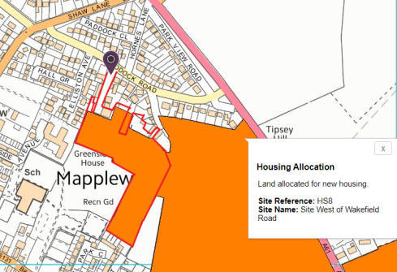
Staincross /Mapplewell fall within Urban Barnsley which is the primary area for the borough’s future growth.

In recognition of the sites allocation the following Local Planning policies apply to the determination of the application:

Local Plan Policies

HS8 - Site West of Wakefield Road , Mapplewell indicative number of dwellings 135.

Part of the site has planning permission for 250 dwellings. The indicative number of dwellings above relates to the remainder of the site.
The development will be expected to retain, buffer and manage all the hedgerows; significant areas of the existing grassland and scrub should be retained and managed as the greenspace provision.

Archaeological remains may be present on this site therefore proposals must be accompanied by an appropriate archaeological assessment (including a field evaluation if necessary) that must include the following:

Information identifying the likely location and extent of the remains, and the nature of the remains;
- An assessment of the significance of the remains; and
- Consideration of how the remains would be affected by the proposed development.

GD1 – General Development – Development will be approved if there will be no significant adverse effect on the living conditions and residential amenity of existing and future residents.

D1 – High Quality Design and Place Making – Development is expected to be of a high quality design and will be expected to respect, take advantage of and reinforce the distinctive, local character and other features of Barnsley.

T4 – New Development and Transport Safety – New development will be expected to be designed and built to provide all transport users within and surrounding the development with safe, secure and convenient access and movement.

LG2 - The Location of Growth - Prioritises development of new homes within Urban Barnsley.

H1 - The Number of New Homes to be Built - The Local Plan seeks to achieve the completion of at least 21,546 net additional homes during the period 2014 to 2033.

H2 - Distribution of New Homes - Identifies that 43% (9070) net new dwellings will be constructed within Urban Barnsley across the plan period.

H6 - Housing mix and Efficient Use of Land - Housing proposals will be expected to include a broad mix of house size, type and tenure to help create mixed and balanced communities. Homes must be suitable for different types of households and be capable of being adapted to meet the changing needs of the population. A density of 40 dwellings per hectare net will be expected in Urban Barnsley and Principal Towns and 30 dwellings per hectare net in the villages.

BI01 - biodiversity and Geodiversity - Development will be expected to conserve and enhance the biodiversity and geological features of Barnsley borough.

CC1 - Climate Change - Seeks to reduce the causes of and adapt to the future impacts of climate change.

CC2 - Sustainable Design and Construction - Development will be expected to minimise resource and energy consumption through the inclusion of sustainable design and construction features, where this is technically feasible and viable.

CC3 - Flood Risk - Seeks to reduce the impact of flooding from development.

CC4 - Sustainable Drainage Systems (SuDS) - Promotes the use of SuDS on both major and minor development. Identifies that planning applications should be supported by a detailed drainage plan.

CL1 – Contaminated and Unstable Land – Where future users or occupiers of a development would be affected by stability issues proposals must be accompanied by a report which shows that investigations have been carried out to work out the nature and extent of the stability issues and the possible effect they may have on the development and its future users. Dependent on the results of the report, a set of detailed measures should be provided to allow the development to go ahead safely by addressing land stability issues resulting from former coal mining activities.

HE6 - Archaeology - Applications for development on sites where archaeological remains may be present must be accompanied by an appropriate archaeological

Poll1 - Pollution Control and Protection - Does not allow development of new housing or other environmentally sensitive development where existing air pollution, noise, smell, dust, vibration, light or other pollution levels are unacceptable and there is no reasonable prospect that these can be mitigated against.

BI01 - Biodiversity and Geodiversity - Development is expected to conserve and enhance biodiversity and geological features by; Protecting and improving habitats, maximising biodiversity value in and around new developments, conserving and enhancing local character, following national mitigation hierarchy, protecting ancient and veteran
trees encouraging enhancements.

Poll2 - Pollution Control and Protection - Development will be expected to demonstrate that it is not likely to result, directly or indirectly, in an increase in air, surface water and groundwater, noise, smell, dust, vibration, light or other pollution which would unacceptably affect or cause a nuisance to the natural and built environment or to people.

Supplementary Planning Guidance

The following LDF Supplementary Planning Documents have now been adopted which are relevant to the proposal:-

‘Designing New Residential Development’ sets out the standards that will apply to the consideration of planning applications for new housing development.

‘Parking’ states that the parking standards for new housing development. It stipulates that 2 parking spaces shall be provided for 3 bed dwellings and above.

The South Yorkshire Residential Design Guide has been adopted as a best practice guide by the Council and covers issues relating to sustainability, local distinctiveness and quality in design and is underpinned by the principles in the CABE ‘Building for Life’ scheme.

NPPF

The National Planning Policy Framework (NPPF), came into force on 27 March 2012 and has been subsequently revised with the last update in July 2021. It is a material consideration in planning decisions. At the heart of the NPPF is a presumption in favour of sustainable development, and the policies, taken as a whole, constitute the Government’s view on what sustainable development in England means in practice for the planning system.
There are three dimensions to sustainable development, which include an economic role (contributing to building a strong, responsive and competitive economy), a social role (providing the supply of housing required to meet the needs of present and future generations) and an environmental role (which includes minimising waste and pollution).
Permission should therefore be granted unless any adverse impacts of doing so would significantly and demonstrably outweigh the benefits, when assessed against the policies in the Framework as a whole; or where specific policies in the Framework indicate development should be restricted or unless material considerations indicate otherwise.
Relevant Chapters Include:
Chapter 5 - Delivering a sufficient supply of homes
Chapter 8 - Promoting healthy and safety communities
Chapter 11 - Making effective use of land
Chapter 12 - Achieving well-designed places
Chapter 14 - Meeting the challenge of climate change, flooding and coastal change
Chapter 15 - Conserving and enhancing the natural environment
Chapter 16 - Conserving and enhancing the historic environment.

7.0 Planning History
Search of the planning records identified the following applications:
2017/1387 - Demolition of existing dwelling and outbuildings and erection of up to 6 dwellings (Outline) - Approved 22/12/2017
2020/1453 - Reserved matters application for 3 dwellings (in connection with outline permission 2017/1387) - Approved 19/04/2021
2021/0596 - Discharge of conditions 6 (ground contamination report), 7 (Drainage details) and 8 (Drainage outfall) of application 2017/1387 (Outline for up to 6 dwellings) - Approved 30/06/2021
2021/1420 - Variation of condition 2 of application 2020/1453 (Reserved matters application for 3 dwellings (in connection with outline permission 2017/1387 to allow changes to site layout including alteration to road and addition of detached garage - Approved 11/01/2022
8.0 Pre Application Advice
Pre-application discussions have been held with the Council to discuss the deliverability of the site. An initial pre-application document, with proposed site plan for the site for a development of 34 dwellings. This was submitted and advice provided by Hannah Andrew under reference 2021/ENQ/00178 dated 10th June 2021.

The response outlined policy and validation requirements. The principle of the residential development was supported but the officer advised that the yield of development should be increased. The number of houses been increased to that of the maximum tolerance of the site’s constraints. Any increase in numbers would conflict with policy requirements and design aspirations.

The officer also advised that the site should observe a connection to the remaining allocation (Bleak House Poultry Farm) to the east of the site boundary. It was suggested that the connections are pedestrian / cycle rather than vehicular but I would ask that you investigate both options.

9.0 Assessment

The National Planning Policy Framework (NPPF) is also an important consideration. The NPPF states that a presumption in favour of sustainable development should be at the heart of every application decision. For decision making this means approving development proposals which accord with an up-to-date development plan without delay.
The Barnsley Local Plan was adopted on 03 January 2019. Policy H1 of the Local Plan commit to the delivery of at least 21,546 net additional domes across the period of 2014 to 2033. Mapplewell falls within Urban Barnsley which is the spatial priority to accommodate the majority of the boroughs anticipated growth.
Urban Barnsley is expected to deliver a total of 9070 new homes - through land allocations and existing planning permissions. This equates to 43% of the overall supply for the borough. At paragraph 5.14 the plan states that the councils want to; 'encourage growth in what are our most accessible and sustainable locations in the borough. Urban Barnsley will be the main focus for development, and will support the important role of Barnsley Town Centre'.

The case to be presented is one of acceptance against the policies of the Barnsley local Plan, Supplementary Planning guidance and that of National Planning Policy. In addition to this statement the proposals should be read in conjunction with the submitted technical report relevant Ecology, Drainage, Heritage, Mining Risk and Trees. On review of this suite of documents it would be hoped that the applicant has presented a fair and balanced case in support of the application.

Principle:
The site is located within an established residential area, it forms part of a larger housing allocation under reference HS8 'Site West of Wakefield Road , Mapplewell'. The principle of residential development is therefore in accordance with Local Plan - in meeting the identified housing requirement for Urban Barnsley and the wider borough’s housing target (as outlined in Policies LG2; H1; and H2 of the Local Plan).

Paragraph 117 of the NPPF states; ' Planning policies and decisions should promote an effective use of land in meeting the need for homes', section 11 of the NPPF compliment the wider objective of paragraph 59 to boost the supply of new homes. The application presents an opportunity to deliver housing in accordance with the aspirations of the adopted Local Plan.

Policy H6 relates to housing mix and the efficient use of land. The policy seeks an appropriate mix of house type, size and tenure together with a target density of 40 dwellings per hectare in Urban Barnsley and Principal Towns. The policy does support lower densities where they are necessary for character and appearance, need, viability or sustainable design.

Policy HS8 provides an indicative figure of 135 dwellings, the allocation includes land to the east which forms part of the Bleak House Poultry Farm.

The demolition and rebuilding of no.28 Paddock Road by the applicant unlocked 2 further development plots at the site. These properties are outside of the HS8 housing allocation, but they present an example of windfall development. By this token, their presence and relationship to the development, the overall development yield could be viewed as 48 dwellings.

Policy H6 provides flexibility to housing density. The case presented by the application is that the current proposals represent the maximum viable development threshold that the site can support. The layout and density is informed by the site conditions and policy requirements. To increase the threshold would result in significant compromise to design requirements, the legacy of this would be a compromised design, reduction to the housing mix, loss of landscaping, poorer amenity standards and parking dominated environment, collectively this would fail to integrate successfully with the locality.

Pre-application discussions with the LPA referenced that development should ideally achieve a density requirement of 40uph. The ability to achieve such a density has been discounted on design grounds as significant compromises to the dwelling types, layout, character, landscaping and amenity standards would need to be made. The most significant influence upon the site’s housing capacity of the development is its irregular shape. The elongated and winding nature of the site coupled with challenging levels and ecological considerations dictates the access runs centrally through the development. The relatively shallow depth/width to the site dictates that plots sizes would need to be significantly reduced should numbers be increased. This ultimately would come at a cost to the design quality and amenity standards of the development.

In making an assessment of the overall density and environmental quality the LPA must give consideration to the housing layout and landscape masterplan, which has been influenced by the following considerations:

- Irregular shape and depth to the site;
- Fall in levels from north to south;
- Prevailing character and density of the existing housing stock;
- Requirement for open space and onsite Biodiversity Net Gain;
- Need to respect the setting of protected Green Space on land to the land to the south and west of the site;
- Requirement to retain as many hedgerows and trees around the site;
- Highway geometry and integration of parking;
- Requirement to achieve a 1:12 gradient;
- Requirement for properties to meet minimum internal and external space standards;
- Requirement to achieve appropriate amenity distances between properties and site boundaries;
- Ability to meet landscaping requirements; and,
- Ability to meet onsite drainage capacity requirements.

Realistically the density of the site could only be increased by revisiting the housing mix and focusing upon smaller high density units. This would not be reflective of the character of Paddock Road, the housing needs for the area or the design aspirations of the applicant to provide high quality residential development. The proposals as presented fall within the flexibility of policy H6, they represent the most logical solution to delivering much needed housing within Mapplewell/Urban Barnsley.

In addition to the above it should be stressed that the site only represents a part of a much larger housing allocation. The shape of the remaining allocated land being much more favourable to delivering an efficient and higher density layout. Ultimately the housing figure quoted within policy HS8 was for a much larger site and not informed by detailed technical or design analysis of the site condition and constraints. The level of development proposed is both realistic and proportionate to meeting the broader spectrum of planning requirements, particularly that relevant to design and quality of environment which government policy holds in the highest esteem.

Aside from the density target requested by policy HS8, the policy also states a requirement for the retention of hedgerows and green space, in addition, there should also be an appropriate level of archaeological investigation.

The Ecological Impact Assessment report prepared by Whitcher Wildlife along with the Arboricultural Impact Assessment prepared by AWA provide an appropriate baseline assessment of the on site ecological value. The site has been largely stripped of vegetation, the primary
habitat that has been lost on the site is grassland, the proposed landscaping incorporates various types of high value grassland habitats were possible to compensate for this. The majority of existing tree and hedgerows will be retained, additional landscaping and onsite public open space will provide wildlife connectivity and an opportunity for Biodiversity net gain to the satisfaction of the policy requirement.

The archaeological impact is evaluated within the accompanying Heritage Statement prepared by Jessop Consultancy. This concludes that; ' There is no recorded evidence for archaeological remains within the site. Cartographic evidence suggests that the site is likely to have been part of the later medieval open field system and in addition that the site has remained as fields since at least the 19th Century. Geological records
indicate that remains of early mining which if present, would be buried may survive within the site. The overall potential for encountering archaeological remains at the site is considered to be low
and the significance of any surviving remains is likely to be local'. The level of investigation is considered to be proportionate and addresses the requirement of policy HS8.

In terms of the overall principle of development the proposals are compliant with the strategic policy objectives of policy H2 and H4 and this complements the government advice within paragraph 60 of the framework to significantly boost the supply of housing.

Allocated sites are invariably sustainable given they are located within or adjacent to established communities where people already live with direct access to transport, employment, services and amenities. The proposals would see the delivery of housing on allocated land, the development of this accessible asset would contribute to the range and choice of housing within the locality. It should therefore not be disputed that the resultant contribution to housing supply is compatible with the objectives of local polices LG2, H2 and HS8 as well as guidance on decisions to be taken on housing supply and growth contained within the NPPF.

The principle in land use terms is considered to meet the expectations of the Development Plan. The scale of the development will create an attractive environment with a range of housing to meet a cross section of housing requirements.

Design
Development Plan Policies GD1 and D1 of the Local Plan sets out the Council’s design principles and expectations for new development proposals. These polices are supplemented by more explicit design guidance contained within the South Yorkshire Residential Design Guide, in addition to guidance within the NPPF and planning practice guidance.
Assisted by the accompanying technical reports the proposals address the requirements of local policy and advice in the NPPF. The proposals seek to respond to local character, reflect the identity of local surroundings and materials and create an aspiration attractive residential environment.
In accordance with the allocation (HS8); the proposal seeks to retain features identified onsite. This includes existing trees and hedging within and bordering the site. The established right of way crossing the site to Mapplewell Park would be retained along its alignment.
The proposals would see the creation of a residential cul-de-sac with access being taken from the newly constructed entrance from Paddock Road. The properties would take a traditional layout with them being sited either side of a central access road with surveillance across the carriageway. The creation of a cul-de-sac would provide a traffic calmed environment, structured planting would provide a desirable break to the hard surfacing. The layout and form mirrors that of the established pattern of development of the existing housing stock which includes clearly defined linear streets.
The layout demonstrates a clear hierarchy of properties along defined streets, these are set around a central spine road that extends from the entrance. A number of small cul-de-sacs are also provided which lead into private drives. All dwellings are orientated so as to engage actively with the street scenes. The layout has also been designed to reflect the standards of relevant separation distances requested within the accompany SPD.,

The applicant has been marketing the site to great success. To accommodate individual design requirements there would be 26 different house types which would create visual interest. The elevations are slightly contemporary in appearance, they would be constructed from a consistent materials palette of stone and slate, further details are provided to elevations in the form of central window panels and feature ground/first floor bays, as a rule all properties located on corner plots are dual. Overall there is sufficient variety within the housing stock to meet varying housing needs, the design and choice of materials is also considered to be of a desirable quality as exhibited from the completed dwelling at 28 Paddock Road.

The development would constitute a density of approximately 22uph, this is considered to be an efficient use of the land and it would not be desirable to see this increased given that any additional numbers would be at a loss to landscaping and car parking. The scale and design of the properties are directly comparable in scale to existing properties situated off Paddock Road and the wider area.

With regard to parking arrangements the layout would not appear overly car dominated, parking is provided in the main to the side of dwellings, the dominance/impact of parking areas is offset by soft landscaping within front gardens as well as communal planting areas. Provision is also made within the layout to accommodate appropriate levels of visitor parking within the street. All of the properties are served with front to rear access which will allow for the storage of bins outside of the public domain.

Within the development, boundaries would consist of a mixture of treatment, the exact details of which would need to be addressed by way of a condition.

Public open space is provided across the site. This provision along with the planting throughout will help to shield views of the site as well as creating an accessible and attractive place to live. Each dwelling has well proportioned private amenity space.
The South Yorkshire Design Guide (2011) sets the required internal space standards. Each dwelling has been designed so as to comply with the minimum space standards to provide a good level of internal amenity space for residents in accordance with the prescribed standards with many dwellings far exceeding minimum standards.
Having full consideration to the design merits of the proposal and the layout of the scheme it is considered that the development would deliver an attractive residential environment which would enhance the existing area. The scale and density of the development is reflective to that of housing within the locality, overall it is considered that the design and layout should successfully assimilate with the existing housing stock, whilst providing good quality family housing. It is therefore, considered that the proposal adheres to the objectives of Development Plan polices GS1, D1. and the guidance outlined in the Open Space Provision on New Housing Developments SPD and South Yorkshire Design Guide.

Parking Provision and Highway Safety
The site access has been established under the approved application 2017/1387, its construction is to recognised adopted standards with suitable visibility onto Paddock Road. The road within the development is designed to ensure that vehicle speeds are low on the approach to the site access. Exact details of carriageway design will need to be determined at detailed design as part of a section 38 agreement.
The main carriageway would be 5.5m wide with 2m wide margins either side. In line with the maximum standards of the adopted SPD on parking all of the properties have 2 off street parking. The position and orientation of the properties ensures that these parking spaces are accessible and also have good surveillance.

The proximity of the site to Mapplewell, in addition to public transport, employment and community services is noted, and on this basis is considered in highway terms to be a highly appropriate location for a residential development.

The access and parking arrangements have been designed in conjunction with advice given from Optima Highways who have been in direct contact with the Local Highway Authority (LHA). Forward visibility and turning heads have been designed as per the advice of the LHA and provision has been made for suitable pedestrian crossing points. The LHA have not identified any known acuity or safety issues within the locality and the local highway network will be able to accommodate the associated movements of the development.

At the request of the LPA provision is made for either a vehicle or pedestrian link from the site to the eastern boundary. This access is provided adjacent to plot 34

With regard to servicing and waste management matters the dwellings would be provided with dedicated bin stores within their rear gardens. Bins would be collected on street albeit for properties located off a private drive where there would be a dedicated collection point, The arrangement is consistent with existing properties on Paddock Road.

Public Transport is immediately on hand with bus stops located within walking distance. Immediate access to services and the public transport network equates to a highly sustainable location, access to the accommodation would therefore not necessarily need to be car dependent.

In accordance with paragraph 109 of the Framework the proposals would not have a demonstrable impact upon local highway safety, nor would it result in any cumulative impacts which could be considered severe. The requirement of paragraph 109 of the framework and Local Plan policy T4 would be met.

Trees & Ecology :
A full Arboricultural impact assessment has identified a total 21 individual trees and 15 groups within the site. The majority of the individual trees (18) and 15 groups falls within retention category 'C'. There are only 2 trees recognised as a category 'B'. These are exclusively located to the site’s boundaries , the central area to the site contains northing of arboricultural significance.

A single tree T21 is required for removal the others can be retained and incorporated into the landscaping scheme. Retained trees would be protected through the development and the layout presents an ideal opportunity to undertake new tree planting throughout the site as part of a soft landscaping scheme. Replacement tree planting of native species can adequately mitigate for the required tree removals and, in the longer term, has the potential to improve the sites tree cover and overall ecology value.

Ecological Impact Assessment prepared in support of the application includes an appropriate assessment of habitats within the site and potential ecological constraints to development. Appropriate mitigation is provided where necessary and opportunities are presented to secure biodiversity net gain, this can be achieved through the provision of bird and bat boxes/bricks and the planting of native species hedgerows to raise the ecological value and facilitate habitat connectivity. This would be appropriate to the scale of development proposed and can be conditioned to address requirements of policy BI01.

Drainage & Flood Risk
The application is accompanied by a Flood Risk and Drainage Assessment prepared by RWO. The document considers the flood risk to the site, surface water and foul drainage arrangements. The assessment confirms that the site is located within Flood Zone 1 and there are no historic records of any surface water flooding.
The site will be drained with separate foul and surface water systems the detailed design of which the applicant would expect to be conditioned.
In terms of the approach to the strategic drainage strategy a search of records has confirmed that there are no culverted or open watercourses crossing the site, consequently an outfall from the site is not viable. Site investigations accompanied by infiltration tests at 12 locations have found that the underlying strata consists of Mudstone with little infiltration characteristics. Consequently, infiltration is not viable as a method of surface water disposal.
It has been agreed in principle with Yorkshire Water that the site can be drained via an attenuated system to a public surface water system within Mapplewell Park. The flow will be restricted to 3.5l/s in all storm events. The level of attenuation would be designed to account for climate change and a 30% increase in rainfall.

The above strategy and accompanying drainage assessment demonstrates that the foul and surface water drainage systems for the new development can be designed and constructed to meet local and national planning and drainage policies. Accordingly, it has been demonstrated for the purposes of the planning assessment that the proposals accord with Policies POLL1, CC3 and CC4 of the Local Plan.

Ground Stability:
A coal mining Risk Assessment has been prepared by G7M Consulting Ltd. The desk- top assessment has identified that the site may be at risk to shallow coal mining works. It recommends that intrusive geoenvironmental investigation is undertaken to fully evaluate ground conditions.

The presence of shallow workings is not unique and a number of solutions can be applied to address mining legacy issues which are particularly prevalent on sites within Barnsley. Ultimately any mitigation will be informed via the findings of further site investigations.

The assessment undertaken to date is considered proportional to meet the tests of NPPF paragraphs 183-184 and policy CL1. Aided through consultation with relevant technical bodies such as the Coal Authority and SYMAS, it is recommended that the LPA apply a pre-commencement condition which suitably addresses this requirement.

Affordable Housing Statement
Location: Paddock Road, Staincross, Barnsley
Local Plan Policy H7 sets the affordable housing requirement for housing developments of 15 or more dwellings it seeks 20% within Darton and Barugh and 10% in North Barnsley to be affordable. It states that “these percentages will be sought unless it can be demonstrated through a viability assessment that the required figure would render the scheme unviable.”
The table below demonstrates the number of affordable houses required for the development at Paddock Road based on the H7 Policy is 9.

The proposed development commits to 20% affordable housing units (9 dwellings). The location and mix of dwellings are shown on the site layout as occupying plots 3, 4, 25-29, 31, 32 and will be constructed as part of the overall programme of works.
The table below provides details of the affordable housing provision by plot.

The affordable housing will be delivered in line with the requirements of the Affordable Housing SPD and First Homes Technical Note and will therefore be held as affordable housing in perpetuity.
Section 106 Contributions
It is understood that contributions towards Education, Open Space and Sustainable Travel may be required commensurate to the scale of development. As with the affordable housing requirements such matters will need to be negotiated and agreed in the process of the planning applications assessment, and then, secured by either a planning condition, or within a section 106 agreement. Any requirement for contributions will need to be complaint with Community Infrastructure Levy (CIL) regulation 122 and demonstrate they are;

- necessary to make the development acceptable in planning terms;
- directly related to the development; and
- fairly and reasonably related in scale and kind to the development.
The response from technical consultations will determine the need and relevance of any contributions to mitigate and associated impacts arising from the development.

Climate Change and Sustainability
Policy CC1 ‘Climate Change’ seeks to reduce the causes of and adapt to the future impacts of climate change through locating and designing development to reduce the risk of flooding, promote use of sustainable drainage systems and promoting investment in Green Infrastructure to promote and encourage biodiversity gains.
The fabric and energy performance of the dwellings will be controlled through the Building Regulations. The properties will be insulated to meet current standards and provision will be made for electric charging points for vehicles.

The Drainage Strategy as detailed is guided by sustainable drainage principles and protects the development against the 1 in 100year storm plus 30% climate change event.

A Proposed Landscaping Scheme is also provided which proposes a variety of planting and species mix which would promote and encourage opportunities for biodiversity.

8.0 Conclusion

The site is allocated for housing development within the adopted Barnsley Local Plan (2019). The principle of development is fully compliant with the aspirations of the adopted spatial strategy and will deliver much sort after residential accommodation within Urban Barnsley.

This statement has identified that the proposed development would be consistent with guidance provided at a national level in the NPPF as well as local Development Plan polices relevant to land use compatibility, highway safety, residential amenity, design, drainage, land stability and ecology matters.

The application seeks to deliver 45 dwellings on site, including 9 affordable homes which should hold substantial material weight in the decision-making process.

The requirements as outlined in the site allocation Policy HS8 would be addressed in a capacity befitting of the site. The figure of 135 dwellings advocated by policy HS8 applies to a larger allocation, it is also only an indicative number and one not informed by technical or design analysis of the sites constraints. The proposals are compliant with policy H6 which permits flexibility on density to respond to local circumstances. The benefits to the design quality of the homes and overall environmental character outweigh and perceived concerns associated with higher density development.

The application is supported by a suite of supporting documents which deal with various technical considerations. The technical assessments demonstrate that there are no issues which would prevent granting planning permission for the proposed development, subject to appropriate mitigation of methods outlined within the accompanying reports where stated.

The proposals represent a considered response to site constraints and local character. The resulting development would be highly sustainable meeting social, environmental and economic objectives.

The statement has presented a balanced and robust case in support of the proposed quantum of development. It has identified that the development would comply with policy requirements and secure the delivery of high quality housing on an allocated site.

The mix of housing reflects the accommodation requirements of a variety of groups and would also provide for much needed affordable housing inline with policy requirements.

The design and layout would create a high quality residential development which would successfully assimilate itself into the local setting; respecting the character and appearance of the surrounding area, as well as the amenity of the existing occupiers surrounding the application site, and the amenity of the future occupiers of the development itself. Specifically the proposal will provide:

- A high quality residential development that complements the surrounding context in terms of density, scale and appearance.
- The materiality and elevation detail dwellings has been developed to ensure all dwellings within the development are in keeping with the surrounding context while providing high quality contemporary design.
- Dwellings meet or exceed the internal space standards and all are provided with well proportioned private amenity space
- All car parking, cycle parking and refuse stores integrated within the design
- High quality landscaped environment with good levels of onsite public opens space and biodiversity habitat

The site is accessible to local services and facilities in addition to employment opportunities. The submitted plans and accompanying documents demonstrate that the proposed development would be of an appropriate density and layout which is reflective to the character and grain of the locality.

Any impact arising from the development, and its associated construction, can be adequately controlled through the use of planning conditions.

It is therefore considered the proposed development satisfies national and local policy requirements. It is therefore considered that planning permission should be granted.

