WELLS HOUSE, 2 Station Road, Royston, BARNSLEY, S71 4EW. Proposal to drop curb as part of boundary wall partial removal to improve parking access to home.
- Kerb Lowering: Required to ensure present vehicular parking access to property is safer, easier and legal.
- Parking sign relocating – The parking restrictions are identical throughout this immediate location. So moving the sign down a few meters would not be detrimental. The Green arrow denotes suggested location. I have already received email confirmation that this would be OK from Streetworks@barnsley.gov.uk details included in planning application.

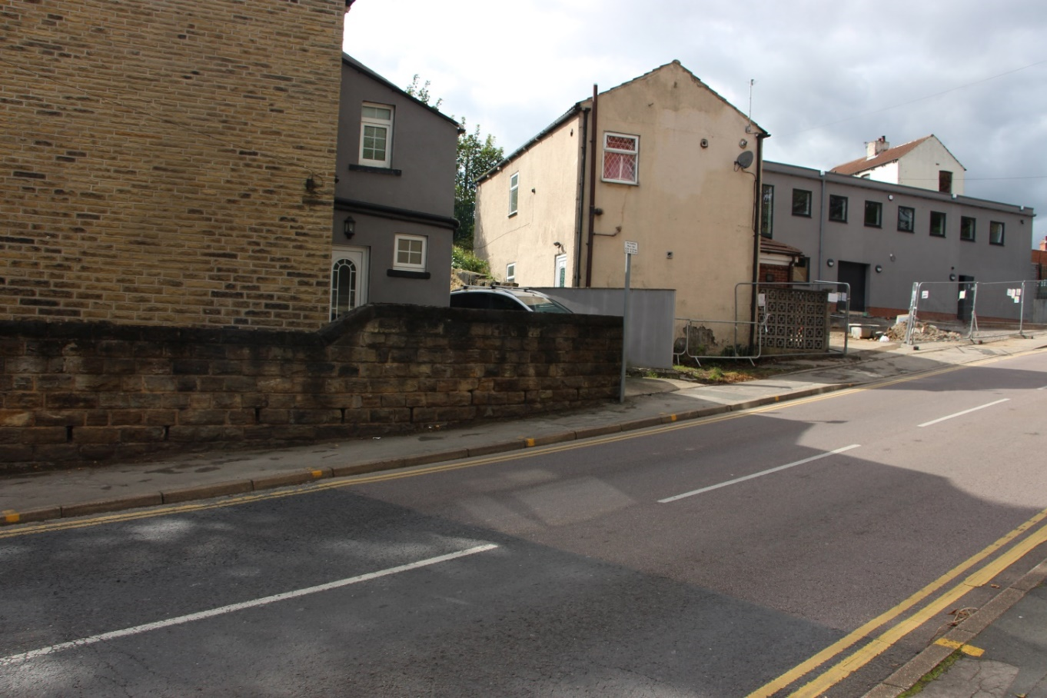
Boundary Wall partial removal: (No more than 2.5 mtrs) to improve existing vehicular access to home. Residential parking in the area is very limited but is even worse with the recent development of the adjacent “COOLE ELECTRICAL”.

PS: Just for info. We actually gave some of our land to the council free of charge many years ago to allow you to modify the wells junction to make it safer as there used to be frequent accidents. As time has moved on and the area become busier and increased parking restrictions imposed, it has made parking a problem for us. This proposed minor work will make existing vehicle access to the property easier and safer.

