DESIGN AND ACCESS STATEMENT
THE PROCESS
- Assessment
- Re position the front door make the disable access easy.
- The structure of the building will not affect development of the planning policy.

- Involvement
- This is not applicable for this development work.

- Evaluation
- There are no conflict issues with this proposed work.

- Design
- The proposed work to re-place the door and infill the window glazing with where the previous door.
- There are no changes on the character of the building due to the new design.
USE
- The proposed ground floor is use as commercial and first floor use as residential.
- There are no changes after the development
AMOUNT
- There no changes on the floor area.
LAYOUT
- The proposed site accessible for the workers and the public.
- Space is safe and convenient.

SCALE
- The drawings prepared for this proposed site is with the scale of 1:100.

LANDSCAPING& APPEARANCE
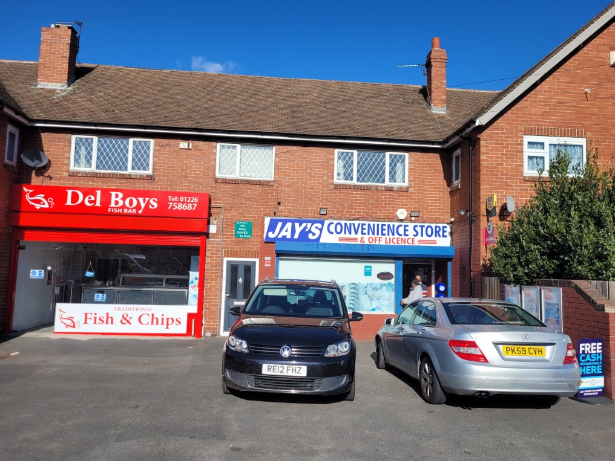

This shows theFront of the store building.

ACCESS
- There is no vehicular and transport access to the proposed site.

