Worsbrough Reservoir Banking Replacement Project – Re-Planting Scheme
Wherever possible, plants and seeds should be native species sourced from areas local to the site but accept this is not always the case.
A long-term management plan is needed to ensure proper establishment of the plants.
There are opportunities to involve local volunteer groups to support planting activity.
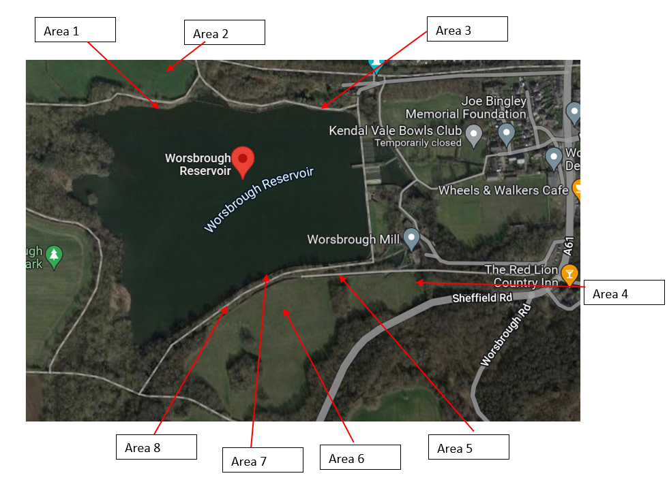

Area 1 – north west banking (aka Shallows) 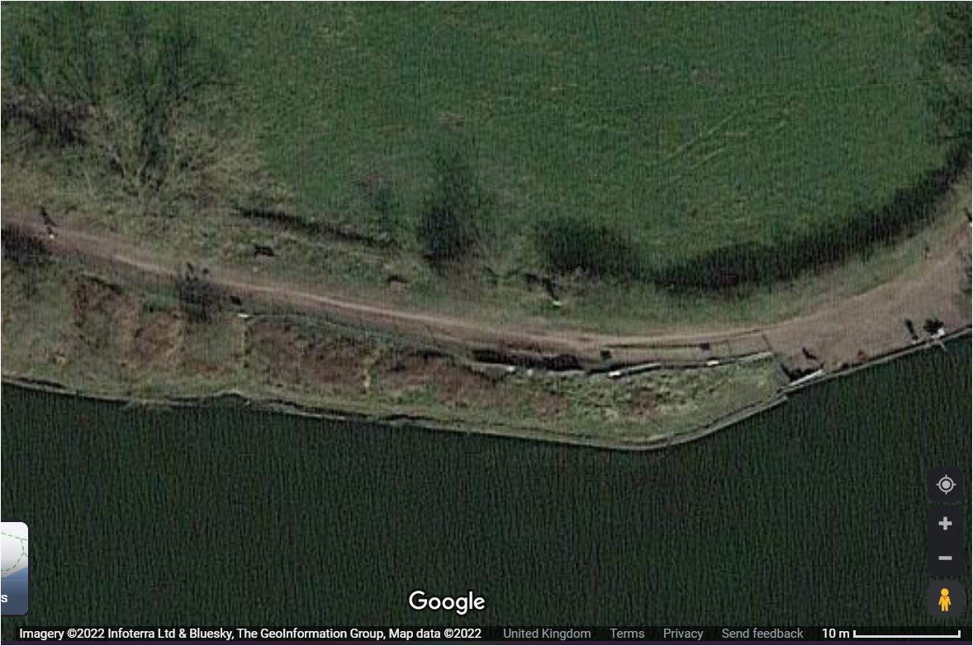
Re-turf (preferably or seed if unable to obtain turf) level banking area with grass and clover mix containing 5% white clover, 60% perennial ryegrass, 20% strong creeping red fescue, 10% hard fescue, 5% smooth-stalked meadow grass (seed mix would be such as https://www.grassseeds.com/grass-seed-mixtures/landscape-grass-seed-1/parks-and-playing-fields/road-verge-and-general-purpose-with-clover/)https://www.grassseeds.com/grass-seed-mixtures/landscape-grass-seed-1/parks-and-playing-fields/road-verge-and-general-purpose-with-clover/)https://www.grassseeds.com/grass-seed-mixtures/landscape-grass-seed-1/parks-and-playing-fields/road-verge-and-general-purpose-with-clover/).
Sloping area: clear any remaining brambles from beside the accessible peg area up to the young oak tree (T713 on arboriculture survey ref: Tree Survey 0264) then seed with a 90% grasses/10% wildflower mix (such as https://wildseed.co.uk/product/mixtures/complete-mixtures/general-purpose-meadow-mixtures/basic-general-purpose-meadow-mixture/ ) across the sloping area.
Accessible pegs area to remain hardcore surface on which wheelchairs can be easily manoeuvred.

Area 2 – North field
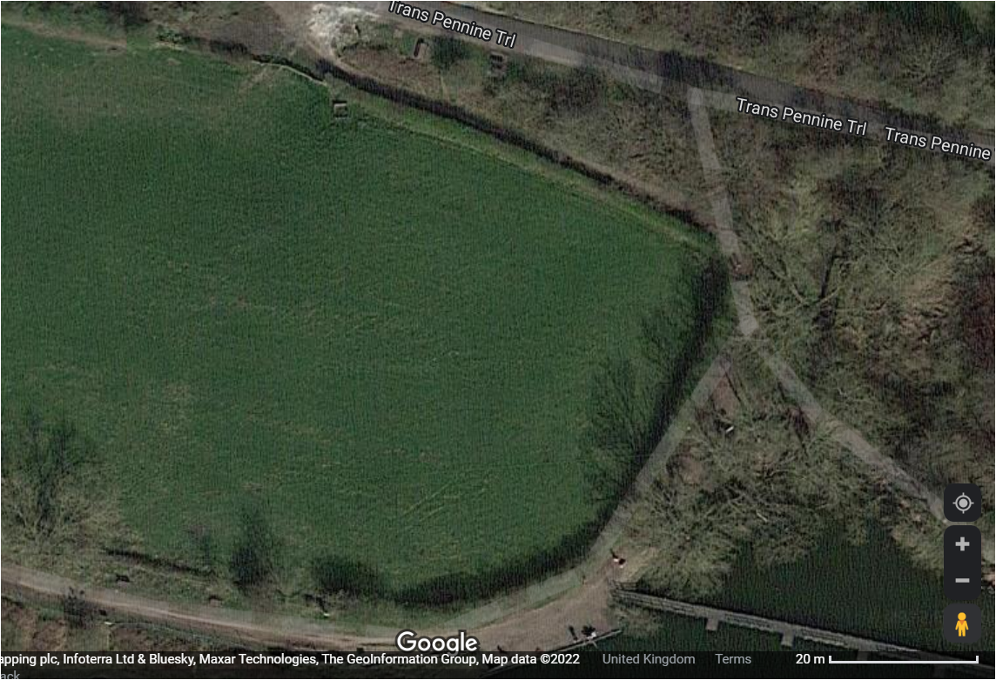
A shade tolerant seed mix (such as https://wildseed.co.uk/product/mixtures/complete-mixtures/special-habitat-mixtures/hedgerow-mixture/ ) is to be laid where the temporary haul road had been positioned (ie in parallel with the northern and eastern hedge lines).
Where compounds/storage areas were present, reseed with an MG6 grassland mix ~25% clovers, legumes and herbs and 75% grasses (such as https://wildseed.co.uk/product/mixtures/other-mixtures/special-old-fashioned-grazing-mixture/ ).
Replace lost/damaged hedgerow with 70% hawthorn (Crataegus monogyna) interspersed with 5% hazel (Corylus avellana), 5% dog rose (Rosa canina), 5% dogwood (Cornus spp.), 5% English Holly (Ilex Aquifolium), 5% guelder rose (Viburnum opulus), and 5% midland hawthorn (Crataegus laevigata).
Plants to be set in two staggered rows 30cm apart with 4-6 plants per linear metre. Plants stems to be staked for support and protected using wrapping such as https://tubex.com/products/tubex-nature/?gclid=Cj0KCQiA14WdBhD8ARIsANao07gQ4ID6ITb2xb_X0RuXvASMred1DrUcRUR0vTV_N0Fi9uFmMO_n4J4aAr4pEALw_wcB or similar.
Area 3 – Kip’s wall (north-eastern bank)
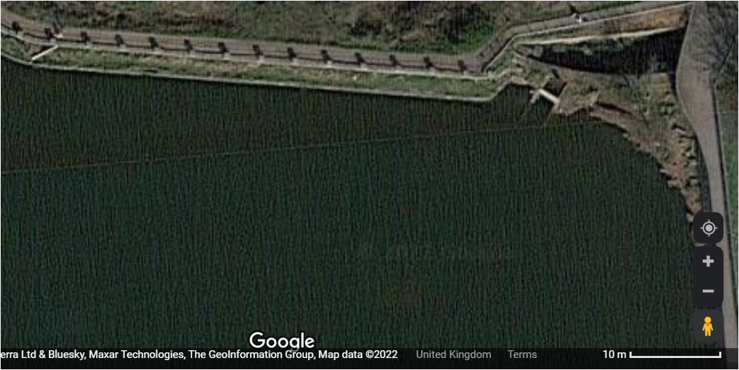
Re-seed with a grass and clover mix containing 5% white clover, 60% perennial ryegrass, 20% strong creeping red fescue, 10% hard fescue, 5% smooth-stalked meadow grass (such as https://www.grassseeds.com/grass-seed-mixtures/landscape-grass-seed-1/parks-and-playing-fields/road-verge-and-general-purpose-with-clover/)Re-turf (preferably or seed if unable to obtain turf) with a grass and clover mix containing 5% white clover, 60% perennial ryegrass, 20% strong creeping red fescue, 10% hard fescue, 5% smooth-stalked meadow grass (seed mix would be such as https://www.grassseeds.com/grass-seed-mixtures/landscape-grass-seed-1/parks-and-playing-fields/road-verge-and-general-purpose-with-clover/)
Area 4 – South-eastern field
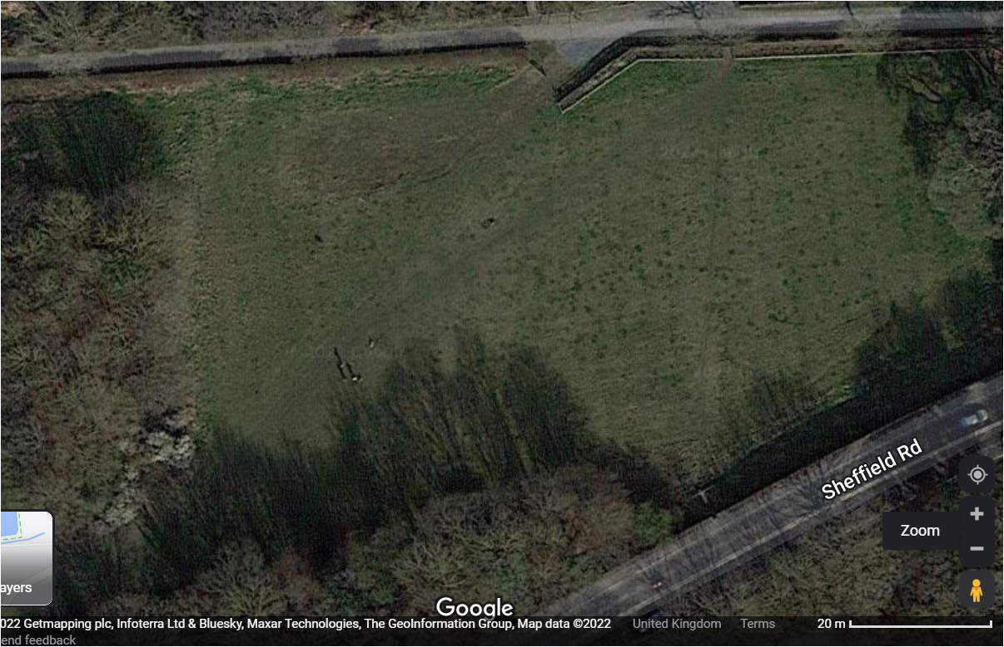
Where compounds/storage areas and haul roads were present, reseed with an MG6 grassland mix ~25% clovers, legumes and herbs and 75% grasses (such as https://wildseed.co.uk/product/mixtures/other-mixtures/special-old-fashioned-grazing-mixture/ ).
Expand the eastern perimeter of the tree copse by planting four each of, oak (Quercus robur), hazel (Corylus avellana), and spindle (Euonymus europaeus).

Area 5 – marshy area in south field
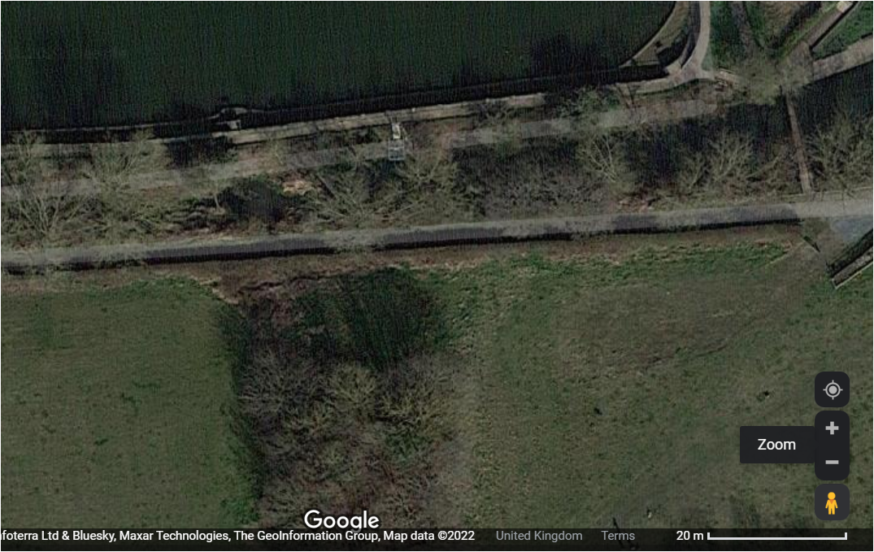
In the marshy area at the base of the copse, plant 3 semi mature (~8-10cm stem ~2.5m high) or 6 younger Alder (Alnus Glutinosa) trees. Towards the hedge line plant (in a staggered arrangement vs the Alders) 3 grey willow trees.
Replace lost/damaged hedgerow with 70% hawthorn (Crataegus monogyna) interspersed with 5% hazel (Corylus avellana), 5% dog rose (Rosa canina), 5% dogwood (Cornus spp.), 5% English Holly (Ilex Aquifolium), 5% guelder rose (Viburnum opulus), and 5% midland hawthorn (Crataegus laevigata).
Plants to be set in two staggered rows 30cm apart with 4-6 plants per linear metre. Plants stems to be staked for support and protected using wrapping such as https://tubex.com/products/tubex-nature/?gclid=Cj0KCQiA14WdBhD8ARIsANao07gQ4ID6ITb2xb_X0RuXvASMred1DrUcRUR0vTV_N0Fi9uFmMO_n4J4aAr4pEALw_wcB or similar.

Area 6 – South-western field
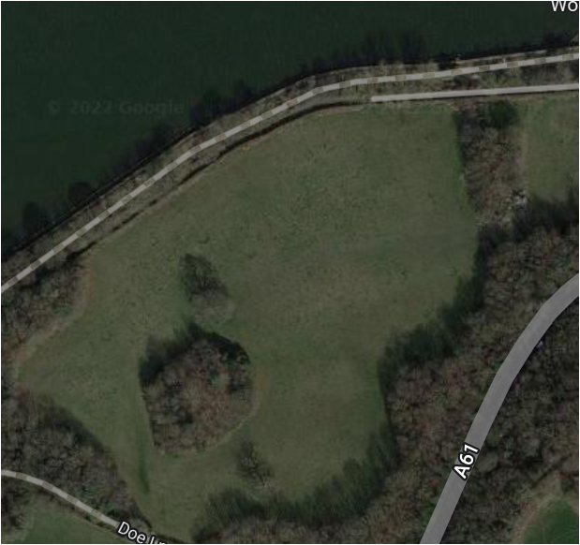
Where compounds/storage areas and haul roads were present, reseed with an MG6 grassland mix ~25% clovers, legumes and herbs and 75% grasses (such as https://wildseed.co.uk/product/mixtures/other-mixtures/special-old-fashioned-grazing-mixture/ ).
Replace lost/damaged hedgerow with 70% hawthorn (Crataegus monogyna) interspersed with 5% hazel (Corylus avellana), 5% dog rose (Rosa canina), 5% dogwood (Cornus spp.), 5% English Holly (Ilex Aquifolium), 5% guelder rose (Viburnum opulus), and 5% midland hawthorn (Crataegus laevigata).
Plants to be set in two staggered rows 30cm apart with 4-6 plants per linear metre. Plants stems to be staked for support and protected using wrapping such as https://tubex.com/products/tubex-nature/?gclid=Cj0KCQiA14WdBhD8ARIsANao07gQ4ID6ITb2xb_X0RuXvASMred1DrUcRUR0vTV_N0Fi9uFmMO_n4J4aAr4pEALw_wcB or similar.

Area 7 – South bank - extent of remedial works area but not encroaching on naturalised stretch to west
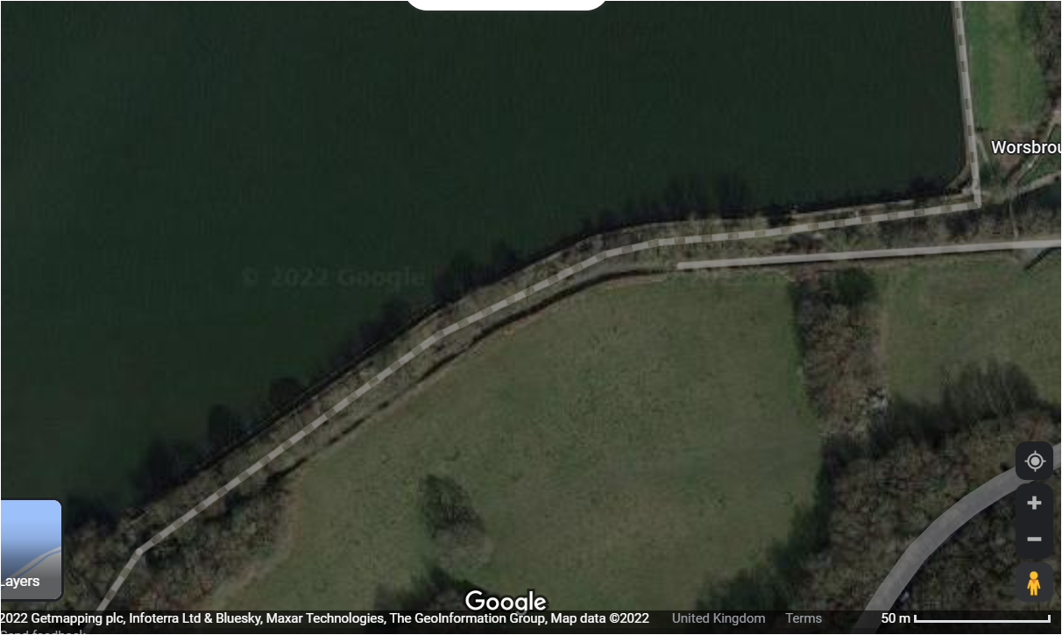 Re-turf (preferably or seed if unable to obtain turf) with a grass and clover mix containing 5% white clover, 60% perennial ryegrass, 20% strong creeping red fescue, 10% hard fescue, 5% smooth-stalked meadow grass (seeds would be such as https://www.grassseeds.com/grass-seed-mixtures/landscape-grass-seed-1/parks-and-playing-fields/road-verge-and-general-purpose-with-clover/)Re-seed with a grass and clover mix containing 5% white clover, 60% perennial ryegrass, 20% strong creeping red fescue, 10% hard fescue, 5% smooth-stalked meadow grass (such as https://www.grassseeds.com/grass-seed-mixtures/landscape-grass-seed-1/parks-and-playing-fields/road-verge-and-general-purpose-with-clover/)
Area 8 – Sections of millstream which had been culverted (approximate areas ringed in red)
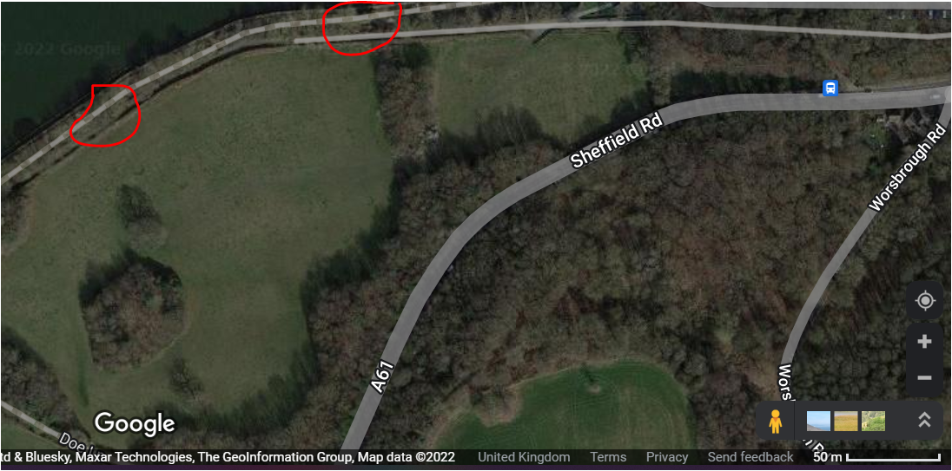
Banks to be laid with pre-seeded erosion control matting impregnated with shade tolerant wildflower seeds (such as https://wildseed.co.uk/product/mixtures/wild-flower-only-mixtures/wild-flowers-for-woodland/).

