River Dearne Footbridge Scheme
Statement of Community Involvement

City Region Sustainable Transport Settlement Fund

Barnsley Council
June 2025
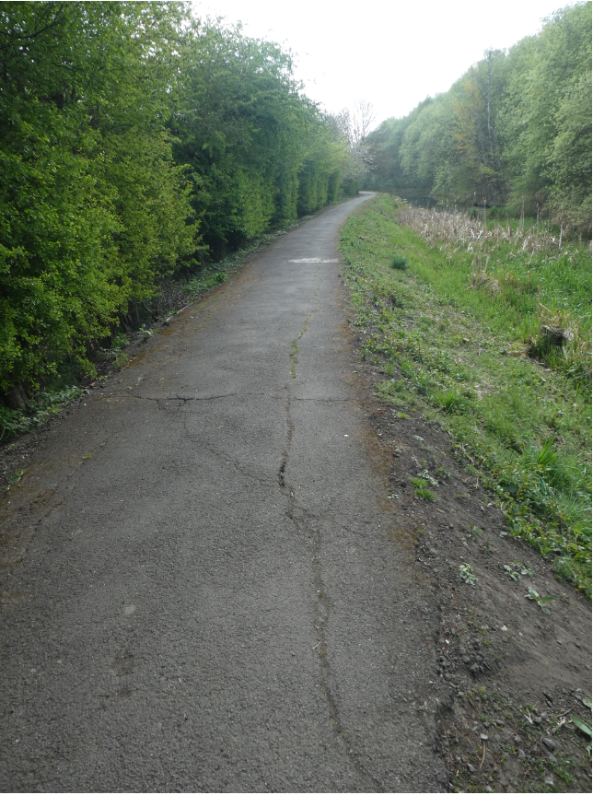

Document Control
Document: | Statement of Community Involvement
Project: | River Dearne Footbridge
Promotor: | Barnsley Council
Job Number:
File Origin:
Contents
- Introduction
- Policy Background
- The Consultation Programme
- Public Consultation Event
- Feedback from the Public Consultation Event
- Conclusion

Appendices
- Appendix A – Address Area
- Appendix B – Consultation Boards

1.0 Introduction
1.1 This Statement of Community Involvement (SCI) has been produced in support of a planning application submitted on behalf of Barnsley Council (“the Applicant”) proposing a new footbridge over the River Dearne in the Dearne Valley Country Park.
1.2 The application is a full submission; the proposals are set out in further detail within the supporting Planning Statement.
1.3 The purpose of this report is to outline the consultation process undertaken which
demonstrates that effective community consultation took place. This document considers the following:

• Relevant Planning Policy and Guidance;
• The consultation process; and
• Summary and conclusions.
Objectives
1.4 The overall objectives of the consultation process are:
• To provide the local community, residents, businesses and users an opportunity to view the proposals and discuss with team members; and
- To understand concerns and views of the community
Background
1.5 The Strategic Transport Service has received over £40m from the City Region Sustainable Transport Settlement fund (CRSTS) to deliver a programme of work, including active travel routes around Barnsley Borough. This includes the development of the construction of the River Dearne Long Route and a new footbridge in the Dearne Valley Country Park which will provide improved access for pedestrians, wheelchair users, and cyclists.

  - Improving active travel opportunities into the town centre, reducing congestion and traffic are central themes in plans to tackle modal shift and the climate emergency in the borough. This route and the new footbridge form an integral part of a comprehensive network of proposed new walking and cycling routes across the borough.

  - The proposals are to construct new foundations and abutments to both banks of the river and install a new decked footbridge with parapets

  - It is proposed retain the existing footbridges; although not LTN 1/20 compliant, they do provide access across the river and would be costly to remove and their removal would cause damage to the river banks and habitats.

2.0 Policy Background

2.1 The process of community involvement has been informed by national, regional and local policy and guidance.
National Planning Policy Framework (NPPF)
2.2 The National Planning Policy Framework (NPPF) sets out the national policy approach to community engagement.
2.3 Paragraph 41 of the NPPF confirms the approach recognised by Local Planning Authorities
and states that:
“ …They cannot require that a developer engages with them before submitting a planning application, but they should encourage take-up of any pre-application services they offer. They should also, where they think this would be beneficial, encourage any applicants who are not already required to do so by law to engage with the local community and, where relevant, with statutory and non-statutory consultees, before submitting their applications.
Barnsley Council’s Statement of Community Involvement
2.4 Barnsley Council’s first Statement of Community Involvement (SCI) was adopted in 2006. Since it was prepared, planning legislation has changed and the Local Development Framework has become the Local Plan. As such, a revised SCI has been prepared by the Council and was adopted in April 2020. The SCI explains how the community and organisations can get involved in the planning process and sets out how the Council will consult and engage with people and organisations.
2.5 Paragraph 1.3 of the SCI states
“It is important to us that all sections of the community are given the opportunity to take part in the planning process at the earliest opportunity so that decisions can take account of the range of community views and reflects, as far as possible, the concerns and aspirations of the people affected by them”.
At paragraph 3.6 applicants are advised to consult the community
`“in developments which are considered likely to have an impact on the community, even in cases where these may be below thresholds for significant applications. This is encouraged at an early stage before the application is submitted”.
2.6 The SCI provides examples of the method of engagement such as an information leaflet and/or letter drop or an exhibition / public meeting for the various types of planning application.

Pre-Application Consultation
2.7 The NPPF highlights the importance of pre-application engagement and frontloading the application process. Paragraph 40 highlights that:
“Early engagement has significant potential to improve the efficiency and effectiveness of the planning system for all parties”.
The same paragraph goes onto state:
“Good quality pre-application discussion enables better co-ordination between private and public resources and improved outcomes for the community”.
2.8 Paragraph 41 of the NPPF encourages engagement with the Local Planning Authority (LPA) and also the local community before an application is submitted. As identified in paragraph 42, the more issues that can be resolved at the pre-application stage, the greater the benefit.
2.9 Paragraph 43 identifies that the participation with consenting bodies in pre-application discussions should:
“enable early consideration of all the fundamental issues relating to whether a particular development will be acceptable in principle, even where other consents relating to how a development is built out or operated are needed at a later stage”.
2.10 The value of pre-application engagement is also heavily emphasised within the Planning Practice Guidance (PPG), a “live” document which was originally issued in March 2014 and provides streamlined planning guidance.
2.11 The section of the PPG entitled “Before submitting an Application” details how preapplication engagement can improve the efficiency and effectiveness of the planning application system and improve the quality of planning applications and their likelihood of success. As stated in Section 1 of this document, “the approach to pre-application engagement needs to be tailored to the nature of the proposed development and the issues to be addressed”.
2.12 It is identified within the PPG that pre-application engagement is a collaborative process between the Applicant and other parties which may include:
• The Local Planning Authority;
• Statutory consultees;
• Non-statutory consultees;
• Elected members; and
• Key stakeholders.
2.13 Paragraph 9 of the same section of the PPG states that:
“pre-application engagement with the community is encouraged where it will add value to the process and the outcome”.

Consultation with Local Members
2.14 The following table sets out the key stages of consultation with Local Members:
Date | Purpose of Meeting
13 November 2019 | Cabinet Approval to accept over £33m from the Transforming Cities Fund
8 November 2021 | All Member Briefing – to discuss the CRSTS funding and the proposed schemes
12 September 2022 | Monk Bretton, Central and Stairfoot ward Elected Members briefed on scheme proposals
2 November 2022 | Cabinet Approval –- to accept over £70m from the City Region Sustainable Transport Settlement Fund (CRSTS)
Due After Planning application has been decided and the Business Justification Case has been approved by SYMCA | Cabinet Report – update of scheme progress, approval to accept CRSTS funding to deliver the bridge

Consultation with the Local Planning Authority
2.15 An informal pre-application discussion with the LPA has been undertaken, given the flood risk and Environment Agency involvement, it was agreed that a planning application for the River Dearne footbridge would be required.

3. The Consultation Programme
3.1 In accordance with the recommendation of Barnsley Council’s policy and national policy and guidance, we undertook a detailed programme of consultation. In addition to engaging with the LPA and Ward Members (as detailed above), the applicant has sought to engage with key stakeholders and the local community prior to the submission of this planning application. The following provides details of the consultation programme that has taken place.
Communication Strategy
3.2 In addition to the consultation process for the planning application, a Communication Strategy has been prepared as part of the submission of the Business Case to the SYMCA. The strategy identifies the communication channels that could be utilised to ensure all relevant stakeholders are kept informed during development and construction.
Consultation Events
3.3 In line with the requirements of the NPPF and the Council’s SCI, community drop-in exhibitions were arranged for members of the local community. These events provided an opportunity for the community to view, discuss and comment upon the development proposals being put forward.
3.5 Two exhibitions were held within the area near to the scheme. The first exhibition was held at Oakwell Stadium from 1.30pm to 6.30pm on Monday 3 October 2022. The following exhibition was held at Priory Campus from 1.30pm to 6.30pm on Tuesday 11 October 2022. The days and timings for the exhibition were chosen to allow maximum attendance.
3.6 We made every effort to inform the local community of the forthcoming exhibitions by:
• Distributing letters to every property within a defined area (as agreed with the LPA) in the week commencing 26 September 2022.
• Letters were sent to local Councillors, MP’s, key stakeholders and business groups
- The event was publicised on the Strategic Transport web site
3.7 The plan in Appendix A illustrates the catchment area for the distribution of letters informing the community of the event. Letters were delivered to approximately 2138 properties in the area. The delivery of leaflets was completed two weeks prior to the event, ensuring the local community had sufficient notice.
3.8 The public consultation events were hosted by the Project Manager to help answer any questions. The events took place at Oakwell Stadium and the Priory Campus and presentation boards were displayed. A copy of the boards can be found at Appendix B. In summary, they provided:
• Background to the scheme;
- High level detail of what is being proposed
• Anticipated timeframes for planning and construction; and
• Contact details should attendees wish to contact the design team.
3.9 The events were well attended with 23 residents visiting the stands.
3.10 Contact details were available (email and telephone) and referenced to allow members of the community to either call and leave a message or email a response. Through calls and emails, those who were unable to attend the events could still be sent the exhibition material and make comment.

Online Survey
3.11 to accompany the in-person events, an online survey was published and advertised with the letter to residents and on social media.
3.12 The survey gathered quantitative data on how strongly the user felt towards different scheme components and also gave the user the opportunity to make an open comment
3.13 In total 29 people completed the survey and support for the bridge upgrades were strong (58% in support, 20% neither supporting or opposing and just 22% opposing)
Key themes
3.14 The following table displays the key themes prevalent in feedback made by any of the available methods (email, online survey, in-person). As shown support for bridge enhancements was one of the most commonly supported scheme components
Commonly Occurring Themes
Positive / Support for | Negative / Objection to | Neutral
Bridge enhancements | Route widths being unnecessarily wide | Would like to see fly tipping / littering addressed
Widened routes | Clearing of greenery for track
Will benefit local business
Upgraded entrance points
Improve horse riding infrastructure
Improved signage

5.0 Conclusion
5.1 The Applicant has undertaken pre-application consultation on their application in line with the guidance contained within the NPPF and Barnsley Council’s Statement of Community Involvement. This has involved pre-application discussions with the Local Planning Authority, Ward Member briefings and consultation with the local community and key stakeholders at the public consultation event.
5.2 Of the comment forms filled in at the public event, the majority were supportive of the development, recognising the benefits created by the proposals. Consideration has been made for the environmental implications of the development and mitigation has been built into the plans to help address this and the related concerns of a small number of attendees at the public exhibition.
5.3 This SCI therefore demonstrates that the view of local residents, the LPA and other stakeholders have been taken into account in the formulation of the application proposals

