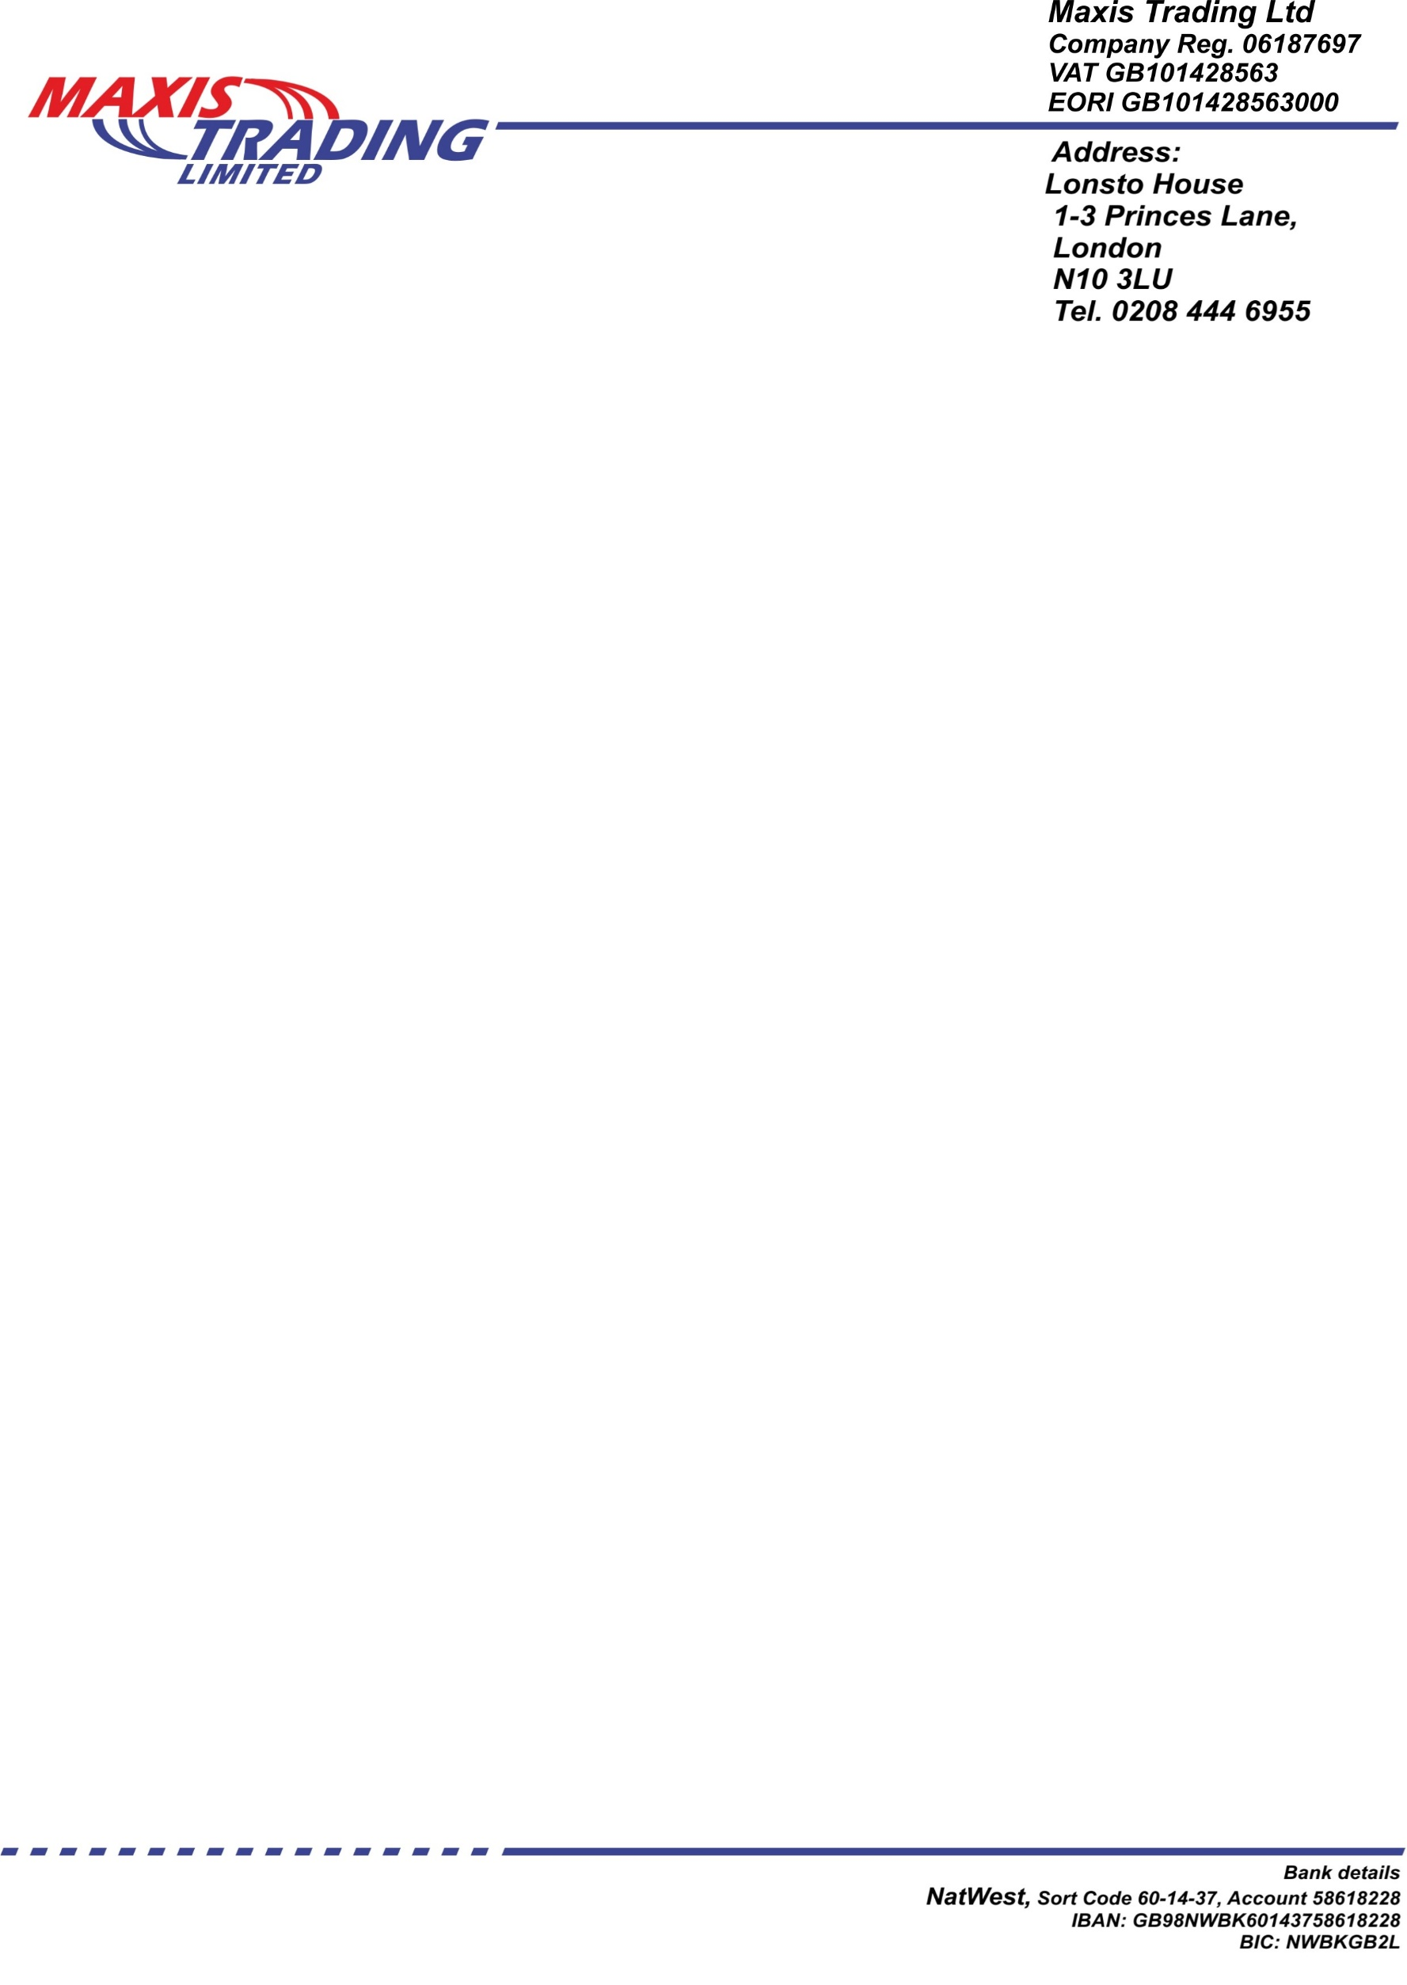

Turning facilities
An access road/Beever Street has 7.5m width with 1.8m width public path on one side and a Commercial property on the opposite side.
The recovery truck does not have to reverse on the public road, it can drive straight through the gates.
The recovery vehicle will enter the site in forward gear and reverse back into the motor salvage area. The car will be unloaded allowing the recovery vehicle to move forward and leave the site in forward gear.
The gates have an opening of 10.5m. The track within the site has 3m clear space from the fence and 13.7m clear space to the wall of the warehouse/3m of which will be constantly kept clear.
The total length of the area available for turning is 24m with 10.5m stopping area available before reversing into the workshop and 10.2m stopping area available when moving forward in the direction of the gates to way out.
Existing business
For the past three years the warehouse is used for the storage of recycling clothes. The clothing items are delivered to the site via Ford Transit van at the end of each working day. The delivery vans operate on the strict time table basis and leave the yard after unloading.

