Supporting Statement for 2 Regent Gardens, Penistone. S36 6DS
The property is located within the conservation area of Penistone central. Previously refurbished by Penistone Developments in 2015, the two-bedroom property provides accommodation over three storeys comprising of a master bedroom to the second floor, first floor bedroom and bathroom and ground floor living room and small kitchen.
The applicant seeks permission to build a single storey rear extension within the rear garden of the property. The small extension extending 1.5m into the garden area will provide much needed accommodation to the ground floor by providing a functional kitchen space to the same standard of the living accommodation provided within the dwelling.
The design of the extension is sited on the rear elevation, which does not appear to retain any historic character / openings of the original building as shown below. The front elevation which fronts the Tesco car park is unchanged.
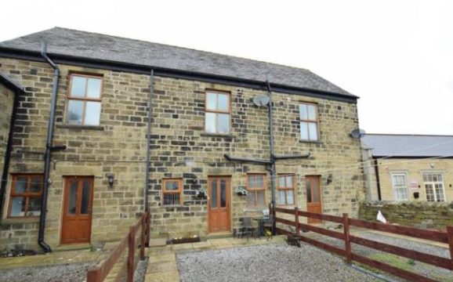
Figure 1 – Existing elevations of 2 Regent Gardens.
The proposed lean-to extension is sympathetic to the building and surrounding conservation area. Proposed materials include natural coursed stone and natural slate roof tiles with two small conservation Velux’s to match the existing. The front door and windows echo the design and style of the present windows approved in the original scheme. Whilst the linear design replicates similar style extensions found within the Penistone Conservation area.
It is felt the proposed works will have a minimal impact upon the conservation area whilst improving the living accommodation and sustainability of the dwelling and will have a positive impact upon the Penistone Conservation area.

