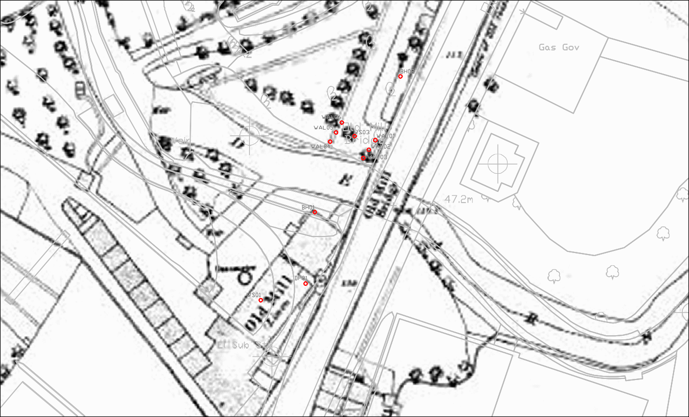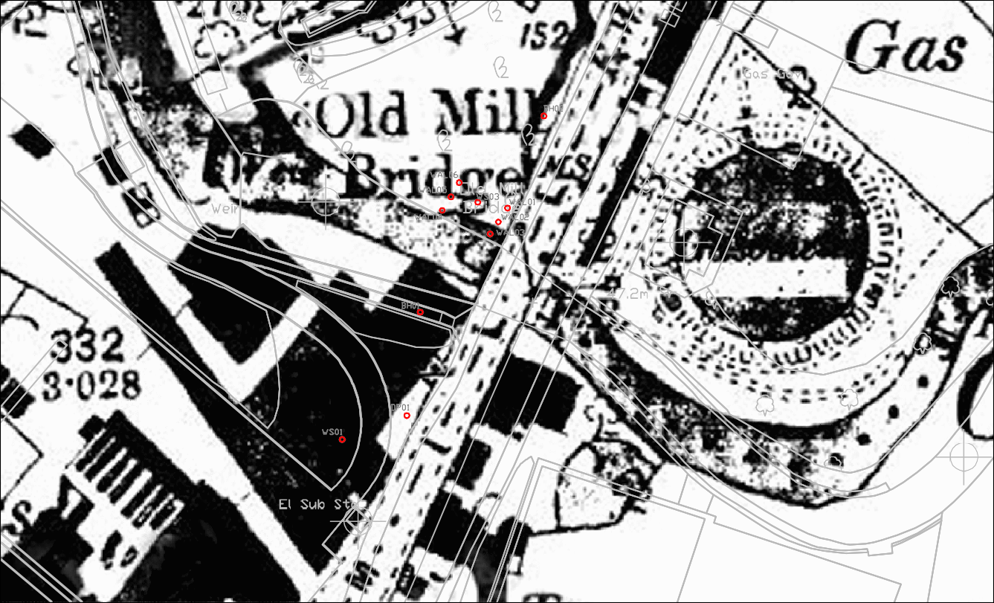
Fig. 4. Barnsley Town Plan 1852, showing location of site and planned interventions in red @ 1:1000 Fig. 5. OS County Series Map of 1892 showing location of site and planned interventions in
red @ 1:1000

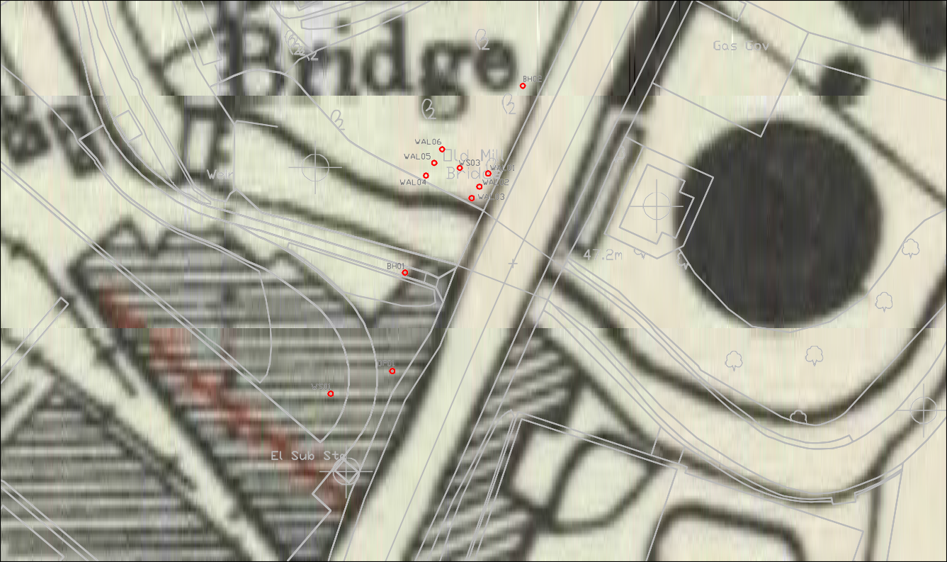

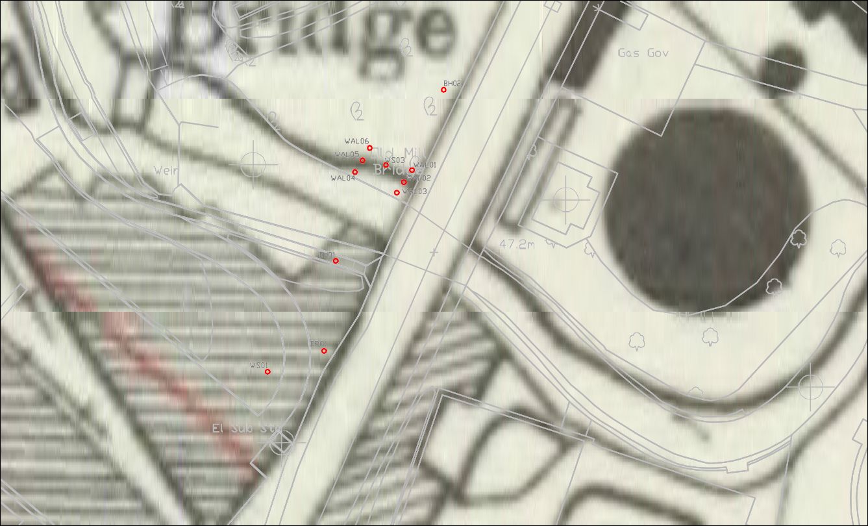
Fig. 6. OS Map of 1929 showing location of site and planned interventions in red @ 1:1000
Fig. 7. OS Map of 1948 showing location of site and planned interventions in red @ 1:1000

