SITE SPECIFIC SUPPLEMENTARY INFORMATION

- Site Details

Site Name: | SYK0168C | Site Address: | Ardagh Glass Barnsley Ltd  Burton Road  Monk Bretton  Barnsley  South Yorkshire  S71 2QG
NGR: | E: 436969 , N: 408819 | Site Address:
Site Ref Number: | SYK0168C | Site Type: Macro | Site Share Upgrade – 02

- Pre-Application Check List

Site Selection

Was an LPA mast register used to check for suitable sites by the operator or the LPA? |  | No
If no explain why:

After a phone call to the LPA it was felt that the industry database was a more up to date source of information.

Was the industry site database checked for suitable sites by the operator: | Yes
If no explain why:

N/A

Pre-application consultation with LPA

Written offer of pre-application consultation: | Yes
Was there pre-application contact: |  | No
Date of pre-application contact: | N/A
Name of contact: | The Director of Planning
Summary of outcome/Main issues raised:

No comments have been received in respect to the proposal.

Ten Commitments Consultation

Rating of Site under Traffic Light Model: | Green
Prior to the submission of this application the applicant initiates pre-consultation discussions with the local planning authority. This provides an opportunity for the LPA to discuss development proposals and identify site specific issues.

Summary of outcome/Main issues raised:

No responses had been received at the time of submission.

School/College

Location of site in relation to school/college:

There are no schools in close proximity that overlook the site.

Outline of consultation carried out with school/college:

N/A

Summary of outcome/Main issues raised:

N/A

Civil Aviation Authority/Secretary of State for Defence/Aerodrome Operator consultation (only required for an application for prior approval)

Will the structure be within 3km of an aerodrome or airfield? |  | No
Has the Civil Aviation Authority/Secretary of State for Defence/Aerodrome Operator been notified? |  | No
Details of response:

N/A

Developer’s Notice

Copy of Developer’s Notice enclosed? |  | Yes
Date served: | 12th January 2022

- Proposed Development

The proposed site:
The proposed site at Ardagh Glass Barnsley Ltd, Burton Road, Monk Bretton, Barnsley, South Yorkshire, S71 2QG is an established telecommunication installation. This submission is purely to upgrade this existing installation with new equipment to facilitate coverage for 02. The existing site is located off Fish Dam Lane to the rear of Ardagh Glass Barnsley Ltd Car Park surrounded by numerous tall mature tree plantings. The tall mature tree planting provides partial screening. All residential amenity issues were addressed at the time of the first installation. The existing site and its surrounding can be seen below in Figures 1-3.

Figure 1:

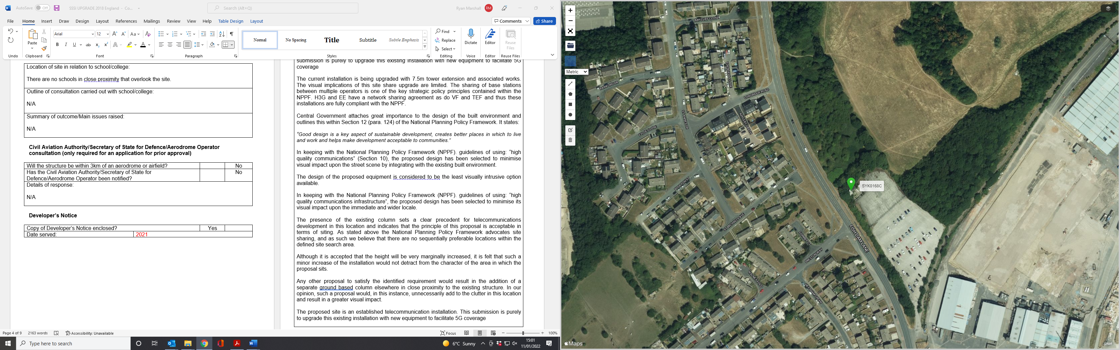

Figure 2:

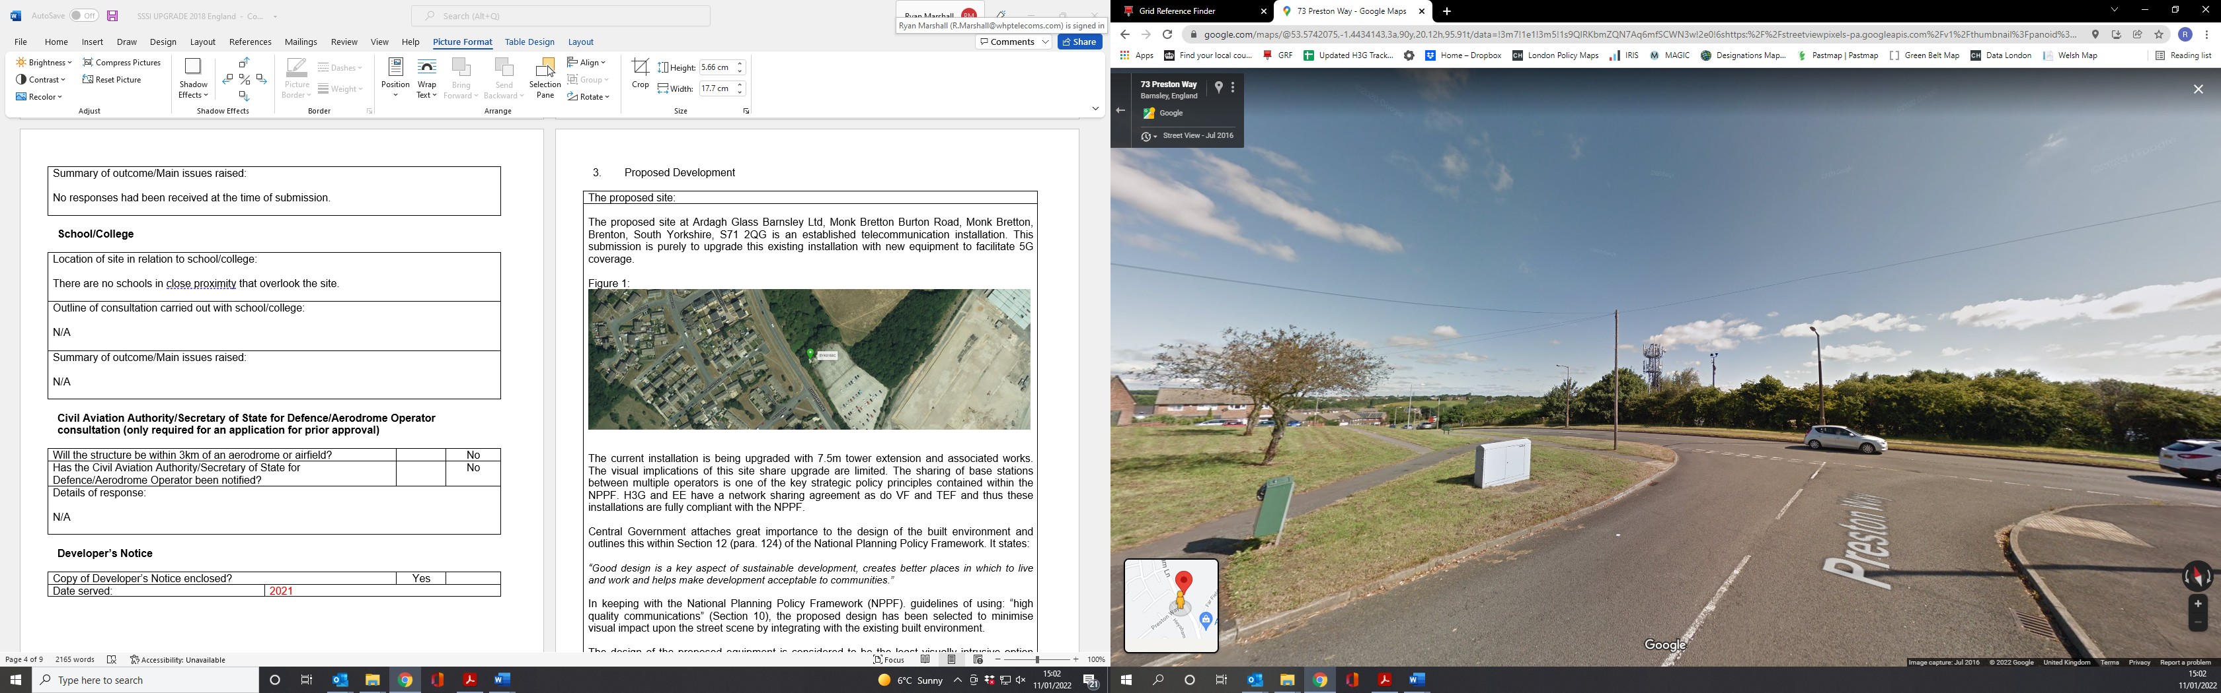

Figure 3:

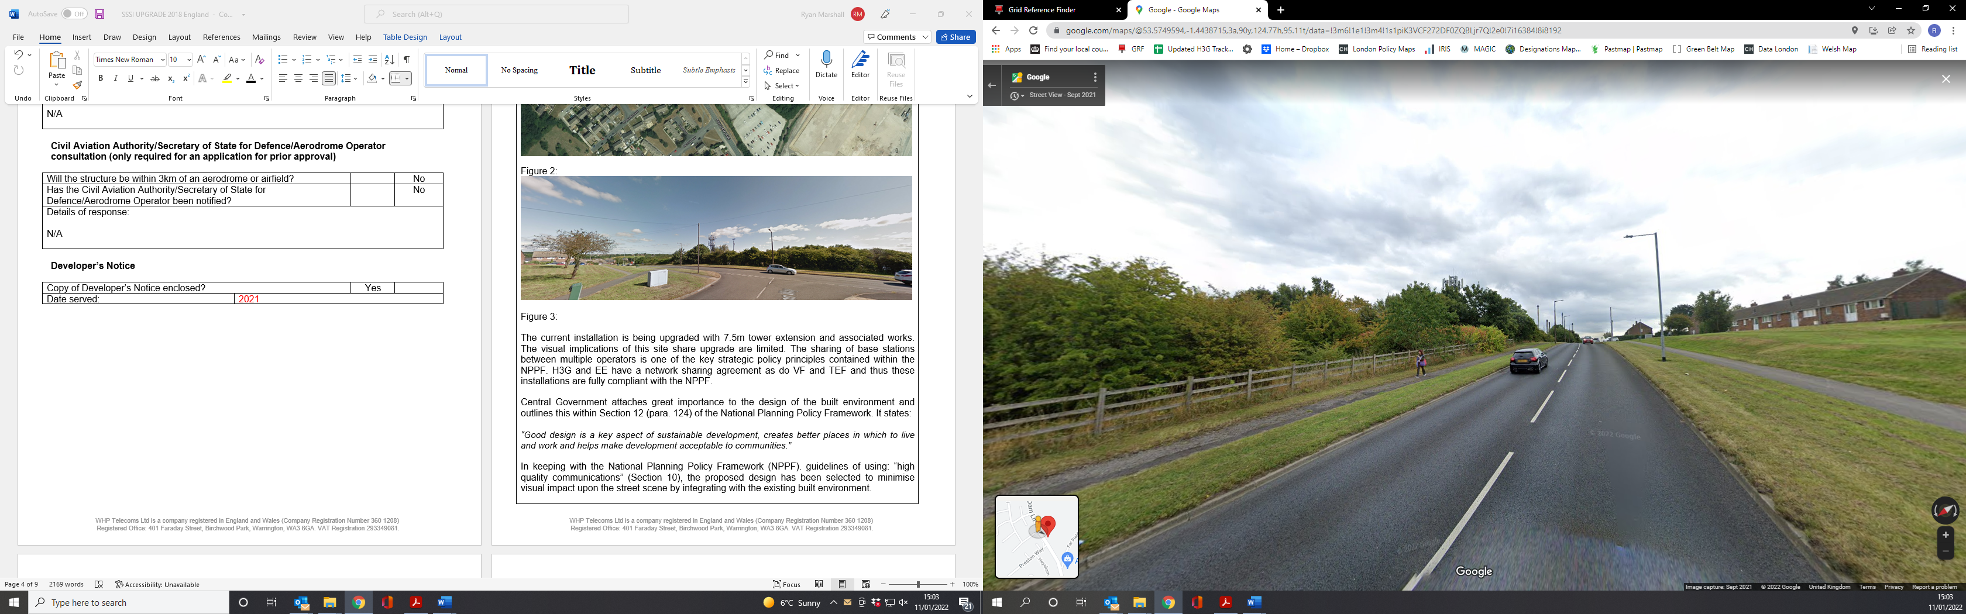

The current installation is being upgraded with 7.5m tower extension and associated works. The visual implications of this site share upgrade are limited. The sharing of base stations between multiple operators is one of the key strategic policy principles contained within the NPPF. H3G and EE have a network sharing agreement as do VF and TEF and thus these installations are fully compliant with the NPPF. The upgrade is for 02 to site share on the existing MBNL mast (EE and 3UK)

Central Government attaches great importance to the design of the built environment and outlines this within Section 12 (para. 124) of the National Planning Policy Framework. It states:

“Good design is a key aspect of sustainable development, creates better places in which to live and work and helps make development acceptable to communities.”

In keeping with the National Planning Policy Framework (NPPF). guidelines of using: “high quality communications” (Section 10), the proposed design has been selected to minimise visual impact upon the street scene by integrating with the existing built environment. The design of the proposed equipment is considered to be the least visually intrusive option available.

In keeping with the National Planning Policy Framework (NPPF). guidelines of using: “high quality communications infrastructure”, the proposed design has been selected to minimise its visual impact upon the immediate and wider locale.

The presence of the existing column sets a clear precedent for telecommunications development in this location and indicates that the principle of this proposal is acceptable in terms of siting. As stated above the National Planning Policy Framework advocates site sharing, and as such we believe that there are no sequentially preferable locations within the defined site search area.

Although it is accepted that the height will be very marginally increased, it is felt that such a minor increase of the installation would not detract from the character of the area in which the proposal sits.

Any other proposal to satisfy the identified requirement would result in the addition of a separate ground based column elsewhere in close proximity to the existing structure. In our opinion, such a proposal would, in this instance, unnecessarily add to the clutter in this location and result in a greater visual impact.

The proposed site is an established telecommunication installation. This submission is purely to upgrade this existing installation with new equipment to facilitate 5G coverage

Local Planning Authority: Barnsley Metropolitan Borough Council

Development Plan: Barnsley Local Plan (2019)

LPA Map Extract (reference only):
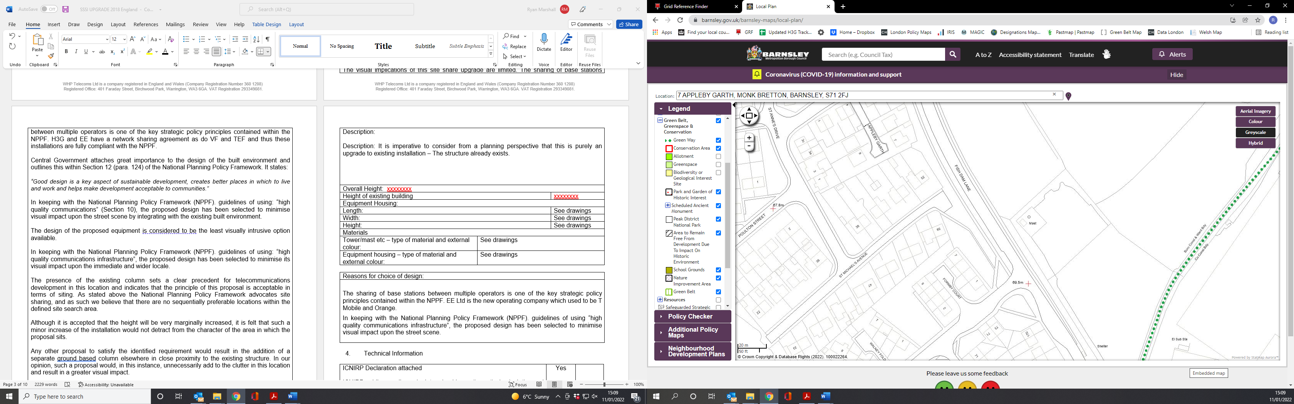

Site and its surrounds

Policy Relevant to the Development Site:

The site is designated as being within the settlement boundary, with urban uses to the north, east, south and west. The site designation is a not material consideration.

Barnsley Metropolitan Borough Council does not have a specific telecoms policy. Therefore the NPPF is of relevance. The National Planning Policy section of this supporting statement goes into detailed analysis of why this site is in compliance with the NPPF.

Policy Analysis:

The proposed works on the existing site would not be to the visual detriment of the surrounding area and would not result in demonstrable harm to the character of the area, but are necessary to ensure improved delivery of service, would respect and continue to maintain the appearance of the area, and would be suitably distant from potentially sensitive users, so according with the principles of the Development Plan. It fully accords with the requirements of the NPPF.

Enclosed map showing the cell centre and adjoining cells:
This can be emailed to the LPA on request

Type of Structure
Description:

Description: It is imperative to consider from a planning perspective that this is purely an upgrade to existing installation – The structure already exists.

PROPOSED TEF GPS MODULE TO BE INSTALLED ON EXISTING SUPPORT POLE.
PROPOSED TEF 3No. MiMo ANTENNAS TO BE INSTALLED ON EXISTING SUPPORT POLES FIXED TO RELOCATED RINGFRAME WITH 7.50m TOWER EXTENSION.
PROPOSED TEF 15No. ERS's (5 PER SECTOR) TO BE MOUNTED ON 6No. NEW 450mm LONG ERS RAILS (2 PER SECTOR) & 3No. 7 WAY DC BOXES FIXED TO ANTENNA SUPPORT POLES.
PROPOSED TEF FIBRE/DC CABLES TO USE EXISTING CABLE MANAGEMENT.
EXISTING TEF 6No. (L21) ERSs MOUNTED ON SUPPORT POLE TO REMOVED AND REPLACE WITH PROPOSED 6No. 4415 ERS's.
Overall Height: 22.5m AGL
Height of existing building |  | N/A
Equipment Housing:
Length: |  | See drawings
Width: |  | See drawings
Height: |  | See drawings
Materials
Tower/mast etc – type of material and external colour: | See drawings
Equipment housing – type of material and external colour: | See drawings

Reasons for choice of design:
The sharing of base stations between multiple operators is one of the key strategic policy principles contained within the NPPF. EE Ltd is the new operating company which used to be T Mobile and Orange.
In keeping with the National Planning Policy Framework (NPPF). guidelines of using “high quality communications infrastructure”, the proposed design has been selected to minimise visual impact upon the street scene.

- Technical Information

ICNIRP Declaration attached  ICNIRP public compliance is determined by mathematical calculation and implemented by careful location of antennas, access restrictions and/or barriers and signage as necessary. Members of the public cannot unknowingly enter areas close to the antennas where exposure may exceed the relevant guidelines.  When determining compliance the emissions from all mobile phone network operators on the site are taken into account. | Yes

- Technical Justification

Reason(s) why site required
The National Planning Policy Framework clearly states that authorities should not question the need for the service, nor seek to prevent competition between operators. Notwithstanding this fact, the Applicant considers it to be important to explain the technical justification for the site and how the facility fits into the overall network.

The site is required to provide enhanced coverage for EE Ltd, ESN and H3G LTE.

- Site Selection Process – alternative sites considered and not chosen

Discounted Options
In accordance with the sequential approach outlined in the National Planning Policy Framework (NPPF) following search criteria have been utilised. Firstly, consideration is always given to sharing any existing telecommunication structures in the area, secondly consideration is then given to utilising any suitable existing structures or buildings and thirdly sites for freestanding ground-based installations are investigated.

This sequential approach is outlined below:

- Mast and Site Sharing
- Existing Buildings Structures
- Ground Bases Installations

In compliance with its licence and the sequential approach outlined in the NPPF all attempts to utilise any existing telecommunication structures where they represent the optimum environmental solution have been employed. The Ofcom Site Finder mast register is always examined prior to the submission of an application.
If no alternative site options have been investigated, please explain why:

This is an upgrade to existing sites thus no other standalone new facilities have been investigated. In line with the sequential site selection process this proposal is to upgrade an existing site and not a new additional mast. A new additional mast to facilitate the upgrade would not be in line with NPPF, as stated by upgrading the current facility the most sequentially preferable option has been progressed.

The current siting was agreed by the LPA as the most appropriate location when the original installation was approved by the Council. Discounted options were supplied with the original planning submission and thus the principle of the siting is already established.

- Additional Relevant Information

Background to the Proposal
Mobile phone base stations operate on a low power and accordingly base stations therefore need to be located in the areas they are required to serve. Increasingly, people are also using their mobiles in their homes, and this means we need to position base stations in, or close to, residential areas.

A further limiting factor is that the position has to be one that fits in with the existing network. Sites have to form a patchwork of coverage cells with each cell overlapping to a limited degree with the surrounding base stations to provide continuous network cover as users move from one cell to the other. However, if this overlap is too great unacceptable interference is created between the two cells.

DEVELOPMENT PLAN POLICY.

Development plan considerations have a special significance in law. Section 54A of the Town and Country Planning Act 1990 (The Act), and re-iterated in Section 38 of the Planning and Compensation Act 2004, it is stated that:

“Where in making any determination under the Planning Acts regard is to be had to the Development Plan, determination shall be made in accordance with the Development Plan unless material considerations indicate otherwise.”

NATIONAL PLANNING POLICY

The Government remain committed to promoting telecommunications and place emphasis on the importance of telecommunications to the wider economy. The National Planning Policy Framework (NPPF July 2021) sets out the Government’s planning policies for England and how these are expected to be applied at the Local level. It provides a framework within which local people and their accountable Councils can produce their own distinctive local and neighbourhood plans, which reflect the needs and priorities of their communities.

The purpose of the planning system is to contribute to the achievement of sustainable development. There are three dimensions of sustainable development, each of which give rise to the need for the planning systems to perform a number of roles including: -

- Economic Role – contributing to building strong, responsive and competitive economy;
- Social Role – Supporting strong vibrant and healthy communities; and
- Environmental Role – Contributing to protecting and enhancing our natural, built and historic environment.
The NPPF contains at its core a presumption in favour of sustainable development which runs through both plan-making and decision-making processes. The NPPF recognises the vital importance of high-quality telecommunications and dedicates a whole chapter to this. Chapter 10 of the NPPF outlines the Governments support for high quality communications. The paragraphs below clearly outline the overarching support from Central Government for telecommunications and how Local Planning Authorities should embrace this vital infrastructure:

NPPF Paragraph 114 states:

“Advanced, high quality and reliable communications infrastructure is essential for economic growth and social well-being. Planning policies and decisions should support the expansion of electronic communications networks, including next generation mobile technology (such as 5G) and full fibre broadband connections. Policies should set out how high-quality digital infrastructure, providing access to services from a range of providers, is expected to be delivered and upgraded over time; and should prioritise full fibre connections to existing and new developments (as these connections will, in almost all cases, provide the optimum solution).”

It continues in Paragraph 115:

“The number of radio and electronic communications masts, and the sites for such installations, should be kept to a minimum consistent with the needs of consumers, the efficient operation of the network and providing reasonable capacity for future expansion. Use of existing masts, buildings and other structures for new electronic communications capability (including wireless) should be encouraged. Where new sites are required (such as for new 5G networks, or for connected transport and smart city applications), equipment should be sympathetically designed and camouflaged where appropriate.”

Operators always follow the sequential site selection process. Where an existing site can be shared or upgraded this will always adhered to before a new proposal is put forward for consideration.

The support for telecoms and the need not to constrain Operators is laid out in Paragraph 118:

“Local planning authorities must determine applications on planning grounds only. They should not seek to prevent competition between different operators, question the need for an electronic communications system, or set health safeguards different from the International Commission guidelines for public exposure.”

Conclusion

We consider that the development is complaint with the council’s policy and that in accordance with Section 38 (6) of the Planning and Compensation Act 2004 permission should be granted for the installation.

We consider the development complies with both central government and local planning policy guidance where the underlying aim is to provide an efficient and competitive telecommunication system for the benefit of the community while minimising visual impact.

Taking into account the factors of technical constraints, available sites and planning constraints we consider that this site and design clearly represents the optimum environmental solution.

On the basis of a recognised need to expand and promote telecommunications networks across the region, it is considered that the proposal fully accords with the requirements of the National Planning Policy Framework and Local Plan Policies.

Damian Hosker BA(Hons) MA MRTPI
d.hosker@whptelecoms.com

Contact Details

Name: (Agent) | Damian Hosker BA(Hons) MA MRTPI | Telephone:
Operator: | EE Ltd & H3G | Fax no: | N/A
Address: | WHP Telecoms Ltd  1a Station Court  Station Road  Guiseley  Leeds  LS20 8EY | Email Address: | d.hosker@whptelecoms.com
Signed: |  | Date: | 14th January 2021
Position: | Principal Planner | Company:  (on behalf of above operator) | WHP

