Proposed Haulage Transport Depot
Albion Works, Stairfoot, Barnsley

Planning Statement

CSO/01/20/BAR

August 2020

Rollinson Planning Consultancy
- Introduction and Scope of Statement

1.1 This Statement has been provided to supplement the current planning application (2020/0289) for the ‘erection of haulage transport depot including 2No. buildings, yard, storage of skips and trailers and maintenance of vehicles’ at the Albion Works site on Hunningley Lane, Stairfoot, Barnsley. It has been requested by the Local Planning Authority (‘the LPA’) to augment the extensive information already submitted with the application documentation.
1.2 The Statement is deliberately succinct, as much of the relevant information has already been provided and as the appointed Case Officer will already be aware of the issues involved in assessing this proposal.

- The Site and Surroundings

2.1 The application site extends to 0.62ha of largely level land. It lies within the main built area of Barnsley, close to the ‘Stairfoot Roundabout’ on the east side of the town.

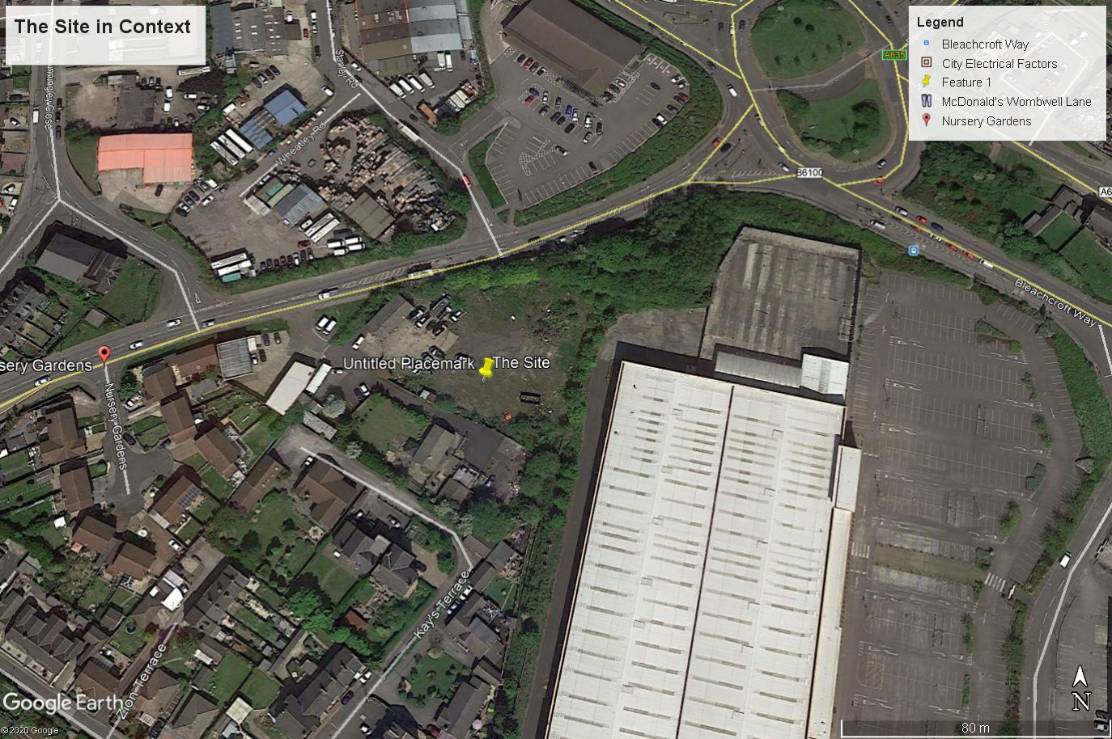

2.2 It lies within the ‘Urban Fabric’ as defined by the Local Plan, adopted in 2019. Within the immediate area are some housing, commercial and retail areas, including a large ‘DIY’ store, warehousing, food outlets, food stores and other commercial areas, including the Stairfoot Business Park.

2.3 The site is now a vacant brownfield one but was formerly in use as a scrap yard.

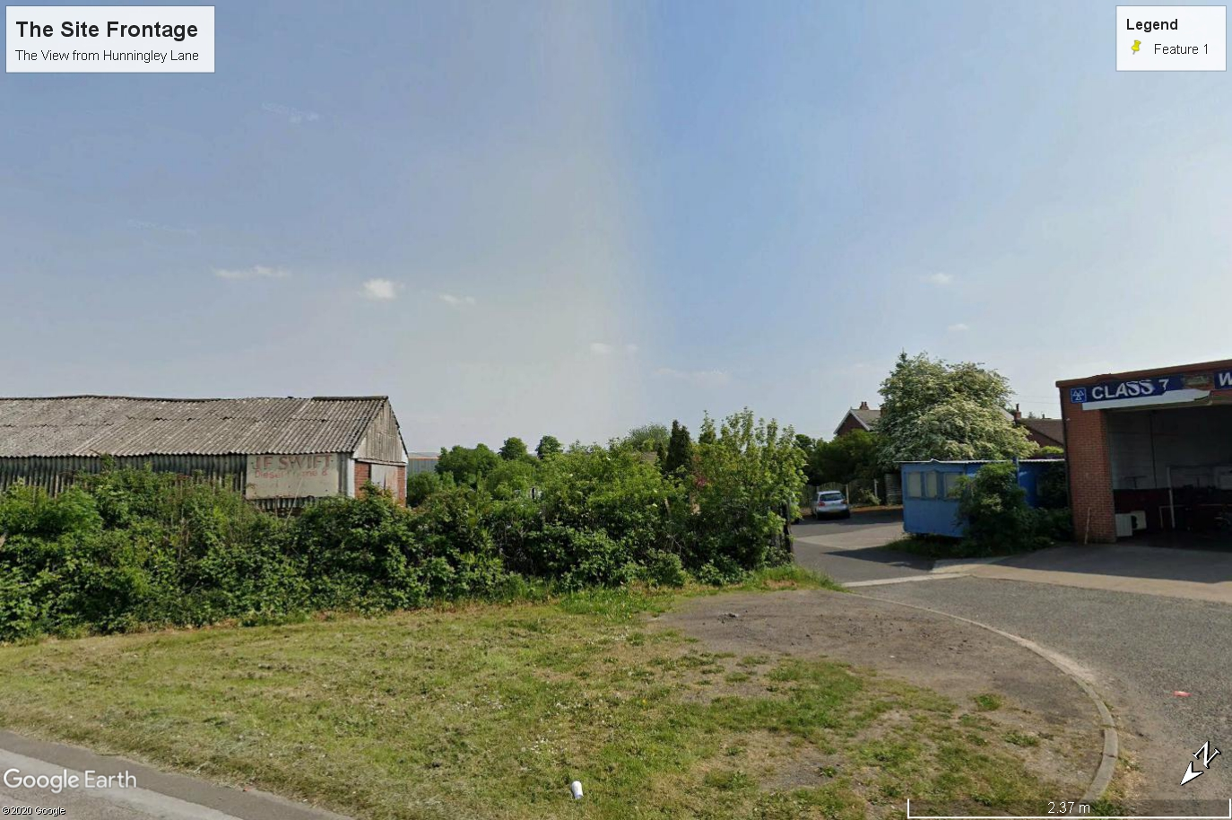

- The Proposal

3.1 This is as described on the application form and the validation email received from the LPA on 24th June. The intention is to bring this vacant site back into employment generating uses through the introduction of a haulage depot for use by a well established local company. Soar and Sons operate principally from Tank Row where they are a leading company for the dismantling and recycling of electrical transformers to major powewr suppliers and other companies.
3.2 The scheme will involve the construction of two new buildings as shown clearly on the submitted drawings.
4.0 Relevant Planning Policy

The National Planning Policy Framework (‘the NPPF’)

4.1 The latest version of this was published in February 2019. It provides a wide range of policy and guidance across all planning issues. There is no need to repeat swathes of the NPPF but of particular relevance are: -

- The purpose of the planning system is defined as being to contribute to the achievement of sustainable development. At the very high level, this meeans meeting the needs of the present without compromising the ability of future generations to meet their own needs;

- To do so, the planning system has three overarching objectives. These are economic, social and environmental. It is pertinent that the revised NPPF notes that these are to delivered through the preparation and implementation of plans abd that they are not criteria against which application or decision can or should be judged;

- Significant weight should be placed on the need to support economic growth and productivity and

- The promotion and support of development of under-utlised land.

The Barnsley Local Plan

4.2 This was adopted in 2019. It is, therefore, an up to date Development Plan. Within this document the site is not allocated for any particlar use, but is within the Uran Fabric i.e. within the main urban area of the Borough. Most geramne within this Plan are: -
- Urban Barnsley is that top of the settlement hierachy which is the main focus for development in terms of the spatial startegey;

- Policy GD1 is a generic policy which requires, amongst other things, that there to be no significant effect on the living conditions and amenity of residents;

- Chapter 8 ‘Economy’ notes that that local economy needs to grow significantly;

- Policy E4 seeks to protect land curently or last use fro employment purposes for that use and

- Policy CC1 gives preference to the the development of previously developed land.

5.0 Consideration of the Application Proposal

Principle of the Development

5.1 This is a vacant, previosuly developed site within the main urban area, within the ‘Urban Fabric’ as defined by the Local Plan. It was last used as a scrap yard and lies in an area characterised by a mix of uses.

5.2 It is a matter of subjective opinion, but our view is that the site currently detracts from the visual amenity of the area and needs ‘tidying up’ and some form of development.

5.3 It needs to be to beneficial use. The proposed use of the site will complement the main site of the applicant company (Tank Row), which specilaises in the recycling of electical products.

5.4 The development will create employment within the main urban area.

5.5 There can’t be any reasonable objection to this proposal as a matter of principle. It is wholly acceptable to re use a vacant former scrap yard within the town for a modest employment generating industrial development.

Other Material Considerations

The Operation

5.6 Many questions from the LPA about how the site will operate will opearte have already been responded to by the agent for the application. Nonetheless, and for completeness, we reiterate the following: -
- The whole site will be used for vehicle storage and storage of equipment, such as timber blocks, aluminium trackway, skips, trailers, vehicles, etc. This is not a waste proposal.

- There would be five class one tractor units and 5 class two skip loaders, perhaps up to twelve;
- The skips and trailers will be stored on the boundary with the DIY store and the Hunningley Lane boundary line;

- Buildings are to be used mainly for storage, maybe some ancillary vehicle maintenance but the main maintenance works will be carried out in the HGV Garage at Tank Row;

- General site hours will be 7.00am – 5.00pm, there may need to be access to the site from 4.00am on occasion if the lorries are travelling from a distance, but this will only be for HGV drivers; no actual work on site will be required before 7.00am, just access;

- Existing vegetation will be left in place and additional landscaping can be put in place around the site boundaries. This could be the subject of a suitably worded condition and

- This is clearly a previously developed site, last used as a scrap yard. The proposed use is not a sensitive use in terms of contamination issues. A Phase 1 desk top report will shortly be submitted in any case.

Transport & Highways

5.7 The site is within the main urban area and has ample space for parking by the employees. Furthermore, the site is easily accessible by public transport. There are frequent services via bus routes 222 and 226.

5.8 We have already provided Swept Path Analyses which show how the existing existing is capable of providing safe access and egress into and from the site.

Dersign

5.9 This is a vacant and, frankly, derelict site in an area of no townscape value. This is not to diminish the area, but a statement of fact. The proposed buildings are functional in their design, but in the context of their surroundings are entirely appropriate. They are not tall and incoporate the use of cladding and brickwork, the details of which can be secured by a suitable condition.

Residential Amenity

5.10 As mentioned above, this is a mixed-use area. It does include some residential properties to the south of the site.

5.11 These properties bound a site which was previously a scrap yard, which was (as far as can be ascertained from the LPA website) unfettered by planning conditions.

5.12 This development will improve the appearance of the site considerably. Furthermore, the submitted drawings show that, given the differences in levels and the distances between the back of the properties on Kay’s Terrace and the rear of the principal building mean that there will be no overlooking, loss of privacy or over dominance. In fact, the proposed new building will act as a buffer between the site and the residential properties at Nos 15 and 17.

Ecology

5.13 An ecological report has been submitted with the application documentation. We have no issue with its recommendations.

Noise

5.14 The Noise Impact Assessment submitted demonstrates that the development will have a low impact when assessed against the existing background noise levels.

6.0 Conclusions

- This is an existing industrial site (previously used as a scrap yard) within the main urban area.

- The use proposed will augment an existing local business, heavily involved in recycling.

- It will generate employment and improve the appearance of the site.

- It will not create harm to highway safety.

- It will not cause harm to the amenity of nearby residents.

- There are no adverse ecological impacts, in fact if the recommendations of the ecological report are secured by condition, there will be benefits in this regard.

- Planning permission should be granted.

