Residential Development – Review of Transport Assessment
Specification No.  02 | Client name  Barnsley Metropolitan Borough Council | Project name  Residential Development at Former William Freeman Site, Wakefield Road, Mapplewell | Date  16 March 2018
Prepared by  Natasha Smithson | Checked & Approved by  Stephen Moss

Introduction
AECOM have been commissioned on behalf of Barnsley Metropolitan Borough Council (BMBC) to provide a review of a Transport Assessment produced by Bryan G. Hall. The application reference is 2017/1718, and the proposals are for up to 85 residential dwellings located on the former William Freeman site along Wakefield Road in Mapplewell, Barnsley. The site location is shown in Figure 1 as provided by Bryan G. Hall.
Figure 1 – Site Location Plan
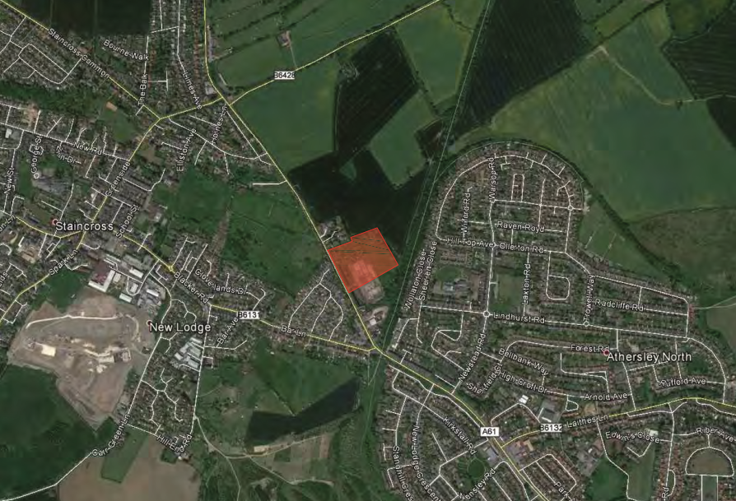
AECOM reviewed the scoping email for the proposals of approximately 82 residential dwellings. The report dated 2 January 2018 concluded that the scope was generally acceptable and the main comments were:
- Suggestions were made regarding committed developments to be considered in the operational assessments;
- Accident data should be presented for the most recent five year period (2012 – 2017, inclusive);
- A growth factor from 2018 to 2023 (five years after submission) is to be used for the Barnsley 004 area;
- Conduct a sensitivity test of the discount food store to be located adjacent to the site; and
- The proposed site access should be designed to the appropriate DMRB standard, with visibility splays clearly shown.
It should also be noted that the site has been identified as a potential development site within the emerging Barnsley Local Plan currently at submission stage and due for adoption in Spring 2018, which will then replace the current Local Development Framework.

National and Local Planning Policy and Guidance
The following national and local planning policy and guidance documents were reviewed:
- National Planning Policy Framework (NPPF);
- Manual for Streets (MfS1);
- Manual for Street 2 (MfS2);
- Planning Practice Guidance;
- South Yorkshire Local Transport Plan;
- Barnsley Local Development Framework – Core Strategy; and
- Barnsley UDP and Emerging Barnsley Development Plan.
It was considered that the proposals are in line with the above policies and guidance.

Existing Site
The site is located on the northern section of the former William Freeman Works brownfield site, located to the east of Wakefield Road in Mapplewell, Barnsley. The site is bounded by the remainder of the former William Freeman Works site to the south (it should be noted that an application has also been submitted for a Lidl Foodstore on this section of land), Wakefield Road to the west, residential properties to the north and a disused railway line beyond which there are residential properties to the east.
The site currently takes access from Wakefield Road which is a two-way road that runs in a north-south direction. The carriageway is approximately 8m wide, there are pedestrian paths on both sides of the carriageway and there is street lighting. It has a speed limit of 40mph imposed which reduces to 30mph approximately 50m south of the existing site access.
Accident data was obtained from BMBC for the most recent five-year period (2012-2016) in the vicinity of the site. In total, there were 53 accidents reported in the study area, of which 44 were classified as slight and the remaining 9 were classified as serious. One of the accidents was located around the proposed site access and was due to a rear end shunt collision on the approach to the Wakefield Road / Bar Lane signalised junction. A cluster of accidents were also identified at the Wakefield Road / Laithes Lane junction, however it was considered that there were no highway safety issues with the road network in the vicinity of the site.

Sustainable Transport Accessibility
Wakefield Road currently has footways on both sides of the carriageway as well as most of the roads and streets on the local highway network, with crossing facilities at most junctions. Within a recommended maximum 2km walking distance, Athersley and Mapplewell are accessible with Athersley North Primary School located within 1km of the proposed site. There are also proposed plans for a Lidl food store located adjacent to the site.
A cycle isochrones map has been provided which shows that Barnsley town centre can be reached within a 5km cycle distance, and many of the suburbs are within an 8km cycle distance. There are a number of existing on and off road cycle routes in the vicinity of the site, including a shared pedestrian / cycle path along Laithes Lane. National Cycle Route 67 also runs between Derby and York and can be accessed via Lee Lane.
The nearest bus stops to the site are located on Bar Lane approximately 350m south of the site. The bus stops are served by the number 1 and X10 bus services. The number 1 bus provides a service every 10 minutes between Staincross and Barnsley Monday – Saturday and every 30 minutes on Sundays. The X10 bus operates an hourly service between Barnsley and Leeds.
Darton train station is approximately 3.6km west of the proposed site and Barnsley train station is approximately 4.4km south, and both are deemed accessible by cycle.

Proposed Development
The development consists of up to 85 residential dwellings. Access to the site will be taken from Wakefield Road via a new priority right turn ghost island ‘T’ junction. AECOM requested in the scoping email response for the junction to be designed in accordance with DMRB standards. Therefore, the following geometries should be used for a road with a speed limit of 40mph:
- Corner radii = 6.0m
- Right-turn lane width = 3.5m
- Right-turn lane length = 50m (40m deceleration length plus 10m turning length)
- Direct taper length = 15m
- Visibility splays = 120m from 2.4m of edge of carriageway
In close proximity to the proposed residential site, there are two developments that are also planned to take access from Wakefield Road. Application ref: 2016/0337 is an already consented residential development with 46 dwellings, and application ref: 2017/1716 is a proposed Lidl food store. As such, the proposed site accesses will need to be considered together. Figure 2 shows the location of each site access and the approximate distances between each.
Figure 2 – Review of Site Accesses
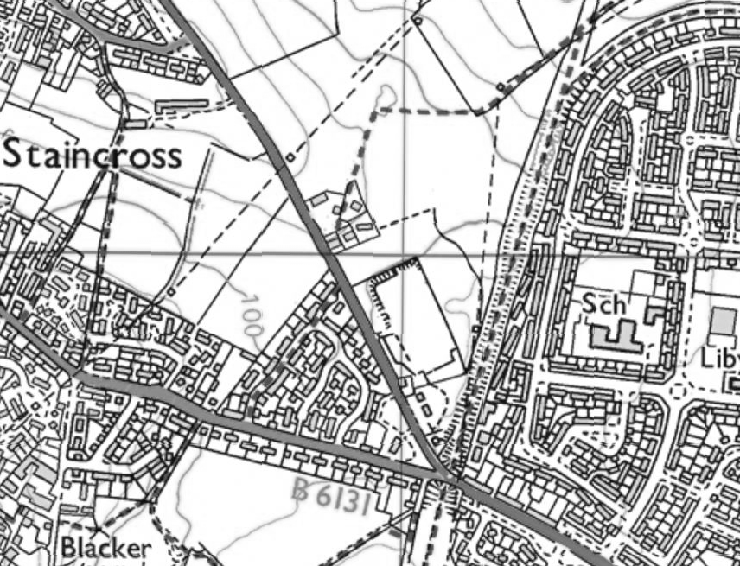
2017/1718 – up to 85 residential dwellings
215m
Key
Site Access
Distance between
site accesses
170m
2017/1716 – Lidl Food Store
2016/0337 – 46 residential dwellings
From the above, the consented site is on the opposite side of the road, and is then around 200m north of the proposed residential access. The proposed residential access is then around 180m north of the Lidl access on the same side of the road. Therefore as the right turns into the consented site will be from the north, this won’t impact upon the two new sites.
There is then around 180m between the Lidl and the residential developments, so this will be enough to get the DMRB right-turn in without the residential site impacting on the Lidl access.
Car parking standards were taken from the ‘Barnsley Local Development Framework – Supplementary Document – Parking’ document which states that 1 space is to be provided for dwellings with 1 or 2 bedrooms and 2 spaces for dwellings with 3 or more bedrooms are to be provided. The TA states that parking will be provided in accordance with these standards.

Traffic Growth
AECOM suggested that the base traffic flows should be growthed to five years post submission. As the counts were undertaken in 2017, and a decision on the application is likely to be made in 2018, 2023 was considered the most appropriate future year. Therefore, TEMPRO was used to find the following growth factors:

Table 1 – Growth Factors
2017-2023 | BGH Growth Factors | AECOM Growth Factors
Weekday AM | 1.0954 | 1.0976
Weekday PM | 1.0917 | 1.0938
Saturday | 1.0938 | 1.0960
Whilst there are slight differences between the growth factors used by Bryan G. Hall and that derived by AECOM, it is likely that this will result in a negligible impact and is therefore deemed acceptable.

Committed Developments
The TA included the following committed developments in their assessments:
- 2015/1015 – approved reserved matters application for up to 325 residential dwellings on land west of Wakefield Lane (North Gawber);
- 2016/0337 – approved reserved matters application for 46 residential dwellings on land west of Wakefield Road opposite the proposed site; and
- 2016/1490 – full consent for 164 residential dwellings on land north of Lee Lane.
Following a search on the planning portal, we would agree that these are acceptable.

Trip Generation
The TRICS database was used to derive trip rates and generations for land use category ‘Residential – Houses privately owned’ and Table 2 shows a comparison between the trip rates and generations derived by Bryan G. Hall in the TA and that derived by AECOM.
Table 2 – Trip Rates and Trip Generation
Residential – houses privately owned (up to 85 dwellings) |  | AM peak |  |  | PM peak
 |  | Arrive | Depart | Two-way | Arrive | Depart | Two-way
Bryan G. Hall | Trip Rate | 0.156 | 0.384 | 0.540 | 0.355 | 0.175 | 0.530
Bryan G. Hall | Trip Generation | 13 | 33 | 46 | 30 | 15 | 45
AECOM | Trip Rate | 0.165 | 0.378 | 0.543 | 0.354 | 0.177 | 0.531
AECOM | Trip Generation | 14 | 32 | 46 | 30 | 15 | 45
The assessments show that the trip rates and trip generations are in-line with each other, and therefore the trip rates derived by Bryan G. Hall for the weekday AM and PM peaks are considered appropriate.
However, we would advise that a Saturday peak trip rate and trip generation be provided given that the Saturday peak has been assessed.

Trip Distribution
The trip distribution has been based on the 2011 Census Journey to Work data for the Middle Super Output Area of Barnsley 004, resulting in the distributions shown in Table 3. AECOM completed a sensitivity test using the same data and Google Maps to find the most likely route taken, and to compare against the trip distributions and resultant two-way trip generations provided by Bryan G. Hall. These are also provided in Table 3.
Table 3 – Trip Distributions and Two-Way Trip Generations
Direction | Bryan G. Hall Distribution | AM Two Way Trips | PM Two Way Trips | AECOM Distribution | AM Two Way Trips | PM Two Way Trips
North of Site Access | 36% | 17 | 16 | 54% | 25 | 24
Wakefield Road (N) | 20% | 3 | 3 | 13% | 3 | 3
Lee Lane | 3% | 1 | 0 | 9% | 2 | 2
Shaw Lane | 0% | 0 | 0 | 32% | 8 | 8
Paddock Road | 13% | 2 | 2 | 0% | 0 | 0
South of Site Access | 64% | 29 | 29 | 46% | 21 | 21
Bar Lane | 16% | 5 | 5 | 5% | 1 | 1
Laithes Lane | 5% | 1 | 1 | 9% | 2 | 2
Rotherham Road | 13% | 4 | 4 | 11% | 2 | 2
Wakefield Road (S) | 30% | 9 | 9 | 21% | 4 | 4
TOTAL | 100% | 46 | 45 | 100% | 46 | 45
From the site access, Bryan G. Hall show 36% of development traffic travelling north along Wakefield Road and 64% travelling south, whilst the trip distributions by AECOM estimate that 54% will travel north and 46% will travel south.
The result of this is 29 two-way vehicles travelling south during the AM peak using the BGH distribution, compared to 21 two-way vehicles using the AECOM distribution. Travelling north, the BGH distribution results in 17 two way vehicles compared to 25 two way vehicles during the AM peak. The results of the PM peak are similar.
Whilst we agree with the method used of using the 2011 Census Journey to Work data, the difference in resultant trip generations is considered negligible, and therefore accepts the derived trip distribution by Bryan G. Hall.

Operational Assessments
Fully classified counts were undertaken on Friday 10th and Saturday 11th November 2017 during the morning (07:00-08:00), evening (15:00-19:00) and Saturday (08:00-18:00) peaks to determine the peak hours. The peak hours were identified as 07:45-08:45 in the morning peak, 16:45-17:45 in the evening peak and 11:45-12:45 on the Saturday. The following junctions were surveyed and assessed in the base 2017 scenario:
- Wakefield Road / Paddock Road priority junction (600m north);
- Wakefield Road / Lee Lane / Shaw Lane staggered crossroads junction (800m north);
- Wakefield Road / Bar Lane signalised junction (250m south);
- Wakefield Road / Laithes Lane signalised junction (800m south); and
- Wakefield Road / Rotherham Road mini-roundabout junction (1.2km south).
The above junctions were assessed using Junctions 8, Junctions 9 and Linsig V3 junction modelling software, and the maximum RFC / DoS and queue length results are summarised below. The geometries for the junctions were also checked and are considered acceptable.
These junctions were modelled in the following assessment scenarios:
- Base 2017;
- Base 2023; and
- Base 2023 + Development.
Bryan G. Hall also conducted a sensitivity test to allow for the Lidl store located adjacent to the site. The results are summarised for each junction below. However, the trip generation for the Saturday peak has not been provided and this will need to be confirmed.
Table 4 shows the individual and cumulative development trips for the residential and Lidl food store developments.

Table 4 – Development Trips
Junction | Residential |  | Lidl |  | Residential + Lidl
Junction | AM | PM | AM | PM | AM | PM
Wakefield Road / Lee Lane / Shaw Lane | 11 | 10 | 9 | 42 | 20 | 52
Wakefield Road / Paddock Road | 17 | 16 | 12 | 67 | 29 | 83
Wakefield Road / Bar Lane | 29 | 28 | 22 | 117 | 51 | 145
Wakefield Road / Laithes Lane | 23 | 22 | 16 | 89 | 39 | 111
Wakefield Road / Rotherham Road | 20 | 19 | 15 | 79 | 35 | 98

Wakefield Road / Paddock Road Priority Junction
Table 5 shows the maximum results of the assessments.
Table 5 – Wakefield Road / Paddock Road
Scenario | Weekday AM |  | Weekday PM |  | Saturday
Scenario | RFC | Queue | RFC | Queue | RFC | Queue
Base 2017 | 0.48 | 1 | 0.83 | 4 | 0.50 | 1
Base 2023 | 0.59 | 1 | 1.03 | 15 | 0.55 | 1
Base 2023 + Dev | 0.60 | 1 | 1.05 | 17 | 0.56 | 0
Base 2023 + Dev + Lidl | 0.62 | 2 | 1.12 | 24 | 0.61 | 1
In the Base 2017 scenario (i.e. at present), the junction operates within capacity, with the maximum RFC of 0.83 recorded during the weekday PM peak along the Paddock Road approach, with an associated queue of 4 vehicles. In 2023, the junction is expected to operate over capacity during the weekday PM peak with an RFC of 1.03 and associated queue of 15 vehicles on the Paddock Road approach.
With the development traffic, the junction is still expected to operate over capacity, during the weekday PM peak. The RFC and queue length increase slightly to an RFC of 1.05 and an additional 2 vehicles. The addition of the proposed Lidl development also increases the RFC and queue length, particularly along the Paddock Road approach.

Wakefield Road / Lee Lane / Shaw Lane
It is understood by Bryan G. Hall that as part of the Lee Lane application, an improvement scheme for the Wakefield Road / Lee Lane / Shaw Lane junction was proposed. Bryan G. Hall state in the TA “this improvement scheme involves widening the approach arms of Shaw Lane and Lee Lane to provide two lanes for a short section on approach to the junction”, and has therefore been assumed to be in place by 2023 and has been used in this assessment year.
We were unable to confirm the geometries for the improved Wakefield Road / Lee Lane / Shaw Lane junction as we were unable to locate a plan of the improved highway works. We therefore ask that this be provided. Table 6 shows the maximum results of the assessments.

Table 6 – Wakefield Rood / Lee Lane / Shaw Lane
Scenario | Weekday AM |  | Weekday PM |  | Saturday
Scenario | RFC | Queue | RFC | Queue | RFC | Queue
Base 2017 | 1.14 | 30 | 0.99 | 11 | 0.99 | 11
Base 2023 | 1.62 | 115 | 1.27 | 42 | 1.17 | 34
Base 2023 + Dev | 1.64 | 117 | 1.28 | 43 | 1.18 | 35
Base 2023 + Dev + Lidl | 1.65 | 119 | 1.35 | 48 | 1.21 | 39
The results show that the junction currently operates over capacity, particularly during the weekday AM peak. The maximum RFC is 1.14 along the Lee Lane approach and queues of 115 vehicles, and it should also be noted that the Shaw Lane approach operates with an RFC above 1.00 and queues of 41 vehicles. In 2023, the junction is expected to operate over capacity during all peak hours despite the improvements implemented.
With the residential development traffic, the junction is likely to operate with a slight increase in RFC and queue lengths. During the weekday AM peak, the Lee Lane approach operates with an RFC of 1.64 and an additional 2 vehicles queueing. With the Lidl development traffic, the RFCs and queue lengths increase slightly with an RFC of 1.65 and an additional 4 vehicles queueing compared to the Base 2023 scenario.

Wakefield Road / Bar Lane
Table 7 shows the maximum results of the assessments.
Table 7 – Wakefield Road / Bar Lane
Scenario | Weekday AM |  | Weekday PM |  | Saturday
Scenario | DoS | Queue | DoS | Queue | DoS | Queue
Base 2017 | 88.6% | 16 | 83.5% | 12 | 79.2% | 12
Base 2023 | 101.5% | 30 | 96.1% | 18 | 90.8% | 16
Base 2023 + Dev | 101.8% | 31 | 97.4% | 19 | 91.3% | 17
Base 2023 + Dev + Lidl | 102.4% | 32 | 100.7% | 26 | 94.8% | 18
The junction currently operates within capacity, though in 2023, it is likely the junction will operate over capacity during the weekday AM peak hour. The maximum Degree of Saturation (DoS) is 101.5% on the Bar Lane approach with an associated queue of 30 vehicles during the Weekday AM peak.The Wakefield Road Northbound approach operates with an RFC under 90%, but with long queue lengths of maximum 24 vehicles, identified during the Weekday AM peak.
The result of the residential development increases the DoS and queue lengths slightly along all approaches. The weekday AM peak operates with a DoS of 101.8% along the Bar Lane approach. The Wakefield Road Northbound approach also operates with a DoS above 100% and an associated queue of 46 vehicles. With the Lidl development, the DoS and queue lengths increase slightly, and the junction is likely to operate above capacity in the weekday AM and PM peaks.

Wakefield Road / Laithes Lane
Table 8 shows the maximum results of the assessments.
Table 8 – Wakefield Road / Laithes Lane
Scenario | Weekday AM |  | Weekday PM |  | Saturday
Scenario | DoS | Queue | DoS | Queue | DoS | Queue
Base 2017 | 88.0% | 25 | 87.6% | 17 | 79.6% | 18
Base 2023 | 99.6% | 48 | 99.3% | 49 | 89.8% | 29
Base 2023 + Dev | 101.0% | 56 | 99.9% | 52 | 90.5% | 17
Base 2023 + Dev + Lidl | 101.5% | 59 | 103.2% | 75 | 92.9% | 33
The Wakefield Road / Laithes Lane junction currently operates within capacity. In the Base 2023 scenario, the junction is likely to operate approaching capacity with a DoS of 99.6% recorded during the weekday AM peak and an associated queue of 48 vehicles along the Wakefield Road (N) approach.
With the residential development, the junction is expected to operate over capacity during the weekday AM peak which has a DoS of 101.0% along the Wakefield Road (N) approach. The queue length also increases by 9 vehicles. The impact of the Lidl development is small with the DoS increasing slightly along all approaches though the queue lengths, particularly in the Weekday PM peak increase by 23 vehicles queueing which is considered significant.

Wakefield Road / Rotherham Road
Table 9 shows the maximum results of the assessments.
Table 9 – Wakefield Road / Rotherham Road
Scenario | Weekday AM |  | Weekday PM |  | Saturday
Scenario | RFC | Queue | RFC | Queue | RFC | Queue
Base 2017 | 0.76 | 3 | 0.73 | 3 | 0.64 | 2
Base 2023 | 0.94 | 10 | 0.89 | 7 | 0.78 | 4
Base 2023 + Dev | 0.96 | 11 | 0.90 | 8 | 0.79 | 4
Base 2023 + Dev + Lidl | 0.97 | 12 | 0.94 | 12 | 0.82 | 4

The results show the junction currently operates below capacity. The maximum RFC is 0.76 during the weekday AM peak along the Rotherham Road approach, with a queue of 3 vehicles. The base 2023 scenario is expected to operate approaching capacity with an RFC of 0.94 and an associated queue of 10 vehicles along the Rotherham Road approach.
The impact of the residential development traffic and the Lidl development traffic increases the RFC and queue lengths slightly along all approaches, though it is still expected to operate approaching capacity.

Site Access
Given that the junction will not exist until the development is brought forward, the site access junction has only been modelled in the Base 2023 scenario. Table 10 shows the maximum results of the assessments.
Table 10 – Site Access
Scenario | Weekday AM |  | Weekday PM |  | Saturday
Scenario | RFC | Queue | RFC | Queue | RFC | Queue
Base 2023 + Dev | 0.10 | 0 | 0.05 | 0 | 0.09 | 0
Base 2023 + Dev + Lidl | 0.10 | 0 | 0.05 | 0 | 0.10 | 0
The results show that the junction will operate well within capacity, also with the Lidl development traffic.
Bryan G. Hall state that the addition of the development traffic is not deemed to result in “material ham to the safe and free flow operation of any of the junctions assessed”.

Summary and Conclusions
AECOM have reviewed the Transport Assessment produced by Bryan G. Hall for a residential development of up to 85 dwellings on the former William Freeman site along Wakefield Road in Mapplewell, Barnsley. The site has been identified as a potential development site within the emerging Barnsley Local Plan, due for adoption in Spring 2018.
AECOM also reviewed the scoping email for the proposals of approximately 82 dwellings in a report dated 2 January 2018. It concluded that the scope was generally acceptable with a few recommendations made.
The full comments for the Transport Assessment are summarised below:
- It is stated that as part of the Lee Lane committed development, improvements will be made to the Wakefield Road / Lee Lane / Shaw Lane junction. However, we have been unable to locate these improvements and ask that this be provided.
- Whilst the weekday trip rates and generations are considered acceptable, the Saturday trip rates and generations should be provided given that this scenario has been modelled.
- A sensitivity test was carried out by AECOM in order to confirm the trip distributions used by Bryan G. Hall. We accept the method of using the 2011 Census Journey to Work data for Barnsley 004.
- AECOM asked in the scoping email review that the site access be designed in accordance with DMRB, however the minor road carriageway width and ghost island taper length appear to be slightly shorter than the DMRB standards. We would require the site access junction measurements to be checked and clarified.
- a number of the junctions are predicted to operate above capacity, and this is then made worse with the cumulative Lidl development.

Framework Travel Plan
A Framework Travel Plan was also submitted as part of the application, and has been reviewed by AECOM.
The Travel Plan states that the overall aim “is to influence the travel choice of residents to achieve a positive modal shift and reduce the impact the development has on the local network” and therefore sets the following objectives:
- To increase awareness of the advantages and potential for travel by environmentally friendly modes;
- To reduce the number of single occupancy car trips; and
- To encourage residents to adopt sustainable modes of travel for most of their journeys to and from the site.
Following occupation of the development, the Framework Travel Plan will be developed into a full Travel Plan.
A Travel Plan Co-ordinator (TPC) will be assigned prior to marketing the site and will be in place for a minimum of 5 years post full occupation. They will be responsible for the overall management and implementation of the Framework Travel Plan.
A dedicated budget will be available for the TPC and this will be provided by the developer, though an exact amount is not stated.
As the site has no travel survey data for the development, data was taken from the 2011 Census Method of Travel to Work for Barnsley 004 Middle Super Output Area (MSOA). A preliminary target of a 5% reduction in single-occupancy vehicle trips and corresponding increase in sustainable travel modes has been assumed. The target will be reviewed following an initial survey to take place within three months of meaningful occupation. These have been assumed as follows:
Table 11 – Modal Split Summary
Mode of Travel | Number | Modal Split (%) | Target Modal Split (%)
Train | 54 | 2% | 2%
Bus | 167 | 5% | 7%
Driving or Passenger (Car / Van) | 2,892 | 84% | 79%
Bicycle | 25 | 1% | 2%
On foot | 273 | 8% | 10%
Total | 3,411 | 100% | 100%

AECOM verified the modal splits and consider it, as well as the target, to be acceptable.
The Framework Travel Plan includes a number of measures that are summarised below:
- Measure 1 – Site Specific Travel Guide; this will be prepared, agreed with BMBC and provided to all new residents. It will include site specific travel information, details of local initiatives and contact details of the TPC.
- Measure 2 – Personalised Travel Planning; a letter will be sent to each resident within one month of occupation to offer each property personalised travel planning with the TPC to help guide people through their travel options.
- Measure 3 – Trial Public Transport Ticket; a trial public transport ticket will be provided via the residents travel guide to show how easy it can be to utilise public transport.
- Measure 4 – Promote Walking and Cycling; all residents will be offered a pedometer or gold standard cycle D-lock as an incentive to encourage walking and cycling. This will be advertised through the travel guide and an associated letter.
- Measure 5 – Promote Car Sharing; the TPC will inform residents of the local web-based scheme ‘Car Share South Yorkshire’.
- Measure 6 – Reducing the Need to Travel; the TPC will promote through the travel guide the advantages of internet use and home delivery to reduce the need to travel.
In terms of monitoring and review of the Travel Plan, residents will be encouraged to participate in a travel survey, the first of which will be undertaken within three months of meaningful occupation of the site (to be determined and agreed with BMBC), and then every 2 years hence for a minimum period of 5 years (i.e. years one, three and five). A snapshot survey will take place in years two and four. The results of the travel survey will be reviewed and shared with BMBC within three months of each survey.

