

11 Peel Square, Barnsley, S70 2QT

Coventry Group (The Co-operative Bank)

PLANNING STATEMENT

March 2026

Prepared by Kimberley Bosworth

INTRODUCTION
This statement has been prepared by Sign Systems (UK) Ltd, a leading UK-based company specialising in the design, manufacture, and installation of high-quality, sustainable signage solutions. With a strong commitment to environmental responsibility and innovative design, we provide tailored signage services to businesses across a wide range of sectors throughout the United Kingdom. Our mission is to deliver durable, visually impactful, and eco-conscious signage that enhances brand visibility while supporting long-term sustainability goals.
This statement is submitted in support of an application for the installation of digital display window screen and fascia signage to two elevations and a digitally printed ATM graphic.
EXISTING SITE
The site is situated in a prime location next to Storeys Gaming Centre and opposite the Corner Pin Public House.
The site (already a Co-operative Bank) is located within Barnsley Metropolitan Borough Council in a mixed-use area comprising commercial and high street buildings and near to No1 Currency Exchange. It does fall within a designated Conservation Area, however, this application has considered all relevant local designations and policies.
Benefiting from existing electricity and water supplies, as well as connectivity to the main drains, this minimizes the need for extensive modifications and installations.
With illuminated shop fronts nearby, the area is bustling with activity, making it an ideal location for businesses seeking high visibility and foot traffic.
PROPOSED WORKS
- A 55’’ digital signage screen positioned internally behind the glazing, visible from the public highway.
- Fascia signage on 2no. elevations.
- Digitally printed ATM graphic.

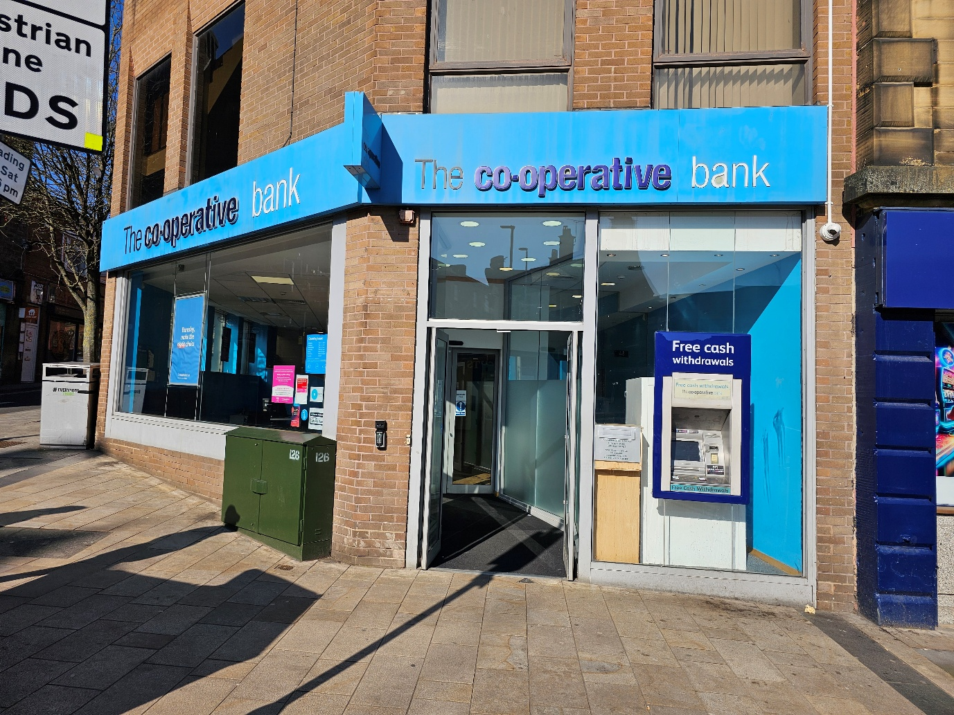

Existing front elevation of the Co-operative Bank , 11 Peel Square, Barnsley.

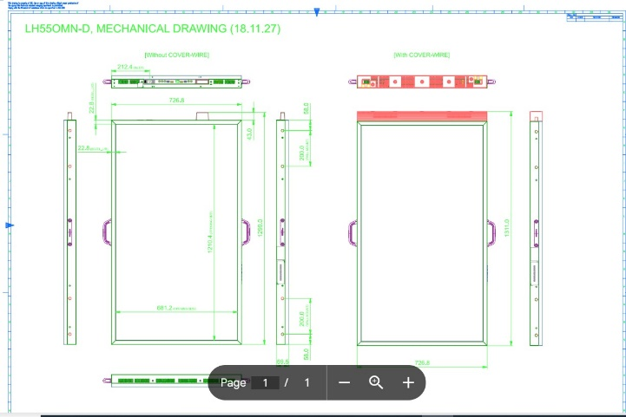
Technical drawing for the Samsung OM55NDS as per proposal no.2
Samsung OM55NDS - Where screens are installed in conservation areas, listed buildings, or other locations of special interest, content restrictions have been applied in line with local council requirements. In these cases, content can be static or feature slow transitions and is designed to complement the local environment while still effectively communicating key messages. The branch content team will be responsible for producing the content and can tailor it to meet specific council stipulations as needed.
The proposed screens feature high brightness capabilities to ensure visibility in daylight. Window screens are equipped with ambient light sensors that automatically adjust brightness according to changing light conditions. Power consumption is managed through control software aligned with the client’s trading hours, ensuring screens are only active when necessary. They can be set to come on 15 minutes before opening and turning off at closing time or screen operation may be further adjusted with nighttime luminance to 300 cd/m ². based on footfall, with screens turning off overnight when pedestrian traffic is minimal or non-existent.
Although a standard power schedule for bank branches has not yet been finalised, the system supports branch-specific scheduling. This allows screen operating hours to be tailored to local council regulations and the unique needs of each location. Currently, there are preliminary plans for the screens to operate between 8:00 a.m. and 10:00 p.m.

MAXIMISE OPERATIONAL EFFICIENCY
With a sleek, efficient design, the OMN-DS series gives retailers the freedom to easily customise small storefront window displays. Unlike conventional displays that are both bulky and limit positioning options, the OMN-DS series frees up space, offering retailers more room to market themselves to potential customers. Additionally, the displays are easily activated with one electric power cord and one LAN cable, drastically reducing cord clutter and increasing energy efficiency.

CONCLUSION
The proposed advertisement is modest, well-designed, and respectful of its context. It will contribute positively to the commercial vitality of the area without harming visual amenity or public safety. We believe this proposal represents a sensitive and appropriate approach to digital signage within its setting. By keeping the installation non-invasive, discreet, and carefully managed in terms of operation and visual output, we aim to preserve the character of the building and its surroundings while allowing the site to operate effectively in a modern commercial way.
We welcome any further guidance or conditions the council may wish to impose to ensure compliance with local heritage policies.

