Art Heritage Statement

The Mill Complex has a number of historically significant buildings and structures listed by Historic England:
The Mill Cottage, Park Road, Worsbrough Grade II Listed no’ 1192294 (4th December 1986) now known as the Miller Tea rooms and visitor centre.
Worsbrough Corn Mill Park Road Grade II* listed no’ 1151044 (11th December 1966) used today as a museum and corn mill.
Bridge some 60 metres from the Mill Grade II listed no’1151045 (11th December 1966)
In terms of planning, design and heritage we have consulted the Council’s Senior Conservation Officer on the installation of the six wooden art features, his advice was to ensure it is completely reversible and not to detract from the setting of the grade II and grade II * listed structures.

We have determined the most appropriate location for the art installation is the grass verge to the east of the Mill Cottage, the art installation is of wheat and grain which is appropriate and fits with the former and current use of the site as a working mill, the art will be seen by visitors entering the site from the main entrance car park, but does not impact the view of the Corn Mill complex, or the main front of the cottage, it will be located to the side on the grass bank which slopes away from the buildings.

Heritage Assets and Heritage Significance

The proposed artwork will not damage buildings, or be permanently fixed into their location, the land being used is not Grade listed in its own right but is still within the curtilage of a Grade II listed structures and as a consequence has national heritage significance. We recognise that the site and the general setting has heritage significance and is relatively sensitive to change.

Photo of the site location
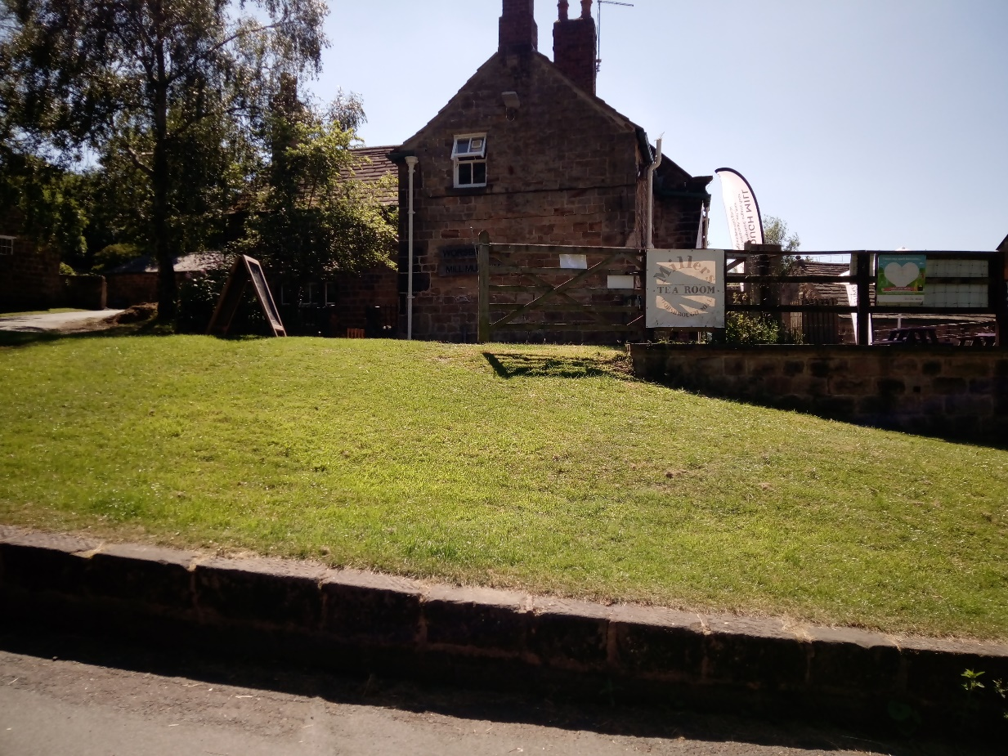

Impacts and Justification

Clearly, the installation of artwork will be in land associated and in the curtilage of listed buildings and will have a small impact on the appearance of the building. However we have explored other locations and this is the only viable location. We feel strongly that any impacts are mitigated by the fact that the installation method will be 100% reversible, no concrete will be used to fix the wooden poles in place, and any minor harm is limited to the grassed area, we believe there is a genuine and significant public benefit as the art feature will be seen by thousands of visitors, it has an educational and historical significance and encourages footfall to the site. As such, we feel that the proposal is justified and accords with BMBC Local Plan policies.

