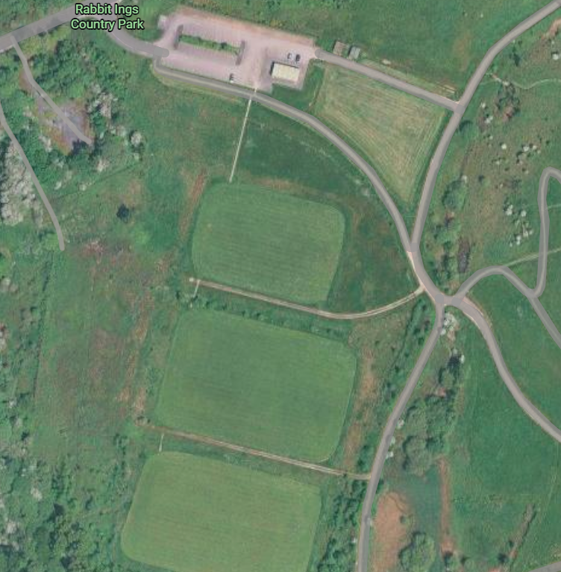

Proposed Location of 20ft x 8ft x 8.5ft Storage Containers.
Storage Containers to be located on a level aggregate base with access doors facing the roadways.

