Method Statement for Protection of Trees
Cliffe Lodge, Burton Road, Monk Bretton, Barnsley, S71 2HE.
Planning application 2025/0421
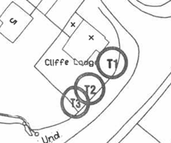
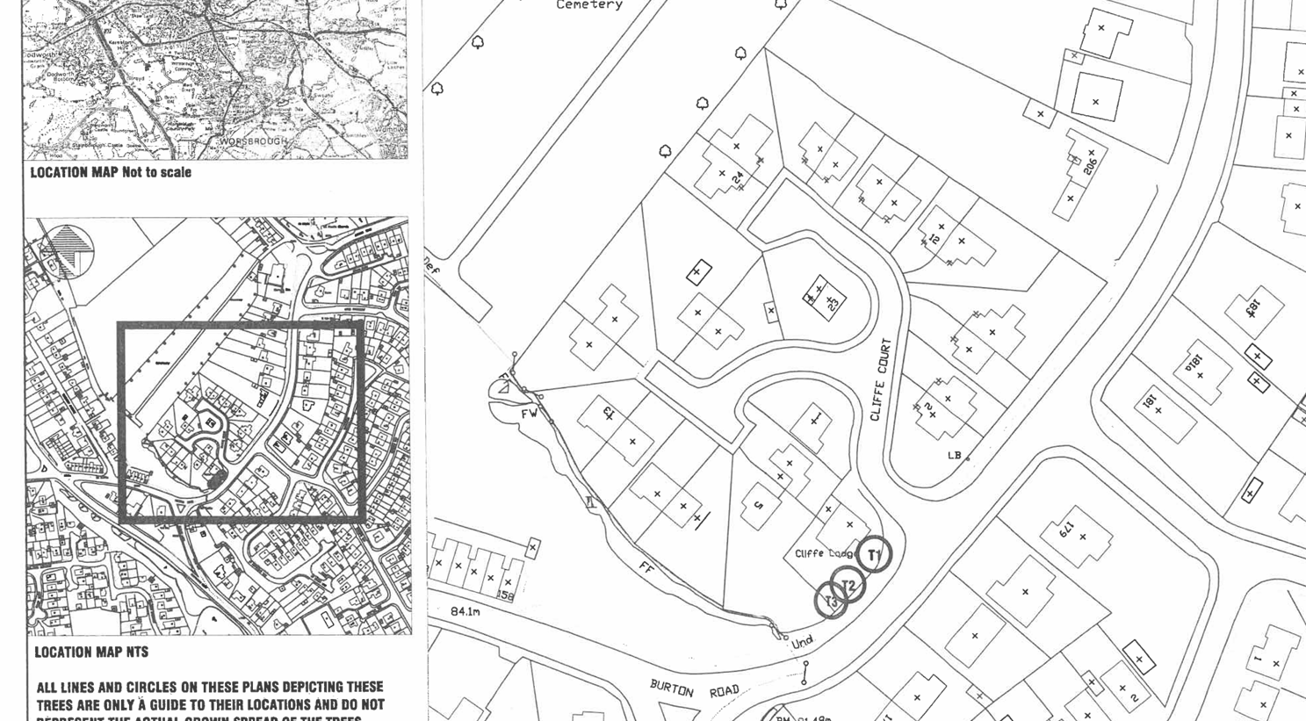

This statement shows the measures that will be undertaken to protect the three trees with TPO’s whilst the planned renovations take place.
I have attached an additional plan that shows the position of the trees in relation to the planned building work. The main work is based around the conservatory which is about 10 metres away from the trees.
Dismantling the conservatory will be managed on the paving around the house and to the front of the existing conservatory building. All the planned building work is being placed on the existing foundations so no new excavation will be needed or further digging for foundations.
Materials will be moved in wheel barrows or using a small 1 tonne dumper, from the drive, using the paved areas and paths.
A protective fence will be used in the form of a plastic barrier, erected a minimum of 2.5 metres away from the base of the tree to protect the roots. However, materials will be carried and stored well way from the bases of the trees.
The fencing will be placed to stop excessive movement in the tree root areas, but as said previously, the materials will be moved in small loads using the existing paths and paved areas.
Pruning of the trees would probably be needed in the future as the branches are very close to the roof. Further discussion with a suitable expert would be taken before anything carried out or cut off any of the trees to ascertain the best practice.

