Waste Development Supporting Statement  Site address: | The Recycling Centre, Shaw Lane, Barnsley, S71 3HZ
Applicant: | Stairfoot Metals Ltd
Proposal: | Change of use to scrap metal recycling yard.

Contents

- Introduction
- The Proposals
- Potential Issues
  - Dust
  - Dust/Mud on Highways
  - Drainage
  - Noise
  - Odour
  - Litter
  - Pests
  - Traffic
  - Contaminated Land
  - Environmental
- Planning Policy
- Conclusion

This Design and Access Statement (DAS) accompanies a planning application for the proposed change of use of land at Shaw Lane, Barnsley.
The DAS has been written to meet the requirements of Article 4C of the Town and Country Planning (General Development Procedure) Order 1995 (as amended).

- Introduction
  - AC Environmental Consulting Ltd have been instructed by Stairfoot Metals to apply for a change in the use of land to a scrap metal recycling yard at The Recycling Centre, Shaw Lane, Barnsley, S71 3HJ.

  - The site is currently being used for general industrial storage.
This planning application seeks to allow for the change of land use and development of a scrap metal recycling yard.

  - Stairfoot Metals are an established waste management company that have been operating as a waste disposal contractor since 2016. They currently operate a site at Wombell Lane, Barnsley, but have been forced to seek alternative premises, due to a change in ownership of the site.

  - The proposal seeks permission for;
    - Change of use from general industrial use to operation of a scrap metal recycling facility.
    - Creating Legio block concrete walls to 3m high,
- on the northern and eastern perimeter of the site to improve security and noise mitigation and;
- to create storage bays for recycled metals.
- Permit the use of a shear for recycling of scrap metals.

  - The site is located at The Recycling Centre, Shaw Lane, Barnsley which is within an industrial site located in an otherwise mainly rural area.

    - The industrial estate is home to a number of other waste management companies and scrap metal recyclers including vehicle breaker yards.
    - To the North of the site is a concrete products manufacturer and beyond is a large vehicle breakers yard.
    - To the south west of the site is another scrap yard.

  - To the East of the site lies a disused railway with the Carlton Marsh Local Nature Reserve some 80m beyond at its nearest point.

  - The nearest housing is approximately 230m north east of the site.

  - The village of Carlton lies 750m west of the proposed site.

  - The industrial estate has many industrial and commercial businesses in operation including potentially contaminative uses. The proposed site is currently used for storage of concrete products and plant.

  - This statement has been produced to demonstrate the methods by which the proposed operation will be managed to mitigate its effect on the local environment.

  - The key issues relating to this operation are;
      - Dust
      - Dust/Mud on Highway
      - Drainage
      - Noise
      - Odour
      - Litter
      - Pests
      - Traffic
      - Contaminated Land
      - Environmental
Each of these issues is considered and the methods used to mitigate their impacts are outlined throughout this statement.
  - The land is being leased by the applicant from Hunter Waste Management Limited. The applicant will be a leaseholder and only has interest in the land within the red line area of the application and not any of the land adjacent to or nearby.

2. Waste Development Statement
2.1 The applicant currently operates a site at Wombell Lane, Stairfoot but due to the landlords plans to redevelop they have been forced to seek alternative premises at short notice. A search for suitable alternative premises has been conducted and the proposed site was the only suitable one available. The only other alternative would be too close the business entirely, resulting in a loss of employment.

2.2 The planning application has been submitted at the earliest opportunity for the application to be determined at the earliest opportunity to minimise the risk to the continuation of the business.

2.3 The development would provide various benefits to the business and local economy. There is opportunity for a more efficient site that is fit for the 21st Century. Furthermore, the development will provide a cleaner and safer site which has less impact on the environment. The development offers the opportunity for business growth, to increase annual tonnage and expand the range of wastes recycled, compared to that of the previous site in Wombell Lane, Stairfoot. The potential business growth would result in further rural employment opportunities in the future which boosts the local economy.

2.4 The applicant will be a leaseholder and only has interest in the land within the red line area of the application and not any of the land adjacent to or nearby.
2.5 The site will not be open to the public and will handle scrap metal wastes arising from scrap metal collectors and commercial and industrial sites throughout the local area. The waste types treated at the site are restricted to dry scrap metal wastes only. The site will operate under a T9 exemption which permits recycling of scrap metal wastes with a limit to store or treat up to 1,000 tonnes at any one time including the storage and treatment of up to 50 tonnes of cables at any one time.
2.5 All wastes will be stored within the building or the Legio Block concrete walled bays.
2.6 Portacabins at the site entrance will be retained and used as a site weighbridge office and canteen. The two existing portacabins are of standard construction with dimensions of 36ft x 10ft. There will be 6 car parking spaces available next to the office.
2.7 The scrap metal recycling operation will be carried out using the following plant;
- a Lefort 500 Mobile Shear
- 2 Liebherr Wheeled 360-degree grabs (Liebherr A924 and Liebherr A904).

- The Proposals
  - The development of a waste transfer station will provide the opportunity to improve on the facilities at the current site in Wombell Lane, Stairfoot.

  - The site has the benefit of an existing steel building which will be used for storage of plant and non-ferrous metals for security.

  - The surfacing at the site is currently a good quality concrete surface. This will be extended with a new interceptor to be installed in the area not currently covered in concrete and this area then fully concreted to provide sealed drainage throughout the whole site.

  - The perimeter Legio block walls to 3m high will effectively screen the site from the nearest sensitive receptors and mitigate any issues with noise, litter, dust etc from affecting neighbouring properties.

  - The site covers an area of 2850m² (0.28ha) and lies off Shaw Lane, Barnsley.

  - Scrap Metal Processing – The waste received on site is restricted to dry scrap metal wastes which will consist of Ferrous and Non-ferrous materials. These are collected from a variety of sources including; registered itinerant collectors, skip companies, scrap metal merchants, local commercial and industrial companies. The waste stream is variable in terms of the quantities received.
Scrap metals acquired in this way will be sorted by hand and utilising the Liebherr grabs with separate fractions stored securely on site within the concrete walled bays. Some fractions will require further processing by shear before storage and finally despatch offsite to downstream recyclers.

  - Annual Tonnage – It’s proposed that the site will be designed to handle up to 75,000 tonnes per annum. Each waste steam has its own operating area to store the waste appropriately. The site will store no more than 1000 tonnes of scrap metals at any one time.

  - Operating Hours -
Mon-Fri: 07:30 – 17:30
Sat: 08:00 – 12:00
It is not intended to operate the site on Sundays, Bank or Public Holidays.
  - This proposal has several advantages;
    - The site is fully concreted and will be completed with a sealed drainage system draining to sewer via a modern 3 stage interceptor.

    - The perimeter walls and concrete bays will effectively screen the site and mitigate issues with noise and dust. It will enable the operator to sort, treat and recycle all waste efficiently and will be a site fit for the 21st Century, creating a safe work environment for current and future employees.

    - The company seeks continuous growth. This creates the opportunity for employment in the future which improves the local economy.

    - The development will provide a much-needed facility for the local area. Whilst the site has a number of other waste management operations in the local area these are primarily vehicle breakers of one form or another. The proposal specifically exclude vehicle breaking operations and restrict activities to recycling of dry scrap metal only which will compliment rather than compete with existing operations.

    - This site will help fulfil the needs and demands of the nearby city of Barnsley and surrounding towns of Carlton, Shafton, Royston, Cudworth and Athersley North/South.

    - The development will have no adverse effect on the traffic in the surrounding area as the operations will be compatible will the scale and nature of the site.

    - The development will be compatible will existing and surrounding uses indicating that the proposals are a viable option for this location.

- Potential Issues
  - Dust
    - The waste types accepted at site are not likely to give rise to dusts. Furthermore, the nature of the operation with no screening or crushing means that the potential for dust to arise is limited.
    - Dust can arise from mud on concrete surfaces and so any accumulation on the site will be removed by a mechanical sweeper when deemed necessary. Therefore, the potential for dust to become an issue is deemed to be very low.

  - Dust/Mud on Highway
    - The surface of the site in concreted which reduces the potential for mud on site. In any case where mud has become apparent, the site and highway will be swept by a mechanical sweeper. This will clear any mud left on the ground. In addition, if deemed necessary a hose and brush will be used to clean the wheels of outgoing vehicles.
  - Drainage
    - The proposed development will be fully concreted and will have a new Interceptor installed. This will flow into the main sewer system.

    - The drainage system will remove the risk of ground and surface water contamination from the proposed operations.
  - Noise
    - A noise survey and assessment has been carried out on 9th September 2017. The survey identified that the noise from various other industrial uses locally together with road noise provided a high level of background noise at the nearest sensitive receptors, these being houses on Shaw Lane some 270m distant.
    - The noise survey identified that the current ambient level (LAeq,t) with no plant operating at the site for the monitoring period was 68dB i.e. already above the desirable external levels from BS8223 (50-55dB). Site activity levels are not likely to add appreciably to the existing LAeq.
    - The noise report concluded, “there is unlikely to be adverse impact given the existing context into which the new facility is introduced.”
  - Odour
    - The nature of scrap metal is that it is not inherently odorous and does not degrade other than by oxidation/rusting and so does not give rise to odours on storage or treatment.
    - Despite the negligible risk of odour becoming an issue, the site does have an odour management procedure as part of its site management plan and this will be implemented immediately it is noticed that odour is an issue. This involves removal of odorous wastes from site immediately and the use of proprietary de-odourising agents to eliminate any residual odour.
  - Litter
    - The nature of scrap metal is that it does not ordinarily give rise to litter.
    - Concrete panel/Lego block walled bays or covered skips will be used as storage for recycled metals. Any litter which escapes will be contained by the sites surrounding perimeter Legio Block walls.
    - During periods of high winds additional staff can be used to clear up any incidents of litter.
    - This indicates that the risk of litter contamination is extremely low and effectively controlled.
  - Pests
    - The nature of scrap metal is that it does not provide a habitat or food source for pests and such the risk of a pest infestation is considered to be negligible.
    - Any waste deemed to cause a pest problem will be removed from site at the earliest opportunity. Mitigation measure will be introduced before accepting any further waste from that waste source.
  - Traffic
    - The site handles waste from registered itinerant scrap metal dealers and from scrap merchants and local commercial and industrial companies. Traffic will be limited and can be strictly controlled.
    - The majority of traffic movements bringing scrap metal to site will be in light vehicles, pick-ups, skips etc. Movements of waste from site will be in 8-wheel LGVs.
    - It is expected that vehicle movements will range from 30 to 50 per day.
    - The site has excellent connection to Shaw Lane and this level of traffic movements is of a scale and nature that is compatible with the location and the existing uses of the surrounding industrial estate.
  - Contaminated Land
    - A ground investigation was carried out in September 2017. This involved drilling 13 windowless sampling boreholes and taking samples of soils and groundwater for analysis.
    - The proposed development has a sealed concrete surface and will have a new interceptor installed which eliminates any potential pollution pathways.
    - In relation to human health, the site is not considered to require any remedial measures in relation to the proposed development for recycling dry metal wastes.
    - Despite elevated concentrations of petroleum hydrocarbons within the soils, above and below the water table, locally beneath the site, groundwater quality is not unacceptably impacted. This is due to the low solubility of the hydrocarbon compounds present. The hydrocarbons are most likely aged waste engine oils associated with the past use of the surrounding land as scrap yards, which partially extended onto the site.
    - The groundwater tests results show that the site does not present an unacceptable risk to off-site controlled water receptors, and no remedial measures are considered necessary in this respect.

  - Environmental
    - A check of the MAGIC website was carried out to ascertain if there were any features of interest in the wider landscape.
    - The check Showed that the site is in a Nitrate Vulnerable Area and Local Nature Improvement Area. The site is bordered by High Spatial Priority Woodland and the Carlton Marsh Local Nature Reserve.
    - The site is situated within a Flood Zone 1 which means that there is low probability of flooding and development of this nature is not at risk from flooding and should not be restricted for this reason.
    - The site is fully concreted with sealed drainage draining to sewer. As such there will be no impact on vulnerable soils or groundwater.
    - The development is located adjacent to the Carlton Marsh Local Nature Reserve. It is possible that protected species including great crested newts may be present here. However, the site is fully concreted, with the concrete in good condition which means that there are no suitable habitats or food sources for any protected species. Furthermore, the Legio block wall proposed for the Eastern perimeter of the site will provide an impediment for any future exploration of the site by protected species.
    - The proposals do not incorporate any lighting and so there will be no effect on nocturnal species such as bats.
    - It is therefore considered that operations on site will have no adverse impacts on adjacent landscapes, habitats or any protected species.

- Planning Policy

  - Joint Waste Plan Policies
The Joint Waste Plan is the detailed planning strategy for providing waste management facilities across Barnsley, Doncaster and Rotherham over the period to 2026.
  - POLICY WCS1: BARNSLEY, DONCASTER AND ROTHERHAM’S OVERALL STRATEGY FOR ACHIEVING SUSTAINABLE WASTE MANAGEMENT

“Provision will be made to maintain, improve and expand the network of waste management facilities throughout Barnsley, Doncaster and Rotherham to achieve sustainable waste management across all waste streams.”

    - This plan sets out various strategies which are;
- New or replacement smaller-scale facilities will be supported where these are required to serve the local catchment areas and communities.
- Waste proposals will be directed towards accessible locations with good transport links, particularly in and around urban areas.
- Priority will be given to waste proposals which maximise the reuse of vacant or underused brownfield land, particularly within established employment areas and which provide opportunities for co-location and priority areas for regeneration.
- Innovative waste technologies will be allowed and promoted where these supports the vision and aims of the Joint Waste Plan.
- Waste proposals will not be allowed (including on safeguarded or allocated sites under policies WCS2, WCS3 and WCS5) which may undermine the integrity of nature conservation sites of international importance (such as Thorne and Hatfield Moors Special Protection Area and Special Areas of Conservation).
- All development proposals (including non-waste uses such as housing) must promote high quality design and layouts that minimise waste and reduce resources (e.g. recycled materials and secondary aggregates), especially during the construction process;
    - The issues which arise from using these strategies are;

- Being able to encourage operators to treat waste further up the hierarchy.
- Reducing the need and reliance on landfill and being able to minimise the amount of waste.
- Encouraging operators to maximise the use of vacant and underused land.
    - The proposal meets the objectives by;

- The development will offer the opportunity for waste to be treated further up the waste hierarchy as it will have an array of facilities and equipment which are fit for the 21st Century.
- The development will serve waste needs within the local catchment area and the areas surrounding.
- The development complements rather than competes with existing waste facilities in the local area.
- The development is in a location where transport links are exceptional whilst not adversely affecting the amount of traffic in the area.
- The proposal means that the site will redevelop an area of land which is under used and will enhance the previous land use making it cleaner and safer for the environment and more beneficial for the local economy e.g. Job creation.
- The site will not undermine the integrity of adjacent landscapes including nature sites as it will be well maintained and constructed in a way that will prevent any adverse impacts on the surrounding landscape.
- These points are accordance with the policies outlined in WCS1.

  - POLICY WCS2: SAFEGUARDING AND ENHANCING EXISTING STRATEGIC WASTE MANAGEMENT SITES.
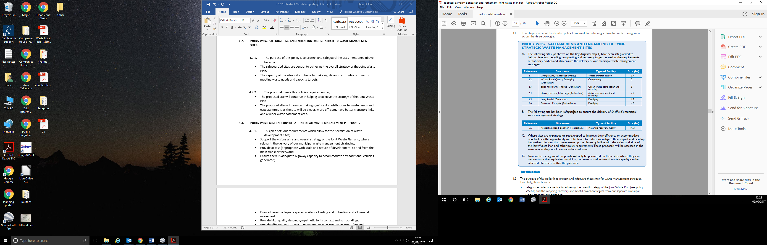
    - The purpose of this policy is to protect and enhance sites because:
- The safeguarded sites are central to achieving the overall strategy of the Joint Waste Plan.
- The capacity of the sites will continue to make significant contributions towards meeting waste needs and capacity targets.
    - The proposal meets this policies requirement as;
- The proposed site will continue in helping to achieve the strategy of the Joint Waste Plan.
- The proposed site will carry on making significant contributions to waste needs and capacity targets as the site will be larger, more efficient, have better transport links and a wider waste catchment area than the operators current site which this proposal replaces.
  - POLICY WCS6: GENERAL CONSIDERATION FOR ALL WASTE MANAGEMENT PROPOSALS.

    - This plan sets out requirements which allow for the permission of waste development sites;
- Support the visions aims and overall strategy of the Joint Waste Plan and, where relevant, the delivery of our municipal waste management strategies;
- Provide access (appropriate with scale and nature of development) to and from the main transport network;
- Ensure there is adequate highway capacity to accommodate any additional vehicles generated;
- Ensure there is adequate space on site for loading and unloading and all general movement.
- Provide high quality design, sympathetic to its context and surroundings;
- Provide effective on-site waste management measures to ensure safety and security;
- Mitigate any constraints that may reduce the potential to redevelop the site and adjoining areas in future.
- Provide adequate means of controlling noise, vibration, glare, dust, litter, pests, odour and other emissions to avoid adverse impacts on the immediate surrounding environment and human health;
- Will not result in loss or damage to the diversity of wildlife and habitats at the site or adjoining land;
- Will not have adverse impacts on the quality of ground and surface water or drainage.

    - The requirements outlined above have been met by this proposal as;
- The development meeting the visions and aims of the Joint Waste Plan which have been mentioned previously.
- The development will provide access to the main transport network as it is located on Shaw Lane which links to many surrounding towns. The highway capacity of Shaw Lane is adequate to cope with the number of vehicles generated by the development. The amount of traffic generated will be compatible with scale and nature of the business.
- The site will have a large area at the eastern part of the site where all activities such as loading, unloading and turning will take place.
- The development will allow for the creation of an effective on-site waste management service whereby the equipment and site design will be fit for the 21st Century leading to a more secure, safer and efficient operation which mitigates all potential impacts.
- All issues which may reduce the potential to redevelop the site will be prevented. Issues such as noise, dust, litter, pests and odour are controlled and prevented as outlined previously in Section 3.
- The site is fully concreted with sealed drainage via a 3 stage interceptor to sewer so no potential pollution pathways exist which could give rise to contamination of soils, ground or surface waters.

All the relevant requirements have been met by this proposal.

  - POLICY WCS7: MANAGING WASTE IN ALL DEVELOPMENTS
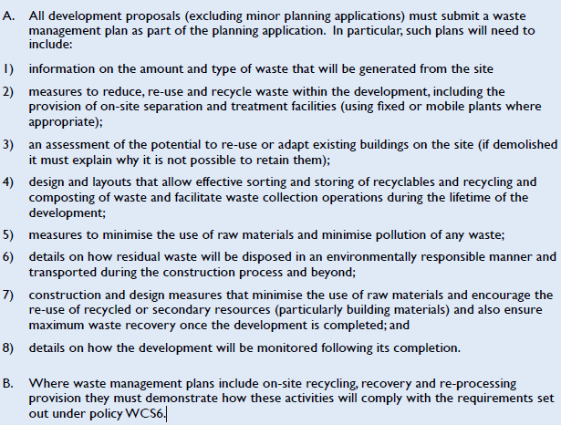

- The proposal has outlined all the points stated in the above image in Section A.
- Section B of the above complies with the requirements set out in Policy WCS6 as previously discussed.

  - The proposal meets all the objectives of the policies mentioned above by;

- Creating a site fit for the 21st Century which is efficient, safe, secure and has exceptional transport links whilst not creating any adverse impacts in the local area.
- The site has taken all measures possible to ensure that all forms of pollution are negated.
- The site will create immediate jobs, and with the business continuously looking to grow and expand, future rural employment is inevitable which boosts the local economy.
- The development supports and stays within the vision and aims of the Joint Waste Plan by meeting all the requirements laid out in the aforementioned policies.

Core Strategy

  - POLICY CSP19: PROTECTING EXISTING EMPLOYMENT LAND
    - Existing employment land, or land last used for employment purposes will be retained to safeguard existing or potential jobs. The redevelopment of employment land will take place if:
- The redevelopment will result in greater local employment rather than a loss of existing jobs or employment potential; and there will be an adequate supply of employment land in the locality.
    - This objective is met by the proposal as the development aims retain employment in the area whilst also increasing the option for future employment.

  - POLICY CSP40: POLLUTION CONTROL AND PROTECTION

    - This policy is outlined in the image below:
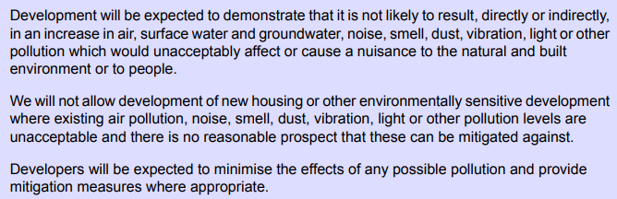

    - The following measures will be taken so that site operations are in accordance with this policy.
- In Section 3 the proposal has outlined the various potential issues and the measures taken to mitigate and prevent them.
- By developing this site all possible pollution such as noise, dust, mud, odours and pest will be mitigated.

  - The proposal meets all the objectives of the policies mentioned above by;
- Encouraging the use of road links but not creating any adverse impacts on road travel as the highways used will be done so in an efficient, clean and safe manner.
- Taking all possible measures to ensure that all forms of pollution are controlled and stopped.
- The site will not result in the loss of any jobs; instead it will create jobs immediately and in the future which boosts the local economy.
- Managing operations to prevent nuisance
- Managing operations to effectively mitigate the risk of contamination to soils, ground and surface waters.
- Managing operations to ensure that there are no impacts on the adjacent Local Nature Reserve.

- Conclusion
  - The proposed development represents a significant investment in waste management infrastructure in the local area. What this development does is clearly demonstrates Stairfoot Metals Ltd.’s commitment and desire to continually improve their operations be a good neighbour and to grow their business, increase recycling rates and secure employment in the local area.

  - There are several benefits of this proposal which have been outlined throughout the statement. These benefits are as follows:
  - The development of the area will improve the local economy of the area due immediate and future increased job creation.
  - The development will significantly increase the amount of waste treated and recycled. The site will be constructed in a well-designed and efficient manner so that it is fit for the 21st Century, whilst effectively minimizing any potential risk of contamination, noise, pests, litter, dust and odours.
  - Due to the sites location transport links will be good, yet the site will be of no hindrance to the wider catchment as all potential issues are fully mitigated.
  - The development of the site will provide a much-needed facility for the local area.
  - The facilities will be improved compared to those of the previous site which will result in less impact on the surrounding environment and residents.
  - The development is compatible with existing uses and of the uses of surrounding businesses. This indicates that the development is a suitable and viable business choice for this area.
  - The scale of the development and the proposals comply with the policies within the Core Strategy and the Joint Waste Plan which has been set out over the next 15 years.
  - With this new development, the company will be closer to meeting their aspirations of treating and recycling more waste and creating future employment.
  - The proposed development is of an acceptable scale and appearance which would complement its surroundings well.

